KAHUHO UHURU HIGH SCHOOL

NAME:………………………………………..…..ADM. NO…………..CLASS………
TUNE UP EXAM
TERM 3 2016
AGRICULTURE
FORM 3
TIME: 2 HOURS

INSTRUCTIONS: ANSWER ALL THE QUESTIONS IN THIS PAPER.

SECTION A (40 MKS)
- Name the methods of farming that involve inclusion of trees growing in crop faming. (1mk)

2. Why is the sub-soil referred to as the layer accumulation? (1 mk)

3. Name four sets of livestock production tools each comprised of tools that must be used together. (2mks)

4. Give any two water storage structures on the farm. (1mk)

5. State four reasons why the jersey breed of cattle is better suited to marginal areas than the Friesian breed. (2 mks)

6. What is minimum tillage? ( 1 mk)

7. What do you understand the term scarcity as used in agricultural economics? (1mk)

8. What is a compound fertilizer? (1 mk)
9. List four methods of harvesting water. (2 mks)

10. Sate four beneficial effects of weeds. (2 mks)

11. State four features of an ideal calf pen (2mks)

12. Give four effects of soil erosion. (2 mks)

13. Distinguish between oestrus and gestation period. (2 mks)

14. State three harmful effects of diseases on vegetables (1 ½ mks)

15. Give three precautionary measured taken in harvesting tea. (1 ½ mks)

16. Name four types of terraces. (2 mks)

17. State four factors that affect efficiency of pesticides. (2 mks)

18. List three weed control methods in paddy rice production. (1 ½ mks)

19. State four roles of trees in soil and water conservation. (2mks)

20. Name three pathogenic causes of crop diseases. (1 ½ mks)

21. Give four pieces of information contained in a title deed. (2mks)

22. Sate four factors that influence solifluction erosion. (2 mks)

23. List three basis of classifying pesticides. (1 ½ mks)

24. State five roles of a worker bee in a bee colony (2 ½ mks)

SECTION B( 20MKS)
25. Study the diagrams S and T of farm tools shown below and then answer the questions that follow.
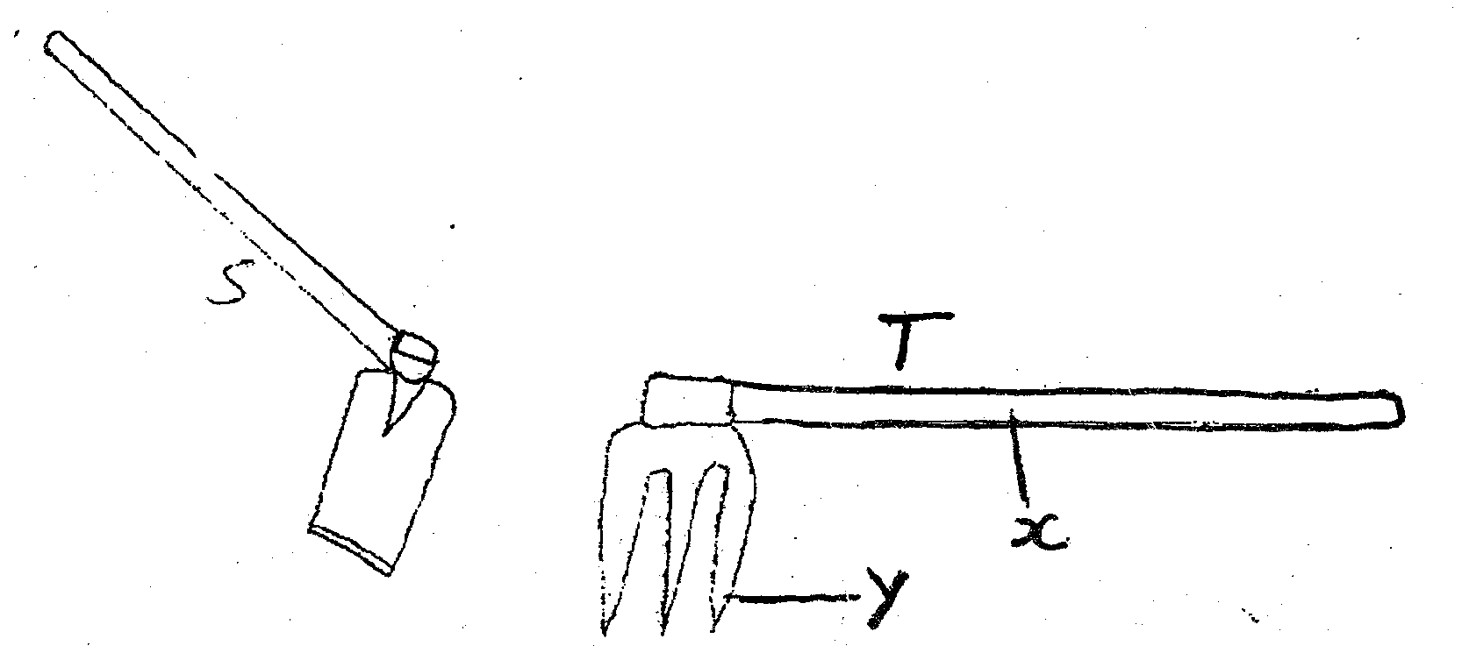
(a) Identify tools S and T (2mks)
S______________________
T_______________________
(ii) Name the parts labeled x and Y on tools T (2 mks)
X___________________
Y____________________
b) Under what three field conditions would a farmer require to use tool T instead of tool s. (3 mks)

26. Below is an illustration of the reproduction system of a bull. Study the illustration and answer the questions that follow.
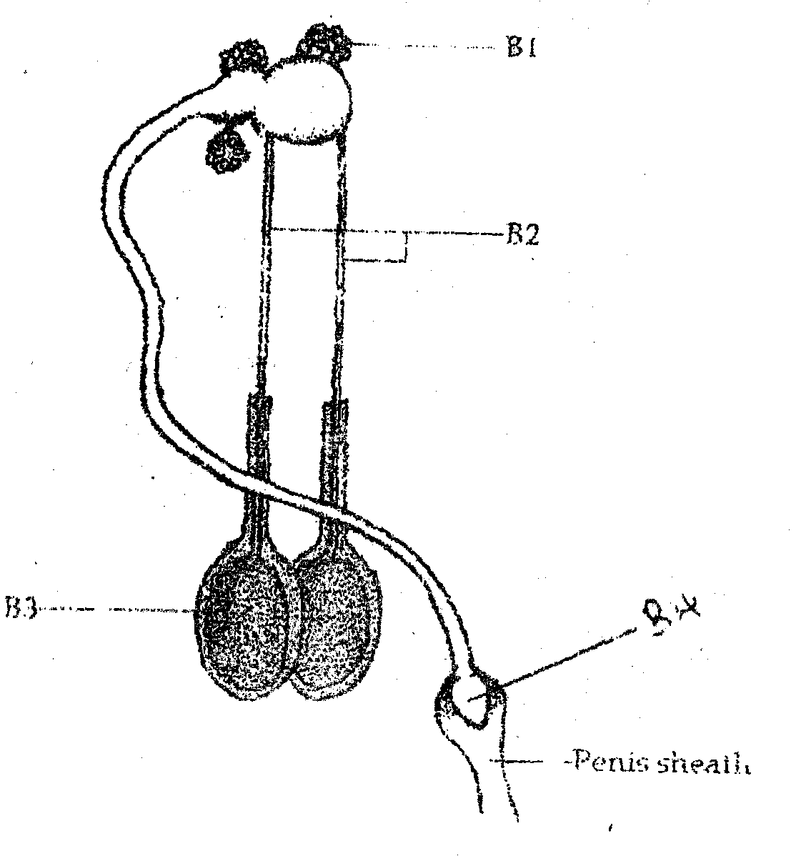
a) Identify the parts labeled B₁, B₂ and B₃( 3 marks )

b) On the diagram label the following:
i) Where seminal fluid is produced. Use letter C (1 mk)
ii) Where male sex hormones are produced. Use letter D. (1 mk)
c) State the role of the part labeled B4 on the diagram. (1 mk)
27. The diagram below illustrates a maize leaf that has been attacked by a field pest of maize. Study it and answer the questions that follow.
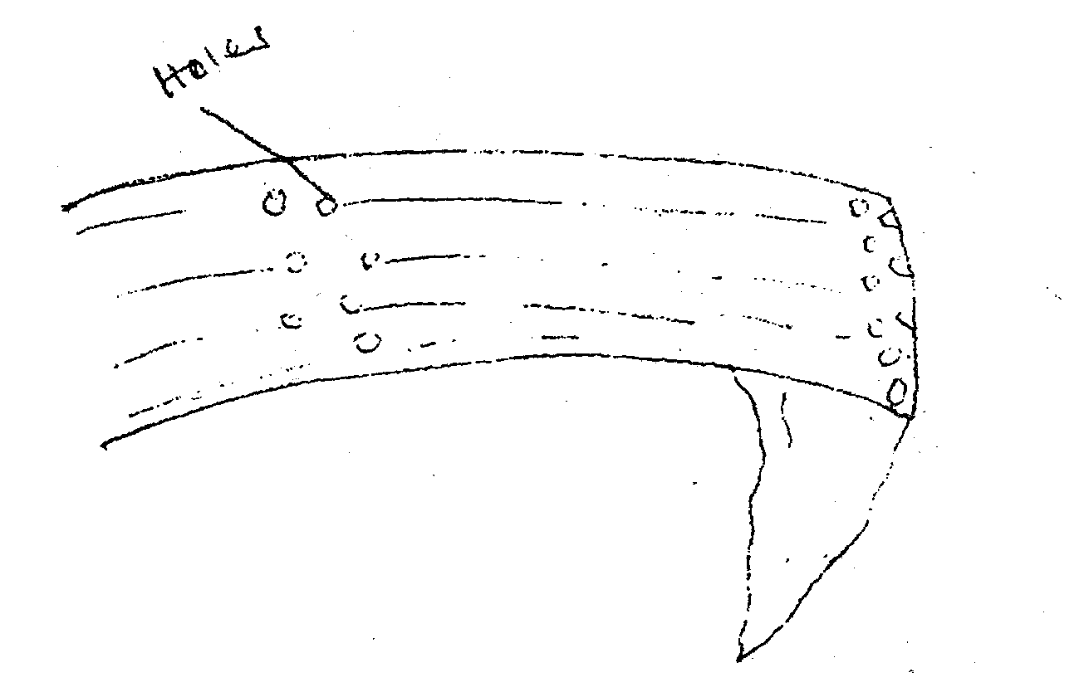
a) Identify the pest whose damages is illustrated above. (1 mk)

b) State three control measures of the pest identified in 25 (a) above (3 mks)

c) Name three maize storage pests. (3 mks)

SECTION C (40 MARKS)
28.(a) Outline five harmful effects of weeds. Give an example of a weed in each case. (10 mks)
b) Explain ten factors that influence the rate of soil erosion. (10 mks)
29. (a) Describe ten factors that are considered when siting farm structures. (10 mks)
b) Explain ten factors considered when selecting a breeding stock in livestock production. (10 mks)

