NAME: ……………………………………..…… DATE: ……………………………………….....

Adm. NO: .…………….……….……..…..… CANDIDATE’S SIGNATURE: …………..…

443
AGRICULTURE
FORM TWO
TIME: 2 HOURS

Kenya Certificate of Secondary Education

INSTRUCTIONS TO CANDIDATES
- Write your name and admission number in the spaces provided above.
- Answer ALL the questions in the spaces provided.

FOR EXAMINERS USE ONLY
QUESTIONS | MAXIMUM SCORE | CANDIDATES SCORE
1 – 26 | 90

- Name four examples of micro nutrient used in an agricultural farm (2 mks)
……………………………………………………………………………………………………………………………………………………………………………………………………………………………………………………………………………………………………
…………………………………………………………………………………………………………………………………………………
…………………………………………………………………………………………………………………………………………………
- Outline four properties of nitrogenous fertilizer (2 mks)
…………………………………………………………………………………………………………………………………………………
…………………………………………………………………………………………………………………………………………………
…………………………………………………………………………………………………………………………………………………
…………………………………………………………………………………………………………………………………………………
- Give two functions of nitrogen in crops of nitrogen in crops (1 mk)
…………………………………………………………………………………………………………………………………………………
…………………………………………………………………………………………………………………………………………………
…………………………………………………………………………………………………………………………………………………

- State two main types of planting materials used in establishing of crops (2 mks)
…………………………………………………………………………………………………………………………………………………
…………………………………………………………………………………………………………………………………………………
- Give four factors determining the spacing of crops (2 mks)
…………………………………………………………………………………………………………………………………………………
…………………………………………………………………………………………………………………………………………………
…………………………………………………………………………………………………………………………………………………
…………………………………………………………………………………………………………………………………………………
- Give four conditions under which shifting cultivation is practiced (2 mks)
…………………………………………………………………………………………………………………………………………………
…………………………………………………………………………………………………………………………………………………
…………………………………………………………………………………………………………………………………………………
…………………………………………………………………………………………………………………………………………………

- Name four factors determining seed rate (2 mks)
………………………………………………………………………………………………………………………………………………………
………………………………………………………………………………………………………………………………………………………
………………………………………………………………………………………………………………………………………………………
………………………………………………………………………………………………………………………………………………………

- Give four factors determining soil forming processes (2 mks)
………………………………………………………………………………………………………………………………………………………
………………………………………………………………………………………………………………………………………………………
………………………………………………………………………………………………………………………………………………………
………………………………………………………………………………………………………………………………………………………

- Give four importance of maintaining farm tools and equipment (2 mks)
…………………………………………………………………………………………………………………………………………………
…………………………………………………………………………………………………………………………………………………
…………………………………………………………………………………………………………………………………………………
…………………………………………………………………………………………………………………………………………………
- Give two ways of achieving tertiary operations (1 mk)
…………………………………………………………………………………………………………………………………………………
…………………………………………………………………………………………………………………………………………………
- Using definitions only differentiate between fertilizer grade and fertilizer ratio (2 mks)
………………………………………………………………………………………………………………………………………………………
………………………………………………………………………………………………………………………………………………………
………………………………………………………………………………………………………………………………………………………
………………………………………………………………………………………………………………………………………………………

- Give four climatic factors influencing agriculture (2 mks)
…………………………………………………………………………………………………………………………………………………
…………………………………………………………………………………………………………………………………………………
…………………………………………………………………………………………………………………………………………………
…………………………………………………………………………………………………………………………………………………
- Name two main farming systems (1 mk)
…………………………………………………………………………………………………………………………………………………
…………………………………………………………………………………………………………………………………………………

- State four factors considered when choosing a type of irrigation (2 mks)
………………………………………………………………………………………………………………………………………………………
………………………………………………………………………………………………………………………………………………………
………………………………………………………………………………………………………………………………………………………
………………………………………………………………………………………………………………………………………………………
- Give four importance of soil p^{H} to crop production (2 mks)
………………………………………………………………………………………………………………………………………………………
………………………………………………………………………………………………………………………………………………………
………………………………………………………………………………………………………………………………………………………
………………………………………………………………………………………………………………………………………………………
- Edna a farmer in Kama Village happens to buy a certified seed of 95% germination percentage and planted at a spacing of 20CM by 10CM in a 2 hectares piece of land. Estimate the plant population.
(3 mks)

- What is scarcity (1 mk)
…………………………………………………………………………………………………………………………………………………
…………………………………………………………………………………………………………………………………………………
- List four types farm records that can be used in bean production (2 mks)
…………………………………………………………………………………………………………………………………………………
…………………………………………………………………………………………………………………………………………………
…………………………………………………………………………………………………………………………………………………
…………………………………………………………………………………………………………………………………………………
- Outline four uses of farm records in the farm (2 mks)
…………………………………………………………………………………………………………………………………………………
…………………………………………………………………………………………………………………………………………………
…………………………………………………………………………………………………………………………………………………
…………………………………………………………………………………………………………………………………………………
- List four soil constituents of soil (2 mks)
………………………………………………………………………………………………………………………………………………………
………………………………………………………………………………………………………………………………………………………
………………………………………………………………………………………………………………………………………………………
………………………………………………………………………………………………………………………………………………………
- Identify four tools used in masonry work (2 mks)
………………………………………………………………………………………………………………………………………………………
………………………………………………………………………………………………………………………………………………………
………………………………………………………………………………………………………………………………………………………
………………………………………………………………………………………………………………………………………………………

- State two causes of hard pan (2 mks)
…………………………………………………………………………………………………………………………………………………
…………………………………………………………………………………………………………………………………………………
- Give four characteristics of plantation farming (2 mks)
…………………………………………………………………………………………………………………………………………………
…………………………………………………………………………………………………………………………………………………
…………………………………………………………………………………………………………………………………………………
…………………………………………………………………………………………………………………………………………………
- Name four methods of irrigating land (2 mks)
…………………………………………………………………………………………………………………………………………………
…………………………………………………………………………………………………………………………………………………
…………………………………………………………………………………………………………………………………………………
…………………………………………………………………………………………………………………………………………………

- Define a fertile soil (1 mk)
…………………………………………………………………………………………………………………………………………………
…………………………………………………………………………………………………………………………………………………
- Give two types organic manure (1 mk)
…………………………………………………………………………………………………………………………………………………
…………………………………………………………………………………………………………………………………………………
- A compound fertilizer bag has the labels 20-10-0.
- What do the figures 10 and 0 stand for (1 mk)
…………………………………………………………………………………………………………………………………………………
…………………………………………………………………………………………………………………………………………………
- Calculate the quantity of nitrogen required in 450 Kg of Ammonium Sulphate (2 mks)

- The diagram below illustrates a planting material. Study it carefully and answer the question that follow;
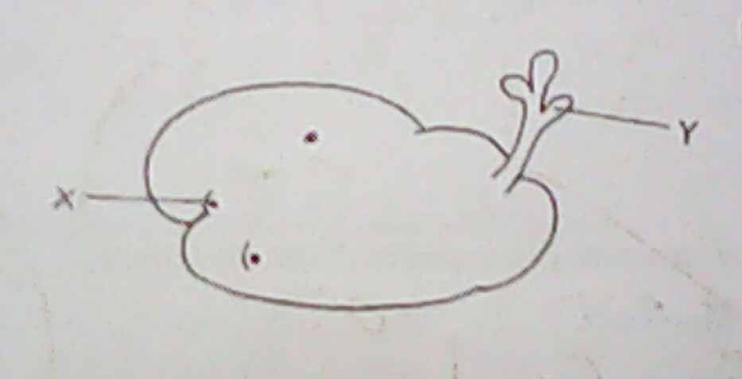
- Identify the organ (1 mk)
…………………………………………………………………………………………………………………………………………………
- Label the parts X and Y (2 mks)
………………………………………………………………………………………………………………………………………………….
…………………………………………………………………………………………………………………………………………………

- Name the method that was used in preparing the above planting material (1 mk)
…………………………………………………………………………………………………………………………………………………
- Give one environmental condition that is necessary for the success of this method of preparing a planting material (1 mk)
…………………………………………………………………………………………………………………………………………………
- State two ways in which agriculture contributes to industrial development (2 mks)
………………………………………………………………………………………………………………………………………………………
………………………………………………………………………………………………………………………………………………………
- State four ways by which wind affects the growth of crops (2 mks)
………………………………………………………………………………………………………………………………………………………
………………………………………………………………………………………………………………………………………………………
………………………………………………………………………………………………………………………………………………………
………………………………………………………………………………………………………………………………………………………
- The diagram below illustrates some types of soil structure. Study and answer the questions that follow;
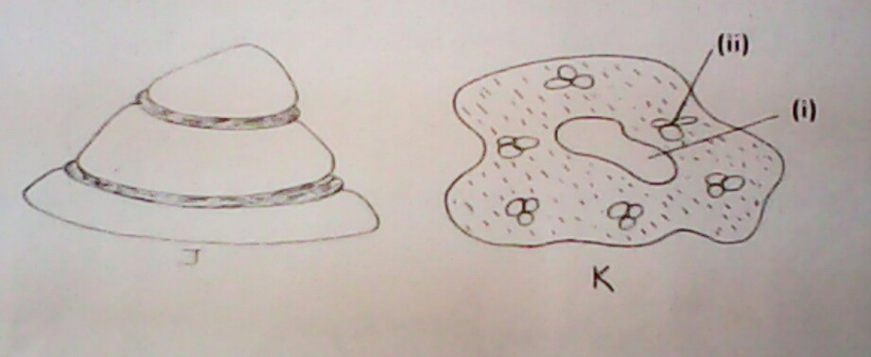
- Identify the types of soil structure illustrated in the diagrams J and K (2 mks)
…………………………………………………………………………………………………………………………………………………
…………………………………………………………………………………………………………………………………………………
- Name the parts labeled (i) and (ii) in the diagram K (2 mks)
…………………………………………………………………………………………………………………………………………………
…………………………………………………………………………………………………………………………………………………
- State two effects of soil structured labeled J in crop production (2 mks)
…………………………………………………………………………………………………………………………………………………
…………………………………………………………………………………………………………………………………………………

- State four importance of sub soiling as tertiary operation (2 mks)
…………………………………………………………………………………………………………………………………………………
…………………………………………………………………………………………………………………………………………………
…………………………………………………………………………………………………………………………………………………
…………………………………………………………………………………………………………………………………………………

- Outline four advantages of rolling in seedbed preparation (2 mks)
…………………………………………………………………………………………………………………………………………………
…………………………………………………………………………………………………………………………………………………
…………………………………………………………………………………………………………………………………………………
…………………………………………………………………………………………………………………………………………………
- Give four importance of drainage as a method of land reclamation (2 mks)
…………………………………………………………………………………………………………………………………………………
…………………………………………………………………………………………………………………………………………………
…………………………………………………………………………………………………………………………………………………
…………………………………………………………………………………………………………………………………………………
- The diagram shows a method of crops;
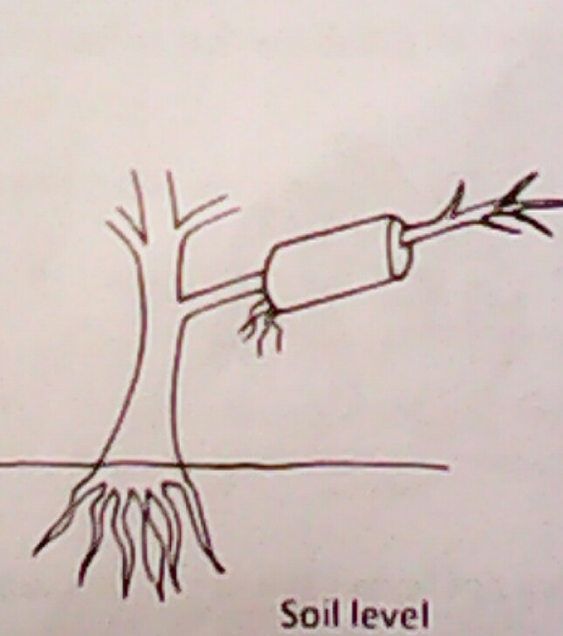
- Identify the propagation method illustrated above (1 mk)
…………………………………………………………………………………………………………………………………………………
- State two ways of initiating faster root development in propagation method illustrated
(2 mks)
…………………………………………………………………………………………………………………………………………………
…………………………………………………………………………………………………………………………………………………
- Give four methods of harvesting water in the farm (2 mks)
………………………………………………………………………………………………………………………………………………………
………………………………………………………………………………………………………………………………………………………
………………………………………………………………………………………………………………………………………………………
………………………………………………………………………………………………………………………………………………………

- State two factors considered when siting compost manure heap (2 mks)
…………………………………………………………………………………………………………………………………………………
…………………………………………………………………………………………………………………………………………………
- State two methods of increasing soil p^{H} (2 mks)
…………………………………………………………………………………………………………………………………………………
…………………………………………………………………………………………………………………………………………………
- Below is a diagram of a domestic tank. Study it and answer the questions that follow;
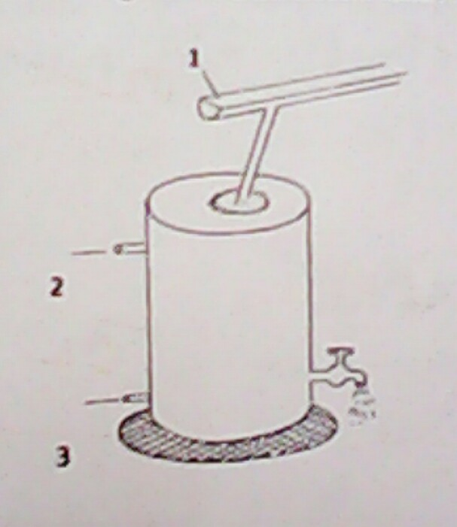
- Name the parts labeled 1, 2 and 3 (3 mks)
…………………………………………………………………………………………………………………………………………………
…………………………………………………………………………………………………………………………………………………
…………………………………………………………………………………………………………………………………………………
Outline four qualities of clean water (2 mks)
…………………………………………………………………………………………………………………………………………………
…………………………………………………………………………………………………………………………………………………
…………………………………………………………………………………………………………………………………………………
…………………………………………………………………………………………………………………………………………………

- Outline two importance of tissue culture in crop production (2 mks)
…………………………………………………………………………………………………………………………………………………
…………………………………………………………………………………………………………………………………………………

- State the difference between a seedling bed and a seedbed (2 mks) …………………………………………………………………………………………………………………………………………………
…………………………………………………………………………………………………………………………………………………

END OF PRINTED PAGE

