COUNTY MULTILATERAL EXAM

END TERM 2

AGRICULTURE FORM 2

INSTRUCTIONS: ANSWER ALL THE QUESTION IN THIS PAPER IN THE SPACES PROVIDED

TIME : 2 HOURS

NAME:…………………………..ADM. NO………………………..CLASS……………

SECTION A (40 MKS)
1. Distinguish between the following:
a) Olericulture and aquaculture. (1 mk)

b) Pomoculture and pastoralism. (1mk)

2. Name the temperature range within which a crop will not grow but produce to its maximum. (1 mk)

3. Name three chemical used in the chemical process of water treatment on farms.
(3 mks)

4. Give the functional differences mason’s trowel and garden trowel. (1 mk)

5. State three disadvantages of intensive system of farming. (3 mks)

6. List two items likely to be found in the consumable goods inventory of a rabbit farmer. (2 mks)

7. Name the following;
a) A breed of dairy goat that is brown in colour with two white stripes running from the eyes to nose and originated from Switzerland. (1 mk)

b) A pig whose origin in Britain with erect ears, broad and slightly dished snout.
(1 mk)

8. Give two mechanical methods used to separate the various soil particles according to their size. (2 mks)

9. State four benefits of minimum tillage. (4 mks)

10. Name the three fertilizer elements. (3mks)

11. Give three reasons for drying maize grains before storage. (3mks)

12. State four qualities of certified seeds that make them good planting materials.
(4 mks)

13. What is a seedling bed? (1 mk)

14. State four desirable qualities of a parent plant from which a rootstock is obtained for grafting. (4 mks)

15. Define the following terms as used in crop production. (3mks)
a) Gapping

b) Rogueing

c) Training

16. Why is it not advisable to apply manure in a seedbed for planting carrots? (1 mk)

17. What is quarantine in livestock health? (1 mk)

SECTION B (20 MKS)
18. Below is an illustration of a cabbage leaf which has been damaged by a pest. Study the diagram carefully and answer the questions that follows.
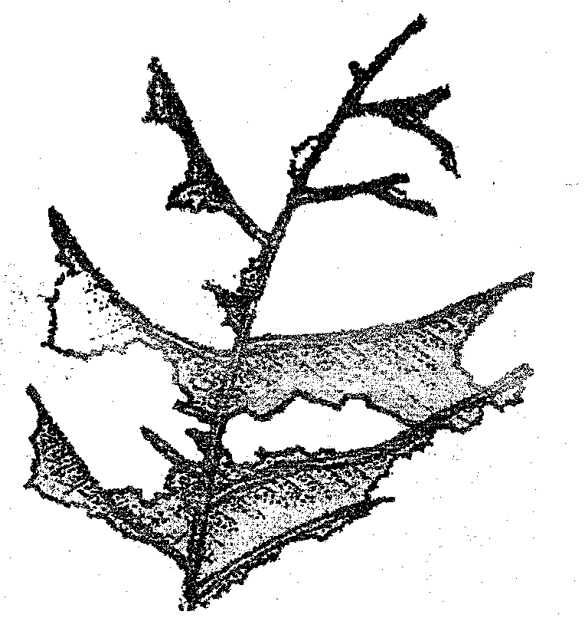
(a) (i) Name the pest that causes the damage shown in the illustration above. (1 mk)

ii) Describe the damage shown in the diagram above. (1 mk)

b) Name the development stage of the pest that causes the damage described in (a) (ii) above. (1 mk)

c) State two control measures of the pest named in (1) (i) above (2 mks)

19. The illustration below shows an experiment set up using soil types G, H, and J and observations made after 24 hours. Study the illustration and answer the questions that follow.
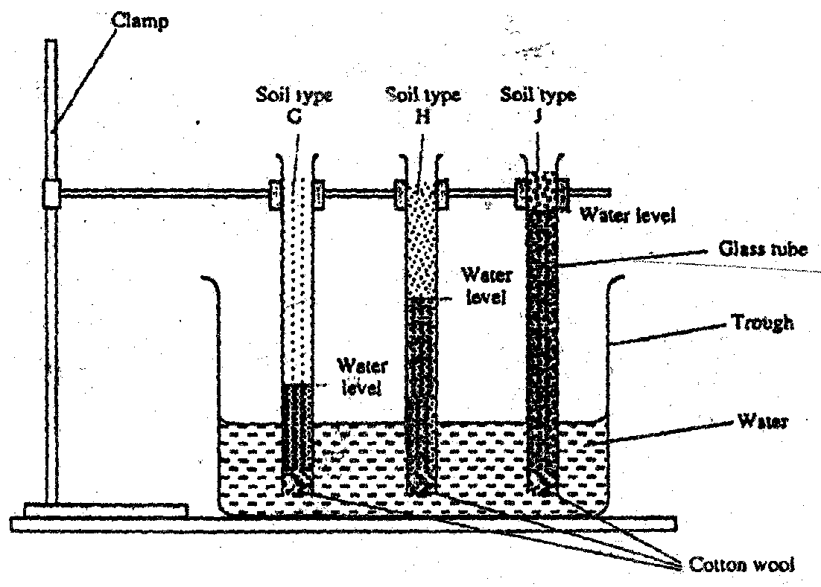
(a)(i) What is the experiment represented above designed to study? (1 mk)

(ii) Name the three soil types (3 mks)

G ___________________________________

H ___________________________________

J ___________________________________

(iii) Give the characteristics texture of soil types G and J. (2 mks)

G _________________________

J __________________________
(iv) State two ways or practices of improving the structure of soil type G. (2 mks)

20. Below is an illustration of a nursery for raising vegetable crop seedlings.
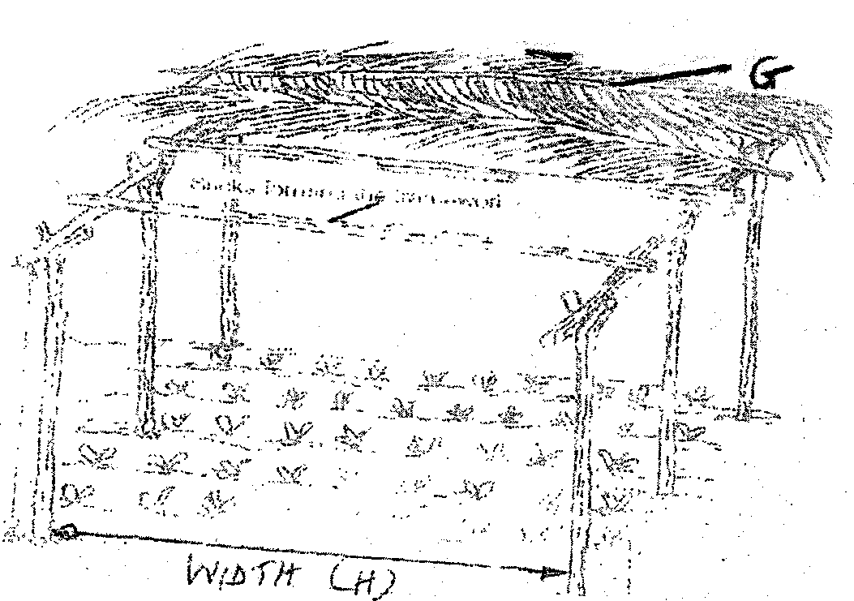

(a) (i) Give the recommended width represented by letter H in the illustration above.
(1 mk)

(ii) State four roles of the part labeled G in a nursery. (4 mks)

b) List two measures taken to minimize root damage during transplanting of vegetable crop seedlings. (2mks)

SECTION C (40 MKS)
21. Explain five benefits of crop rotation. (10 mks)

22. State and explain four factors that influence the depth of planting. (8 mks)

23. Outline four benefits of soil testing. (8 mks)

24. Outline four practices done in a maize grain store in preparation for storage of a produce. (8 mks)

25. Outline six reasons for land preparation (6 mks)

