NAME ___________________________________________________ INDEX NO________________
443/1
AGRICULTURE PAPER 1
TIME 2 HOURS
PERIOD – JULY/AUGUST 2017
3KNT FRATERNITY EXAMINATION
INSTRUCTIONS
- Answer all the questions in section A and B
- Section C has 3 questions, choose 2 questions
- Answer all the questions in the spaces provided
SECTION | QUESTIONS | MARKS
A | 1 – 18
B | 19  20  21  22
C | 23  24  25

SECTION A 30 MKS
IN THE SPACES ANSWER ALL THE QUESTIONS IN THIS SECTION PROVIDED
- State four factors considered when identifying a farming system in an area (2mks)

- Give four advantages of intensive farming (2mks)

- What is soil structure? (1mk)

- Write four reasons for early land preparation (2mks)

- Why is burning discouraged in land clearing? (2mks)

- Write three characteristics of a fertile soil (1 ½ mks)

- Give two ionic forms in which nitrogen is absorbed by plants (1mk)

- Differentiate between straight and compound fertilizers (1mk)

- Write four advantages of row planting (2mks)

- Give four pieces of information in a land title deed . (2mks)

- Highlight the meaning of the following terms
- Mixed cropping

- Monocropping

- Intercropping

- Write 4 factors considered in choosing seed rate (2mks)

- Give 4 factors that contribute to the competitive ability of weeds (2mks)

- What is crop disease ( ½ mk)

- Give three methods of utilizing maize as fodder (1 ½ mks)

- Write the meaning of the following terms (2mks)
- monopoly

- Monopsony

- State 4 sites for agro forestry trees (4mks)

- Write 4 benefits of agro forestry to a maize crop (2mks)

SECTION B ANSWER ALL THE QUESTIONS
- The diagram below illustrates a method of collecting soil samples from a field
8
7
6
5
4
3

22
1 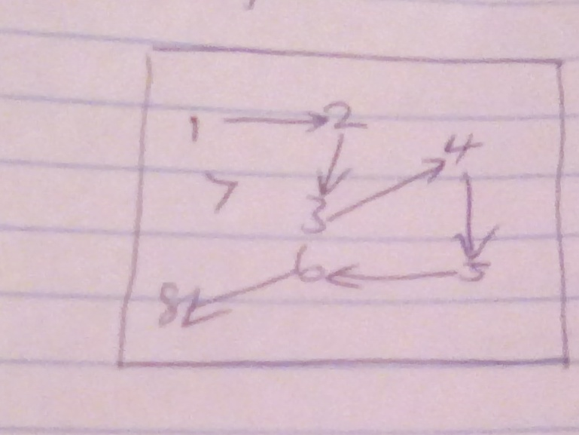 1

- Identify the method illustrated above (1mk

- State 3 precautions a former should take when collecting a representative soil sample from the field for testing (3mks)

- Give one reason for soil testing (1mk)
20) The photograph below illustrates a method of irrigation

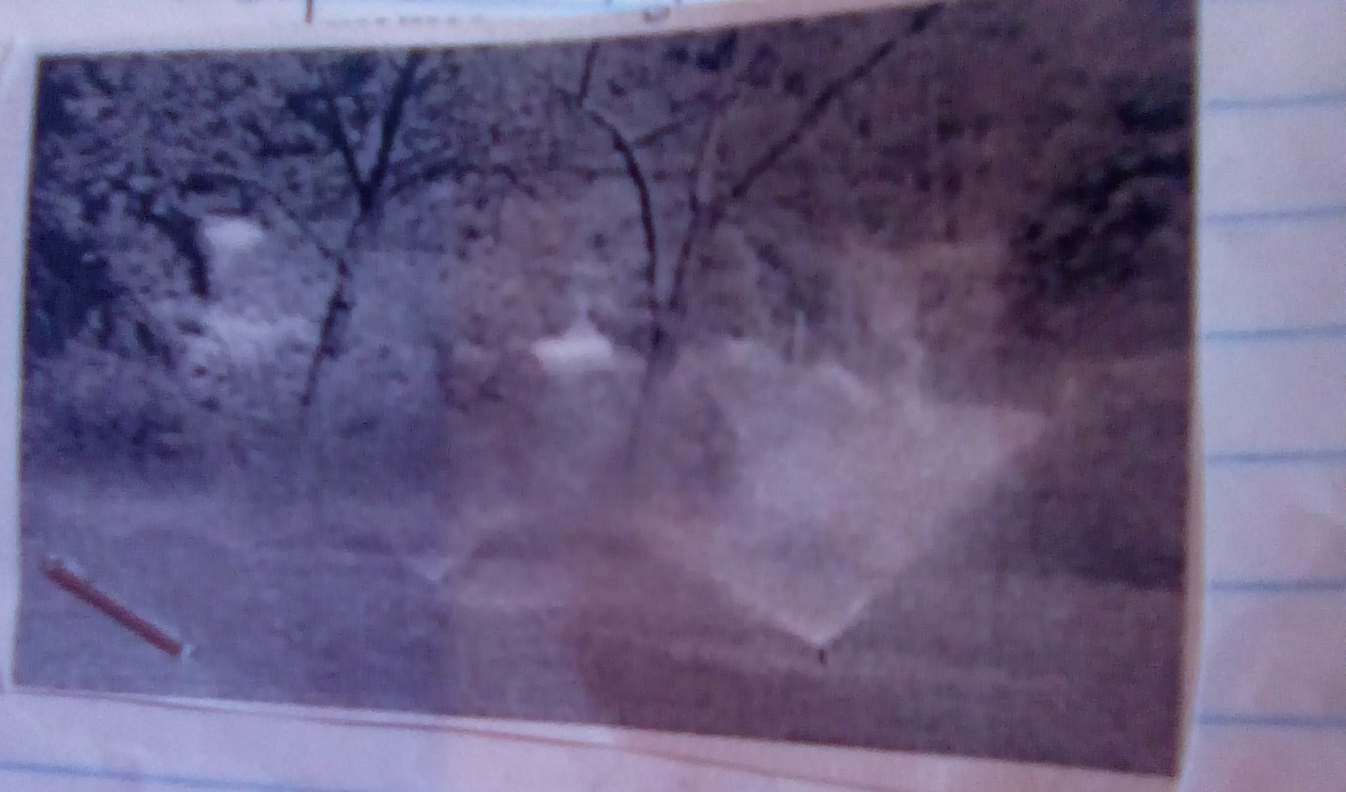

- Identify the method of irrigation illustrated above (1mk)

- State two maintenance practices that are carried out on the equipment used in the method illustrated above. (2mks)

c. Give two advantages of drip irrigation have over the method of irrigation illustrated above in crop disease control. (2mks)

21. The diagram below illustrates a condition that affects carrots in the field.

- Identify the disorder on the carrot illustrated above. (1mk)

- State one factor that could lead to the condition above. (1mk)

- Outline three field management practices that is done to carrots (3mks)

22. At the end of the year ended 31:12:2015 the following information was recorded in Upendo farm.
Kshs
Perennial crops 250,000
Bank loans 30,000
Cash at hand 5,000
Bank overdrafts 15,000
Land 350,000
Unpaid wages 3,000
Debts receivable 20,000
Stocks in store 25,000
Livestock 200,000
Bank balances 100,000
- Prepare a balance sheet as at 31.12.2015 (4mks)

- Did Upendo farm qualify for a loan? Give a reason for your answer (1mk)

SECTION C ANSWER ANY OF THE TWO QUESTIONS
23. Describe the production of sorghum under the following sub-headings
a) Ecological requirement (4mks)
b) Land preparation and planting (6mks)
c) Pest and disease control (6mks)
d) Harvesting and marketing (6mks)

24. a) Explain Eight cultural methods of soil and water conservation (8mks)
b) Explain four ways in which
i) HIV/Aids limits agricultural production (4mks)
ii) Government policy improves agricultural production (4mks)
iii) Low levels of Education and technology influences Agriculture (4mks)

25. a) Explain seven physical methods of pest control (7mks)
b) Explain eight factors that contribute to competitive ability or weeds (8mks)
c) Describe harvesting of coffee 5mks)

