MUKINDURI SECONDARY SCOOL
MIDTERM 1 EXAM 2017
FORM 3
NAME ……………………………………………… ADM …………………………
CLASS …………………………..
SECTION A (30MKS) ANSWER ALL THE QUESTIONS.
- State two types of farm records. (2mks)

- List four desirable of a good ewe for breeding should have. (2mks)

- State two methods of selection? (1mk)

- State two reasons for docking sheep. (1mk)

- Name any four dual purpose breeds of cattle. (2mks)

- Give 2 reasons for culling in cattle production (1mk)

- Give two types of ticks that attack livestock. (2mks)

- Give three causes of nutritional diseases. (3mks)

- State two characteristics of the bacteria in camel. (1mk)

- Name two types of bees. (1mk)

- A) Give three factors to consider when selecting animals for breeding. (1 ½ mks)

b) Define the term breeding. (1mk)

c) Name two reasons for breeding. (2mks)

- Define pre-disposing factors. (1mk)

B. State four pre-disposing factors of of livestock diseases. (2mks)

- Give four symptoms of internal parasites in livestock. (2mks)

- State two reasons for culling in livestock production. (1mk)

- State five signs of fawowing in sows. (2 ½ mks)

- Differentiate between terms apiculture and aquaculture as used in Agriculture. (1mk)

SECTION B (Answer all the questions.) 20mks)
- Study the illustration below and use it to answer the questions that follow.
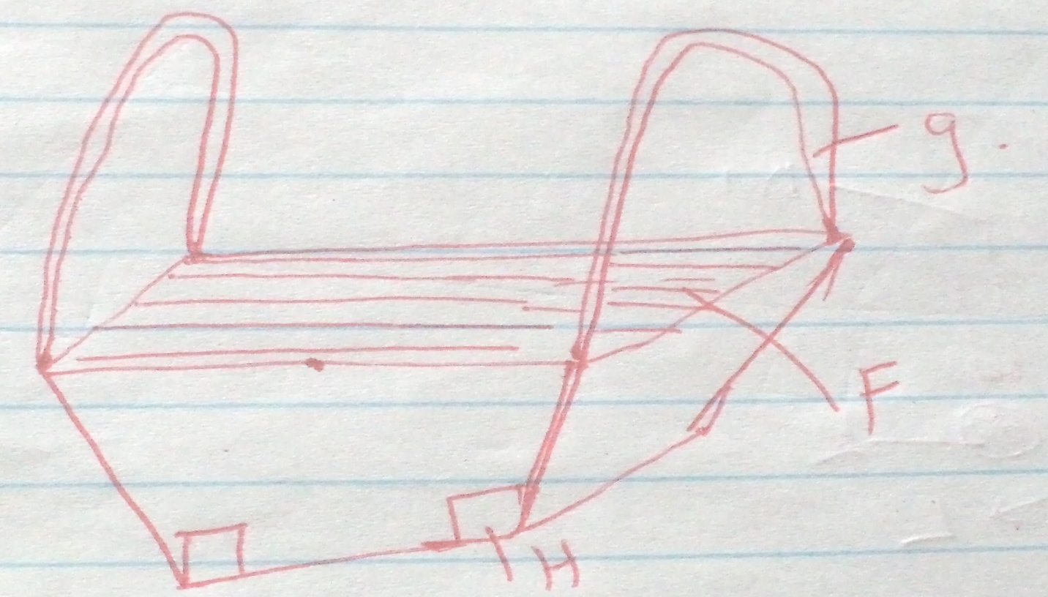

- Name the type of beehive shown. (1mk)

- Give names of other two types of hives. (1mk)

- Name the parts labeled F,G AND H. (3mks)

- Define the term digestibility. (1mk)

b. Using the person’s square method compute how much maize meal (8%cp) and soyabean meal 43%cp would be required toprepare 100kg of the mixture containing 15% cp. (4mks)

- Study the diagram below of a reproductive system of a cow.
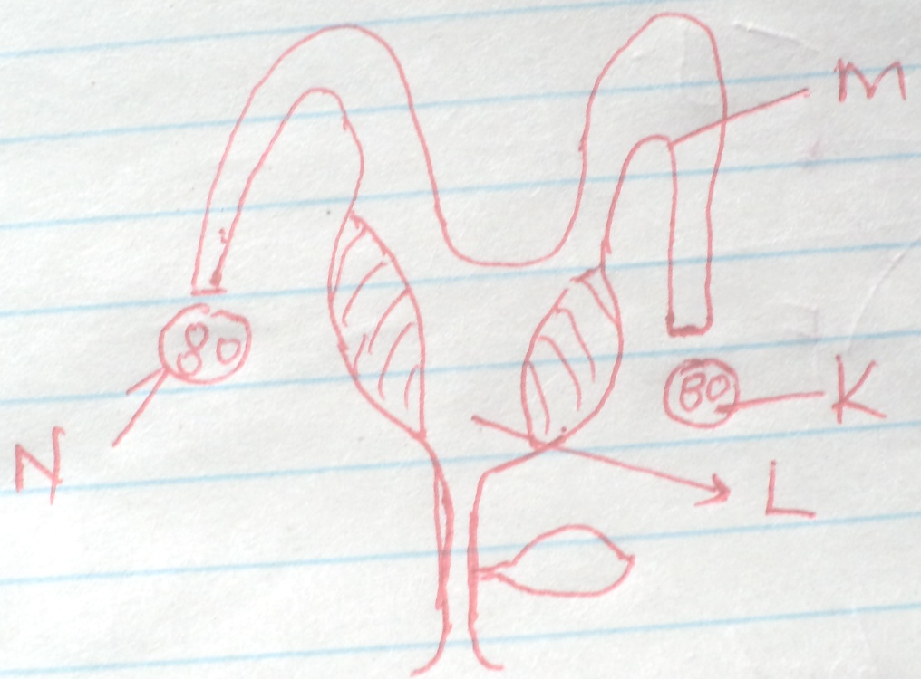

- Name the parts labeled k and l. (1mk)

- Give the use of the parts M and N. (2mks)

- State any four cultural methods of controlling ticks. (2mks)

- Diagrams F, G, H and J illustrate farm tools.
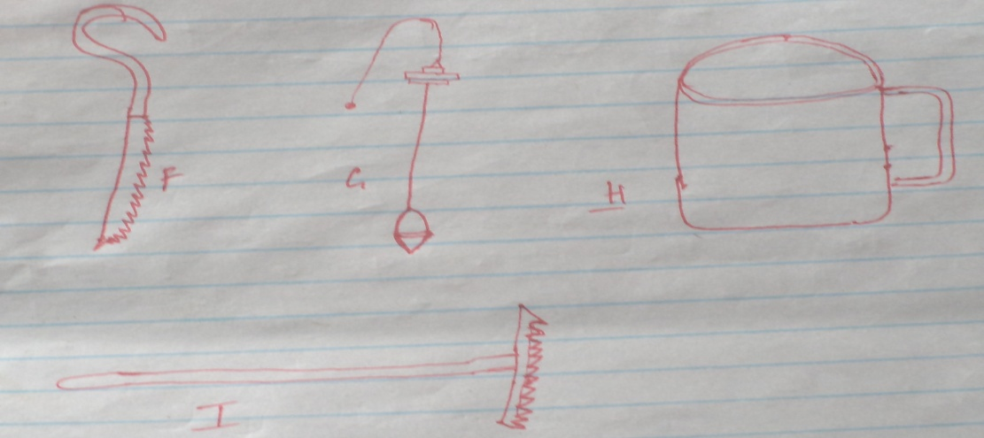

- Identify the tools F, G, H and I. (2mks)

- Give the function of each of the above tools. (2)

- Indicate two maintenance practices on tool H. (1mk)

SECTION C (Answer any two questions) 40mks.

- Outline six advantages of artificial insemination in dairy cattle management. (6mks)

b. Explain five factors to consinder when siting an apiary. (10mks)

c)state 4 reasons why bees swarm

- Describe the importance of keeping livestock healthy in the farm. (10mks)

b. Outline five signs of ill health in livestock. (5mks)

c. List any five signs of paturition in a rabbit. (5mks)

24 a) Describe the process of egg formation with an aid of a diagram in poutly production 20MKS

