NAME …………………………….. INDEX NO. ……..…
DATE ……………………………. CLASS ……………..

MUKINDURI SECONDARY SCHOOL MID TERM 1 EXAMS 2018
AGRICULTURE FORM THREE
2 HRS

INSTRUCTIONS TO CANDIDATES
(a) Answer your name and index number in the spaces provided above.
(b) Answer all the questions in the spaces provided in the question paper.
(c) Mathematical tables and silent electronic calculators may be used.
(d) All working must be clearly shown where necessary.

SECTION A 30MKS
- state two ways in which agriculture contribute directly to the development of industries
2x ½ =2mks

- list four features of rainfall a farmer should consider when deciding no crop to grow
(4mks x ½=2mks.

- Name any four dual purpose breeds of cattle.(2mks)

- Give four effect of low level of education and technology in Agriculture(2mks)

- State two reasons for docking sheep 1mk

- list two determinants of soil colour.1mk

- list two crops that may be propagated by means of splits.1mk

- Differentiate between intercropping and mixed cropping.2mks.

- Mention four roles of NITROGEN in crops.2mks.

- Give four factors to consider when culling animals for breeding. 2mks.

- State four characteristics of good green manure plants. 2mks.

- Outline four post harvest practices carried out on crops after harvesting.2mks.

- Give any 4 methods of breaking seed dormancy.2mks.

- Differentiate between over sowing and under sowing of seeds in crop production.1mk.

- Give any 4 importance of a Nursery in crop propagation.2mks.

- Differentiate between terms apiculture and aquaculture as used in Agriculture 2mks

- Mention two advantages of using farm yard manure.1mk.

- Give any four advantages of pruning in coffee.2mks.

SECTION B (SECTION 20MKS)
- Study carefully the illustration below of a bag of fertilizer and answer the questions that follow.

- I) what do the figures on the diagram stand for 18 and 46. (1mk)

ii) What class of inorganic fertilizer does dap belong to? Why? 1mk

- A farmer was advised to apply 250kg/ha of sulphate of ammonia while top dressing nappier grasss. Sulphate of ammonia contains 21% N calculate the amounts of nitrogen that he/she would apply in a two hectares field.3mks.

20 Study the illustration below and use it to answer the questions that follow.
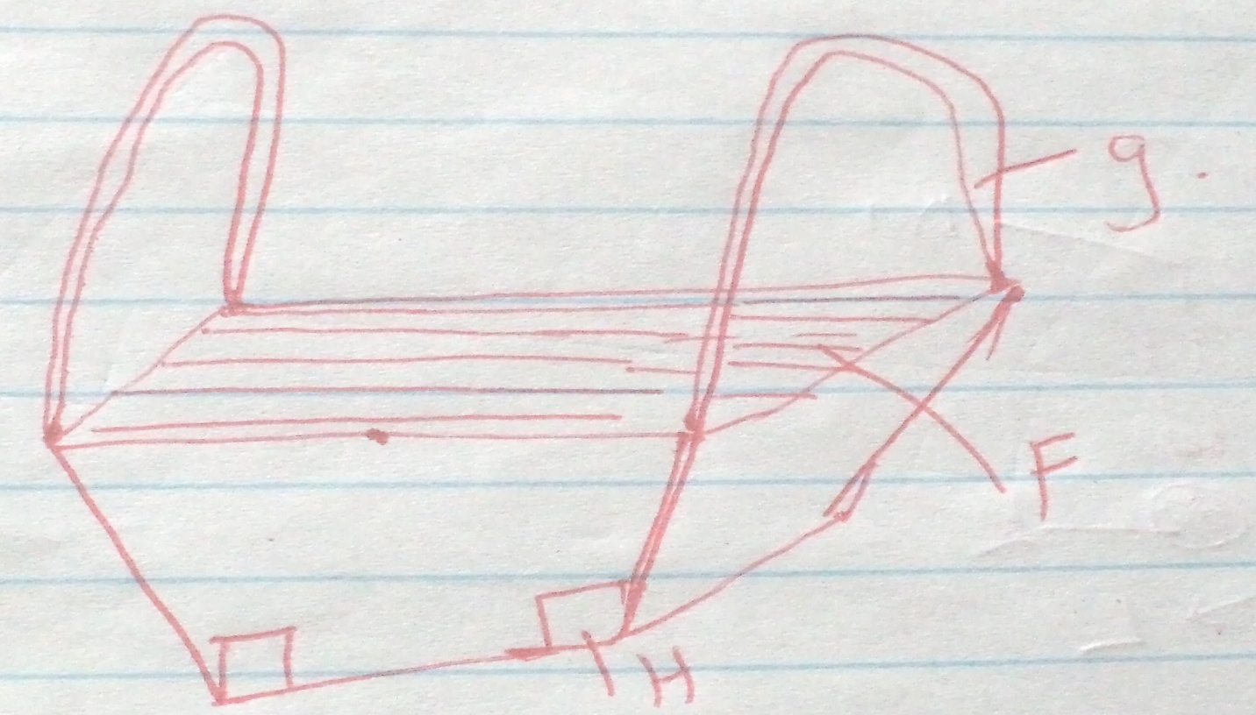

- Name the type of beehive shown. (1mk)

- Give names of other two types of hives. (1mk)

Name the parts labeled F,G AND H. (

- List three aspect of light that influence crop growth.3mks.

- The diagram below shows an experiment set up using soil type G, H and J. observations were made after 24hrs, study the diagram and answer the questions that follows.

- What is the experiment represented above designed to study? 1mk.

- Name the three types of soil G,H and J. (3mks)

- What is the characteristics texture of soil type G and J 2mks.

- State how a farmer would improve the structure of soil type G.

SECTION C 40MKS. ANSWER ANY TWO QUESTIONS.
22a) describe factors influencing spacing of crops.6mks.

b. state and explain 6 advantages of crop rotation in crop production.12mks.

c. name two methods of preparing compost manure.2mks.

23. a. Describe the importance of livestock in the farm. (5mks)

b. Outline five signs of ill health in livestock. (5mks)

24. Describe importance of Drainage as a land Reclamation method.6mks.

b. discuss 6 characteristics of fertile soil.6mks.

c. explain any 4 factors to consider in choosing seedrates. 8mks.

