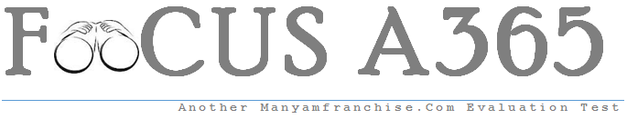

Gatitu Mixed Secondary School
Form 3 | Term 1 | 443 - Agriculture | 07-Jan-16 | Opener
- Describe five factors that affect the rooting of cuttings. 10mks

- Describe the factors considered when selecting seeds for planting. 4mks

- Define the following terms
- Seed dressing 2mks

- Seed dormancy 2mks

- Seed inoculation 2mks

- Chitting 2mks

- State five factors that affect the spacing of crops . 5mks

- Explain the following methods of sowing
- Undersowing 2mks

- Oversowing 2mks

- State five factors that are considered when sitting a nursery bed. 5mks

- What are the advantages of budding in crop production. 5mks

- Define tissue culture. 1mk

- State four advantages and four disadvantages of tissue culture. 8mks

