GATITU MIXED SECONDARY SCHOOL
AGRICULTURE FORM 3
MIDTERM EXAM TERM 1 2015
SECTION A (30MKS)
ANSWER ALL QUESTIONS IN THIS SECTION
- Name two internal parasites of livestock. 2mks

- State two roles of carbohydrates in the body of an animal. 2mks

- What does metabolic water refer to in livestock nutrition? 1mk

- State two ways by which proper feeding contributes to the control of disease in livestock. 2mks

- Give two functions of water in the body of an animal. 1mk

- State two qualities of clean water for livestock. 2mks

- State two dairy products that can be prepared from milk cream. 2mks

- What is skim milk? 1mk

- Give two reasons for candling incubated eggs. 2mks

- State two factors that necessitate culling in a flock of layers. 2mks

- Name two tools used in riveting 2mks

- Give one functional difference between a brace and a hand drill. 1mk

- Name two exotic dairy goat breeds. 2mks

- Outline three factors that may lower quality of wool. 3mks

SECTION B (20MKS)
ANSWER ALL QUESTIONS IN THIS SECTION
- The illustrations below show a practice in layer birds. Use them to answer the questions that follow.

- What practice is represented above? 1mk

- Which illustration shows the right way of carrying out the practice? 1mk

- State two reasons for carrying out this practice in poultry. 2mks

- The following is a diagram showing part of the poultry’s digestive system. Use it to answer the questions

- Name the parts labeled Q,S,T and R. 3MKS

- Give two structural adaptations of R to its functions. 2mks

- The graph below shows the relationship in milk yield and foetal growth against time.

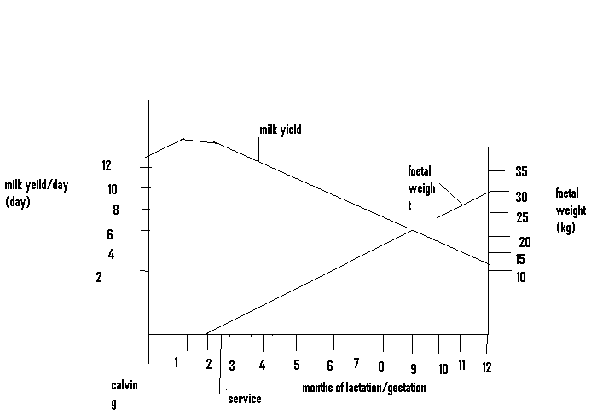

- Name the stage between the months in respect to lactation and gestation:

- 2nd to 12th month 1mk

- 10th to 12th month 1mk

- 1st to 10th month. 1mk

- Give two practices carried out on the in calf cow within the period from the 10th to the 12th month. 2mks

- State one routine practice a farmer should avoid carrying out on the in calf cow between the 10th and 12th month. 1mk

- From the graph find the birth weight of the calf. 1mk

- The diagram below shows the male reproductive system in cattle. Use it to answer the questions that follow.

- Name the parts labeled Z and W. 2mks

- State the functions of parts labeled V and Y 2mks

- How is part W adapted to its function? 1mk

SECTION C (40MKS)
ANSWER ANY TWO QUESTIONS FROM THIS SECTION

- What are predisposing factors in livestock disease? 2mks
- Explain the common predisposing factors in livestock diseases. 18mks

- Describe the life cycle of a two host tick. 15mks
- Give five effects of ticks on livestock. 5mks

- Explain the factors that influence the daily water requirement of a dairy cow. 10mks
- Discuss the digestion of food in poultry from the crop to the gizzard. 10mks

