MWAKICAN JOINT EXAM TEAM (MJET)

FORM 3 AGRICULTURE PAPER 2

END OF TERM 2 – 2015

NAME…………………………………………………… ADM ……….. CLASS ……………

SECTION A (30MKS)

- State two uses of sickle on farm (1mk)

- Distinguish between a zoonotic disease and a notifiable disease. (2mks)

- State three factors considered when siting poultry house (1 ½ mks)

- List any four farm structures that are necessary for holding dairy animals. (2mks)

- Give any four non-chemical methods of controlling ticks in the farm. (2mks)

- State two advantages of using wood in the construction of farm building (1mk)

- (a) What is embryo transplant ? (1mk)

(b) Give two advantages embryo transplant (2mks)

- State two uses of footbath in cattle dip (2mks)

- State four management practices that should be carried out during the mating season in sheep. (2mks)

- Distinguish between crutching and ringing in livestock management. (2mks)

- State two purposes of adding addictives in livestock feed. (1mk)

- (a) Define caponization (1mk)

(b) Give four reasons for caponization (2mks)

- List four ways in which vaccines can be administered to animals. (2mks)

- Give two functions of spill-way in fish pond. (1mk)

- Name any four dairy goats (2mks)

- State three signs of farrowing in sows (1 ½ mks)

- ‘I am breed of goat mainly kept for hair production’. Who am I ? (1mk)

SECTION B (20MKS)
Attempt all questions.

- Study the illustration below carefully of a farm structure used in rearing poultry.
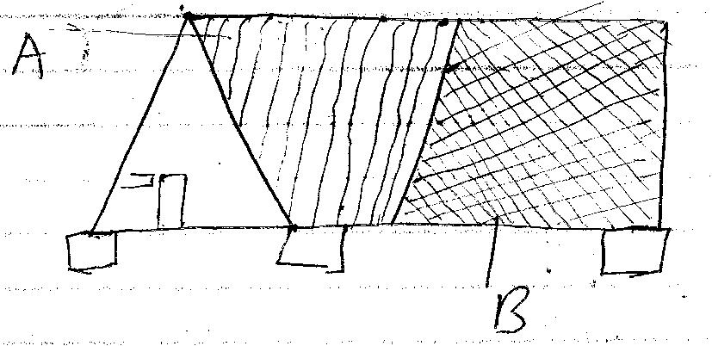

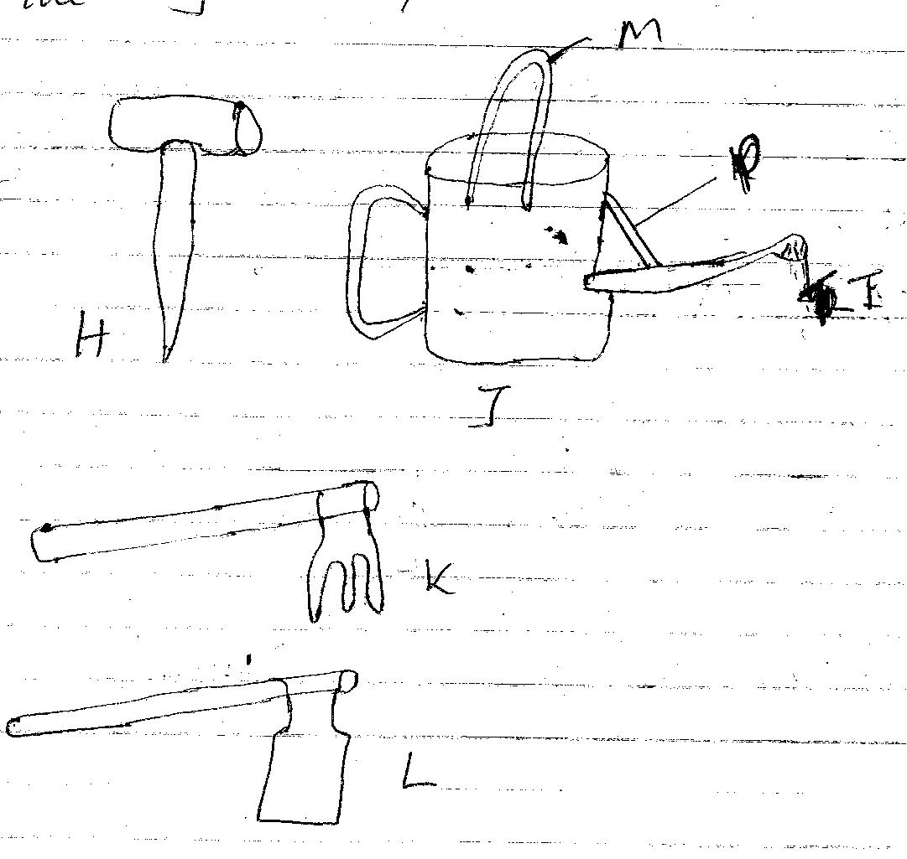

- Identify the structure (1mk)

- Name the materials used in construction of the parts A and B. (2mks)

- Give two uses of the structure (2mks)

- Using the pea sons square method, calculate how much of wheat 10% DCP would be mixed with sunflower seed cake 35% DCP to come up with 100kg Duck mash 20% DCP. (Show your working) (6mks)

- The diagrams H, J, K, L institute some tools.

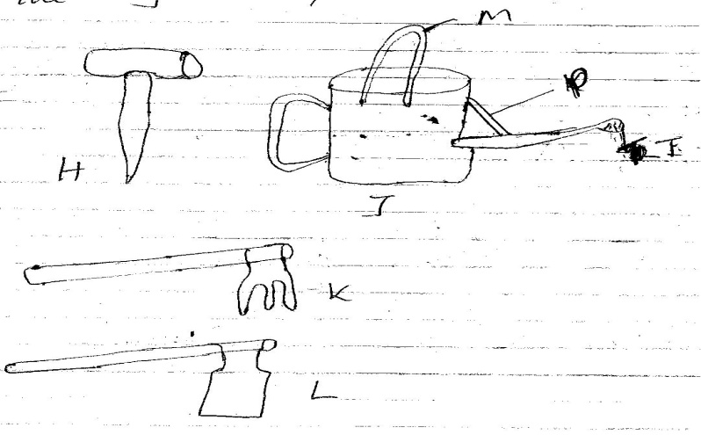

- Identify the above tools. (2mks)

H -
J -
K -
L -

- State the uses of the tools (4mks)
L -

H -

J -

K -

- Name the labelled parts of tool J (1 ½ mks)
M -
K -
L -

- The diagram below represent livestock parasites.

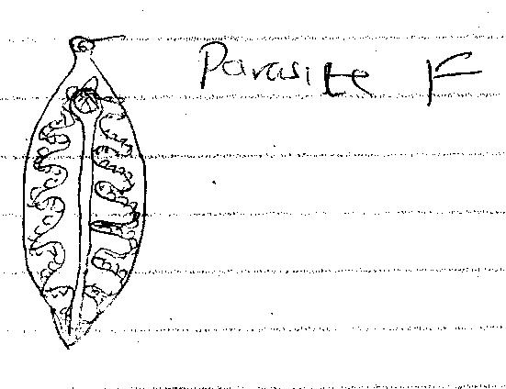

- Identify the parasite F (1/2mk)

- State two symptoms of attack by parasite F in an animal. (1mk)

SECTION C:

Choose any two questions

22(a) Outline the uses of fences in the farm. (10mks)

(b) Highlight five disadvantages of live fences. (5mks)

(c) List five ways of maintaining farm fences. (5mks)

23(a) Discuss five methods of identification in livestock (15mks)

(b) State five reasons for culling in cattle production (5mks)

24(a) State five factors to consider in selecting construction materials. (5mks)

(b) Explain factors to consider in siting farm structures (10mks)

(c) Indicate the importances of farm buildings (5mks)

