NAME …………………..………………………. SCHOOL …………………………………

ADM. ……………….. CANDIDATE’S SIGNATURE …………..…..………..

443
AGRICULTURE FORM 1
THEORY
2 ½ HOURS

443
AGRICULTUREFORM 1
THEORY
JULY/AUGUST 2015
2 ½ HOURS

INSTRUCTIONS TO CANDIDATES
- Write your name and admission numbernumber in the spaces provided above.
- This paper has THREE sections: A , B and C
- Answer ALL the questions in section A and B and any TWO questions in section C
- ALL answers MUST be written in the spaces provided.
- Do not remove any pages from this booklet.
- This paper consists of 10 printed pages. Candidates should check to ensure that all pages are printed as indicated and no questions are missing

FOR EXAMINER’S USE ONLY

 | Questions | Maximum score | Candidate’s score
A | 01- 15 | 30 marks
B | 16 -19 | 20 marks
C | 20- 22 | 40 marks
Total score |  | 90
SECTION A (30 MARKS)
Answer ALL the questions in the spaces provided
1. State 4 reasons for primary cultivation. (2 mks)
……………………………………………………………………………………………………………………………………………………………………………………………………………………………………………………………………………………………………………………………………………………………………………………………………………………………………………………………………………………………………………………………………………………………………………………………………………………..
2 Give four benefits a farmer gets when practicing minimum tillage. (2 mks)
……………………………………………………………………………………………………………………………………………………………………………………………………………………………………………………………………………………………………………………………………………………………………………………………………………………………………………………………………………………………………………………………………………………………………………………………………………………
3. Differentiate between olericulture and pomoculture (2 mks)
……………………………………………………………………………………………………………………………………………………………………………………………………………………………………………………………………………………………………………………………………………………………………………………………………………………………………………………..…………
4. List four environmental factors that affect crop distribution in Kenya. (2 mks)
………………………………………………………………………………………………………………………………………………………………………………………………………………………………………………………………………………………………………………………………………………………………………………………………………………………………………………………………
5. State any two disadvantages of pastoral nomadism system of farming. (1 mk)
………………………………………………………………………………………………………………………………………………………………………………………………………………………………………………………………………………………………………………………………………………………………………………………………………………………………………………………………
6 State 3 ways by which wind affects the growth of crops. (1.5 mks)

…………………………………………………………………………………………………………………………………………………………………………………………………………………………………………………………………………………………………………………….………………………………………………………………………………………………………………………………………..

7. a) Define the term Agriculture (1 mk)
……………………………………………………………………………………………………………………………………………………………………………………………………………………………………………………………………………………………………………………………………………………………………………………………………………………………………………………………..
b) Give two roles of micro-organisms in the soil that are beneficialto crops (1 mk)
………………………………………………………………………………………………………………………………………………………………………………………………………………………………………………………………………………………………………………………………………………………………………………………………………………………………
c) State three properties of soil that are influenced by its texture. (1,5mks)
…………………………………………………………………………………………………………………………………………………………………………………………………………………………………………………………………………………………………………………………………………………………………………………………………………………………………………………………………………………………………………………………………………………………………………
8 What is plantation farming? (1 MK)
………………………………………………………………………………………………………………………………………………………………………………………………………………………………………………………………………………………………………………………………………………………………………………………………………………………………………………………………
9. State FOUR reasons why use of fire in clearing land is discouraged. (2 mks)
…………………………………………………………………………………………………………………………………………………………………………………………………………………………………………………………………………………………………………………………………………………………………………………………………………………………………………………………………………………………………….……………………………………………………………………………………………………………….
10 State two causes of hard pan in a crop yield. (1 mk)
………………………………………………………………………………………………………………………………………………………………………………………………………………………………………………………………………………………………………………………………………………………………………………………………………………………………………………..………………
11 List down the four aspects of rainfall that affect agriculture. (2 mks)
……………………………………………………………………………………………………………………………………………………………………………………………………………………………………………………………………………………………………………………………………………………………………………………………………………………………………………………………………………………………………………………………………………………………………………………………………………………

12 State four reasons for secondary cultivation (2 mks)
………………………………………………………………………………………………………………………………………………………………………………………………………………………………………………………………………………………………………………………………………………………………………………………………………………………………………………………………………………………………………………………………………………………………………………………………………………….....
13 Outline three effects of soil organisms which benefit crop growth (1.5 mks)
……………………………………………………………………………………………………………………………………………………………………………………………………………………………………………………………………………………………………………………………………………………………………………………………..………………………………………………………………..
14 a) Name two processes of rock weathering. (1 mk)
………………………………………………………………………………………………………………………………………………………………………………………………………………………………………………………………………………………………………………………………………………………………………………………………………………………………………………………………
b) Differentiate between soil texture and soil structure. (2mks)
………………………………………………………………………………………………………………………………………………………………………………………………………………………………………………………………………………………………………………………………………………………………………………………………………………………………………………………………
c) State three benefits of good soil structure in crop production (1.5 mks)
…………………………………………………………………………………………………………………………………………………………………………………………………………………………………………………………………………………………………………………………………………………………………………………………………………………………………………………………………………………………………………………………………………………………………………
15 List four implements used to carry out secondary cultivation (2 mks)
………………………………………………………………………………………………………………………………………………………………………………………………………………………………………………………………………………………………………………………………………………………………………………………………………………………………………………………………………………………………………………………………………………………………………………………………………………..…..

SECTION B(20 MARKS)
Answer ALL questions in the spaces provided
16 Study the farm tools illustrated below and answer the questions that follow
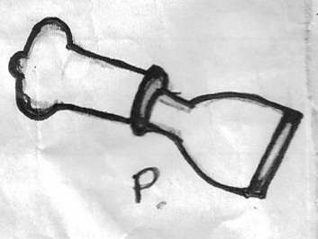

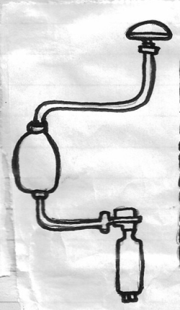
S
P

Q

R

(a) Identify the farm tools labeled S,P,Q and R (2mks)
S …………………………………………………..………………………………………………
P …………………………………………………..………………………………………………
Q …………………………………………………..………………………………………………
R …………………………………………………..………………………………………………
(b) State the use of each of the tools labeled S and P (1mk)
S…………………………………………………..……………………………………………………
P…………………………………………………..……………………………………………………

(c) Give two safety precaution that should be taken when using the pair of tools Q and R above (1mk)
…………………………………………………..………………………………………………………
…………………………………………………..………………………………………………………
(d) State two maintenance practices which should be carried out on the tool Q (1mk)
…………………………………………………..………………………………………………………
…………………………………………………..………………………………………………………
17. The diagram labeled V and W illustrates some soil structures. Study the diagrams and answer
the questions that follow

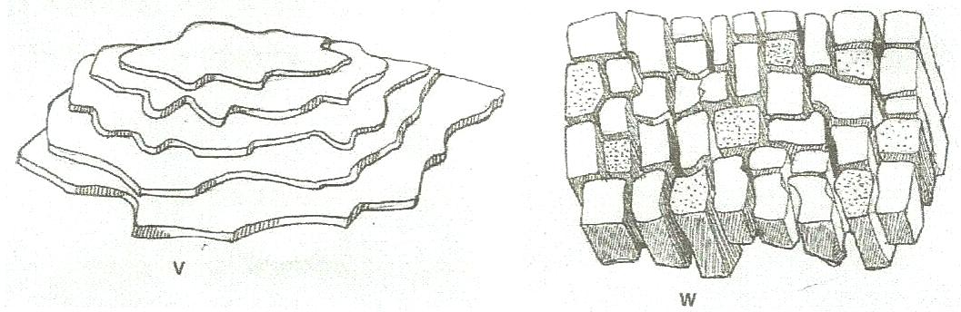

a) Identify the two structures labeled V and W
V…………………………………………………………………………………………...(1mk)
W…………………………………………………………………………………………(1mks)

b) Name the types of soil from which structures labeled V and W can be found.
V…………………………………………………………………………….. (1mk )
W……………………………………………………………………………… ( 1mk)
c) State two ways through which structure V may influence crop performance. (2mks)
………………………………………………………………………………………………………………………………………………………………………………………………………………………………………………………………………………………………………………………………………………………………………………………………………………………………
18. The following are diagrams illustrating a soil profile labeled A and two types of soil structure labeled B and C. Use them to answer the questions that follow.

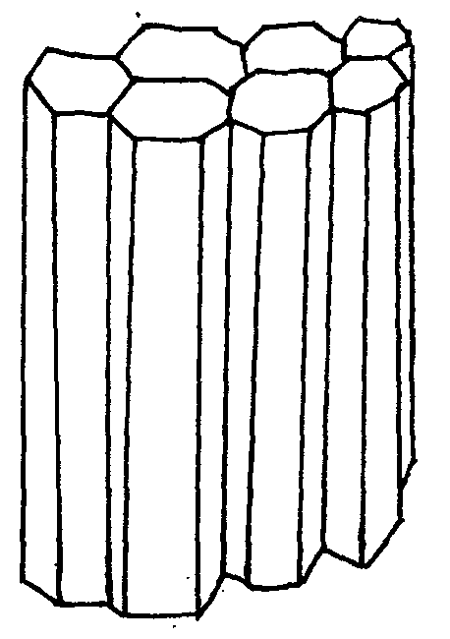
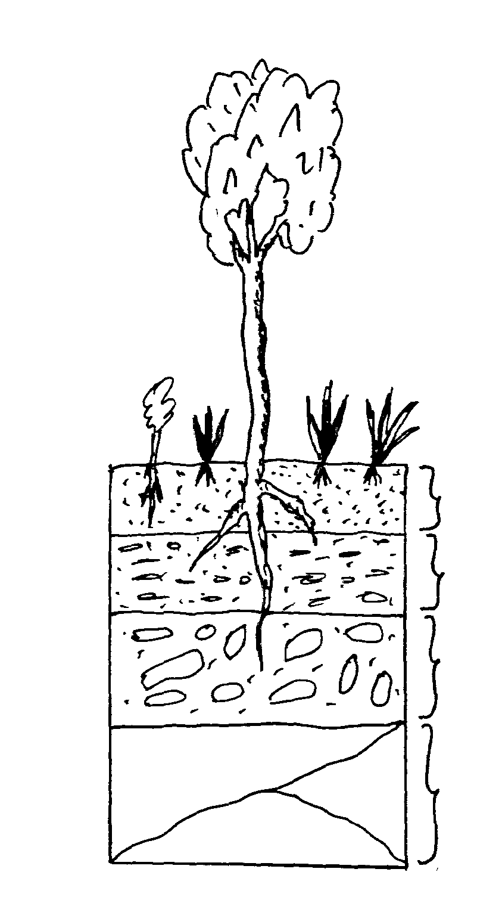
1
2

3

4
C
B
A

- Identify the strata of the soil profile labeled 1,2, 3 and 4 (2 mks)
1………………………………………………
2………………………………………………
3………………………………………………
4………………………………………………

- Identify the types of soil structure labeled B and C (1mk)
B………………………………………………
C……………………………………………
- Name a natural process that may change soil structure B into structure C (1 mk)
5
………………………………………………………………………………………….………………
……………………………………………………………………………………………….…………
- State two limitations of the hard layer of soil that develops in layer 2 (1mk)
………………………………………………………………………………………….………………
……………………………………………………………………………………………….…………

- List two farming practices that may destroy structure B (1mk)
………………………………………………………………………………………….………………
……………………………………………………………………………………………….…………
19. The diagram below illustrates an investigation on a property of soil using soil samples labeled J, K and L.
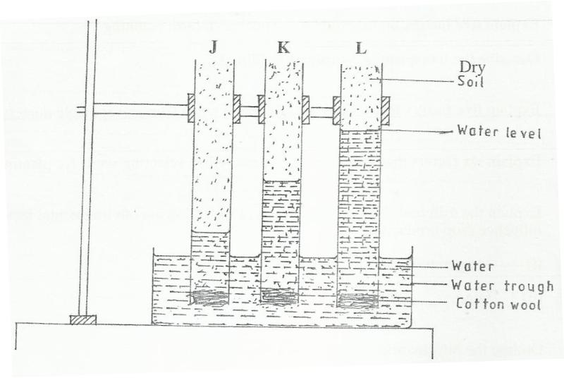

(a) If the levels of water shown in the diagram were observed after three hours, name the property of soil being investigated. (1 mark)
……………………………………………………………………………………………
(b) name the type of soil labeled K and L (1 mark)
…………………………………………………………………………………………..
……………………………………………………………………………………………
(c) Which soil sample would be suitable for growing paddy rice? (1 mark)
…………………………………………………………………………………………..

SECTION C (40 MARKS)
Answer any TWO questions from this section
20. a) Outline six reasons why a farmer is advised to prepare his land before planting. (6 mks)
b) State 4 tools used in primary tillage (4 mks)
c) Discus five factors one should consider before selecting an implement for primary cultivation (10 mks)
21.a). Discus five methods of farming (10 mks)
b). Discus five ways in which soil profile influence crop production (10 mks)
22. a). Outline five reasons for proper maintenance of a wheelbarrow (5 mks)
b). Outline five maintenance practices of a knapsack sprayer (5 mks)
c) Give five categories of farm tools and equipments (5 mks)
d). Describe five precautions to be taken when using farm tools and equipment (5 mks)

