GATITU MIXED SECONDARY SCHOOL
END OF TERM EXAM
AGRICULTURE FORM 4 2015

1a.Explain the factors that influence the work output of a draught animal. 10mks

b.Give five advantages of embryo transplant technology. 5mks

2a.Give reasons why the following practices are carried out. 10mks
- Steaming up

b.Flushing

c. Creep feeding
.3 Below is the longitudinal section of a cow’s udder.

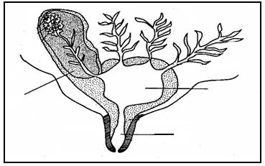
C
B
A

(a) Identify the parts labeled A, B, C. (3mks)

A __________________________________________________________________________

B __________________________________________________________________________

C __________________________________________________________________________

(b) Give four pre-requisites of clean milk production. (2mks)

________________________________________________________________________

________________________________________________________________________

________________________________________________________________________

________________________________________________________________________
c. Describe the working of four strokes cycle in a petrol engine. (10mks)

