GATITU MIXED SECONDARY SCHOOL
AGRICULTURE FORM 4
MIDTERM EXAM TERM 1 2015
SECTION A (30MKS)
- What is a notifiable disease? 1mk

- State three ways in which infectious disease can spread from one animal to another . 3mks

- Name an indigenous beef breed of Africa with a broad head and muzzle, short neck, loose skin having short fine hair, with a straight band broad back. 1mk

- State three social cultural values of livestock in Kenya. 3mks

- Give two reasons for carrying out inbreeding in animal production. 2mks

- State three signs of heat in pigs. 3mks

- Give three precautions observed in handling vaccines in animal disease control. 3mks

- Give two main functions of each of the following organs in a female bird:
- The isthmus. 2mks

- The uterus 2mks

- The funnel 2mks

- State three factors considered in selection of meat goats as breeding stock. 3mks

- Give three limitations of deep litter poultry houses. 3mks

- State two functions of a queen bee in a colony. 2mks

SECTION B (20MKS)
ANSWER ALL QUESTIONS IN THIS SECTION
- The illustrations below show a practice in layer birds. Use them to answer the questions that follow.

- What practice is represented above? 1mk

- Which illustration shows the right way of carrying out the practice? 1mk

- State two reasons for carrying out this practice in poultry. 2mks

- The following is a diagram showing part of the poultry’s digestive system. Use it to answer the questions

- Name the parts labeled Q,S,T and R. 3MKS

- Give two structural adaptations of R to its functions. 2mks

- The graph below shows the relationship in milk yield and foetal growth against time.

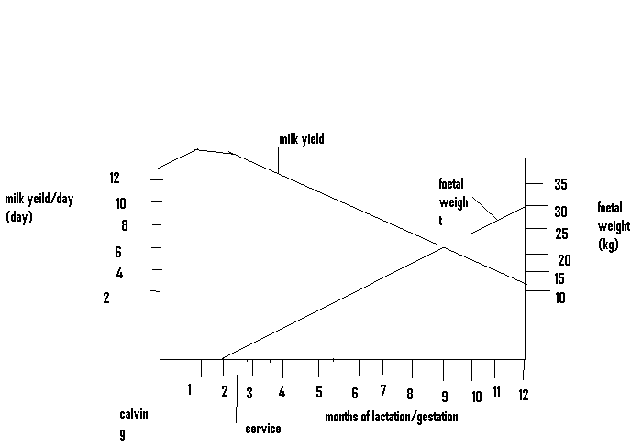

- Name the stage between the months in respect to lactation and gestation:

- 2nd to 12th month 1mk

- 10th to 12th month 1mk

- 1st to 10th month. 1mk

- Give two practices carried out on the in calf cow within the period from the 10th to the 12th month. 2mks

- State one routine practice a farmer should avoid carrying out on the in calf cow between the 10th and 12th month. 1mk

- From the graph find the birth weight of the calf. 1mk

- The diagram below shows the internal structure of an egg. Use it to answer the questions that follow.

- Name the parts labeled P and Q 2mks

- Give two defects that may be found on part M making the egg unsuitable for incubation. 2mks

- State one role of part R. 1mk

SECTION C (40MKS)
ANSWER ANY TWO QUESTIONS FROM THIS SECTION
- With the help of a diagram, discuss artificial incubation under the following subtitles
- Management of the incubator.
- Advantages and disadvantages of artificial incubation 20mks

- Describe the management of growers up to the point of lay. 12mks
- Explain the advantages of rearing birds through a battery cage system. 8mks

- Discuss foot rot disease in sheep under the following subtitles:
- Causal agent. 1mk
- Predisposing factors 3mks
- Symptoms of attack 6mks
- Control measures 5mks
- Explain the importance of keeping livestock healthy. 5mks

