ST.CLARE GIRLS HIGH SCHOOL NAME ………………………………………………….

443/1 OPENER EXAMINATION

AGRICULTURE
PAPER 1
FORM 4
TIME: 2 HOUR

- State four reasons why ridging is important in crop production. (2marks)
……………………………………………………………………………………………………………………………………………………………………………………………………………………………………………………………………………………………………………………………………………………………………………………………………………………

- Define the term sub-soiling. (1mark)
…………………………………………………………………………………………………………………………………………………………………………………………………………
- Give four features of plastic pipes a farmer should consider before buying the pipes. (2marks)
………………………………………………………………………………………………………………………………………………………………………………………………………………………………………………………………………………………………………………
…………………………………………………………………………………………………….
- State two means by which water can be conveyed from the place of storage to where it is needed on the farm. (1mark)
…………………………………………………………………………………………………………………………………………………………………………………………………………
- State four factors to be considered before deciding on irrigation system in crop production.
(2marks)
……………………………………………………………………………………………………………………………………………………………………………………………………………………………………………………………………………………………………………………………………………………………………………………………………………………
- Give four reasons why most farmers do not use farm yard manure. (2marks)
................................................................................................................................................................................................................................................................................................................................................................................................................................................................................................................................................................................................................................

- State two roles of Sulphate of Ammonia in the preparation of compost manure. (1mark)
…………………………………………………………………………………………………………………………………………………………………………………………………………

- State two farming methods that contribute to loss of soil fertility (1marks)
…………………………………………………………………………………………………………………………………………………………………………………………………………
- List two labor records. (1mark)
…………………………………………………………………………………………………………………………………………………………………………………………………………
- Differentiate between scarcity and opportunity cost. (1mark)
………………………………………………………………………………………………………………………………………………………………………………………………………………………………………………………………………………………………………………
- Fill in the table. (2marks)
Plant Part | Crop Propagated
Slips
 | Sisal
 | Sugarcane
Splits

- Outline two advantages experienced by planting bean crop in the correct spacing. (1mark)
…………………………………………………………………………………………………………………………………………………………………………………………………………
- State four qualities of a mother plant that should be considered when selecting vegetative materials for planting. (2marks)
……………………………………………………………………………………………………………………………………………………………………………………………………………………………………………………………………………………………………………………………………………………………………………………………………………………

- Distinguish between direct sowing and over sowing in regard to pasture establishment. (1mark)
………………………………………………………………………………………………………………………………………………………………………………………………………………………………………………………………………………………………………………
…………………………………………
- Define Integrated Pest Management. (1mark)
…………………………………………………………………………………………………………………………………………………………………………………………………………
- State four cultural measures that a farmer can use to control pests in maize field. (2marks)
……………………………………………………………………………………………………………………………………………………………………………………………………………………………………………………………………………………………………………………………………………………………………………………………………………………

- Mention two fungal diseases that attack bean crop in the field. (1mark)
…………………………………………………………………………………………………………………………………………………………………………………………………………
- Give two precautions that a farmer should observe while spraying crops. (1mark)
…………………………………………………………………………………………………………………………………………………………………………………………………………………………………………………………………………………………………………………………………………………………………………………………………………………………………………………………………………………………………………………………………………………………………………….

SECTION B (20 MARKS)
Answer ALL the questions in this section in the spaces provided.

- The diagrams below illustrate some soil structures. Study them and answer the questions that follow.
X
Y

- Identify the soil structures F and G. (2mark)

……………………………………………………………………………………………………………………………………………………………..
…………………………………………………………………………………………………………………………………………………………

- Name the part labeled X and Y in diagram F. (1mark)
……………………………………………………………………………………………………………………………………………………………………………………………………………………………………………………………………………………………………………………………………………………

- State two ways through which structure G influence crop production. (2marks)
…………………………………………………………………………………………………………………………………………………………………….
……………………………………………………………………………………………………………………………………………………………………

20.The diagram below illustrates how a plucking table is developed in a given crop.
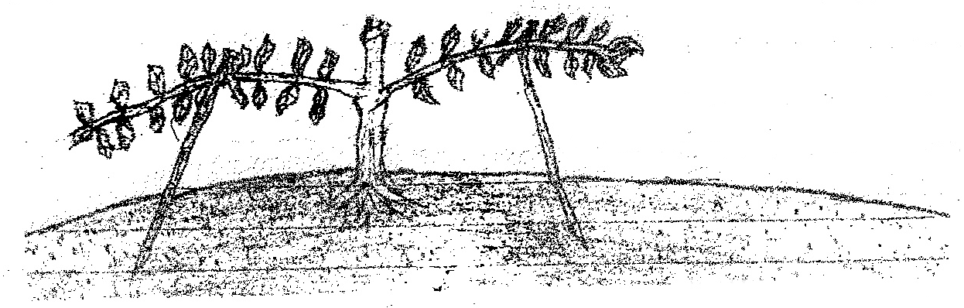

(a) Identify the crop where the above practice is carried out. (1 mark)
………………………………………………………………………………………

(b) Name the method. (1mark)
……………………………………………………………………………………

(c) Mention three advantages of pruning a crop. (3 marks)

21.The diagram below shows a banana tissue culture. Study it and answer the questions that follow.
(a) Name two ways of inducing the rooting of plantlet (1mark)

(b) Outline three steps followed in the development of tissue culture. (3marks)

(c) State two advantages of propagating crops by tissue culture technique. (1mark)
SECTION C (30 MARKS)
Answer ANY TWO questions from this section in the spaces provided
- a) Explain ten factors that influence soil erosion on the farm. (10marks)
b) State five disadvantages of having hard pan layer in a soil profile. (5marks)
c) State five problems associated with land lordship and tenancy (5marks)
20 a) Describe five reasons why earthing up is important in crop production. (5marks)
b) Explain five factors which contribute to the competitive ability of weeds. (5marks)
c) Describe various ways through which the Kenyan government can help to control the negative effects/disadvantages of Pastoral-nomadism. (10marks)
- a)Describe the establishment of kales under the following sub – headings:
i) Establishment in the nursery (3marks)
ii) Transplanting of seedlings. (5marks)
b Describe the harvesting of pyrethrum under the following subheadings.
i) Stage of harvesting. (1mark)

ii) Method and procedure (3marks)
iii) Precautions in harvesting. (3marks)
c) State five factors that a farmer should consider before applying fertilizer in a maize field. (5marks)

