AGRICULTURE PAPER 1 FORM 4
MARKING SCHEME
- a) Factors that determine the method used to harvest a crop.
- Growth habit of the crop
- Scale of production
- Part harvested
(3 = 1½mks)
b) ways in which cereals are stored in Kenya.
- In traditional granaries
- In Cyprus silos/bins
- In maize cribs
- In bags
(4 x ½ = 2mks)
- Outline two disadvantages of tenancy system in farming
- Soil conservation measures can be poor particularly when the lease period is short or there is no written agreement.
- There may be no incentives to make expensive long term/permanent investment on land.
- The method of rent repayment for example share cropping may discourage the tenant from intensive investment.
- The tenant has no title deed to act as security.
(2 x ½ = 1mk)
- Control measures of downy mildew in onions.
- Spraying the crop with appropriate fungicide\use certified seed/healthy seedlings
- Planting resistant varieties
- Rogueing
(2 x ½ = 1mk)
- Two pasture legumes grown in medium altitude zones.
- Lucerne
- Desmodium – Accept specific species of desmodium i.e either silver leaf desmodium or green leaf desmodium
- Stylo
(2 x ½ = 1mk)
- Reasons for root pruning.
- Make lifting of seedlings during transplanting easier.
- To minimize root damage during transplanting.
- For seedlings to develop short and dense root system.
(2 x ½ = 1mk)

- a) Define the term joint products.
- This is a situation whereby a farmer aims at producing one product, but automatically ends in getting another product.
(1 x 1 = 1mk)
b) Examples of joint products in crop production
- Beef and hides
- Mutton and skin
- Honey and wax
- Cotton lint and cotton seed
- Milk and butter
(2 x ½ = 1mk)
- Benefits of optimum soil temperature in crop production
- Enhance seed germination
- Enhance plant growth
- Enchance soil microbial activities
- Improve quality of cops e.g. tea, pineapples
(2 x ½ = 1mk)

- Four factors which determine the depth of ploughing
- Type of crop/rooting system of crop to be grown.
- Type of implement available.
- Type of soil.
- Soil moisture content at ploughing time.
- Presence of certain weeds e.g. cough grass.
(4 x ½ = 2mks)

- Two sub- branches of arable farming
- Field crops cultivation
- Horticulture
(2 x ½ = 1mk)
- Two effects of scarcity in agricultural production
- Prices go up
- Demand is high
(2 x ½ = 1mk)

- Two conditions that must exist for a market to be purely competitive.
- Many sellers of the same product
- Price of same product in metal containers
(2 x 1 = 2mks)
- Two types of pests in piercing and sucking mouth parts.
- Aphids
- White flies
- Mealy-bug
- Nematodes
- Mites
(2 x ½ = 1mk)

- Four ways in which land reform can be implemented in Kenya.
- Land consolidation
- Land adjudication and registration
- Land settlement and resettlement/land redistribution
- Tenancy reform
- Improved land legislation
(4 x ½ = 2mks)
- Four reasons why most farmers don’t use green manure in crop production.
- Most of the crops used are food crops.
- Green manure crops use most of the soil moisture leaving little for the next crop.
- Most nutrients are used by micro-organisms in the process of decomposing the green manure.
- It delays planting as it takes time for green manure crop to decompose.
(4 x ½ = 2mks)

- Two crop production practices carried out after planting to achieve optimum population.
- Thinning
- Gapping
(2 x ½ = 1mk)

- four practices that increase light reaching a crop
- pruning (4 x ½ = 2mks)
- thinning
- wider spacing
- weeding

- Three functions of the coffee Board of Kenya
- Marketing of coffee (payment storage selling transporting market research , advertisement, pricing.
- Offering advisory sercices to the coffee industry/Ministry of Agriculture.
- Financial coffee research.
- Licensing coffee farmers, millers, dealers and pulpers.
(3 x ½ = 1½mks)

- Four reasons why it is difficult to control Sodom apple(Solanum incanun in pastures
- It has a thorny stem.
- Produces many seeds
- It is deep rooted
- Regenerates.re growth after cutting.
(4 x ½ = 2mks)

- Reasons for liming soils
- Raise soil pH /lowers soil acidity
- Improves soil structure/improves particles aggregation/improves drainage.
- Supplies calcium to plants.
- Hastens decomposition of organic matter.
- Facilitates the availability and absorption of nitrogen and phosphorus.
- Improves legume nodulation and nitrogen fixation
- Encourages multiplication of micro-organisms in the soil.
(4 x ½ = 2mks)

SECTION B (20MARKS
- Observe the diagram below and answer the questions that follow.
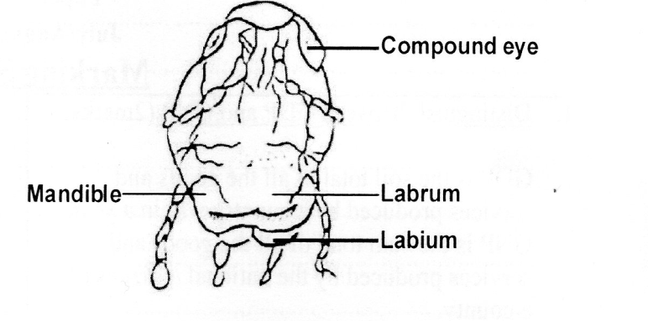
- Identify the mode of feeding exhibited by a pest having such features
Biting and chewing
(1 x 1 = 1mk)
- Name any four pests with the above feeding habits. (2mks)
- Locusts
- Grasshoppers
- Crickets
- Termites
- Bollworms
- Maize stalk borers.
(4 x ½ = 2mks)
- Below are two diagrams of Irish potato tubers after being subjected to some condition before panting.

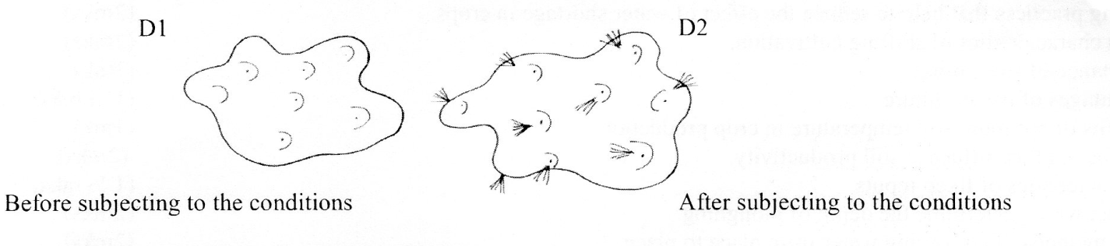
- Which process of the potato treatment is illustrated above?
Chitting / sprouting.
(1 x 1 = 1mk)
- State two conditions necessary for the above process
Humidity/moist environment
Diffuse light. (NB. Avoid dark room)
(2x 1 = 2mks)
- Give two reasons for carrying out the above practice.
- Ensure uniform growth after planting.
- To ensure growth commences immediately ager planting
- To break seed dormancy.
( 2 x 1 = 2 mks)
- Using the information on the table blelow answer the questions that follow.

Fertilizer input (units | Maize yield (bags | Marginal products (bags)
0  1  2  3  4  5 | 50  62  66  68  69  69 | -  12  4  2  1  0

The cost of is kshh 1500 per unit and the price of maize sh. 1200 per bag.
- At what unit of fertilizer input should the farmer be advised to stop applying any more fertilizer to the maize?
- At the end of the third unit fertilizer application/3
(1 x 1 = 1)

- Give a reason for your answer in (i) above.
This is the cost profitable unit of fertilizer application, beyond which there would be a loss
( 1 x 1 = 1mk)
- Calculate the marginal return at the point of optimum production.
MR = SHS 1200 X 2 = 2400
(1 X 1 = 1mk)
b) State the law of diminishing return in production function.
- States that if successive units of one input are added to fixed units of other inputs a point is eventually reached where additional output per additional unit of input will decline.

(1 x 1 = 1mk)
23. The diagram below illustrates a physical method that is used to control soil erosion. Study it carefully and answer the questions that follow

D

- Name the physical soil erosion control method illustrated by the diagram above
- cut-off drain
- (1 x 1 = 1mk)
- Name the part labelled D on the diagram
Embarkment/bund/ridge
- (1 x 1 = 1mk)
c) State four places where water from the structure named in (a) above is discharged (2 mks)
- Into a natural waterway such a a river.
- Onto a non-erodable stony or rocky ground.
- onto grassland with well-established grass cover
Into an artificial waterway
(4 x ½ = 2mks)

24. . The diagram below illustrate common weeds in arable land. Study them and answer the questions that follow.

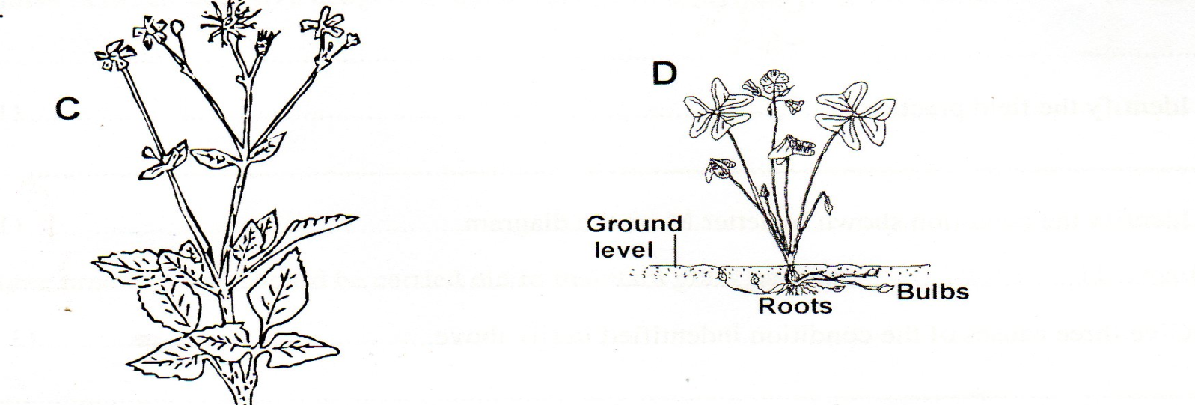

- Identify the weeds labellled D and c
C – black Jack
D – oxalis

- x 1 = 2mks)
- Classify the weed labeled C according to plant morphology
Broad leaved weed
- x 1 = 1mk)
- Give one reason why it is difficult to control the weed labeled D

Presence of underground bulb

(1 x 1 = 1mk)
SECTION C (40MARKS)

25. Ways in which farmers adjust to risks and uncertainty in farming.
- By diversification of enterprises on the farm
- By selecting more certain enterprises that can survive risks
- Farmers enter contracts to supply farm produce to certain customers
- Insure property against loses
- Input rationing by investing less inputs in enterprises that are riskier
- Flexibility in production Governed by the market situation
- Adopting modern methods of production.
(7 x 1 = 7mks)
- Qualities of a good farm manager
- Knowledgable on agricultural principles
- Marketing and accounting
- Hardworking time conscious
- Has practical farming skills
- Responsible
- Dynamic and prudent in farm business
- Flexile in decision making by adjusting to changes of society.
(5 x 1 = 5mks)
- Profit and loss account for Pioneer farm the year ending 2014
Purchase and expenses Shs . Cts sales and receipts Shs. Cts
Opening valuation 150,000 sale of wheat 120,000
Concentrates 5,500 cabbages sold 40,000
Seeds 4,500 milk sold 30,000
Fertilizers 7,000 poles sold 25,000
Fuel 2,000
Disc harrow 175,000
Sub total 344,000
Net profit 121,000 closing valuation 250,000
Total 465,000 Total 465,000
½mks x 4 = 2mks. For sub titles ; 2 marks for the 2 columns of content ; ½mks for subtotals ; ½for net profit; ½ x 2 = 1mk for the 2 columns of total; The farm made a profit of Ksh. 121,000 (1mk)

26. a) Methods used in harvesting water on the farm
- Roof catchment – water from the roof are colledfted using gutters and stored in tanks.
- Rocks catchments – water flowing from a rock are collected at the bas of construction a wall or using gutters.
- Dams – walls constructed across a water way blocks water to fall for a reservoir
- Ponds – small water reservoir depression on the surface where runoff water is collected.
- Retention ditches- are ditches/channels dug along the contours to collect water flowing down slope. They allow water to infiltrate into the soil
- x 1 = 5mks)
b) Uses of water on the farm
- for diluting /mixing chemicals used to control pests, disease and weeds.
- For watering livestock e.g drinking
- For watering plants e.g irrigation
- Used in the processing of farm produce e.g. coffee, carrots hides skins etc
- For washing utensils, equipments cleaning calf pens milking sheds.
- For domestic use e.g. drinking, cooking, seage disposal.
- For rearing fish.
- For mixing concrete in the construction.
- For recreation e.g. swimming pool
- Cooling and running machine engines cooling animals
- x 1 = 7mks)
c) Soils losses fertility through
- Leaching – soluble minerals ae carried deep into the soil beyond the reach of nutrients.
- Soil erosion – the top fertile soil is carried away by the agents of erosion
- Change of pH –alteration of soil will affect availability of certain nutrients to plants
- Burning of land – leads to volatilization of nutrients like nitrogen and destroys organic mater and micro-organics.
- Accumulation of salts – changes the soul pH and soil soline for plant growth.
- Fixation of nutrients/N-lock-up –Nitrogen becomes unavailable to crops
- Uptake by plants/by weeds – nutrients used by plants are carried away through harvesting
- Monocropping/presence of pastors diseases make soil unsuitable for growth of crops.
- Soil capping/developments of hard pans
- x 1 = 8mks)
27. Describe the production of tomatoes under the following sub-heading.
- Transplanting
- Ready after 1 month /4 – 5 true leaves/15cm high/pencil thick.
- Select healthy and vigorous seedlings
- Lift the seedling with a ball of earth on the root.
- Plant the seedling at the same depth they were in the nursery.
- From the soil around the base of the planted seedlings.
- Transplant on a cloudy day or late in the evening
- Water the seedlings immediately after transplanting.
( 5x 1= 5mks )

- Mention five importance organic matters in the soil.
- Binding soil particles together/improves soil structure
- Add nutrients in the soil.
- Improves microbial activities in the soil.
- Buffers the soil pH.
(5 x 1 = 5mks)
- State ten uses of water in the farm.
- Rearing fish.
- Recreation e.g. swimming pools
- Diluting chemicals used to control pests, parasite etc.
- Domestic use, cooking, drinking, washing.
- Cleaning calf pens, milking sheds.
- Mixing concrete in construction.
- Cleaning animals.
- Cooling running machine engines.
- Processing farm produce e.g. coffee, hides carrots.
- Watering livestock/drinking.
- Watering plant/irrigation.
- Cooling of farm animals.
- Navigation.
- Source of power/generating Hydro electric power.

(10 x 1 =10mks)

28. a) Describe five management practices carried out in nappier grass to maximize production
- Weed control to avoid unnecessary competation for growth resources
- Gapping to ensure maximum use of space.
- Irrigation under dry condition to maximize growth.
- Top dressing to ensure adequate nutrients in the soil.
- Timely harvesting.
- Disease and pests control.
- x 1 = 5mks)
b) Five ways in which draining marshy laid encourage crop growth.
- It reduces soil erosion by increasing water holding capacity thus reducing runoff.
- It increases soil aeration necessary for rooting respiration and micro-organism.
- It increases soil volumes thus increasing range from which crops root obtain nutrients.
- Increase microbial activities in the soil due to proper aeration and improved temperatures.
- Ir removes toxic activities in the soil due to proper aeration and improved temperatures.
- It removes toxic substance’s from the soil that otherwise negatively affect crop growth.
(5 x 1 = 5mks
c) Effects of mass wasting/solifluction
- Transfer of fertile soils from higher land to lowlands.
- Creation of lakes –
- Soil erosion on steep slopes – creation of permanent ugly scars on the land scapes.
- Tourist attraction of rock fall.
- Destruction of property.
- Death of people and livestock
(1 x 5 = 5mks)

- Ways in which soil loses fertility
- Leaching – soluble minerals are carried deep into the soil beyond the reach of nutrients
- Soil erosion – The top fertile soil is carried away by the agents of erosion.
- Change of PH – alteration of soil will affect availability of certain nutrients to plants.
- Burning of land – leads to volatilization of nutrients like nitrogen and destroys organic natter and micro-organics.
- Accumulation of salts – changes the soil PH and soil soline for plant growth.
- Fixation of nutrients/N-lock-up Nitrogen became unavailable to crops.
- Uptake by plants/by weeds – nutrients used by plants are carried away through harvesting.
- Monocroppping/presence of pastors diseases makes soil unsuitable for growth of crops.
- Soil capping/developments of hard pans.
(1 x 5 = 5mks)

