Name: ……………………………………………... Index no ……..….................................

School: …………………………………………….. Candidate’s sign …………………….
Class………………………………………….…..… Adm No…………………...………….

AGRICULTURE 443/1
KASSU MOCK
SEPTEMBER 2021
TIME: 2 HOURS

FORM FOUR KASSU MOCK
Kenya Certificate of Secondary Education (K.C.S.E.)
Agriculture
Paper 1
INSTRUCTIONS TO CANDIDATES:
- Write your name and index number in the spaces provided above.
- Sign and write the date of examination in the spaces provided above.
- This paper consists of three sections A, B and C.
- Answer all the questions in section A and B.
- Answer any two questions in section C.
- All answers should be written in the spaces provided.
- This paper consists of 13 printed pages.
- Candidates should check the question paper to ascertain that all the pages are printed as indicated and that no questions are missing.
- Candidates should answer all the questions in English.
For Examiner’s Use Only:
SECTION | QUESTIONS | MAXIMUM SCORE | CANDIDATES SCORE
A | 1-17 | 30
B | 18-21 | 20
C |  | 20
 |  | 20
 | TOTAL SCORE | 90

SECTION A (30 MARKS)
- State two types of labour records. (1mk)
………………………………………………………………………………………………………………………………………………..……………………………………………..………………………………………………………………………………………………
- List four climatic factors that influences crop production. (2mks)
………………………………………………………………………………………………………………………………………………………………………………………………………………………………………………………………………………………………………………………………………………………………………………………………………………………………………………………………………………………………
- Name three types of pipes used to convey water in the farm. (1¹/₂mks)
………………………………………………………………………………………………………………………………………………..……………………………………………………………………………………………………………………………………………………………………………………………………………………………………………
- Give five causes of land fragmentation in Kenya. (2¹/₂mks)
…………………………………………………………………………………………………………………………………………………………………………………………………………………………………………………………………………………………………………………………………………………………………………………………………………………………………………………………………………………………………………………………………………………………………………………………………………………………………………………………
- State four important objectives of land tenure reforms. (2mks)
………………………………………………………………………………………………………………………………………………………………………………………………………………………………………………………………………………………………………………………………………………………………………………………………………………………………………………………………………………………………………………………………………………………………………………………………

- State four reasons why burning of vegetation when clearing land should be discouraged.
(2mks)
……………………………………………………………………………………………………………………………………………………………………………………………………………………………………………………………………………………………………………………………………………………………………………………………………………………………………………………………………
- Outline four importance of good soil profile in crop production. (2mks)
………………………………………………………………………………………………………………………………………………………………………………………………………………………………………………………………………………………………………………………………………………………………………………………………………………………………………………………………………………………………………………………………………………………………………………………………
- Give three ways of achieving minimum tillage. (1¹/₂mks)
………………………………………………………………………………………………………………………………………………..…………………………………………..…………………………………………………………………………………………………………………………………………………………………………………………………………………………………………………………………………………………………
- Differentiate between the following terms;
- Over sowing and under sowing. (1mk)
……………………………………………………………………………………………………………………………………………………………………………………………………………………………………………………………………………………………………………………………………………………………………………………………………………………………………………………………………
- Hardening off and pricking out. (1mk)
……………………………………………………………………………………………………………………………………………………………………………………………………………………………………………………………………………………………………………………………………………………………………………………………………………………………………………………………………

- List four environmental factors that influences the effectiveness of herbicide. (2mks)
………………………………………………………………………………………………………………………………………………………………………………………………………………………………………………………………………………………………………………………………………………………………………………………………………………………………………………………………………………………………………………………………………………………………………………………………
- State three importance of mulching in crop production. (1¹/₂mk)
………………………………………………………………………………………………………………………………………………………………………………………………………………………………………………………………………………………………………………………………………………………………………………………………………………………………………………………………………………………………
- State two disadvantages of basin irrigation. (1mk)
…………………………………………………………………………………………………………………………………………………………………………………………………………………………………………………………………………………………………………………………………………………………………………................................
- Give four effects of soil erosion. (2mks)
………………………………………………………………………………………………………………………………………………………………………………………………………………………………………………………………………………………………………………………………………………………………………………………………………………………………………………………………………………………………………………………………………………………………………………………………
- Give four reasons for pasture conservation. (2mks)
………………………………………………………………………………………………………………………………………………………………………………………………………………………………………………………………………………………………………………………………………………………………………………………………………………………………………………………………………………………………………………………………………………………………………………………………

- State four characteristics of a fertile soil. (2mks)
………………………………………………………………………………………………………………………………………………………………………………………………………………………………………………………………………………………………………………………………………………………………………………………………………………………………………………………………………………………………………………………………………………………………………………………………
- State four roles of calcium in crop production. (2mks)
………………………………………………………………………………………………………………………………………………………………………………………………………………………………………………………………………………………………………………………………………………………………………………………………………………………………………………………………………………………………………………………………………………………………………………………………
- Give two reasons why polythene sheet is used in vegetative propagation nursery unit.
(1mk)
………………………………………………………………………………………………………………………………………………………………………………………………………………………………………………………………………………………………………………………………………………………………………………………………

SECTION B 20MKS
Answer all the questions in this section in the spaces provided.
- A student was to apply a compound fertilizer 5:20:10 at the rate of 200kg per hectare on her Agriculture project plot measuring 3m by 4m.
- What do the figures 5 and 10 in the compound fertilizer stand for? (2mk)
5……………………………………………………………………………………………………………………………………………………………………………………..
10……………………………………………………………………………………..……………………………………………………………………………………………..
- Calculate the amount of fertilizer she would require for the plot. (3mks)

- Study the diagram below and answer the following questions.
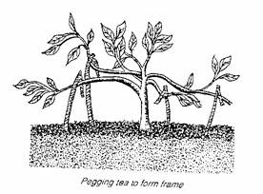
- Identify the practice above. (1mk)
………………………………………………………………………………………
- State two reasons for carrying out the practice above. (2mks)
………………………………………………………………………………………………………………………………………………………………………………
- State two disadvantages with the practice above. (2mks)
………………………………………………………………………………………………………………………………………………………………………………
- The following is an illustration of an infected Irish potato plant. Study it carefully and answer the questions below.
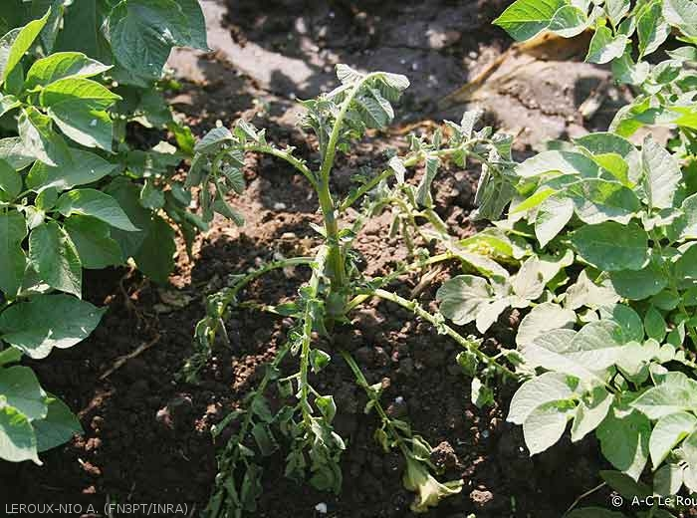
- Identify the disease which may have caused the condition shown in the Illustration. (1mk)
………………………………………………………………………………………
- Name any other crop which may be affected by the disease identified illustrated above. (¹/₂mk)
………………………………………………………………………………………
- Mention three other factors which can lead to the same condition as shown by the illustration. (1¹/₂mks)
………………………………………………………………………………………………………………………………………………………………………………………………………………………………………………………………………
- State two measures that can be used to control the disease illustrated above.
(2mks)
………………………………………………………………………………………………………………………………………………………………………………
- The diagram below shows a common weed. Study it carefully and answer the questions the follows.

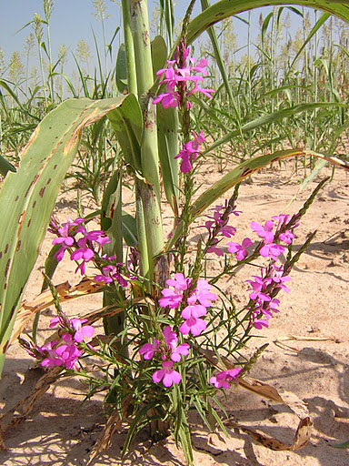
- Identify the weed. (1mk)
………………………………………………………………………………………
- Give one reason why the weed illustrated above is referred to as parasitic weed.
(1mk)
………………………………………………………………………………………………………………………………………………………………………………
- Name two crops that the weed illustrated above commonly attack. (2mks)
………………………………………………………………………………………………………………………………………………………………………………………………………………………………………………………………………
- State one cultural method of controlling the weed above. (1mk)
………………………………………………………………………………………………………………………………………………………………………………

SECTION C 40MKS
Answer any two questions from this section in the spaces provided.
- a) Describe the production of carrots under the following subheadings.
- Land preparation. (3mks)
- Planting. (3mks)
- Field management practices. (4mks)
b) State and explain the factors that determine the stage and time of harvesting crops.
(5mks)
c) State five effects of HIV/AIDS on Kenya’s agricultural production. (5mks)

- a) Outline 7 importance of pruning in coffee production. (7mks)
b) Explain the precautions that should be observed during the harvesting of pyrethrum.
(3mks)
c) Give ten uses of farm records in the farm. (10mks)

- a) State and explain five factors that determine seed rate. (10mks)
b) Describe the procedure of transplanting a vegetable seedling. (7mks)
c) Give three reasons for processing agricultural produce. (3mks)
………………………………………………………………………………………………………………………………………………………………………………………………………………………………………………………………………………………………………………………………………………………………………………………………………………………………………………………………………………………………………………………………………………………………………………………………………………………………………………………………………………………………………………………………………………………………………………………………………………………………………………………………………………………………………………………………………………………………………………………………………………………………………………………………………………………………………………………………………………………………………………………………………………………………………………………………………………………………………………………………………………………………………………………………………………………………………………………………………………………………………………………………………………………………………………………………………………………………………………………………………………………………………………………………………………………………………………………………………………………………………………………………………………………………………………………………………………………………………………………………………………………………………………………………………………………………………………………………………………………………………………………………………………………………………………….……………………………………………………………………………………………………………………………………………………………………………………………………………………………………………………………………………………………………………………………………………………………………………………………………………………………………………………………………………………………………………………………………………………………………………………………………………………………………………………………………………………………………………………………………………………………………………………………………………………………………………………………………………………………………………………………………………………………………………………………………………………………………………………………………………………………………………………………………………………………………………………………………………………………………………………………………………………………………………………………………………………………………………………………………………………………………………………………………………………………………………………………………………………………………………………………………………………………………………………………………………………………………………………………………………………………………………………………………………………………………………………………………………………………………………………………………………………………………………………………………………………………………………………………………………………………………………………………………………………………………………………………………………………………………………….……………………………………………………………………………………………………………………………………………………………………………………………………………………………………………………………………………………………………………………………………………………………………………………………………………………………………………………………………………………………………………………………………………………………………………………………………………………………………………………………………………………………………………………………………………………………………………………………………………………………………………………………………………………………………………………………………………………………………………………………………………………………………………………………………………………………………………………………………………………………………………………………………………………………………………………………………………………………………………………………………………………………………………………………………………………………………………………………………………………………………………………………………………………………………………………………………………………………………………………………………………………………………………………………………………………………………………………………………………………………………………………………………………………………………………………………………………………………………………………………………………………………………………………………………………………………………………………………………………………………………………………………………………………………………………….……………………………………………………………………………………………………………………………………………………………………………………………………………………………………………………………………………………………………………………………………………………………………………………………………………………………………………………………………………………………………………………………………………………………………………………………………………………………………………………………………………………………………………………………………………………………………………………………………………………………………………………………………………………………………………………………………………………………………………………………………………………………………………………………………………………………………………………………………………………………………………………………………………………………………………………………………………………………………………………………………………………………………………………………………………………………………………………………………………………………………………………………………………………………………………………………………………………………………………………………………………………………………………………………………………………………………………………………………………………………………………………………………………………………………………………………………………………………………………………………………………………………………………………………………………………………………………………………………………………………………………………………………………………………………………….……………………………………………………………………………………………………………………………………………………………………………………………………………………………………………………………………………………………………………………………………………………………………………………………………………………………………………………………………………………………………………………………………………………………………………………………………………………………………………………………………………………………………………………………………………………………………………………………………………………………………………………………………………………………………………………………………………………………………………………………………………………………………………………………………………………………………………………………………………………………………………………………………………………………………………………………………………………………………………………………………………………………………………………………………………………………………………………………………………………………………………………………………………………………………………………………………………………………………………………………………………………………………………………………………………………………………………………………………………………………………………………………………………………………………………………………………………………………………………………………………………………………………………………………………………………………………………………………………………………………………………………………………………………………………………….……………………………………………………………………………………………………………………………………………………………………………………………………………………………………………………………………………………………………………………………………………………………………………………………………………………………………………………………………………………………………………………………………………………………………………………………………………………………………………………………………………………………………………………………………………………………………………………………………………………………………………………………………………………………………………………………………………………………………………………………………………………………………………………………………………………………………………………………………………………………………………………………………………………………………………………………………………………………………………………………………………………………………………………………………………………………………………………………………………………………………………………………………………………………………………………………………………………………………………………………………………………………………………………………………………………………………………………………………………………………………………………………………………………………………………………………………………………………………………………………………………………………………………………………………………………………………………………………………………………………………………………………………………………………………………….……………………………………………………………………………………………………………………………………………………………………………………………………………………………………………………………………………………………………………………………………………………………………………………………………………………………………………………………………………………………………………………………………………………………………………………………………………………………………………………………………………………………………………………………………………………………………………………………………………………………………………………………………………………………………………………………………………………………………………………………………………………………………………………………………………………………………………………………………………………………………………………………………………………………………………………………………………………………………………………………………………………………………………………………………………………………………………………………………………………………………………………………………………………………………………………………………………………………………………………………………………………………………………………………………………………………………………………………………………………………………………………………………………………………………………………………………………………………………………………………………………………………………………………………………………………………………………………………………………………………………………………………………………………………………………….…………………………………………………………………………………………………………………………………………………………………………

