MWAKICAN TERM 1 2016

NAME………………………………………………………………………………..ADM………………………….CLASS…………….
443 /1 AGRICULTURE PAPER 1

FORM 3 MWAKICAN JOINT EXAM
TIME: 2HRS
INSTRUCTIONS
- WRITE YOUR NAME CLASS AND ADMISSION NUMBER IN THE SPACES PROVIDE ABOVE.
- ANSWER ALL QUESTIONS IN SECTION A AND B AND ANY TWO IN SECTION C.
- ENSURE THAT YOUR QUESTION PAPER CONSIST OF THE THREE SECTIONS. SECTION A-30MKS, B-20MKS, C-40MKS.

SECTION A (30 MARKS)
Answer ALL Questions in the Spaces Provided
- State two precautions when handling inoculated seeds. (1mk)

- Explain the meaning of the following post-harvesting practices carried out in crops such as beans. (3mks)
    - Dusting

    - Threshing

    - Cleaning

- Give four characteristics that a good plant used as green manure should possess. (2mks)

- State three ways in which crop rotation may improve soil fertility. (3mks)

- State three ways in which primary tillage destroy soil-borne pests. (3mks)

- Give four edaphic factors that influence crop production. (2mks)

7. (i) Define opportunity cost (1mark)

(ii) Name Two types of inventory records kept by farmers (1mark)

8. (a) Give TWO importance of sub-soiling (1mark)

9. (i) Give TWO destructive effects of moles in crop production (1mark)

(ii) Apart from moles, name TWO other rodent pests (1mark)

10. State FOUR field pests that attach maize (2marks)

11. Differentiate between apiculture and aquaculture as used in Agriculture (1mark)

12. State TWO ways in which burning leads to loss of soil fertility (1mark)

13. State TWO benefits of hardening off seedlings before transplanting . (1mark)

14. Give two examples of the following: (3marks)
a) Organic manures

b) Straight fertilizer

c) Incomplete compound fertilizer

15. Name the primary macronutrient responsible for the following in plants. (2marks)

- Protein synthesis

ii) Proper root establishment and development

16. State four factors that would increase the seed rate of maize. (2marks)

17. Give the role of the following in water treatment process. (3 marks)

- Alluminium sulphate

b) Chlorine

c) Sodium bicarbonate

18. List THREE soil constituents (1 ½ mark)

19. State THREE ways in which nitrogen is lost from the soil (1½ marks)

SECTION B (20 MARKS)
Answer all the questions in this section in the spaces provided

20.The diagram below shows a practice in crop production
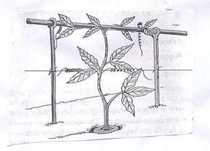

a) i) Give the identity of the field management practice illustrated above (½mks)

ii) Give 2 reasons for carrying out the above field management practice (2 mks)

b) A plot measuring 4m x 3m was prepared for planting cabbages at a spacing of 60 cm x 60 cm. Calculate the plant population in the plot .. Show your working (3mks)

21 a) Identify the illustration P and Q which are materials used in propagation of sugarcane (1mk)

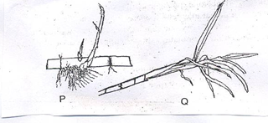

b) Giving reasons which of the above is more suitable as a planting material in sugar cane? (2 marks)

22. The diagrams below labeled H and J are illustrated of coffee plants establishing using two different pruning systems. Examine them closely and answer the questions that follow.
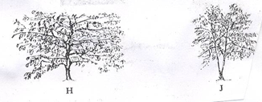

a) Name the pruning systems illustrated by diagrams H and J (1 mark)

b) Give two advantages of pruning system illustrated by diagram Hover that one illustrated by diagram J ( 2 marks)

c) Name two types of pruning that should be carried out after the coffee bush has been established using the system J ( 2 marks)

23.The diagrams V and W illustrate some soil structures. Study the diagrams and answer the questions that follow
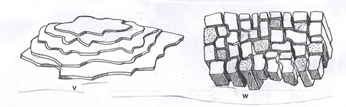

a) Identify two structures labeled V and W (1mark)

b) Name the types of soils from which structures labeled V and W can be found (1mark)

c) State two ways through which structure V may influence crop production (2 marks)

24. The diagram below illustrates a method of preparing compost pit manure, study the diagrams and answer the questions that follow.
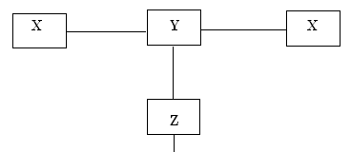
a) Identify the method illustrated (1 mk)

b) By using arrows between the boxes indicate the direction of movement of materials from X to the field. (2 mks)

c) i) In regard to Y what is the volume of X? (1 mk)

ii) How long should the materials stay in X and Y. (1 mk)
SECTION C (40MKS)
Answer any two questions from this section in the spaces provided.

25. Describe the establishment of cabbage under the following subheadings.
a) Nursery establishment and management (8 mks)

b) Land preparation (4 mks)

c) Transplanting (8 mks)

26 (a) Outline the role of phosphorous in plants (5mks)

(b) Describe the policies used by the government to regulate the amount of imported agricultural good in Kenya (5mks)

(c) Describe uses of farm records in the farm (10mks)

27. (a) Discuss the human factors which influence agriculture. (10 marks)

(b) Explain five factors to consider when choosing the planting time. (10 marks)

