FORM 4 TERM 2 2019
AGRICULTURE FORM 4 PAPER 2
TIME; 2HRS

NAME_____________________________________________________________________CLASS_____ADM NO____

SECTION A
ANSWER ALL QUESTIONS ON THE SPACES PROVIDED

1) Name TWO beef cattle breeds reared in Kenya. 1mk
i)

ii)

2) Name a breed of dairy animal having the following characteristics. Red coat with white markings on the legs, face tail switch and girth. ½ mk

3) Give two diseases transmitted by brown ear tick. 1mk
i)

ii)

4) Name two species of tapeworms found in livestock. 1mk
i)

ii)

5)List four factors considered when formulating livestock ration. 2mks
i)

ii)

iii)

iv)

6) State the cause of grass tetany in livestock. ½ mk

7) Give two precautions taken by farmers to prevent piglet anaemia. 2x ½ = 1mk
i)

ii)

8) Name the type of breeding system represented below.
Aryshire Sire x Boron dam Heifer x Hereford. ½ mk

9) List three disadvantages of embryo transplant 3 x ½ = 1 ½ mks
i)

ii)

iii)

10) List four causes of sterility in dairy cows. 2mks
i)

ii)

iii)

iv)

11) Give two signs that would indicate a cow has died of anthrax. 1mk
i)

ii)

12) State for pre-milking activities that should be carried out by a stock man. 4 x ½ = 2mks
i)

ii)

iii)

iv)

13) Give four functions of the worker bees in a bee colony. 4x ½ = 2mks
i)

ii)

iii)

iv)

14)Name four signs of broodiness in poultry . 2mks
i)

ii)

iii)

iv)

15) State four demerits of live fences. 2mks
i)

ii)

iii)

iv)

16) Give four advantages of carrying out raddling in sheep management. 2mks
i)

ii)

iii)

iv)

17) Name two development stages of a liver fluke. 1mk
i)

ii)

18) Name any four farm structures that are necessary for handling dairy animals. 2mks
i)

ii)

iii)

iv)

19) List down maintenance practices of a mould board plough 4x ½ = 2mks
i)

ii)

iii)

iv)

20) List three functions of lubrication systems. 3 x ½ = 1 ½ mk
i)

ii)

iii)

iv)

21) Name three notififable diseases in cattle. 1 ½ mks

SECTION B (20MKS) COMPULSORY

22)Study the diagram below and answer the questions that follow

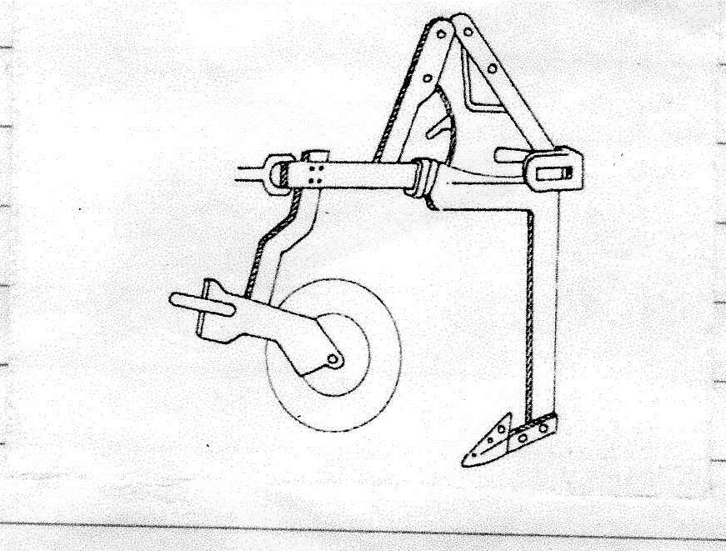

a) Identify the implement. 1mk

b) What are the advantages of using the implement. 2mks
i)

ii)

23) Study the following tools and use them to answer the questions that follow.

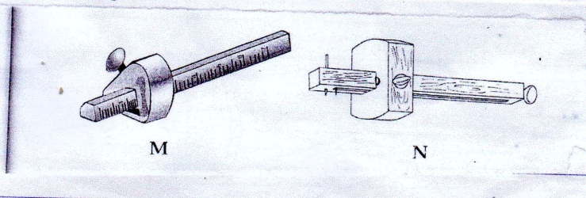

a) Identify the workshop tools shown above. 1mk
M----

N---------

23b) State the functional /difference between the above tools. 1mk

24) Below is an illustration of a structure used for tick control in the farm. Study it carefully and answer the questions that follow.

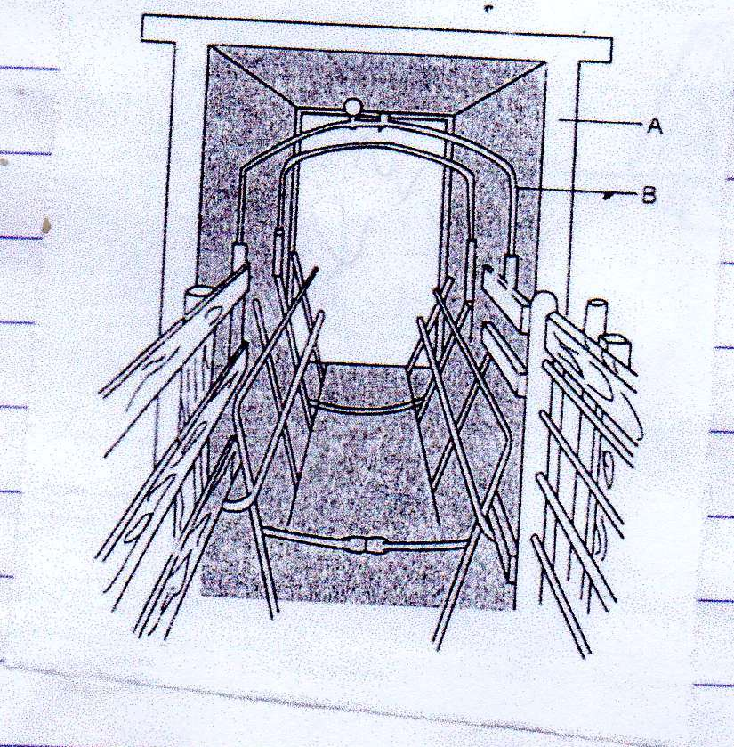

a) Identify the structure. 1mk

bName the parts labeled A and B 1MK
A

B

c) What is the function of the parts labeled A and B. 1mk
A

B
d) State four advantages of using this structure to control ticks. 2mks
i)

ii)

iii)

iv)

25) Below is a type of bee hive

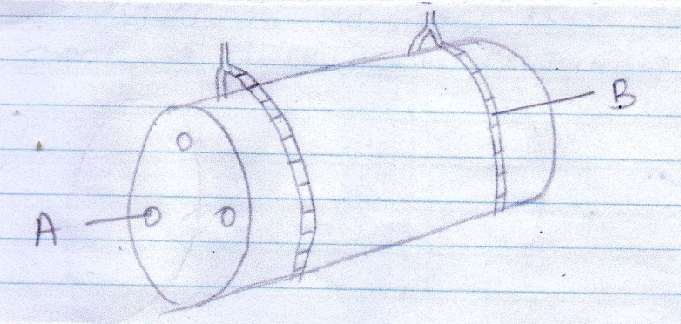

i)Name the type of beehive 1mk

ii)Name the parts labeled A and B. 2mks
A

B

iiii)State four advantages of using the Kenya top bar hive (KTBH) over the type of bee hive named in (i) above. 2mks

26a)If maize meal containing 6% DCP and fish containing 64% DCP calculate the amount of each feedstuff in kilograms required to prepare 200kg of chick mash containing 18% DCP 4mks

b)Name two other feed ingredients which should be added to the chick mash to make it a balanced feed. 1mk
i)

ii)

SECTION C 40MKS
CHOOSE ANY TWO QUESTIONS IN THIS SECTION

27a)State four characteristics of effective acaricides. 4mks

b)Give three methods of applying acaricides on livestock . 3mks

c)Outline six causes of swarming in bees. 6mks

d)Describe seven differences been a petrol and diesel engine. 7mks

28a)Describe the digestive system of poultry under the following sub-heading.
i)crop2mks
ii)provintriculus 1mk
iiii)Gizzard. 3mks
iv)Duodenum 3mks
v)Caecum1mk

b)Describe the procedure of constructing a barbed wire fence. 5mks

c)What are the advantages of farm mechanization. 5mks

29a) Discuss Coccidiosiss disease under the following headings
i)Causal organism. 1mk
ii)Livestock species attacked. 2mks
iii)Symptom of attack. 4mks
iv)Control measures. 3mks

b) Outline five advantages of artificial insemination. 5mks

c) Explain four economic importance of parasites in livestock production. 5mks

30a) Explain ten advantages of battery cage system in poultry rearing. 10mks

b) State five operational differences between a disc and mould board plough. 10mks

