- Area

1. Calculate the area of the shaded region below, given that AC is an arc of a circle centre B. AB=BC=14cm CD=8cm and angle ABD = 75⁰ (4 mks)
75⁰
A
C
B
B
8 cm
14 cm
14 cm

2 The scale of a map is 1:50000. A lake on the map is 6.16cm². find the actual area of the lake in hactares. (3mks)
3. The figure below is a rhombus ABCD of sides 4cm. BD is an arc of circle centre C. Given that ∠ABC = 138⁰. Find the area of shaded region. (3mks)
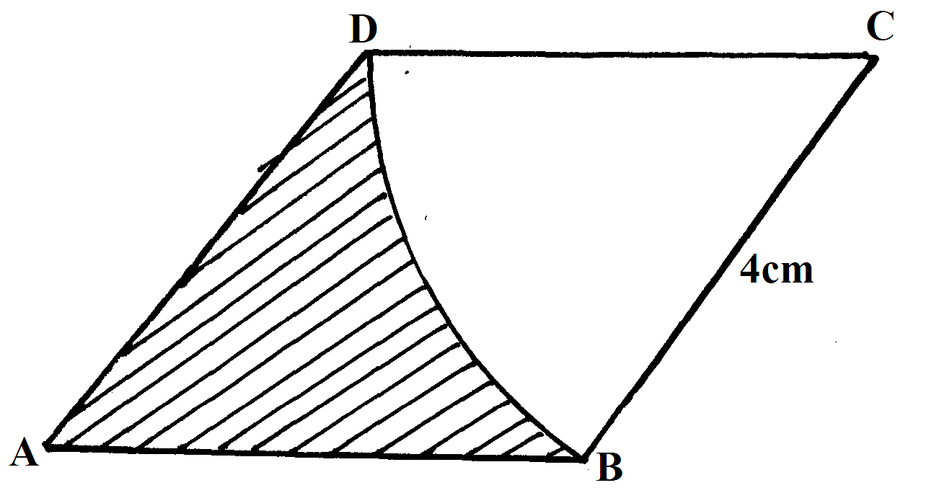
4. The figure below sows the shape of Kamau’s farm with dimensions shown in meters
140m
20 m
80m
100m

Find the area of Kamau’s farm in hectares (3mks)
5. In the figure below AB and AC are tangents to the circle centre O at B and C respectively,
the angle AOC = 60⁰

Calculate
(a) The length of AC (2 marks)

6. The figure below shows the floor of a hall. A part of this floor is in the shape of a rectangle of length 20m and width 16m and the rest is a segment of a circle of radius 12m. Use the figure to find:-
(a) The size of angle COD (2mks)
(b) The area of figure DABCO (4mks)
(c) Area of sector ODC (2mks)
(d) Area of the floor of the house. (2mks)
END
7. The circle below whose area is 18.05cm² circumscribes a triangle ABC where AB = 6.3cm, BC = 5.7cm and AC = 4.8cm. Find the area of the shaded part (4 mks)
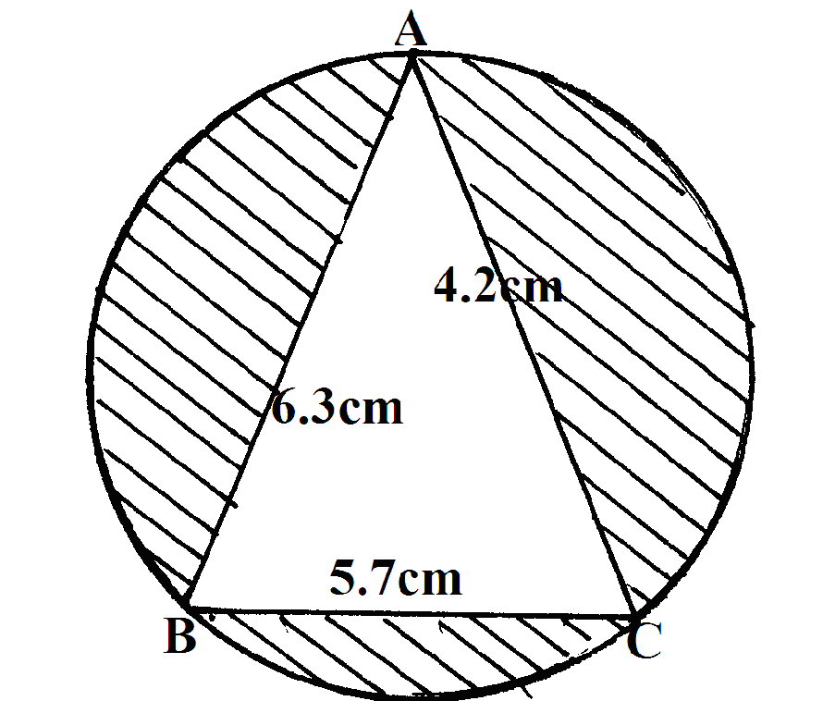
8. In the figure below, PQRS is a rectangle in which PS=10k cm and PQ = 6k cm. M and N are midpoints of QR and RS respectively

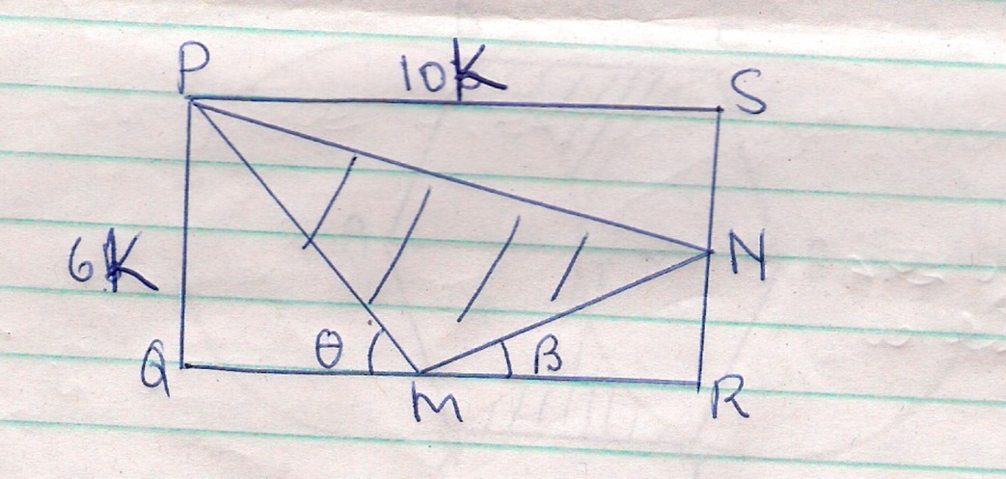

    - Find the are of the shaded region (4 marks)
    - Given that the area of the triangle MNR = 30 cm². find the dimensions of the rectangle (2 marks)
    - Calculate the sizes of angles and giving your answer to 2 decimal places (4 marks)
9. The figure below shows two circles each of radius 10.5 cm with centres A and B. the circles touch each other at T

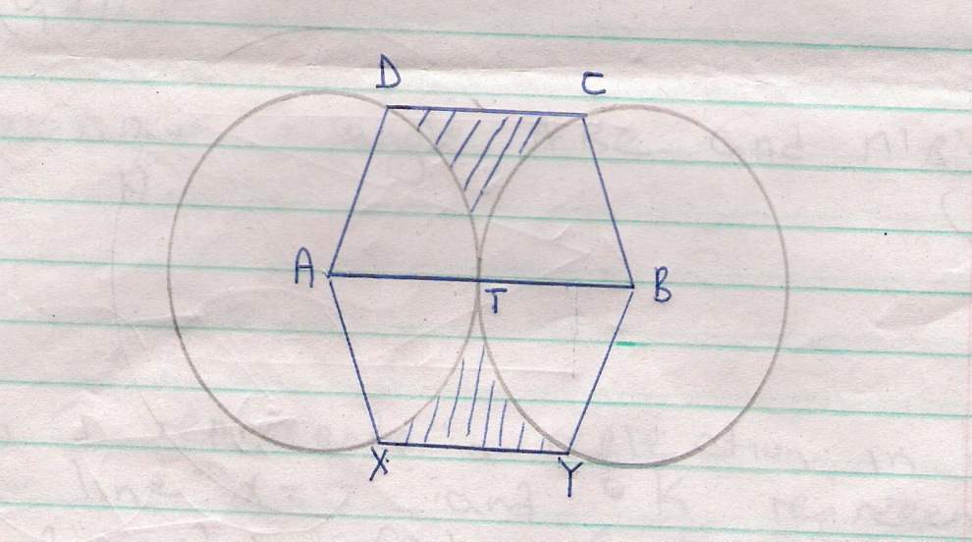
Given that angle XAD =angle YBC = 160⁰ and lines XY, ATB and DC are parallel, calculate the area of:
    - The minor sector AXTD (2 marks)
    - Figure AXYBCD (6marks)
    - The shaded region (2 marks)
10. A student took the measurements of his classroom and gave the width as 7m and the length as 9m.
If there is an error of 2% in each measurement, determine the greatest value of x + y
x
if x and y are the width and length of the classroom respectively.
Give your answer to 4 decimal places.

11. The floor of a room is in the shape of a rectangle 10.5 m long by 6 m wide. Square tiles of
length 30 cm are to be fitted onto the floor.
(a) Calculate the number of tiles needed for the floor.
(b) A dealer wishes to buy enough tiles for fifteen such rooms. The tiles are packed in cartons
each containing 20 tiles. The cost of each carton is Kshs. 800. Calculate
(i) the total cost of the tiles.
(ii) If in addition, the dealer spends Kshs. 2,000 and Kshs. 600 on transport and subsistence
respectively, at what price should he sell each carton in order to make a profit of 12.5%
(Give your answer to the nearest Kshs.)

12. The figure below is a circle of radius 5cm. Points A, B and C are the vertices of the triangle
ABC in which ∠ABC = 60º and ∠ACB=50º which is in the circle. Calculate the area of ΔABC )
A
C
B
60º
50º

13. Mr.Wanyama has a plot that is in a triangular form. The plot measures 170m, 190m
and 210m, but the altitudes of the plot as well as the angles are not known. Find the area
of the plot in hectares

14. Three sirens wail at intervals of thirty minutes, fifty minutes and thirty five minutes.
If they wail together at 7.18a.m on Monday, what time and day will they next wail together?

15. A farmer decides to put two-thirds of his farm under crops. Of this, he put a quarter under
maize and four-fifths of the remainder under beans. The rest is planted with carrots.
If 0.9acres are under carrots, find the total area of the farm
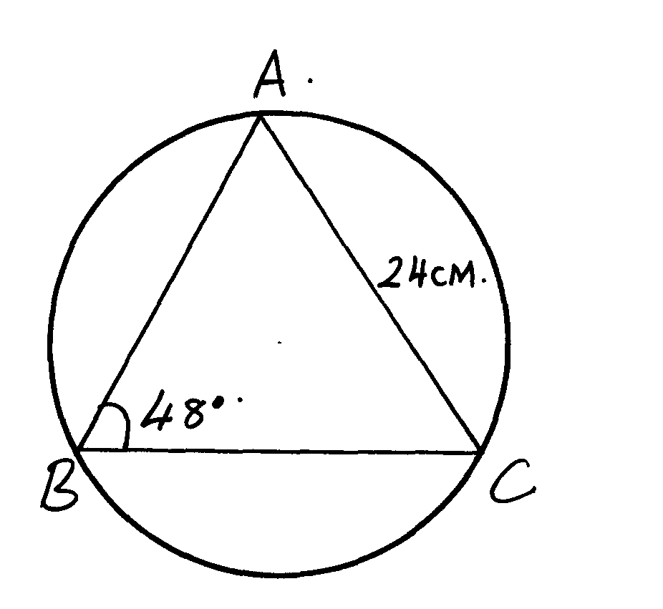
16. Find the area of the circle sector.

- Volume and capacity

1. The figure below shows a bucket of depth 30cm used to fill a cylindrical tank of radius 1.2m and height 1.35m which is initially three-fifth full of water.

30cm
40cm

  - Calculate, in terms of Π;
    - The capacity of the bucket in litres (5mks)
    - The volume of water required to fill the tank in litres (2mks)
    - Calculate the number of buckets that must be drawn to fill the tank (3mks)
2. A bucket is in the shape of a frustum with base radius 12cm and top radius 16cm. The slant height of the bucket is 30cm as shown below. The bucket is full of water.
(a) Calculate the volume of the water. (Take π = 3.142) (6 marks)

16

30

12

(b) All the water is poured into a cylindrical container of circular radius 12cm. If the cylinder has height 45cm, calculate the surface area of the cylinder which is not in contact with water. (4 marks)

3. The British government hired two planes to airlift football fans to South Africa for the World cup tournament. Each plane took 10 ½ hours to reach the destination.
Boeng 747 has carrying capacity of 300 people and consumes fuel at 120 litres per minute. It makes 5 trips at full capacity. Boeng 740 has carrying capacity of 140 people and consumes fuel at 200 litres per minute. It makes 8 trips at full capacity. If the government sponsored the fans one way at the cost of 800 dollars per fan, calculate:
(a) The total number of fans airlifted to South Africa. (2mks)
(b) The total cost of fuel used if one litre costs 0.3 dollars. (4mks)
(c) The total collection in dollars made by each plane. (2mks)
(d) The net profit made by each plane. (2mks)
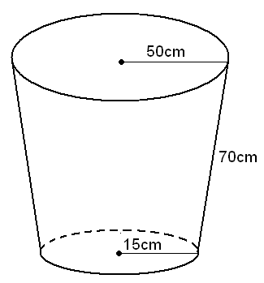
4. The figure below represents a part in form of a frustum of a right circular cover. The upper and the lower radii are 50cm and 15cm respectively. The slant height is 70cm.

a. Calculate the height of the pail. (5 cm)

b. Find the capacity of the pail to the nearest a litre. (5 mks)

5. Consider the vessel below
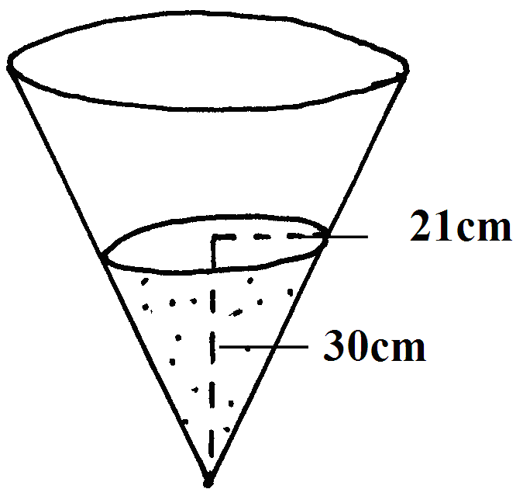
a) Calculate the volume of water in the vessel.
b) When a metallic hemisphere is completely submerged in the water, the level of the water rose by 6cm. Calculate:
i) the radius of the new water surface.
ii) the volume of the metallic hemisphere (to 4 s.f)
iii) the diameter of the hemisphere (10 mks)
6. A village water tank is in the form of a frustrum of a cone of height 3.2m.
The top and bottom radii are 18m and 24m respectively
(a) Calculate:
(i) The surface area of the tank excluding the bottom
(ii) The capacity of the water tank

(b) 15 families each having 15 members use the water tank and each person uses
65 litres of water daily. How long will it take for the full tank to be emptied

7. The diagram below shows a bucket with a top diameter 30cm and bottom diameter 20cm.
The height of the bucket is 28cm
(a) Calculate the capacity of the bucket in litres
30cm
28cm
20cm

(b) Find the area of the metal sheet required to make 100 such buckets taking 10% extra for
overlapping and wastage

8. A rectangular water tank measures 2.6m by 4.8m at the base and has water to a height
of 3.2m. Find the volume of water in litres that is in the tank

9. The figure alongside shows a cone from which a frustum is made. A plane parallel to the base
cuts the cone two thirds way up the vertical height of the cone to form frustum ABCD.
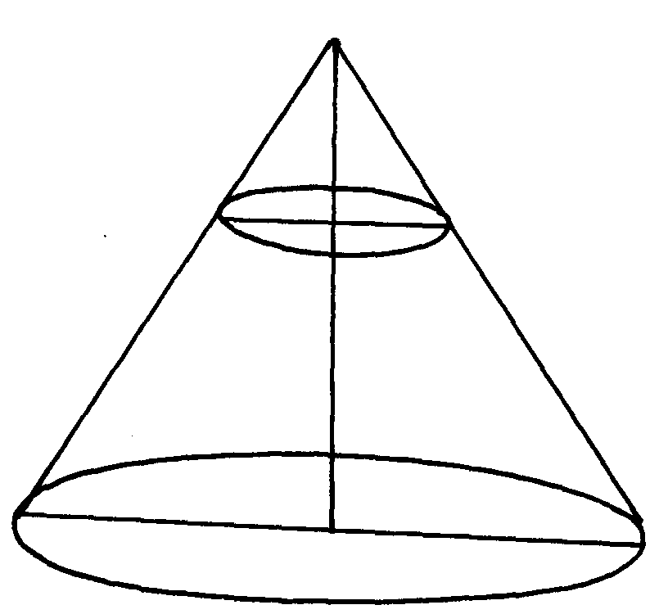 The top surface radius of the frustum is labeled r and the bottom radius is R
V
D
C
Y
B
A
r
x
R

a) Find the ratio r:R
b) Given that r = 7cm, find R
c) If the height VY of the original cone is 45cm, calculate to the nearest whole number the volume
of the frustum
d) The frustum represents a bucket which is used to fill a rectangular tank measuring 1.5m long, 1.2m wide and 80cm high with water. How many full buckets of water are required
to fill the tank

- Commercial arithmetic

1. Jane is a sales executive earning a salary of Ksh. 20,000 and a commission of 8% for the sales in excess of Ksh 100,000. If in January 2010 she earned a total of Ksh.48, 000 in salaries and commissions.
    - Determine the amount of sales she made in that month (4 mks)
    - If the total sales in the month of February and March increased by 18% and then dropped by 25% respectively. Calculate
(i) Jane’s commission in the month of February (3 mks)
(ii) Her total earning in the month of March (3 mks)
2. Wekhomba bought a laptop in Uganda for Ush.1, 050,000. He then paid 60 US dollars as transportation charges to Kenya. On arrival in Kenya he paid duty and sales tax amounting to 55% of the cost in Uganda. He then gave it to a friend in Tanzania tax free. If the exchange rates were I US dollar = Ush 1016, 1Ksh = Ush 24.83 and Tsh 1 = Ksh 0.0714
(a) Calculate the total expenses in Kenya shillings incurred by Wekhomba (3 mks)
(b) Find the expenditure on transportation and taxes as a percentage of the total
expenditure (2 mks)
(c) What is the total value of the laptop in Tanzanian shillings (2 mks)
(d) Find the overall increase in value of the laptop as percentage of the buying price (3 mks)
3. Wekesa deposited a certain amount of money in bank that paid compound interest at the rate of 20% P.A. Calculate to the nearest year the time he would have to wait for his investment to tripple. (3 mks)
4. A Kenya scholar to Japan exchanged converted Kenyan shillings to Yens. He received a total of 36,632.8 Yens. If the bank rates were as below, find how much to the nearest shilling he exchanged.
Buying selling
100 Japanese Yens Ksh 62.76 63.16 (2mks)
5. Ann bought 24 trays of eggs at sh 225 each. Each tray contains 30 eggs. 54 eggs got broken during transportation. At what price must he sell each egg in order to realize a profit of 22%. Answer to the nearest 1 shilling. (4mks)
6. A man invests Ksh 10000 in an account which pays 16% interest p.a. The interest is compounded quarterly. Find the interest earned after 1 ½ years to the nearest shilling. (4mks)
7. On Monday this currency exchange rate was
1 Euro (E) = Kshs.95.65
1 US dollar($) = Ksh.76.50
A gentle man Tourist decided to exchange half of his 2400E into Dollars.
Calculate to 2 decimal places the number of dollars he received. (3 marks)
8. A trader sold an article at sh.4800 after allowing his customer a 12% discount on the marked price of the article. In so doing he made a profit of 45% .
- Calculate
  - the marked price of the article. (3 marks)

  - the price at which the trader had bought the article (2 marks)
- If the trader had sold the same article without giving a discount. Calculate the percentage profit he would
have made. (3 marks)
- To clear his stock, the trader decided to sell the remaining articles at a loss of 12.5% (Calculate the price at which he sold each article. (2 marks)
9. A Kenyan businessman bought a washing machine in Europe at 500 Euros. On coming back, the Kenyan government imposed a 120% import duty and a 50% sales tax. He decided to sell the washing machine at a profit of ksh. 32,800.
Calculate
(a) Import duty (2 mks)
(b) Sales tax (2 mks)
(c) Percentage profit (3 mks)
(d) Selling price (3 mks)
Take 1 Euro Є = 95 Kenya shillings
10. A farmer made a loss of 28% by selling a goat for Sh.1440. What percentage profit would he have made if he had sold the goat for Sh.2100? (3mks)
11. A drapper bought some shirts and some trousers from a wholesaler Y at Sh.200 per shirt and Sh.600 per trouser, spending a total of Sh.22, 000. If he had bought the same items from wholesaler X, he would have paid 25% more for a shirt and 15% less for a trouser and he would have spent Sh.700 more.
  - Write a simultaneous equation to represent the above information.(1mk)
  - Determine the number of each item he bought (3mks)
  - He sold all the items as a profit of 50% per shirt and 30% per trouser. Find the total profit he made if he bought from wholesaler X. (3mks)
  - Calculate to the nearest whole number, the percentage profit he made if he bought from wholesale Y (3mks)

12. Chepkurui imports rice from the United States at an initial cost of 500US Dollars per tonne. He then pays 20% of this amount as shipping costs and 10% of the same amount as custom duty. When the rice reaches Mombasa he has to pay 5% of the initial cost to transport it to Nairobi.
(a) Given that on the day of this transaction the exchange rate was 1US Dollar = Ksh 76.60, calculate the total cost of importing one tonne of rice up to Nairobi in Kenya Shillings
(4mks)
(b) Chepkurui intends to make a profit of 20%. Giving your answer to the nearsest ten cents, calculate the price at which he must sell the rice per kilogram (4mks)
(c) If on the day that he completes the sale of this import he changes the total collection back to US Dollars at the rate of 1US Dollar = Ksh 78.20, calculate the actual profit that Chepkurui realized correct to three decimal places (2mks)

13. The purchase price of a TV consists of sh.4600 deposit and 8 equal monthly installments of sh.840. Given that the carrying charge is sh.2800. Find the cash price (3mks)
14. Three business partners Asha, Ogola and Jane contributed ksh.60,000, ksh.85,000 and ksh.105,000 respectively. They agreed to put 25% of the profit back into the business each year. They also agreed to put aside 40% of the remaining profit to cater for taxes and insurance. The rest of the profit would then be shared among the partners in the ratio of their contributions. At the end of the first year the business realized a gross profit of ksh.225,000.
  - Calculate the amount of money Jane received more than Asha at the end of the year (5mks)
  - Ogola further invested ksh.25,000 into the business at the beginning of the second year. Given that the gross profit at the end of the second year increased in the ratio of 10:9 and that 40% of it was shared, calculate Ogola’s share of the profit at the end of the second year (5mks)
15. A man imported a vehicle at Shs. 600,000 and sold it at Sh. 1,080,0000. Find his percentage profit if he spent sh. 60,000 for clearing the vehicle from the port and a further sh. 40,000 for shipping. ( 3 marks )
16. A Kenyan tourist left Germany for Kenya through Switzerland. While in Switzerland he bought a watch worth 52 Deutsche marks. Find the value of the watch in:-
(a) Swiss Francs
(b) Kenya shillings (3 marks)
Use the exchange rates below
1 Swiss Franc = 1.28 Deutsche marks
1 Swiss Franc = 45.21 Kenya shillings

17. Juanita sold goods worth ksh 95,000 and earned a total commission of Ksh 4,500. If the commission on the first Ksh. 50,000 was half of the total commission, what were the two rates of commission? (4mks)
18. Mr. Sitienei sold a house to Mr. Lagat at a profit of 10%. Mr. Lagat then sold it to Mr. Rotich at a profit of 5%. Mr. rotich paid Ksh 110,000 more than Mr. Lagat for the house. Find how much Mr. Rotich paid for the house. (3mks)
19. A Kenya bank buys and sells foreign currencies as shown below.
Buying (Ksh) Selling Ksh
1 Euro 84.15 84.26
100 Japanese yen 65.37 65.45
A Japanese traveling from France in Kenya with 5000 Euros. He converted all the 5000 Euros to Kenya shillings at the bank. While in Kenya, he spent a total of Ksh. 289850 and then converted the remaining Kenya shillings to Japanese Yens at the bank. Calculate the amount in Japanese Yen that he received. (3mks)
20. Kimani bought a car at kshs. 120,000. Its value depreciated by 8% per year for the first 2 years and by 12% per year for the subsequent years.
    - Determine the value of the car after 6 years. (4 mks)

    - After 6 years, the car was sold through an agent at 25% more than its value. If the sales price was to be taken as its value after depreciation, calculate the average monthly rate of depreciation for the six years. (6 mks)
21. Muthoni went to a shop and bought 50 packets of milk and 25 packets of salt all for Kshs.200.00. She sold the milk at a profit of 28% and the salt at a profit of 24% thereby making a net profit of Kshs.53.50. Find the cost price of a packet of milk and a packet of salt. (4 mks)
22. The cost of a camera outside Kenya is US$1000. James intends to buy one camera through an agent who deals in Japanese Yen. The agent charges him a commission of 5% on the price of the camera and further 1260 Yen as importation tax. How many Kshs. Will he need to send to the agent to obtain the camera, given that:- (3 mks)
1 US$ = 105.00 Yen.
1 US$ = Kshs.63.00
23. When shop keeper sells articles at sh. 240.50 each he makes a profit of 25% on the cost price. During a sale he reduces the price of each article by sh. 22.90. Calculate the percentage profit on an article sold at the sale price. (3 marks)
24. Factorise the expression (2 marks)
25. In certain day the bank rates for changing dollars to shillings are given below.

 | Buying | selling
Dollar | 78.43 | 79.25

An American tourist changed US dollar 1500 to shillings, but then had to return to U. S. A immediately and changed all the shillings back to dollars using the same rates. How much did he lose? ( 3 marks)
26. Find the angle θ in degrees from the figure below

2x – 3y + 6 = 0
A
O
B
θ
C

27. In the diagram below, determine the equation of the line XY in the form y = mx + c
A (-2, -1)
B (4, 7)
Y
X

28. Find the equation of a line which passes through the point (2, 3) and is perpendicular to
y – 3x+ 1 = 0, giving your answer in the form y = mx + c

29. T is the mid-point of line XY where X is point (1,4) and Y is the point (-5, 10). Find the
equation of a line, L₂ which is perpendicular to line XY and goes through point T

30. (a) On the grid provided below, plot points A(2,1) B(-4,3) and C(2,5)
b) Given that the gradient of CD = -1 and CD =AD locate D and complete the
quadrilateral ABCD
(c) What name is given to quadrilateral ABCD?
31. In the figure below (not drawn to scale), PQRS is a rectangle and P and Q are the points
(3, 2) and (1,4) respectively
Q (1, 4)
P (3, 2)
R
S
y
x

Given that the equation of the line PQ is y =3x -7, find:
- The equation of line QR
- The coordinates of point R
- The coordinates of point S

32. OABC is a trapezium such that the coordinates of O, A , B and C are (0, 0), (2, -1), (4, 3)
and (0, y)
(a) Find the value of y
(b) M is the mid-point of AB and N is the mid-point of OM. Find in column form
(i) the vector AN
(ii) the vector NC
(iii) Vector AC
(c) Hence show that A, N and C are collinear

33. Use ruler and a pair of compasses only in this question.
(a) Construct triangle ABC in which AB = 7 cm, BC = 8 cm and ∠ABC = 60⁰.
(b) Measure (i) side AC (ii) ∠ ACB
(c) Construct a circle passing through the three points A, B and C. Measure the radius of the
circle.
(d) Construct ∆ PBC such that P is on the same side of BC as point A and ∠ PCB = ½ ∠ ACB,
∠ BPC = ∠ BAC measure ∠ PBC.

34. ABCD is a parallelogram with vertices A (1,1) and C(8,10). AB has the equation
4x -5y = -1 and BC has the equation 5x – 2y = 20. Determine by calculation;
(a) the co-ordinates of the point M where the diagonals meet
(b) The co-ordinates of the vertices B and D
(c) the length of AB correct to 4 significant figures

35. The table shows corresponding values of x and y for a certain curve;
x | 1.0 | 1.2 | 1.4 | 1.6 | 1.8 | 2.0 | 2.3
y | 6.5 | 6.2 | 5.2 | 4.3 | 4.0 | 2.6 | 2.4

Using 3 strips and mid-ordinate rule estimate the area between the curve, x-axis,
the lines x =1 and x =2.2

- Geometrical Constructions

1. Using a ruler and a pair of compasses only,
a) Construct a triangle ABC in which AB = 9cm, AC = 6cm and angle BAC = 37½⁰
    - Drop a perpendicular from C to meet AB at D. Measure CD and hence find the area of the triangle ABC
    - Point E divides BC in the ratio 2:3. Using a ruler and Set Square only, determine point E. Measure AE.

2.
A
X
C
B

On the diagram, construct a circle to touch line AB at X and passes through the point C. (3 mks)
3. Using ruler and pair of compasses only for constructions in this question.
(a) Construct triangle ABC such that AB=AC=5.4cm and angle ABC=30⁰. Measure BC (4 mks)
(b) On the diagram above, a point P is always on the same side of BC as A. Draw the
locus of P such that angle BAC is twice angle BPC (2 mks)
(c) Drop a perpendicular from A to meet BC at D. Measure AD (2 mks)
(d) Determine the locus Q on the same side of BC as A such that the area of triangle
BQC = 9.4cm² (2 mks)
4. (a) Without using a protractor or set square, construct a triangle ABC in which AB = 4cm, BC = 6cm and ∠ABC = 67½⁰. Take AB as the base. (3mks)
Measure AC.
(b) Draw a triangle A¹BC¹ which is indirectly congruent to triangle ABC. (3mks)
(c) Taking the mid point of AB as your centre of rotation (M). find the triangle A¹¹B¹¹C¹¹ the image of A¹B¹C¹ after -90⁰. (4mks)
5. Construct triangle ABC in which AB = 4.4 cm, BC = 6.4 cm and AC = 7.4 cm. Construct an escribed circle opposite angle ACB (5 mks)
(a) Measure the radius of the circle (1 mk)
(b) Measure the acute angle subtended at the centre of the circle by AB (1 mk)
(c) A point P moves such that it is always outside the circle but within triangle AOB, where O is the centre of the escribed circle. Show by shading the region within which P lies. (3 mks)
6. (a) Using a ruler and a pair of compasses only, construct a parallelogram PQRS in which PQ = 8cm, QR = 6cm and PQR = 150⁰ (3 mks)
(b) Drop a perpendicular from S to meet PQ at B. Measure SB and hence calculate the area of the parallelogram. (5 mks)
(c) Mark a point A on BS produced such that the area of triangle APQ is equal to three quarters the area of the parallelogram (1 mk)
(d) Determine the height of the triangle. (1 mk)
7. Using a ruler and a pair of compasses only, construct triangle ABC in which AB = 6cm, BC = 8cm and angle ABC = 45º. Drop a perpendicular from A to BC at M. Measure AM and AC
(4mks)
8. a) Using a ruler and a pair of compasses only to construct a trapezium ABCD
such that , ,and (5mks)
b)From the point D drop a perpendicular to the line AB to meet the line at E. measure DE hence calculate the area of the trapezium (5mks)
9. Using a pair of compasses and ruler only;
(a) Construct triangle ABC such that AB = 8cm, BC = 6cm and angle ABC = 30⁰. (3 marks)
(b) Measure the length of AC (1 mark)
(c) Draw a circle that touches the vertices A,B and C. (2 marks)
(d) Measure the radius of the circle (1 mark)
(e) Hence or otherwise, calculate the area of the circle outside the triangle. (3 marks)
10. Using a ruler and a pair of compasses only, construct the locus of a point P such that angle APB = 60⁰ on the line AB = 5cm. (4mks)
B
A

11. Using a set square, ruler and pair of compases divide the given line into 5 equal portions. (3mks)

12. Using a ruler and a pair of compasses only, draw a parallelogram ABCD, such that angle DAB = 75⁰. Length AB = 6.0cm and BC = 4.0cm from point D, drop a perpendicular to meet line AB at N
a) Measure length DN
b) Find the area of the parallelogram (10 mks)
13. Chebochok deposited shs.120,000 in a financial institution which offered a compound
interest at 8% p.a, compounded quarterly for 9 months. Find the accumulated amount by
the end of the period

14. Using a ruler and a pair of compasses only, draw a parallelogram ABCD in which AB = 6cm,
BC = 4cm and angle BAD = 60º. By construction, determine the perpendicular distance between
the lines AB and CD

15. Without using a protractor, draw a triangle ABC where ∠CAB = 30º, AC = 3.5cm and
AB = 6cm. measure BC

16. (a) Using a ruler and a pair of compass only, construct a triangle ABC in which
angle ABC =37.5º, BC =7cm and BA = 14cm
(b) Drop a perpendicular from A to BC produced and measure its height
(c) Use your height in (b) to find the area of the triangle ABC
(d) Use construction to find the radius of an inscribed circle of triangle ABC

17. In this question use a pair of compasses and a ruler only
a) Construct triangle PQR such that PQ = 6 cm, QR = 8 cm and <PQR = 135°
b) Construct the height of triangle PQR in (a) above, taking QR as the base

18. On the line AC shown below, point B lies above the line such that ∠BAC = 52.5º and]
AB = 4.2cm. (Use a ruler and a pair of compasses for this question)
A
C

(a) Construct ∠BAC and mark point B
(b) Drop a perpendicular from B to meet the line AC at point F . Measure BF

19. Juma paid shs.450 for a trouser after getting a discount of 10%. The trader still made a
profit of 25% on the sale. What profit would the trader have made if no discount was allowed?

- Scale Drawing

1. Three mountains Mikai, Kembo and Chaka in a village are situated in such a way that Kembo is 900m on a bearing of 120⁰ from Mikai. Mt. Chaka is 1200m on a bearing of 030⁰ from Kembo.
  - Draw a sketch showing the position of the three mountains (1 mk)
  - Calculate the distance of Mt. Chaka from Mt. Mikai (2 mks)
2. Shopping centres XY and Z are such that Y is 12km south of X and Z is 15kn from X. Z is on a bearing of N30⁰W from Y. Calculate and give compass bearing of Z from X. (4mks)
3. Four telephone posts PQR and S stand on a level ground such that Q is 28m on a bearing of 060⁰ from P. R is 20m to the south of Q and S is 16m on a bearing of 140⁰ from P.
(a) Using a scale of 1cm represent 4m show the relative positions of the posts. (4mks)
(b) Find the distance and bearing of R from S. (3mks)
(c) If the height of post P is 15.6m. on a separate scale drawing, draw a diagram and determine the angle of depression of post R from the top of post P. (3mks)
(Same scale as above)
4. Alice chepchumba on her cycling practice cycled on a bearing of 120º for 5.5km, then on a bearing of 200º for 8km finally he turned northwards for 13.5km, by scale drawing determine her final position from starting point. (4 marks)
5. A surveyor recorded the measurement of field in a field book using lines AB = 260m as shown below.
 | B
 | 130 | R40
 | 70 | Q10
 | 50 | P20
S50 | 10
 | A
a) Use a suitable scale to draw the map of the field. (2 marks)
b) Find the area of the field. (2 marks)
6. (a) In a Safari rally drivers are to follow route ABCGA. B is 250km from A on a bearing of 075⁰ from A. C is on a bearing of 110⁰ from A and 280km from B. the bearing of C from D is 140⁰ and at a distance of 300km. By scale drawing, show the position of the point A, B, C and D. (4 mks)
(b) Determine
(i) Distance of A from C (2 mks)
(ii) The bearing of B from C (1 mk)
(iii) The distance and bearing of A from D (3 mks)
7. Town X is 20km in the direction 060º from Y and Z is 30km in the direction 150º from Y. Using the scale 1cm represents 5km, find by scale drawing;
(a) the bearing of Y from Z
(b) the distance of X from Z (4mks)
8. A field was surveyed and its measurements recorded in a field book as shown below.
E 40  C 40 | F  100  80  60  40  20  A | D 50  B 30

(a) Using a scale of 1cm to represent 10m, draw a map of the field. (4mks)
(b) Calculate the area of the field.
(i) in square metres. (4mks)
(ii) in hectares. (2mks)
9. A plane leaves town P to town Q on a bearing of 130⁰ and a distance of 350km. it then flies to town R 500km away and on a bearing 060⁰. Find by scale drawing the distance of R from P (3mks)

10. A surveyor recorded the following information in his field book after taking measurements in metres of a plot. The baseline is the straight line AH = 300m.

40 to F  120 to D | H  250  200  180  100  A | 100 to G  80 to C  60 to B

(a) Using a scale of 1cm to represent 20m, draw an accurate diagram of the plot. (5mks)
b) Use your diagram to calculate the actual area of the field in hectares (5mks)

11. Three town P,Q and R are such that P is on a bearing of 120° and 20 km from Q. Town R is on bearing of 220º and 12km from P
a) Using a scale of 1 cm to 2 km, draw and locate the positions of the three towns. (3mks)
b) Measure
i) the distance between Q and R in kilometres. (2mks)
ii) the bearing of P from R. (1mk)
iii) the bearing of R from Q. (2mks)
c) Calculate the area of the figure bounded by PQR. (2mks)

12. The area of a forest on a map whose scale is 1:50,000 is 17cm². Calculate the area of the forest in hectares. (2 mks)
13. Four towns P, Q, R and S are such that town Q is 120km due east of town P. Town R is 160km due North of town Q. Town S is on a bearing of 330º from P and on a bearing 300 º from R. use a ruler and a pair of compasses only for all your constructions.
a) Using a scale of 1cm to represent 50km, construct a scale drawing showing the positions P, Q, R and S. (6 mks)
b) Use the scale to determine
          - The distance from town S to town P. (1 mk)
          - The distance from town S to town R. (1 mk)
          - The bearing of town S from town Q. (2 mks)
14. The actual area of an estate is 3510 hectares. The estate is represented by a rectangle measuring 2.6cm by 1.5cm on the map whose scale is l:n. Find the value of n (3 mks)
15. The following measurements were recorded in a field book of a farm in metres (xy = 400m)
C60  B 100  A 120 | y  400  340  300  240  220  140  80  x | 120 D  100 E  160 F
a) Using a scale of 1cm representing 4000 cm, draw an accurate map of the farm.
b) If the farm is on sale at Kshs.80,000.00 per hectare, find how much it costs. (10 mks)
16. Four points A, B, C and D are situated on a horizontal plane such that B is 250 m on a bearing of 070⁰ from A. C is 325 m on a bearing of 150⁰ from B. D is due west of C and on a bearing of 210⁰ from B. (6 marks)
    - Using a scale of 1 cm to 50 m draw an accurate drawing to show the position of A, B, C and D.
    - Use your scale drawing fo find the :
      - The distance between A and D (2 marks)
      - The bearing of A from D (2 marks)
17. Town X is 13.5km from town Y on a bearing of 028^{o.} A matatu leaves y at 7:35a.m
towards a bearing of 080º. The matatu is at point Z due south of X at 8:55a.m
(a) Calculate the average speed of the matatu from Y to Z
(b) If the matatu continues on the same bearing, calculate the distance it covers from Z
when it is East of X
18. Three towns X, Y and Z are such that Y is 500km on a bearing of 315º from X. Z is on
a bearing of 230º from X. given that the distance between Y and Z is 800km.
(a) using a scale of 1cm to represent 100km, draw a scale diagram to show the position
of the Towns
(b) Find the bearing of;
(i) X from Z
(ii) Z from Y
(c) Use the scale drawing to find the distance from X to Z

19. Two aeroplanes S and R leave an airport at the same time. S flies on the bearing of 240º
at 750Km/h while R flies due East at 600Km/hr..
(a) (i) Calculate the distance of each aeroplane after 30minutes
(ii) Using a scale of 1cm to represent 50km make an accurate scale drawing to show
the positions of the aeroplanes after 30minutes
(b) (i) Use the scale drawing to find the distance between the two aeroplanes after 30minutes
(ii) If each aeroplane landed after 30minutes and S received a signal to join R in 45minutes.
Find its speed
(c) Determine the bearing of :
(i) S from R
(ii) R from S

20. The table below gives a field book showing the results of a survey of a section of a piece of land
between A and E. All measurements are in metres.
D33  C21  B 42 | E  95  90  70  30  25  A | F 36  G 25  H 40
(a) Draw a sketch of the land.
(b) Calculate the area of this piece of land.

21. Three towns A B and C are situated such that town A is 40km from B on a bearing of 280º.
C is 60km from B on a bearing of 130º. Another town D is only 10km from C on a bearing of 210º.
(a) Drawing accurately and using a scale of 1cm to 10km find the:-
(b) Distance from A to C and the bearing of A from C
(c) (i) Distance of B from D
(ii) Distance of A from D
(iii) Bearing of A from D
(iv) Bearing of C from D

22. A train left Naivasha for Nakuru at 1000hours. It traveled at an average speed of 45km/h
and reached Gilgil after 40minutes. It then covered the remaining 50km in 1½ hours. A second
train left Nakuru for Naivasha at 1015 hours and arrived at Gilgil at the same time as the first
train arrived at Nakuru.
a) Using a scale of 1cm to represent 10minutes in the time axis and 1cm to represent 10km
on the distance axis, draw on the same axes the graphs to show the movement of the two
trains
b) use your graph to find;
i) the distance between Naivasha and Nakuru
ii) the time at which the train met
c) calculate the average speed, in km/h of the second train

23. On a certain map, a road 20km long is represented by a line 4cm long. Calculate the area
of a rectangular plot represented by dimensions 2.4cm by 1.5cm on this map – leaving
your answer in hectares

24. A port B is on a bearings of 080º from a port A and at a distance of 95km. a submarine is
stationed at a port D, which is on a bearing of 200º from A, and a distance of 124km from B.
A ship leaves B and moves directly southwards to an island P, which is on a bearing of 140º
from A. the submarine at D on realizing that the ship was heading for the island P, decides to
head straight for the island to intercept the ship.
(a) Using a scale of 1cm to represent 10km draw a diagram to show the positions of A,B,D, and P
(b) Hence;
Determine;
(i) the distance from A to D
(ii) the bearing of the submarine from the ship when the ship was setting off from B
(iii) the bearing of the island P from D
(iv) the distance the submarine had to cover to reach the island P

25. Use a scale of 1cm represents 50km in these questions. Five towns A, B, C, D and E are
situated such that A is 200 km from B on a bearing of 050° from E. C is 300 km from B on
a bearing of 150° from B. D is 350km on a bearing of 240° from C. E is 200km from D and the bearing of D from E is 100°
a) Draw the diagram representing the positions of the towns
b) From the diagram, determine;
i) The distance in km of A from E
ii) The bearing of D from B

26. Four towns P, Q, R & S are such that P is 280 km North of R, S is190 km from R on a
bearing of 310º and Q is 240 km from P on a bearing of 105º.
a) Using scale of 1 cm rep. 50 km, locate the four towns.
b) Find; (i) distance SQ.
(ii) Bearing of S from Q.
(iii) The shortest distance between P and side QR.

27. Four ships are at sea such that a streamliner S is 150km on a bearing of 025° from a cargo
ship C. A trawler T is 300km on a bearing of 145° from the cargo ship and a yacht Y is due
West of C and on a bearing of 300° from T.
a) Using a scale of 1cm= 50km, draw on accurate scale drawing showing the positions of S, C, T
and Y
b) By measurement from your scale drawing determine:
i) The distance and bearing of Y from S
ii) The distance ST
iii) The distance YT

28. A tea farm in Kakamega forest was surveyed and the results were recorded in the surveyors
note book as shown below. The measurements are in meters
 | 250 | Y
C80  A60 | 240  170  70  50 | D70  B60
X | 0
Using a scale of 1: 25, draw the map of the plot and hence calculate the area of the plot in Hectares

29. The information below shows the entries in a surveyor’s field book after a survey of a farm.
XY = 280m is the baseline. All measurements are in metres
 | 280 | Y
B 105  A 100 | 230  190  160  90  40 | 110E  45E  95G
X | O
(a) Use a scale of 1cm represents 20m to draw the map of the farm
(b) Estimate the area of the farm in hectares
(c) If the point Y lies due north of X, find correct to 1 decimal place, the :
(i) Bearing of E from X
(ii) Distance of E from X

30. The measurements of a flower garden were recorded in a surveyor’s field book as shown.
 | 250 | Y
C80 | 240  170  70 | D 70  B 60
X | 0
Draw a sketch of the field and find its area. (Measurements are in m)

31. A map has a scale 1:40,000:
(a) Calculate the distance between two points on the ground if the corresponding distance
shown on the map is 3.25cm
(b) Calculate the area in the map of woodland which occupies 36ha on the ground
32. Three scouts John, Peter and Samwel stand on three adjacent peaks of equal altitude
on mountain range. The distance between John and Peter is 800metres and the bearing
of Peter from John is 020º. The distance between John and Samwel is 1500metres, and the
bearing of Samwel from John is 320º.
(a) Calculate the bearing of John from Peter
(b) Calculate:- (i) the distance
(ii) the bearing of Samwel from Peter

33. The figure below represents a surveyor’s sketch of a plot of land. Calculate the area of the plot in
square metres given that XY = 50m, XK = 20m, XM = 25m, XL = 35m, KA = 40m, MD = 38m
and LB = YC = 60m.
Y
D
X
A
C
K
B
L
M

34. Two boats P and Q are located 30km apart; P being due North of Q. An observer at P
spots a ship whose bearing he finds as S 56ºE from Q, the bearing of the same ship is 038º. Calculate the distance of the ship from Q to 2 decimal places
35. A map is drawn to scale of 1:100,000. What area in km², is represented by a rectangle
measuring 4.5cm by 5.4 cm

36. Two places A and B are 900km apart on the earth’s surface. If A is due North of B and
given that the latitude of A is 5ºN. Find the latitude of B. (Take radius of the earth to be 6370km)
37. A car starts from rest and build up a speed of 40m/s in 1min 40seconds. It then travels
at this steady speed for 5minutes. Brakes are then applied and the car is brought to rest
in 2minutes.
(a) Draw a velocity-time graph to show the journey
(b) Use your graph to find;
(i) the initial acceleration
(ii) the deceleration when the car is brought to rest
(iii) the distance traveled
38. The diagram below represents two vertical watch-towers AB and CD on a level ground.
P and Q are two points on a straight road BD. The height of the tower AB is 20m and
road BD is 200m
B
C
A
D
Q
P

(a) A car moves from B towards D. At point P, the angle of depression of the car from
point A is 11.3º. Calculate the distance BP to 4 significant figures
(b) If the car takes 5 seconds to move from P to Q at an average speed of 36km/.hr. Calculate
the angle of depression of Q from A to 2 decimal places
(c) Given that QC = 50.9m, calculate;
(i) the height of CD in metres to 2 decimal places
(ii) the angle of elevation of A from C to the nearest degree
39. Town B is 180 km on a bearing of 050⁰ from town A. Another town C is on a bearing of 110⁰
from town A and on a bearing of 150⁰ from town B. A fourth town D is 240 km on a bearing of
320⁰ from A. Without using a scale drawing, calculate to the nearest kilometer.
(a) The distance AC
- The distance CD

- Vectors
1. Given that and find
    - (i) (3 mks)
  - || (3 mks)
- Show that A (1, -1), B (3, 5) and C (5, 11) are collinear (4 mks)
2. Given the column vectors and that
- (i) Express p as a column vector (2mks)
- (ii) Determine the magnitude of p (1mk)
3. Given the points P(-6, -3), Q(-2, -1) and R(6, 3) express PQ and QR as column vectors. Hence show that the points P, Q and R are collinear. (3mks)

4. The position vectors of points x and y are and respectively. Find x y as a column vector (2 mks)
5. Given that (3mks)
6. The position vectors of A and B are 2 and 8 respectively. Find the coordinates of M
5 -7
which divides AB in the ratio 1:2. (3 marks)

7. The diagram shows the graph of vectors and .
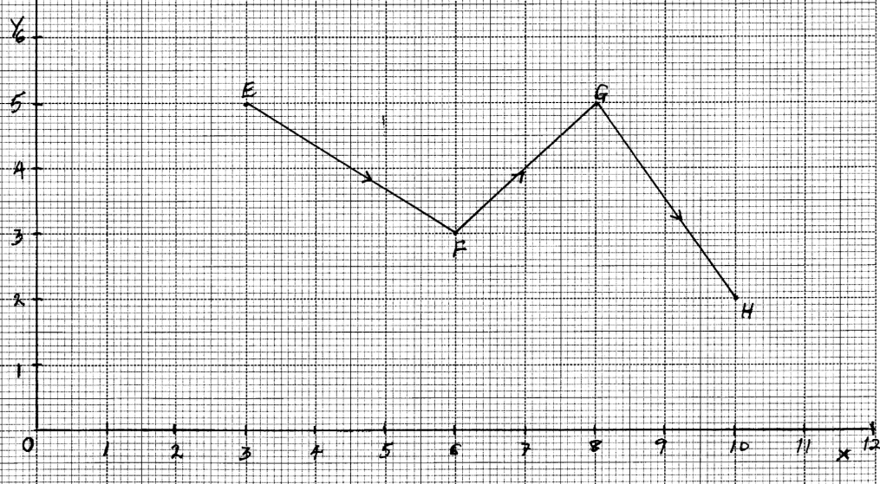
Find the column vectors;
(a) (1mk)
(b) || (2mks)
8. . Find (2mks)
9. Show that P (4, 0 -4), Q (8, 2, -1) and R (24, 10, 11) are collinear. (3 mks)
10. Given that = 2i – j + k and q = i + j +2k, determine
a. │p + q│ (1 mk)
(b) │ ½ p – 2q │ (2 mks)
11. Express in surds form and rationalize the denominator.
1
Sin 60º Sin 45º - Sin 45º

12. If OA = 12i + 8j and OB = 16i + 4j. Find the coordinates of the point which divides AB
~
~
~
~
internally in the ratio1:3

13. Find scalars m and n such that

m 4 + n -3 = 5
3 2 8

14. In a triangle OAB, M and N are points on OA and OB respectively, such that OM: MA = 2:3
and ON: NB = 2:1. AN and BM intersect at X. Given that OA = a and OB = b
B
A
O
M
N
~
~

(a) Express in terms of a and b
~
~
(i) BM
(ii) AN
(b) By taking BX = t and AX = h AN, where t and h are scalars, express OX in two
different ways
(c) Find the values of the scalars t and h
(d) Determine the ratios in which X divides :-
(i) BM
(ii) AN

15. OABC is a parallelogram, M is the mid-point of OA and AX = ²/₇ AC, OA=a and OC = c
∼
∼
O
M
A
Y
B
C

(a) Express the following in terms of a and c
∼
∼
(i) MA
(ii) AB
(iii) AC
(iv) AX
(b) Using triangle MAX, express MX in terms of a and c
(c)The co-ordinates of A and B are (1, 6, 8) and (3, 0, 4) respectively. If O is the origin and P
the midpoint of AB. Find;
(i) Length of OP
(ii) How far are the midpoints of OA and OB?

16. a) If A, B & C are the points (2, - 4), (4, 0) and (1, 6) respectively, use the vector method
to find the coordinates of point D given that ABCD is a parallelogram.
b) The position vectors of points P and Q are p and q respectively. R is another point with
~
~
~
position vector r = ³/₂ q - ½ p. Express in terms of P and q
~
~
~
~

(i) PR
(ii) PQ, hence show that P, Q & R are collinear.
(iii) Determine the ratio PQ : QR

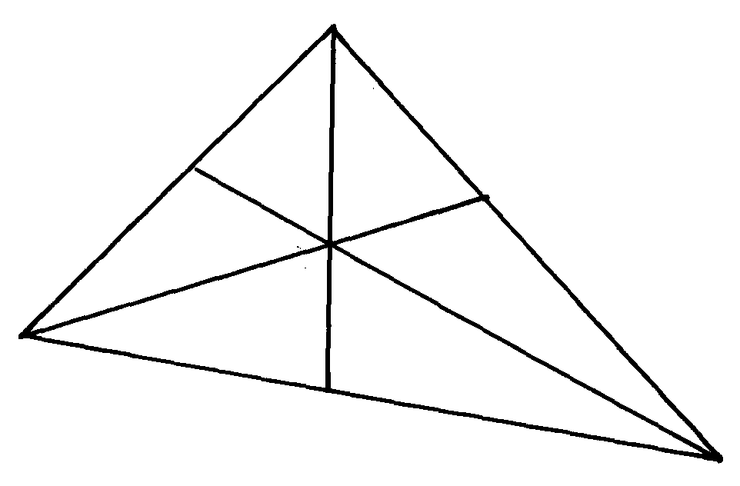17. The figure shows a triangle of vectors in which OS: SP = 1:3, PR:RQ = 2:1 and T is the
T
Q
R
P
O
S
M
midpoint of OR

a) Given that OP = p and OQ = q, express the following vectors in terms of P and q
i) OR
ii) QT
b) Express TS in terms of p and q and hence show that the points Q, T and S are collinear
c) M is a point on OQ such that OM = KOQ and PTM is a straight line. Given that
PT: TM = 5:1, find the value of k

18. Given that a = , b = and c = and that p = 3q – ½ b +¹/₁₀c
Express p as a column vector and hence calculate its magnitude /P/ correct to two decimal places

19. In a triangle OAB, M and N are points on OA and OB respectively, such that OM:MA= 2:3 and
ON:NB= 2:1. AN and BM intersect at X. Given that OA = a and OB = b
~
~
(a) Express in terms of a and b:-
~
~
(i) BM
~
(ii) AN
~
(b) Taking BX = kBM and AX =hAN where k and h are constants express OX in terms of
~
~
~
~
~
~
(i) a, b and k only
~
~
~
(ii) a, b, and h only
~
~
(c) Use the expressions in (b) above to find values of k and h
.
20. In the figure below OAB is a triangle in which M divides OA in the ratio 2:3 and N
divides OB in the ratio 4:1. AN and BM intersects at X

X
X
A
O
M
B
N

(a) Given that OA = a and OB = b, express in terms of a and b
∼
∼
∼
∼
(i) AN
∼
(ii) BM
∼
(iii) AB
∼
(b) If AX = sAN and BX = tBM, where s and t are constants, write two expressions
~
~
~
~
for OX in terms of a, b, s and t. Find the value of s and t hence write OX in terms
of a and b

21. A student traveling abroad for further studies sets a side Kshs. 115800 to be converted into US
dollars through a bank at the rate of 76.84 per dollar. The bank charges a commission of 2 ½ %
of the amount exchanged. If he plans to purchase text books and stationery worth US$270, how
much money, to the nearest dollar, will he be left with?

22. Given that:- r = 5i – 2j and m = -2i + 6j – k are the position vectors for R and M respectively.
~
~
~
~
~
~
~
Find the length of vector RM
~

23. OABC is a trapezium in which OA = a and AB = b. AB is parallel to OC with 2AB = OC.
~
~
~
~
~
~
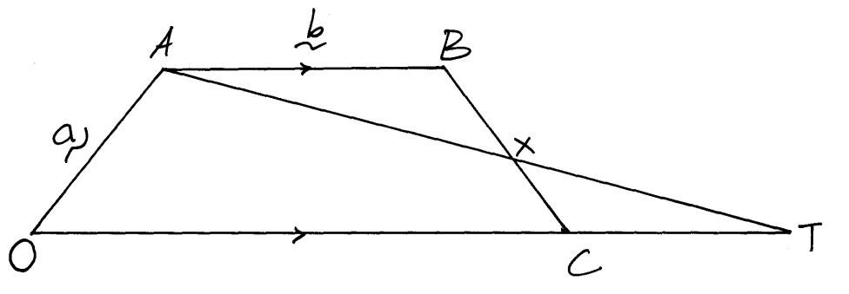
T is a point on OC produced so that OC: CT = 2:1. At and BC intersect at X so that BX = hBC and AX = KAT
~
~

(a) Express the following in terms of a and b:-
~
~
(i) OB
~
(ii) BC
~
(b) Express CX in terms of a, b and h
~
~
~
(c) Express CX in terms of a, b and k
~
~
~
(d) Hence calculate the values of h and k

24. Given that a = 2i + j – 2k and b = -3i + 4j – k find :-
~~
~
| a + b|.

25. In the figure below, E is the mid-point of BC. AD:DC=3:2 and F is the meeting point of
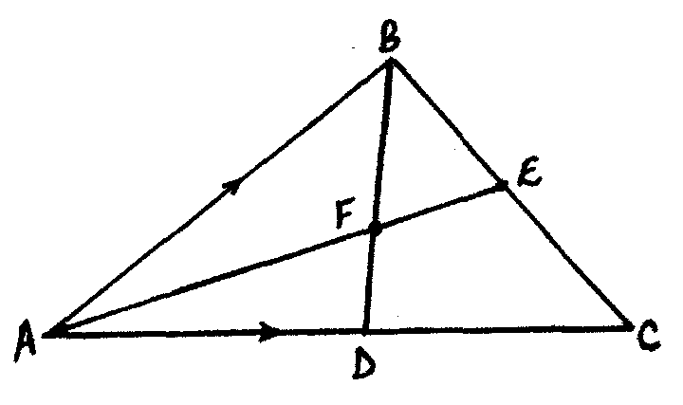
BD and AE

If AB = b and AC = c;
~
~
(i) Express BD and AE in terms of b and c
~
~
~
~
(ii) If BF =tBD and AF =nAE, find the values of t ad n
(iii) State the ratios in which F divides BD and AE

26. The coordinates of point O, A, B and C are (0, 0) (3, 4) (11, 6) and (8, 2) respectively.
A point P is such that the vector OP, BA, BC satisfy the vector equation OP = BA + ½ BC
Find the coordinates of P

27. A point Q divides AB in the ratio 7:2. Given that A is (-3, 4) and B(2, -1).
Find the co-ordinates of Q

- Commercial Arithmetic 2
1. The table below shows the rate at which income tax is charged for all taxable income.
INCOME RATE IN EXCH TWENTY SHILLINGS
On the first shs.116 160 10%
On the next shs.109 440 15%
On the next shs.109 440 20%
On the next shs.109 440 25%
On all income over shs.444 480 30%
Mr. Nyongesa earns a basic salary of sh.54, 450 per month. He is housed by the company and therefore 15% of his monthly salary is added to the basic salary as a taxable income. He is also given taxable medical and transport allowances of shs.4,000 and shs.2,000 per month respectively. He is entitled to a family relief of sh.1, 100 per month.
(a) Calculate Nyongesa’s annual taxable income (3 mks)
(b) Calculate his monthly P.A.Y.E after the relief (5 mks)
(c) If 20% of his basic salary goes towards deductions, determine his monthly income. (2 mks)

2. All employees of silver springs enterprises pay income tax at the rate shown in the table below.

Taxable income (p.a) | Rate sh. Per K₤
1 – 3780  3781-7560  7561-11,340  11,341-OVER | 2  3  4  5

Mr. Mooka earns a basic salary of sh.12,150 and a house allowance of sh.2800 per month. He is
entitled to a family relief of sh.450 per month. A part from income tax the following deductions are also made from his monthly pay.
- Servicing loan payment sh.450
- Hospital fund sh.260
- Sacco contribution sh.120

Determine Mr. Mooka’s net monthly income. (10 marks)

3. The taxation rates for income earned in a certain year were as follows:
Income Tax Rate
K£ p.a Kshs. Per £
1 – 4512 2
4513 – 9024 3
9025 – 13536 4
13537 – 18048 5
18049 – 22560 6
Over 22560 6.5
After a personal relief of Kshs.1056 per month, Otieno paid tax amounting to Kshs.18,152 that year.
a) How much tax would he have paid if he did not have the personal relief (2 mks)
b) Find his taxable income in K£ that year (5 mks)
c) If Otieno receives allowances amounting to 18% of the taxable income. Calculate his monthly basic salary in Kshs. (3 mks)
4. Chepkemoi bought a new washing machine for Kshs.420,000. Its value depreciated over
the next 5years at the following rates; 15%, 13%, 12%, 9% and 7%. For the next 6 years,
the rate of depreciation remained constant at 5% then the rate of depreciation remained at 4%
each. How long did it take for the value of the washing machine to be ¹/₃ of its original value?
5. The table below shows income tax rates for the year 2006

Taxable income in shs. Pa | Rate of tax in %
1 – 120,000 | 10
120,001 – 240,000 | 15
240,001 – 360,000 | 25
360,001 – 480,000 | 35
Over 480,000 | 50

Nafula is married and claims a tax relief of shs.1,120 per month. She stays in a company house
For which she pays a nominal rent of shs.1200 per month. She found that in a particular month,
her employer deducted shs.4830 as tax. If she is entitled to a maximum insurance policy; relief
of shs.600 per month. Calculate her monthly salary. (10mks)

6. The figure below represents two pulley wheels, centres A and B with a rubber band
CDEFGHC stretched round them. Radius of wheel centre A = 16cm, AB = 30cm. CD,
GF are tangents to the circles < CAB = 86.3°
B
F
D
86.3º
G
H
A
C

a) calculate the length of the belt CD
b) Find the angle ABD
c) Find the length of the belt that would go round the pulleys (CDFGHC)

7. In the figure below, ABCD is a cyclic quadrilateral and BD is a diagonal. EADF is a straight line,
∠CDF = 68º, ∠ BDC = 45º and ∠ BAE = 98º.
E
A
D
F
B
C
98º
45º
68º

Calculate the size of:
a) ∠ ABD.
b) ∠ CBD

8. A customer deposited Ksh.15,500 in a savings account. Find the accumulated amount
after 3½ years if interest was paid at 16% per annum compounded semi-annually

9. A retailer mixes three types of rice, Bismatti costing shs.120 per tin with Pishori costing shs.150
per tin and Ahero rice costing shs.80 per tin in the ratio x : 1 : 2 respectively. If he sells the
mixture at shs.137.50 per tin making a profit of 25%. Calculate the value of x.

10. Ashanti is a saleswoman and earns a commission on sales based on the monthly rates shown
in the table below:-
Sales (Kshs) | Commission rate % of sales
The first 5000 | 10%
The next 3000 | 15%
Sales above 8000 | 20%

In addition, she earns a basic monthly pay of Kshs.6700. During a certain month, she earned
a total salary amounting to Kshs.8368. How much worth of sales did she make?

11. The table below shows the annual income tax rates for a certain year.

Total income per month in Kshs. | Rates in Kshs. Per £
1-10164  10165 – 19740  19741 – 29316  29317 – 33892  388983 and above | 2  3  4  5  6
Automatic personal relief shs.1162

Kiptoo earns a monthly salary of Kshs.25000. He is entitled to house and medical allowances
of Kshs.12000 and Kshs.3000 respectively
Calculate:
(a) His taxable income per month
(b) His monthly tax payable
(c)His annual tax payable

12. A company employee earns a basic salary of Kshs.25,000 and is also given taxable allowances
amounting to Kshs.10,480.

Monthly taxable income | Rate in Kshs. /Pound
1- 4350  4351 – 8900  8901 - 13455  13451 – 18005  18006 and above | 2  3  4  5  6

Using the table of taxation above:-
(a) Calculate the employee’s taxable income
(b) If the employee is entitled to a personal tax relief of Kshs.800 per month, determine the net tax
(c) If the employee was given 40% increase in his income, calculate the percentage increase
in his income tax
13. A certain amount of money was invested at compound interest of 10% compounded
every two years for ten years. Given that the investor invested a total of 500,000/= at the
end of the ten years, find the amount of money invested to the nearest shillings

14. The cash price of a T.V set is Ksh. 26,000. Linda bought the set on hire purchase terms by
paying a deposit of Ksh. 6,000 and the balance by 24 equal monthly installments of
Khs. 1,045.30. Find the compound rate of interest per year.
.
15. What would Kshs.15000 amount to after 3years at 16% per annum compounded quarterly?
16 . Income rates for income earned were charged as follows:
Income in Kshs. p.m Rate in Kshs. per sh.20
1- 8400 2
8401- 18,000 3
18,001- 30,000 4
30,000 - 36,000 5
36,001 - 48,000 6
48,001 and above 7
A civil servant earns a monthly salary of Ksh.19,200. His house allowance is Ksh12,000 per
month. Other allowces per month are transport Ksh.1300 and medical allowance Ksh.2300.
He is entitled to a family relief of Kshs. 1240 per month.
Determine:
a) (i) His taxable income per month.
(ii) Net tax. b) In addition, the following deductions were made
NHIF shs. 230
Service charge Kshs. 100
Loan repayment Kshs. 4000
Co-operative shares of Kshs. 1200.
Calculate his net salary per month.

17. Use the taxation rates in the table below to answer the questions that follow;-
Taxable income in K £ p.a | Rate % per K£
1-4500  4501-7500  7501 – 10500  10501 – 13500  13501 – 16500  0ver 16500 | 10  15  20  25  30  35
The manager of a certain company is entitled to a monthly personal relief of shs.3000
and her tax (PAYE) is kshs.9000 per month she is also deducted NHIF shs.350 per month,
WCPS shs.800 per month and cooperative shares shs.1200 per month, calculate
(a) The managers total deductions per month
(b) Total tax per month
(c) The manager’s annual gross salary
(d) The manager’s monthly basic salary if her monthly allowance and medical allowances
are 10000 and 2000 shillings

18. The table below shows the income tax for a certain year;
Monthly taxable income (Kshs.) | Tax rates (%)
1- 9680  9681- 18800  18801 – 27920  27921 – 37040  37940 and above | 10%  15%  20%  25%  30%
In that year, Odero paid a net tax of Kshs.5,512 per month. His total monthly taxable allowances
amounted to Kshs.15,220 and he was entitled to a monthly personal relief of kshs.1,162.
Every month the following deductions were made;
N.H.I.F Kshs.320
Union dues Kshs.200
Co-operative shares Kshs.7,500
(a) Calculate Odero’s monthly basic salary in Kshs
(b) Calculate his monthly salary

19. (a) A car is worth shs.800,000 when new. During the first year it depreciates by 20%
of its value and in the second it deprecates by 5% of its value at the start of the year.
During the third, fourth and fifth year, depreciation rate is 10%. How much less will
it cost at the end of the fifth year?
(b) Find by how much the compound interest will exceed simple interest on shs.3,000
for two years at 15% per year

20. The table below shows the income tax rates:
Income per month (K£) Rate in Kshs per £
1 - 325 2
326 – 975 3
976 - 1300 5
1301 – 1625 6
Over 1625 7.50
Mr. Misoi is a public servant who lives in a government house and pays a nominal rent of Kshs.1,220 per month. He earns a basic salary of Kshs. 24,800 and a house allowance of Kshs.12,000 per month. He is entitled to a monthly relief of kshs.1620.
(a) Calculate his monthly;
(i) Taxable income in K£
(ii) Tax payable without relief
(iii) Tax after relief
(b) Apart from the income tax. The following monthly deductions are made from his earnings
-HELB loan repayment Kshs.2400
- Health insurance fund Kshs.1200
- 2% of Basic salary union fee

Calculate:- (i) the total monthly deduction made on Mr. Misoi’s income
(ii) Mr. Misoi’s net income per month

21. Joseph bought a camera on hire purchase (H.P) term by paying a deposit of shs.7200
and cleared the balance in 24 equal monthly installments each of 1250.
(a) find the hire purchase price of the camera
(b) the hire purchase price of the camera is 24% higher than the cash price. Find the
cash price of the camera
(c) Kangara took a loan from a financial institution and bought the camera with cash.
He repaid the loan at 18% p.a compound interest at the end of the two years. Find
the total interest paid by Kangara.

22. Income tax for all the income earned was charged at the rates shown.
Total Income p.a (K.£) | Rate in sh per K£
1 – 1980  1981 – 3960  3961 – 6440  6441 – 7920  7921 – 9900  Excess of 9900 | 2  3  5  7  9  10
(a) Wanyonyi earned a salary of Kshs.10,500 per month. In addition he was given a house
allowance of Kshs. 6500 per month. He got tax relief of Kshs. 300 per month.
Find ; (i) His taxable income p.a (ii) Income tax he pays per month. (b) A part from income tax the following deductions are made per month. NHIF of Kshs.320,
widow and pension scheme of 2% of his gross salary. Calculate his net monthly pay.

- Probability

1. During inter-school competitions, rugby and football teams from Ranje sec school took part. The probability that the rugby would win their first match was ⅛ while that the handball team could lose was. Find the probability that;
(a) Both teams won their first matches. (1 mk)
(b) At least one team won the first match (3 mks)
2. Two identical baskets A and B contain white and red balls. Basket A contains 7 white balls and 3 red balls while basket B contains 5 white balls and 5 red balls. A bag is chosen at random and 2 balls picked from it one after another without replacement.
(a) Illustrate this information using a tree diagram. (2mks)
(b) Find the probability that:-
(i) The 2 balls picked are of the same colour. (2mks)
(ii) The two balls picked are of different colours. (2mks)
(iii) Only one of the balls picked is red. (2mks)
(iv) At least one white ball is picked. (2mks)
3. The probability that a girl goes to school by bus is ¹/₃ and by matatu is ½ .If she uses a bus, the probability that she is late to school is ¹/₅ and if she uses a matatu the probability that she is late to school is ³/₂₀ . If she uses other means of transport, the probability of being late is ¹/₂₀.
a) Draw a probability tree diagram to represent this information. (3mks)
b) What is the probability that she will be late to school. (3mks)
c) What is the probability that she will be late for school if she does not use a matatu. (2mks)
d) What is the probability that she will not be late to school. (2mks)
4. If a certain unfair coin is tossed, the chance of obtaining a tail is 25%. Find:-
a) The probability of getting two heads when the coin is tossed twice. (2 mks)
b) The probability of obtaining at least one tail when the coin is tossed twice. (2 mks)
5. A bag contains 3 black balls and 6 white ones. If two balls are drawn from the bag one at a time,find;
(a) The probability of drawing a black ball and a white ball.
(i) Without replacement.
(ii) With replacement.
(b) Drawing two white balls.
(i) Without replacement.
(ii) With replacement.
6. A cupboard has 7 white cups and 5brown cups all identical in size and shape.
There is a blackout in the town and Mrs. Bett has to select three cups one after another
without replacing the previous ones.
(a) Draw a tree diagram for the information
(b) Calculate the probability that she chooses;
(i) Two white cups and one brown cup
(ii) Two brown cups and one white cup
(iii) At least one white cup
(iv) three cups of the same colour
7. A two digit number is formed from the first four prime numbers.
a) Draw the table to show the possible outcomes, if each number can be used only once.
b) Calculate the probability that a number chosen from the digit numbers is an even number

8. The probability that a boy goes to school by bus is ¹/₃ and by matatu is ½. If he uses a bus,
the probability that he is late to school is ¹/₅ and if he uses a matatu, the probability of being
late is ³/₁₀. If he uses other means of transport, the probability of being late is ¹/₂₀
(a) Draw a probability tree diagram to represent this information
(b) What is the probability that he will be late for school
(c) What is the probability that he be late for school if he does not use a matatu
(d) What is the probability that he is not late for school
9. One day during inspection in a certain secondary school, it was discovered that there was a
probability of ²/₅ that a students had shaggy hair, if a student had shaggy hair, there was
a probability of ½ that he had torn uniform. But if he had properly combed hair, there was
a probability of ¼ that he had a torn uniform. If a student had torn uniform there was a probability
of ⁴/₅ that he had unpolished shoes. Otherwise there was a probability of ³/₅ that he had
polished shoes.
a) Represent this information in a probability tree diagram
b) Find the probability that:-
i) a student had all the three faults
ii) a students had exactly two faults
iii) a students had no faults at all
10. A shop is stocked with plates which are from two suppliers A and B. They are brought
in the ratio of 3:5 respectively. 10% of plates from A are defective and 6% of plates from
B are de
11. In a science class ²/₃ of the class are boys and the rest are girls. 80% of the boys and 90% of
the girls are right handed and the rest are left handed. The probability that a right handed student
will break a test-tube in any session is ¹/₁₀ and the corresponding for the left handed student is ³/₁₀, their probability being independent of the student sex .
- Complete the probability tree diagram given below
B
G
R
L
R
L
Break
wBreak
wBreak
Break
wBreak
Break
wBreak
Break

b) Using the tree diagram, find the probability that :
i) A student chosen from the class is left handed ii) A test-tube is broken by a left handed student
iii) A test-tube is broken by a right handed student
iv) A test-tube is not broken in any session

12. Students who performed well in an examination are to be given an outing. A student
has to throw two dice. If he gets a sum greater than 8, he gets a two-days outing,
otherwise he gets a one day outing.
(a) Find the probability that a student gets a two-day outing
(b) A student who qualifies for a two-day outing throws a die and a coin to decide
whether he gets pocket money for the two days or for only one day. If he gets a
head and a multiple of 3 he gets pocket money for two days. Find the probability
that he is given a two-day outing but given pocket money for only one day
(c) If a student gets a one-day outing, he throws a die to decide if he gets pocket
money or not. If he gets a number greater than 4 he gets the pocket money.
Find the probability that:-
(i) A student gets pocket money for two days
(ii) A student gets pocket money

13. A bag contains 6 red beads and 4 white ones. Two beads are selected from the bag at random
without replacement.
(a) Draw a tree diagram to represent the above information.
(b) Calculate the probability that:
(i) Both beads are white.
(ii) Both beads are of the same colour.
(iii) At least a red bead is picked.
(iv) The two beads are of different colours.

14. A bag contains blue, green and red pens of the same type in the ratio 8:2:5respectively.
A pen is picked at random without replacement and its colour noted.
a) Determine the probability that the first pen picked is;
(i) blue
(ii) either green or red.
b) Using a tree diagram, determine the probability that;
(i) the first two pens picked are both green.
(ii) Only one of the first two pens picked is red.
c) (i) Draw the probability space for the possible outcomes when a coin is tossed and a die
thrown simultaneously
(ii) Determine the probability of getting a head and an even number.

15. A box contains five red balls and four black balls all identical. Three balls are drawn without
replacement from the box at random;
(a) Draw a tree diagram to show the situation
(b) use the tree diagram to find the probability that;
(i) the balls picked are of the same colour
(ii) more red balls were picked
(iii) at least a black ball was picked
(iv) atmost 1 red ball was picked

16. A bag contains 10balls of which 3 are red, 5 are white and 2 are green. Another bag contains
12balls of which 4 are red, 3 are white and 5 are green. A bag is chosen at random and then a
ball chosen at random from the bag. Find the probability that the ball so chosen is red

17. In a certain science class ²/₃ of the class are boys and the rest girls. ⁴/₅ of the boys and ⁹/₁₀
of the girls are right handed, and the rest are left handed. The probability that a right handed
student will break a test-tube in any session is ¹/₁₀ and the corresponding probability for a left
handed student is ³/₁₀, these probabilities being independent of the student’s sex.
(a) Represent this information on a tree diagram

(b) Using the diagram above;
(i) determine the probability that a student chosen at random form the class is left handed
(ii) determine the probability that a student chosen at random from the class is right handed
and will break a test tube in any session
(c) determine the probability that a test tube is broken in any session

18. A box contains 5 red biro pens, 4 black biro pens and 6 green biro pens. If three pens are
picked once at random, find the probability that:
(i) all the biro pens are red
(ii) the biro pens are of the same colour
(iii) the biro pens are one of each colour
(iv) none of the biro pens is red

19. The probability that Chebet goes to bed on time ¾ . If she goes to bed on time, the probability
that she wakes up on time is ⁵/₆ , otherwise her probability of waking up on time is ¹/₃.
(a) (i) Find the probability of Chebet getting to bed on time and waking up on time by use
of diagram
(ii) Waking up late
(b) If Chebet wakes up late, her probability of getting to class on time is ¹/₅ otherwise, her
probability of getting to class on time is ³/₅.
(i) Find the probability of Chebet getting to bed on time and gets to class late
(ii) Getting to bed late and get to class on time

