MWAKICAN JOINT EXAMINATION TEAM(MJET)
FORM THREE
BIOLOGY PAPER 1 2015
TIME: 2HRS

NAME _______________________________________________ADM NO ___________
INSTRUCTIONS: ANSWER ALL THE QUESTIONS
1(a) What is an enzyme? (1mk)

(b)(i) What is the difference between denaturation and inactivation of an enzyme. (2mks)

(ii) State a factor that can denature an enzyme. (1mk)

2(a) What is the relationship between a genus and a species. (1mk)

(b) Name the three divisions of the kingdom plantae. (3mks)

(c) Classify the black jack(Bidens pilosa into the following toxa. (4mks)
Kingdom ___________________________________________________________
Division _____________________________________________________________
Subdivision __________________________________________________________
Class ________________________________________________________________
3(a) Name two plant tissues that are lignified. (2mks)

(b) Name the tissue that
(i) Transports synthesized food substances in a plant. (1mk)

(ii) Supports the plant (2mks)

4(a) Some students examined a slide of onion epidermal cells under the light microscope. They were able to count 12 cells across the diameter of the field of view. They removed the slide and placed a transparent ruler on the stage and counted three millimeters spaces across the diameter of the field of view. Work out the size of one cell in microns(Imm=1000$μm$) (2mks)

(b) Which animal cells are likely to have large number of mitochondria. (2mks)

(c) When examining cells from an unidentified rabbit organ under an electron microscope it was found that most cells are rich in rough endoplasmic reticulum and Golgi bodies. What does this tell you about the organ? (1mk)

5 Slices of onion epidermis were placed in different sucrose solution concentrations. The percentage of plasmolysed cells were determined after thirty minutes. The results were as follows:
Concentration of sucrose solution(molar) | 0.55 | 0.6 | 0.65 | 0.7 | 0.75
Percentage of plasmolysed cells | 0 | 5 | 20 | 80 | 100

(a) What does the word plasmolysis mean? (1mk)

(b) Explain the results obtained 0.55 molar sucrose solution. (1mk)

(c) What description/term would be used on a plant where 100% of its cells were plasmolysed? (1mk)

6(a) Explain how wilting assists plants to reduce excessive water loss to the atmosphere. (2mks)

(b) Define osmosis. (2mks)

7(a) Name the structural units of lipids. (1mk)

b) Liver damage leads to impaired digestion of fats. Explain this statement. (1mk)

8(a) State any three functions of the mucus which is secreted along the wall of alimentary canal. (3mks)

(b) Give the two major functions of the small intestine. (2mks)

9(a) Give two structural features which enable plants to reduce the loss of water. (2mks)

(b) Which apparatus is used to measure the rate of transpiration (1mk)

10(a) Which blood vessel:
(i) carries oxygenated blood to the heart tissues (1mk)

(ii) Connects arteries to the veins (1mk)

(iii) Transports blood from the body tissues back to the heart (1mk)

(b) What is the role of the semi lunar valves. (2mks)

(c) Explain why the wall of left ventricle is more muscular than that of the right ventricle. (2mks)

11(a) Apart from the lungs,name two gaseous exchange surfaces in a frog. (2mks)

(b) What is the effect of contraction of the diaphragm muscles during breathing in mammals? (3mks)

12 5C₅₁H₉₈O₆ + 145O₂ 102 CO₂ + 98 H₂O + Energy.
The above equation shows an oxidation reaction of food substances.
(a) What do you understand by the term respiratory quotient. (1mk)

(b) Determine the respiratory quotient of the oxidation of the food substance shown above. (2mks)

(c) Identify the type of respiration taking place. (1mk)

(d) Other than carbon(iv)oxide,name the other products of anaerobic respiration in plants. (2mks)

13 A part of the nephron is shown in the diagram below. Use it to answer the questions that follow
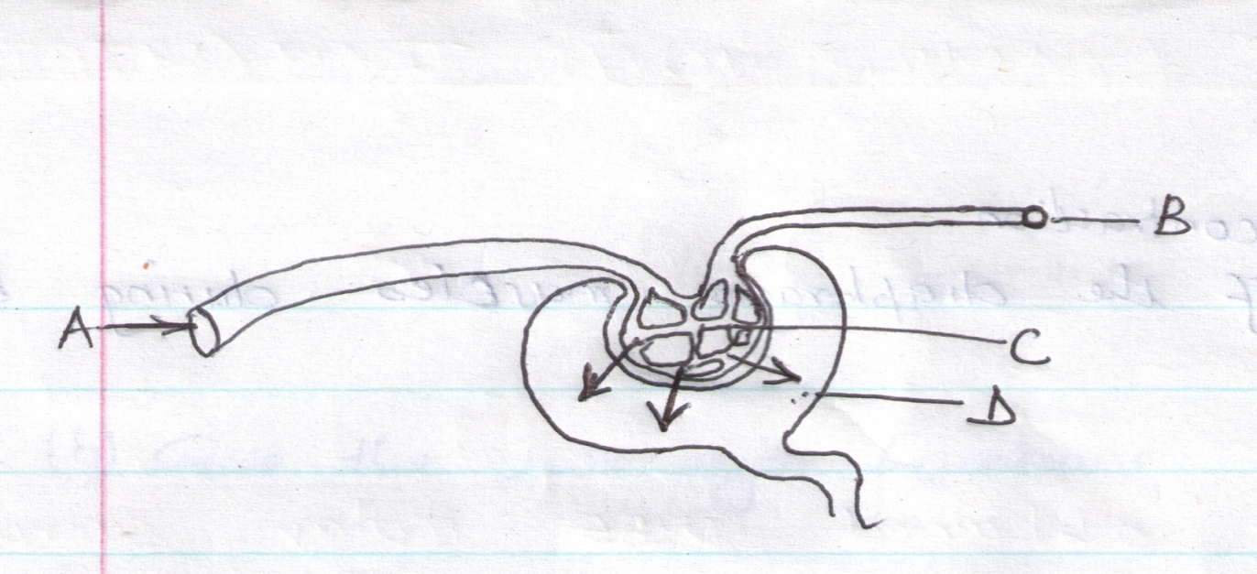

(a) Name the parts labeled A,B,C and D (2mks)
A- B-
C- D-
(b) Name the process by which fluid in D is formed. (1mk)

(c) What is osmoregulation? (2mks)

14 Explain why the rate of transpiration is reduced when the humidity is high. (2mks)

15(a) A millipede,grasshopper and crayfish all belong to phylum arthropoda. State three major characteristics that they have in common. (3mks)

(b) List three characteristics that are used to sub-divide arthropoda into classes. (2mks)

16(a) Give two reasons as to why clotting of blood is important. (2mks)

(b) Why do the people living regularly at higher attitude have more number of red blood cells than people living at sea level? (2mks)

17(a) What is meant by each of the following ecological terms:
(i) Population (1mk)

(ii) community (1mk)

(iii) Ecosystem (1mk)

b) Name the equipment used to measure the following factors in an ecosystem:
i) light penetration in water. (1mk)

ii) Wind velocity (1mk)

iii) Atmospheric pressure (1mk)

18 Name the spore bearing structure in the members of division pteridophyta. (1mk)

