MWAKICAN FORM 3
PAPER 1 - TERM 1 2015
GEOGRAPHY

SECTION A

1. (a) Name the (i) Planet nearest to the sun (1mk)

(ii) Furthest from the sun (1mk)

(b) State three effects of rotation of the earth (3mks)

2 (a) Name two types of compressional boundaries (2mks)

(b) Describe how a fold mountain is formed by geosycline (4mks)

3. (a) Define a river (1mk)

(b) State three ways in which a river erodes (3mks)

4. (a) The table below shows temperature reading at a weather stations for one week

Tem/day | Mon | Tue | Wed | Thur | Fri | sat | Sun
Max (⁰C) | 28 | 27 | 28 | 26 | 29 | 29 | 26
Min (⁰C) | 18 | 18 | 20 | 16 | 22 | 21 | 19

Calculate

- (i) The diurnal range of temperature for Thursday (1mk)

- The mean temperature for Monday (1mk)

- (i) Apart form water vapour name two other substances that are suspended in the atmosphere (2mks)

SECTION B
Answer question 6 and any other two questions

6. Study the Map of Karatina (sheet 121/3) provided and answer the following questions

- (i) Name two human features found on grid square 8257 (2mks)

(ii) Give the magnetic declination of the map as at January 1992 (1mk)
- Give two methods used to represent relief on the Map (2mks)

- Calculate the area enclosed by the district boundary and the Northing 53 to the east of the area covered by the Map: give your answer ion Km² (2mks)

- Name two types of scales shown on the Map (2mks)

- (i) Describe the drainage of the area covered by the Map extract (2mks)

(ii) Giving evidence explain three human activities that take place in the area (6mks)

- Geography students of Ragati Secondary school in grid square 9249 decided to carry out a field study in the area around Karatina Township

- Name two means of transport they are likely to have used to travel to Karatina township (2mks)

- Identify the adjoining sheet and number to South east of Karatina (2mks)

7. (a) (i) Apart from Rift Valley name two other relief features that were formed as a result
of faulting (2mks)

(ii) With aid of a diagram describe how Rift valley was formed through tensional
forces (8mks)

(b) Explain four effects of faulting (8mks)

- Students are planning to carry out field study in area affected by faulting
- State four reasons why its important for the students to have a pre-visit of the area
(4mks)
- State three ways the students would use to collect data (3mks)

8. (a) (i) What is the difference between weathering and mass wasting (2mks)

(ii) Apart form plants give three other factors that influence rate of weathering (3mks)

(b) (i) List two types of slow mass wasting other than soil creep (2mks)

(ii) Explain three factors that causes soil creep (6mks)

(c) Explain four effects of mass wasting on the environment (8mks)

9. (a) (i) What is climate? (2mks)
(ii) Name two instruments found in a Stevenson screen (2mks)

(b) The diagram below shows climatic regions of Kenya
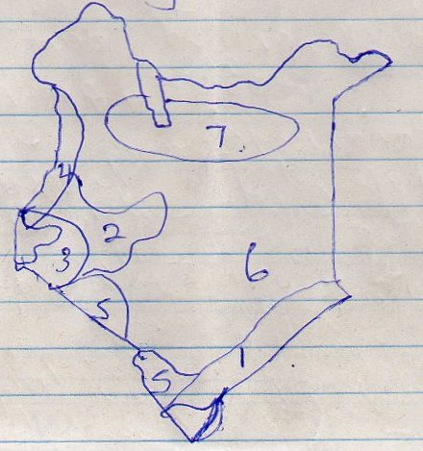

- Name the climatic region marked 1, 2 5 and 7 (4mks)

- Explain four climatic characteristics of the region marked 3 (4mks)

- Describe the characteristics of desert type of climate (4mks)

- Explain three consequences of climate change (3mks)

- Name three countries that experience Tropical Monsoon type of climate outside Africa (3mks)

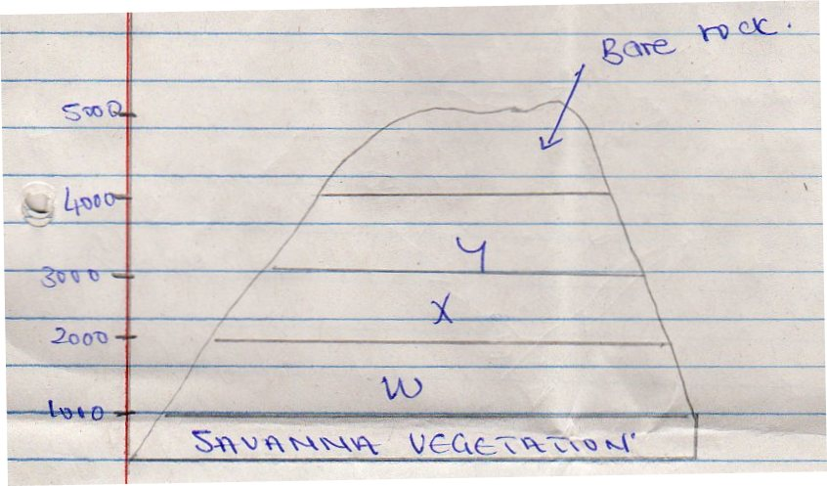
10. The diagram below represents zones of natural vegetation on a mountain in Africa. Use it to answer a(i) and (ii)

- (i) Name the vegetation zones marked (3mks)

X

W

Y

(ii) Describe the characteristics of Savanna vegetation (6mks)

(iii) Name the temperature grasslands found in the following countries
- South Africa (1mk)
- Australia (1mk)
- Argentina (1mk)

- Explain three causes of the decline of the areas under forests (6mks)

- You are supposed to carry out a field study on the uses of vegetation in the area around d your school.

- State three reasons why it would be necessary to visit the area before the day of study (3mks)

- Give four uses of vegetation you are likely to identify during study (3mks)

