PERFECT STEPS PUBLISHERS
0721745374/0721707626
Nairobi

END OF YEAR EXAMS 2015

NAME.................................................................................................CLASS............ ADM.
BIOLOGY EXAMINATION FORM ONE
TIME 2 HOURS.
Instructions to Candidates.
The paper consist of two sections, A and B
Answer all questions in sections A in the spaces provided.
1n section B answer one question only.

1 What is active transport?

2mk
2 a) State the role of salivary amylase during digestion........1mk

b) Name two of the end products of lipid digestion..2mk
3 Which one of the cell organelles would be numerous in;
a) An enzyme secreting cell.....1mk

b) A rapidly respiring cell in comparison to other cells in the same organism? 1mk
4 Name the locomotory structure of most members of Monera kingdom.
................................................................................................................................................1mk
5 The diagram below shows half the lower jaw of a mammal.
Name the kind of teeth labeled
a) A................................................
b) D................................................. 2mk
6 State the branch of biology that would be used in solving the problem of disputed parentagemk
7 (a) Name one enzyme found in living tissues of plants and animals
.1mk
(b) Give the function of the named enzyme above.1mk
8 a) In an electron microscope………………….............is used to illuminate the specimen Under
observation. 1mk
b) Controls the amount of light entering the specimen......................................................... 1mk
c) Magnifies the object..........................................................................................................1mk
d) Used for focusing image under low power .......................................................................1mk
9 Study the diagram below and answer the questions that follow.
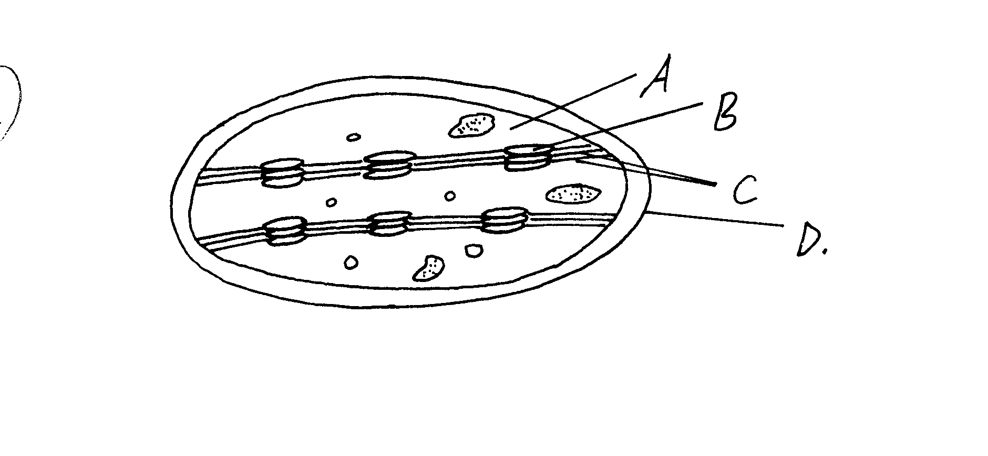
Name the parts labeled:
A.................................................................................................................................

D.............................................................................................................................................2mks

In which of the labeled parts would:
c) Carbon (iv) oxide fixation occur..............................................................................................1mk

d) Light absorption take place.......................................................................................................1mk

10. Examine the following classification of organisms:
Organisms Lion Maize Dog
Kingdom Animalia Plantae Animalia
Species Leo Mays Familiaris
(a) Identify organisms that are not related
Organism.................................................................................................................................
Reasons.......................................................................................................................2mk
(b) Identify organisms which are closely related
Organism............................................................................................................................
Reasons...................................................................................................................2mk
(c) Define the following terms as used in classification.
(i) Species.......................................................................................................................
............................................................................................................................. ....2mk
(ii) Binomial nomenclature..........................................................................................................
..................................................................................................................................2mk
(iii) Describe how a lion teeth are adapted to its mode of feeding. 2mks
11 A student set up the following experiment using a potted plant which had been kept in the dark
for 48hours.
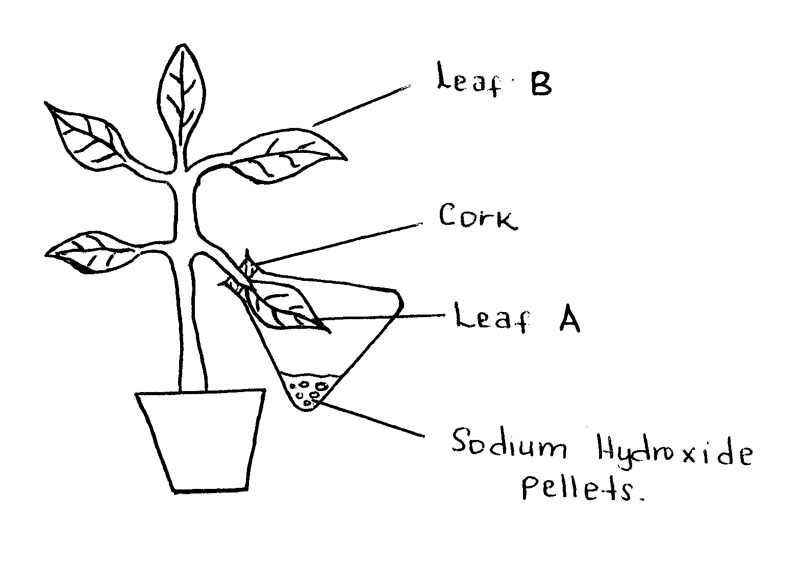

The plant was well watered then leaf A was enclosed in a conical flask containing Sodium Hydroxide pellets as shown in the diagram above. The potted plant was then placed in sunlight for 8 hours. Leaf A and B were then tested for starch.
(a) Why was the potted plant kept in the dark for 48hours before setting up the experiment?
……………………………………………………………………………………………………1mk(b) State the observations made during the test for starch in.
Leaf A……………………………………………………………………………........................1mk
Leaf B………………………………………………………………………….............................1mk (c) Account for the observations made in B above
2mks
(d) State why leaf B was also tested for starch
………………………………………………………………………………………………1mk
(e) What role is played by the following factors in the process of photosynthesis?
(i) Light.
……………………………………………………………………………………………………………………………………………………1mk
(ii) Optimum temperature.
...………………………………………………………………………………....................1mk
12 An experiment was set-up as shown below and left for one hour
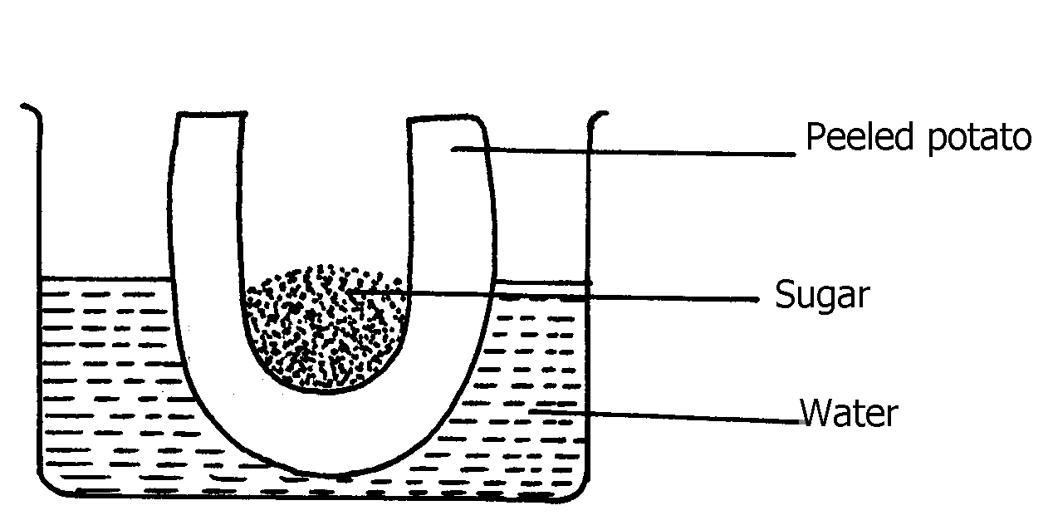

a) State the expected observations at the end of one hour
................................................................................................................................................................................................................................................................................................................................2mks
b) Explain the observations made in this experiment
13 Explain why small mammals such as moles feed more frequently than larger ones such as elephant..........2mks

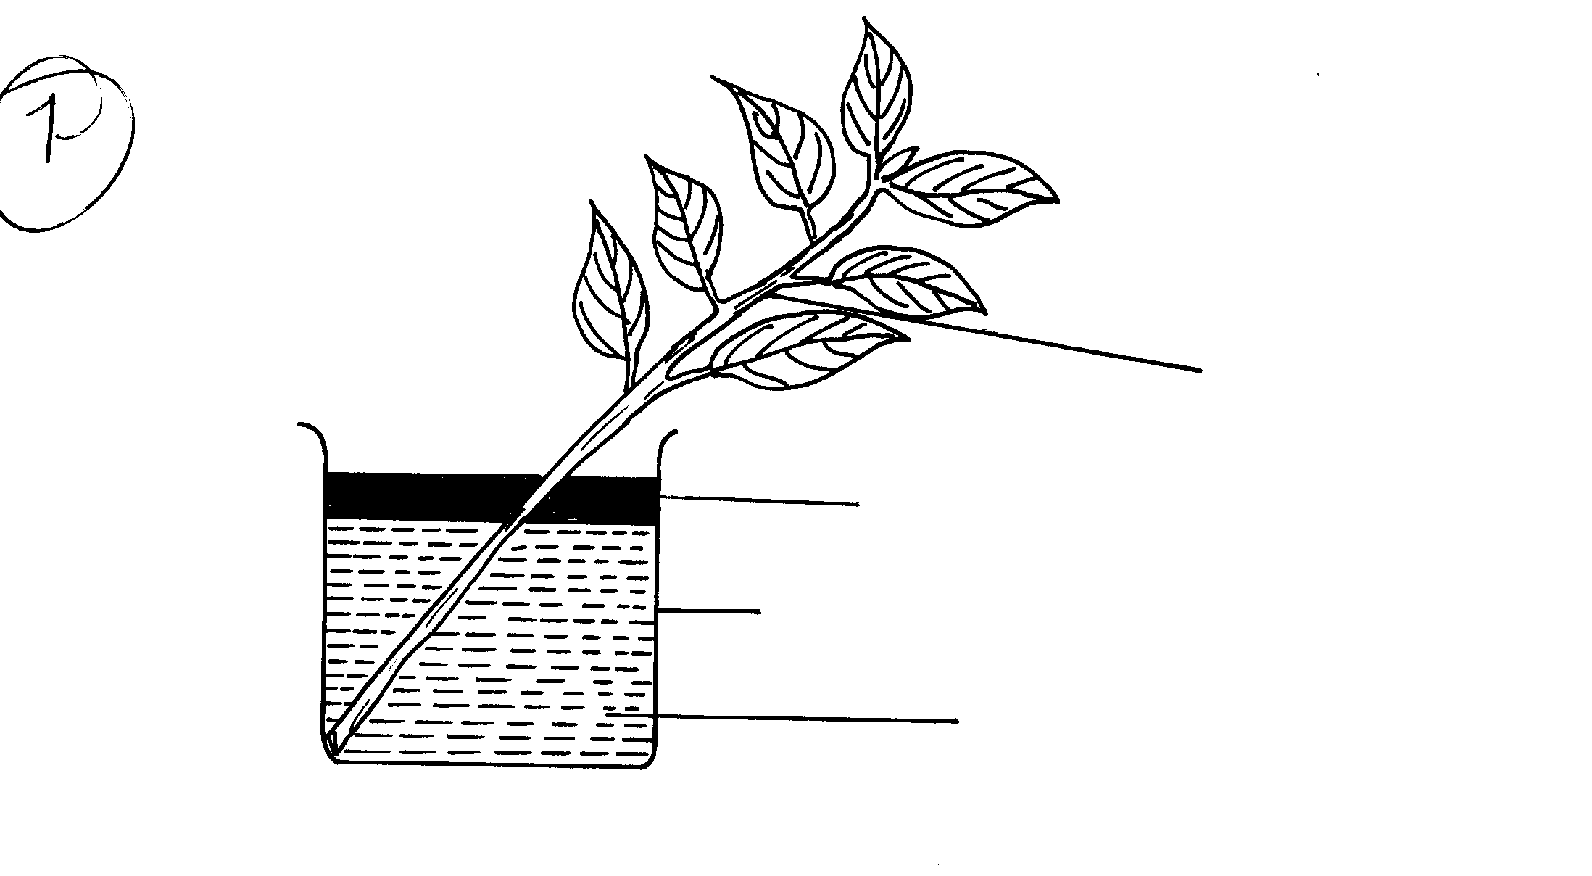14 An experiment shown below was set-up to investigate a certain physiological process in plants:-
Leafy Shoot
Oil
Beaker
Water

a)Which process was being investigated? 1
.............................................................................................................................................1mk
b) State the role of the oil layer in this experiment
........................................................................................................................................................1mk
c) What observation did the students make after leaving the set-up in bright sunlight for
two hours?2mksd)
d) Explain the observation in (c)(i) above
.............4mks
(d) What effect will the following have on the observation made?:-
(a) Fanning the shoot ..2mks
(b) Removing all the leaves from the shoot ( 2mks (iii) Placing the set-up in the dark (2mks (e) State another factor which may affect the experiment. 1mk
15 The diagram below shows the mammalian digestive system. Study it carefully and answer the questions that follow
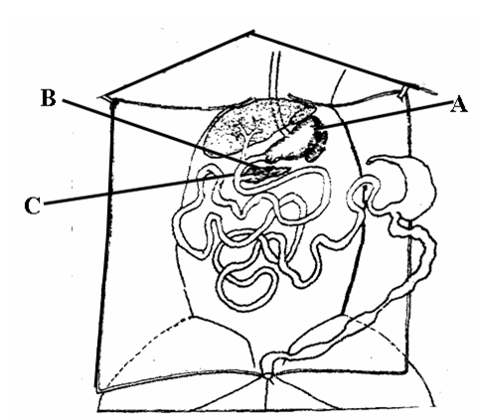
a) Name the parts labeled A and B. A……………………………………………………………………………………
B. …………………………………………………………………………………......(2mks)
b) How is the structure labeled A in the diagram adapted to carry out its function?
(2mks)
c) Name the hormone secreted by the walls of part labeled C(1mks)
iv) Explain the role of the hormone in b (i) above in digestion.(3mks)
SECTION B 30 MARKS ATTEMPT ONE QUESTION ONLY FROM THIS SECTION
15(a) Describe the functions of lipids in the human body (14mk)

(b) Define the term enzyme (1mk)
(c) Describe how a leaf is tested for starch. (10 marks

d) Give the function for the following process when preparing temporary slides.
Sectioning...........................................................................................................................
Fixation...............................................................................................................................
Staining................................................................................................................................ 3mk
e) Name any two types of Polysaccharides found in plants.
2mks
16 (a) Explain how internal and external structures of plant leaves are suited to photosynthesis.
20mks)

- State five features which enable small intestines to carry out their function (10mk)

PRINTED AND COMPILED BY
PERFECT STEPS PUBLISHERS
0721 745374/ 0721 707626 NAIROBI

