MKS f1 bio- x/100
FORM ONE BIOLOGY
1. State the function of the following parts of a light microscope. (2mks)
a) Objective lens
Magnification of object/ image√1
b) Diaphragm
Regulates the amount of light illuminating the object√1.
2. What are the functions of the following cell organelles. (2mks)
a) Ribosomes
Protein synthesis√1
b) Lysosomes
Breakdown worn out cells/organelles.√1
3. a) Distinguish between diffusion and active transport. (2mks)
Diffusion | Active transport
- Molecules move along the concentration gradient/from highly concentrated region to a lowly concentrated region.√1/2  - No energy is required.√1/2  - No carrier molecules required.√1/2 | 1.Molecules move against concentration gradient /from a lowly concentrated region to a highly concentrated region.√1/2  2. Energy is required.√1/2  3. Carrier molecules required.√1/2

b) State one role played by osmosis in:
i) Plants. (1mk)
Absorption of water from the soil.√ 1. Movement of water between cells of the same plant√1.
Opening and closing of stomata√1 Support due to turgidity√1. Feeding in insectivorous plants.√1

ii) Animals. (1mk)
Reabsorption of water by blood capillaries from renal tubules√1.
Absorption of water in the colon from kidney tubules.√1
Movement of water from one cell to another in the alimentary canal.√1
4. Explain how the following factors determine the daily energy requirement in humans.
a) Age (1mk)
Young people are actively growing hence require more energy than older people who are less active√1
b) Occupation. (1mk)
Manual workers require more energy than sedentary workers√1
c) Sex. (1mk)
Males are more muscular hence require more energy than females who are less muscular.√1
5. Below is a diagram of an organelle that is involved in respiration

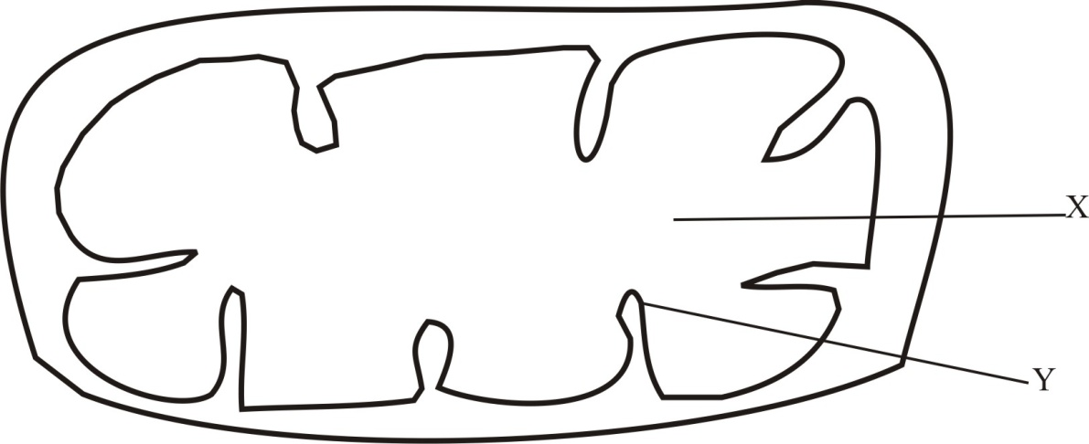

- Name t he organelle -Mitochondrion√1 Rej.Mitochondria. ( 1mk)

- Name the part labeled X Matrix√1 (1 mk)

- What is the purpose of the part labeled Y

To increase surface area for attachment of respiratory enzymes.√1

6. Plant cells do not burst when immersed in distilled water. Explain. (2mks)
They have cellulose cell wall which is rigid √1and does not stretch when the plant gains water.√1
7. State three functions of Golgi apparatus. (3mks)
Production of lysosomes.√1.
Transport of carbohydrates/proteins /glycoproteins/lipids√1.
Modification of carbohydrates and proteins/formation of glycoproteins.√1
Packaging of carbohydrates and proteins/ glycoproteins.√1
Secretion of substances such as hormones, enzymes, polysaccharides.√1 3x1=3mks

8. Name the disease caused by deficiency of
a) Iodine (1mk)
Goiter √1
b) Vitamin B₂ (1mk)
Pellagra√1
9 a). Identify the following apparatus and state its functions.

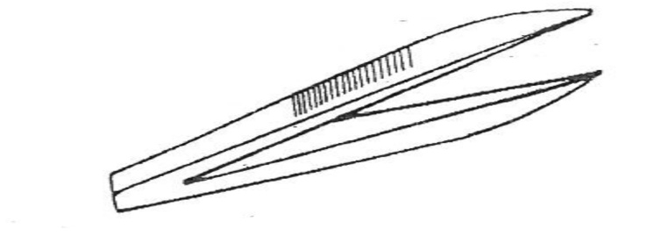
- Name Pair of forceps√1(1mk)

- Function for picking up small crawling animals eg. Stinging insects√1. (1mk)

b) A student measured the length of a mitochondrion on a photomicrograph whose magnification was X 40000 and found it to be 1mm. Calculate the actual size of the mitochondrion. (3 mks)
Magnification= Image size √1 1mm= 1000um
Actual size

4000= 1x1000um √1 = 1/40 =0.015um√1
Actual size

c) An experiment was set up as shown below
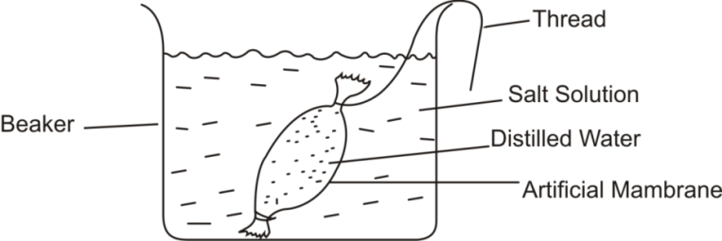

The set up was left for 30 mins.
- What was the aim of the experiment (1mk)
To investigate if osmosis has taken place.√1
- State and explain what would be observed after 30 minutes. (3mks)
The artificial membrane is decreased in size√1 because salt solution is hypertonic√1 and develops osmotic pressure which draws water by osmosis making the membrane flaccid.√1
10. State two adaptations of leaves that maximize efficiency in trapping sunlight for photosynthesis. (2mks)
Broad flat lamina to increase surface area for absorption of light during photosynthesis.√1
Waxy transparent cuticle to allow light to pass through for photosynthesis.√1
Thin leaf to reduce the distance move by light, water and gases during photosynthesis√1
11. Name one organelle found in the actively respiring tissues. (1mk)
Mitochondrion√1
12. a) What is meant by the term symbiosis? (1mk)
An association where two organisms live together and mutually benefit from each other√1
b) i) What are the final products of digestion of fats? (1mk)
Fatty acids √1/2 Glycerol√1/2
ii) Under which conditions will the body use proteins as a source of energy . (1mk)
In the absence of fats and carbohydrates/ during starvation.√1
iii) Name one nutrient that does not require digestion before it is absorbed. (1mk)
Vitamins√1
13. Study the diagram of the mammalian tooth below and answer the questions that follow.
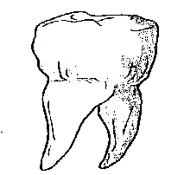

(a) Identify the tooth. (1mk)
Pre-molar√1

(b) Give a reason for your answer in (a) above. (1mk)
Has two roots√1
(c) State one adaptation of the tooth to its function. (1mk)
Have cusps to increase the surface area for grinding/chewing food.√1
Wide to increase surface area for chewing food.√1
14. .(i) Identify the mode of feeding of the animal whose dental formula is shown below.(1mk)
I O C O PM 3 M 3
3 O 3 3
Herbivorous√1 Rej Herbivore
(ii) Give reasons for your answer in 14(i) above (2mks)
Has diastema√1. No canines√1.Has only lower incisors√1

15. a) State two factors that denature enzymes. (2mks)
High temperature√1. Extreme pH levels√1
b) Give two functions of the large intestines in human beings. (2mks)
Absorption of substances.√1
Neutralize acidity of chyme from stomach√1
16. State the role of the following parts of the mammalian intestine.
a) Goblet cells. (1mk)
Secrete mucus to reduce friction by moving food.√1
b) Lacteals in the villi. (1mk)
Transport lipids/fatty acids and glycerol.√1

17. Distinguish between hypertonic and hypotonic solutions. (2mks)
Hypertonic solution | Hypotonic solution
Has high/ more solutes in the solvent√1 | Has lower/ less solutes in the solvent√1

18. A form one student obtained the results below in an experiment
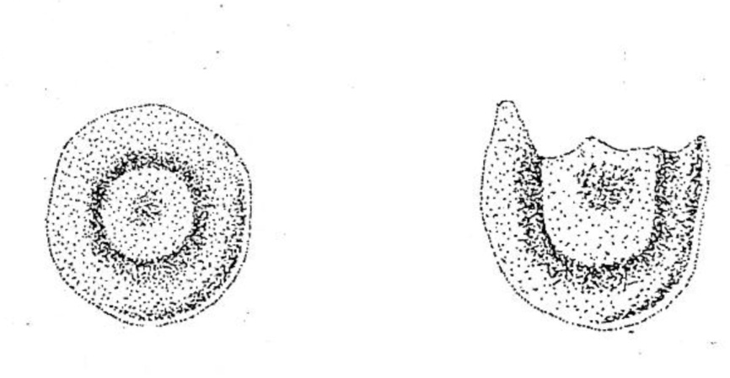
Red blood cell
At start of experiment

Red blood cell
At end of experiment

- Identify the physiological process under investigation. (1mark)

Osmosis√1
- Account for the result obtained (3mks)
Red blood cells were placed in a hypotonic solution√1gained water by osmosis, swelled up√1 and eventually burst its weak cell membrane.√1
19. Below is a diagram of an organelle. (2mks)

- State the function of the organelle drawn above. (1mk)
Contains chloroplast with chlorophyll to trap light for use during photosynthesis √1
- Name the parts of the organelle where :
  - Oxygen gas is produced as a by product. (1mk)
Granum√1
  - Carbon (IV) oxide is utilized. (1mk)
Stroma √1
20. Name the organelle that:
a)Manufacture and transport lipids and steroids in a cell. (1mk)
Smooth endoplasmic reticulum√1

b) Control enzymes that are capable of destroying old damaged cells. (1mk)

Lysosomes√1
c) Control all the processes in a cell (1mk)

Nucleus√1
d) Form cilia and flagella in cells that have them. (1mk)
Centrioles√1

21. State the branch of biology that deals with the study of: (2mks)
i) Insects
Entomology√1
ii) The relationship between organisms and their environment

Ecology√1
22. Name the field of science that specializes in the study of cells. (1mk)
Cytology√1

23. The scientific name for beans is Phosedus vulgaris.
a) What taxon does the term phosedus represent. (1mk)
Genus√1

b) State two rules that are followed when giving a scientific name to an organism. (2mks)
The genus name should begin with capital letter and species name with a small letter√1
Should be printed in italics or when handwritten should be underlined as separate words√1
Should be Latinized i.e made to sound like Latin words.√1

24. Compare the structure of plant and animal cells. (4mks)

Plant cells | Animal cells
- Have cellulose cell wall.√1/2  - Have vacuoles filled with cell-sap √1/2  - Generally have a definite shape√1/2  - Green plants have cells with chloroplasts√1/2 | 1 .Have no cellulose cell wall.√1/2  2.Rarely have vacuoles, if they do, they are temporary and small.√1/2  3.Have no definite shape√1/2  4. Chloroplasts do not occur√1/2  (Answer must tie in both sides.)

25. List seven characteristics that must be shown by all living organisms. (7mks)
Movement/locomotion√1. Respiration√1. Nutrition√1. IrritabilitySensitivity√1. Growth and development√1. Gaseous exchange√1. Excretion√1. Reproduction√1

26. a) The diagram below shows chemical reactions I and II which are controlled by enzymes.
Glucose + Glucose

Reaction II Reaction I
Enzyme B Enzyme A

Maltose + Water

- Into which class of carbohydrates is maltose (1mk)
Disaccharides√1
- Name reaction I and enzyme A (2mks)
Reaction ICondensation√1 Enzyme A Maltase√1

b) The word equation below shows a biological process.
Water Hydrogen atom + oxygen
i) Name the process. (1 mk)
Photolysis√1

ii) Where does the process named in a) above take place? (1 mk)
Granum√1
iii) State two conditions necessary for the process to occur. (2 mks)
Light√1. Chlorophyll molecules√1
27. List the seven major taxonomic units of classification of living things. In ascending order. (7mks)
Kingdom√1
Phylum in animals/Division in plants√1.
Class√1.
Order√1
Family√1
Genus√1
Species√1
28. Classify the following organisms into their kingdoms. (4mks)
Organisms Kingdom
- Maize, Beans Plantae√1
- Mushroom, Yeast Fungi√1
- Protozoa, algae Protoctista.√1
- Bacteria Monera√1.
\

29. . How is support brought about in herbaceous plants? (3 mks)

Plant cells absorb water by osmosis√1become turgid√1 hence strong to support the weak herbaceous plants.√1
END.

