NAME: ------------------------------------------------------------ADM.No:---------------- CLASS: ----------
KAHUHO UHURU HIGH SCHOOL
FORM 2: BIOLOGY
TUNE UP EXAMINATIONS
TERM 3 2016
TIME: 2 HOURS
INSTRUCTIONS: The paper contains three sections A, B, and C.
Answer all questions in all sections on the spaces provided after each.

SECTION A
1. State one main structural adaptation of veins to their function. (1 mk)

2. Name the process that results to formation of tissue fluid. (1 mk)

3. Name the respiratory sites of the following organisms. (2 mk)
a) Insects

b) Amoeba

4. State three differences between osmosis and diffusion. (3 mks)

5. In which form is carbon (IV) oxide transported in mammals. (3mks)

6. State two ways in which a red blood cell differs from other animal cells. (2 mks)

7. State the functions of (3 mks)
a) Bait trap

b) Pooter

8. Name two types of periodontal diseases. (2 mks)

9. List down two differences between polysaccharides and monosaccharides. (2mks)

10. State two beneficial effects of transpirtation to a plant. (2 mks)

11.(a) Define the term immunity. (2 mk)

b) Name two diseases that children are immunized against. (2 mks)

12(a) what is mastication? (1 mk)

b) What is the significance of the above process? (1 mk)

c) Name the enzymes present in pancreatic juice. (3 mks)

13. The Anme ipomeakituyesis belongs to a creeping plant found in Kitui County. Identify.
a) Genus to which the plant belong. (1 mk)

b) The kingdom to which the plant belong. (1 mk)

14. An animal cell whose real diameter is 0.125mm was observed under a light microscrope whose total magnification was x200. Calculate the diameter of the image of the cell observed. (3 mks)

15(a) Why is oxygen important in the process of active transport in cells. (1mk)

b) An experiment was set up as shown below.
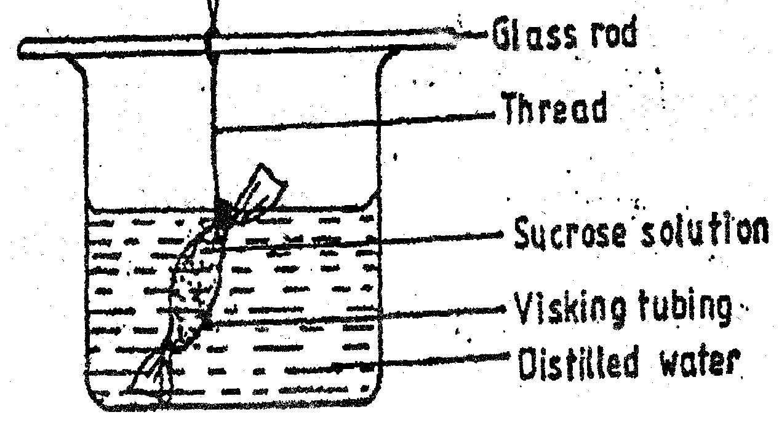
The set up was left for 30 minutes.
i) State the expected results. (2 mks)

ii) Explain your answer in (a) above. (4mks)

SECTION B
16. The diagram below represents part of phloem tissue.
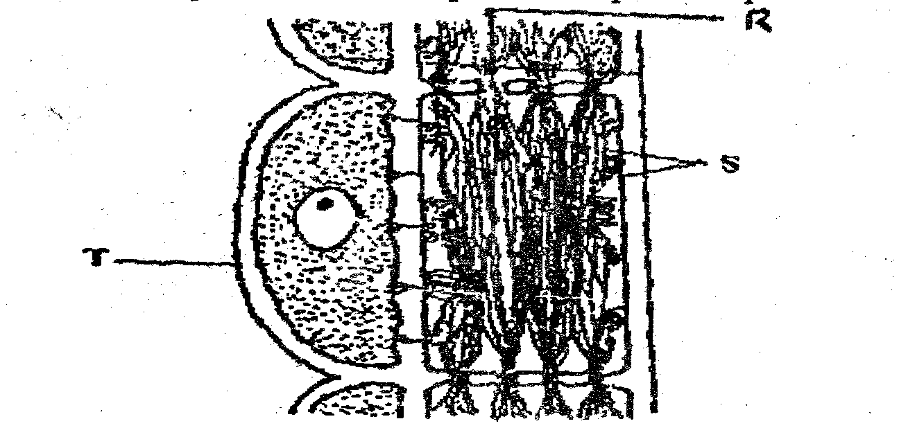
(a) Name the structures labeled R and S and the cell labeled T. (3mks)
R –

S-

Cell labeled T

(b) State the function of the structure labeled S. ( 1 mk)

c) If labeled T is destroyed, the functioning of phloem tissues stops. Explain.
(2 mks)

d) (i) Explain why xylem is a mechanical tissue. ( 1mk)

ii) Name one component of xylem tissue. (1 mk)

17. The diagram below shows gaseous exchange in tissues.
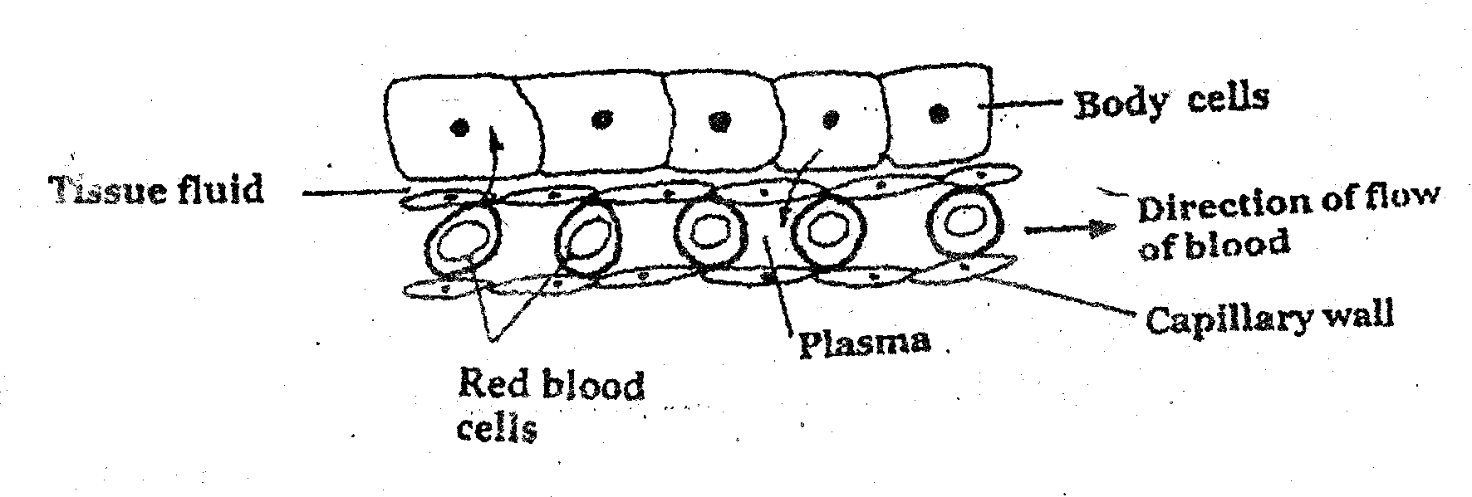

a) Name the gas that diffuses:
(i) To the body cells. (1mk)

ii) From the body cells. (1 mk)

d) Which compound dissociates to release the gas named in (a)
(i) Above? (1 mk)

e) (i) What is tissue fluid? (1 mk)

ii) What is the importance of tissue fluid? (1 mk)
f) Name the blood vessel with the highest concentration of:
i) Glucose (1 mk)

ii) Carbon dioxide (1 mk)

g) Define ultrafiltration (1 mk)

18. The diagram below represents an organ from bony fish, study it and answer the questions that follow.
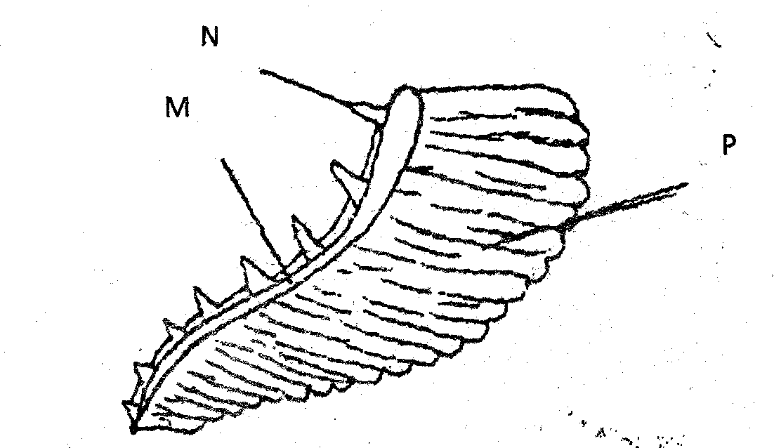
a) Identify it. (1mk)

b) Name each of the parts labeled M and P. (2 mk)

c) State the function of part labeled N. (1 mk)

d) How are the structures labeled P adapted to their functions? (3 mks)

e) Name a structure in a mammal that performs the same function as the structure labeled P. (1 mk)
19. Examine the diagram below carefully and use it to answer the questions that follow.
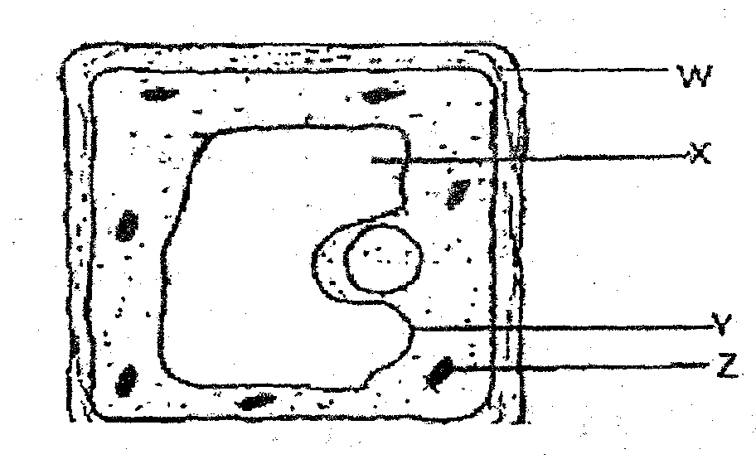
(a) Name the parts X, Y and Z. (3 mks)

b) State the main substance which make up the part labeled W. (1 mk)

c) Name the process through which mineral salts move into the structure labeled X. (1 mk)

d) Explain what happens to a red blood cell when placed in distilled water. (3 mks)

20. The following leaf was detached from a plant that had been exposed to light for some time and tested for presence of starch.
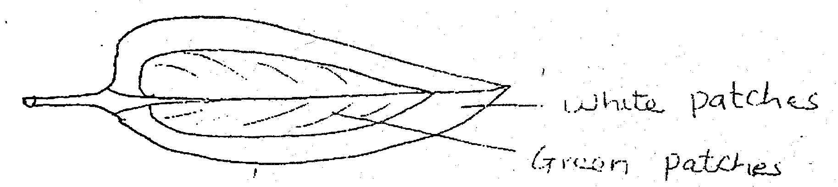
(a) What was the aim of this experiment? (1 mk)

b) (i) State the observation after the starch test. (2 mks)

ii) Explain the observation you have stated in b(i) above. (2 mks)

c)(i) Name the parts of alimentary canal where digestion of starch occur. (2mks)

ii) Name the end product of starch digestion. (1 mk)

SECTION C
21(a) Describe opening and closing of stomata using the photosynthetic theory. (10 mks)
b) Explain the process of inhalation during breathing in humans. (10 mks)

