DARAJANI SECONDARY SCHOOL,
P.O. BOX 20-90129, NGWATA.

MID-TERM 2, 2015_ EXAMINATION
FORM 2
BIOLOGY
TIME: 2HRS

NAME…………………………………………………………………………………………ADM. NO……………….. CLASS:…………….
1. (a) What is meant by the term entomology? (1mk)
(b) Give two reasons why classification is important (2mks)

2. Explain the following terms; (3mks)
a) Binomial nomenclature

b) Taxonomy

c) Classification
3. Name the organelles that perform each of the following functions in a cell. (2mks)
(a)Protein synthesis __________________
(b)Transport cell secretions __________________
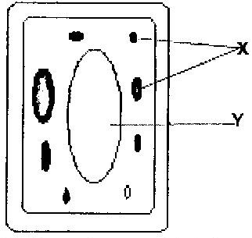
4. The diagram below represents a cell.

a) Name the parts labeled x and y (2mks)
X _______________
Y _______________
b) Suggest why the structures labeled x would be more on one side than the other side. (1mk)

5. (a) What is diffusion? (2mks)

(b) How do the following factors affect the rate of diffusion?
i) Diffusion gradient (1mk)
ii) Surface area to volume ratio (1mk)
iii) Temperature (1mk)
(c) Outline 3 roles of active transport in the human body (2mks)

6. Define the following terms in relation to a cell (3mks)
a) Isotonic solution
b) Hypotonic solution
c) Hypertonic solution
7. State the importance of osmosis in plants (3mks)

8. Explain why
a) Red blood cells burst when placed in distilled water while plant cells remain intact. (2mks)

b) Fresh water protozoa like amoeba do not burst when placed in distilled water. (2mks)
9. Photosynthesis takes place in two stages. Name the part of the chloroplast where
(i) Light stage occurs
(ii) Dark stage occurs (2mks)

b) How is dark stage dependant on the light stage of photosynthesis? (2mks)
10. Name a disease caused by lack of each of the following in human diet;
(i) Vitamin D (2mk)
(ii) Iodine

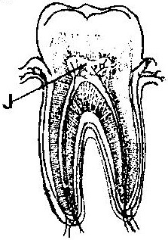
11. The diagram below represents a section through a human tooth.

a) i) Name the type of tooth shown. (1mk)

ii) Give a reason for your answer in (a) (i) above. (1mk)

b) State a factor that denatures enzymes. (1mk)

12. Explain the role of the following organs in the digestion of food in a mammal.
a) Salivary gland

b) Pancrease

c) Liver (3mks)
13. State any three functions of the mucus, which is secreted along the wall of the alimentary canal. (3mks)

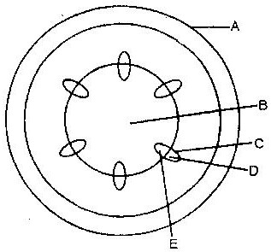
14. The diagram below represents a transverse section of a young stem.

a) Name the parts labeled A and B (2mks)
A___________________
B____________________
b) State the functions of the parts labeled C, D and E (3mks)
C________________
D_______________
E_______________
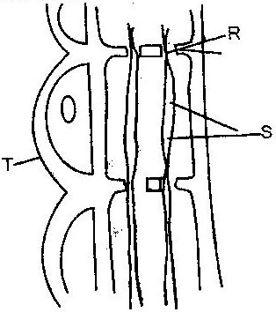
15. The diagram below represents part of phloem tissue

a) Name the structures labeled R and S and a cell labeled T.
R ___________________
S ___________________
Cell T ___________________ (3mks)
b) State the function of the structure labeled S. (1mk)

c) Explain why xylem is a mechanical tissue (2mks)

16. a) i) Name the blood vessels that link arterioles with venules. (1mk)
ii) Explain four ways in which the vessels you named in (a) above are suited to carrying out their functions. (4mks)

b) State two ways in which the composition of blood in the pulmonary arterioles differ from that in the pulmonary venules. (2mks)

17. a) Give an example of a phylum where all members have
i) Open circulatory system

ii) Closed circulatory system (2mks)

18. a) What is the importance of transpiration to plants? (3mks)

19. State two ways in which the root hairs are adapted to their function. (2mks)

20. Explain how birds of prey are adapted to obtaining their food. (2mks)

21. The Biological name of housefly is MUSCA DOMESTICA.
(i) State two mistakes in the way the biological (scientific) name is written. (2mks)

(ii) Write the name in the correct manner following the rules of binomial nomenclature. (1mk)

***************************END*******************************

