19.Define the term species. (1 mark)
......................................................................................................................................................................................................................................................................................................................................................................................................................................................................................
20. State two adaptations of cell membrane to it’s function. (2 marks)
......................................................................................................................................................................................................................................................................................................................................................................................................................................................................................
21.The diagram below represents a cell organelle.

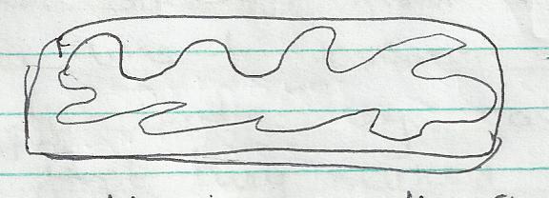

Identify the organelle. (1 mark)

State two ways in which the organelle is adapted to it’s function. (2 marks)
......................................................................................................................................................................................................................................................................................................................................................................................................................................................................................
22. Distinguish between diffusion and osmosis. (2 marks)
......................................................................................................................................................................................................................................................................................................................................................................................................................................................................................
23.State two functions of bile juice in the digestion of food. (2 marks)
......................................................................................................................................................................................................................................................................................................................................................................................................................................................................................
24. .Study the diagram below and answer the question that follow

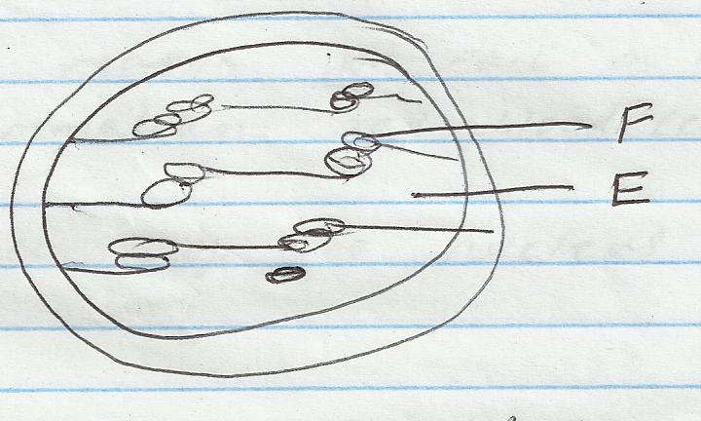

What process takes place in E and F. (2 marks)
E __________________________

F __________________________
25. State the functions of the pulp cavity in a mammalian tooth. (2 marks)
....................................................................................................................................................................................................................................................................................................................................................................................................................................................................................
26. .. Explain how the following factors affect the rate of photosynthesis in green plants
- temperature (1 mark)
…………………………………………………………………………………………………………………………………………………………………………………………………………………………………………………………………………………………………………………………
- size of the leaf (1 mark)
…………………………………………………………………………………………………………………………………………………………………………………………………………………………………………………………………………………………………………………………
- numerous chloroplasts in the mesophyll layer (1 mark)
………………………………………………………………………………………………………………………………………………………………………………………………………………………………………………………………………………………………………………………
27. Distinguish between diffusion and osmosis 2mks…

