MUKINDURI MIXED DAY SECONDARY SCHOOL
MIDTERM EXAM TERM 2 2017
BIOLOGY FORM 2
NAME……………………………………………………..ADM……………

ANSWER ALL THE QUESTIONS IN THE SPACES PROVIDED .

- a) What is diffusion ? (1mk)

b)State three factors that affect the rate of diffusion. (3mks)

- The equation below represents a process that takes place in plants.
6CO₂ + 6H₂O C₆H₁₂O₆
- Name the process (1mk)

- State two conditions necessary for the process to take place. (2mks)

- State what happens to the end-products of the process. (3mks)

- a)The action of ptyalin stops at the stomach . Explain. (2mks)

b) Name a factor that denatures enzymes. (1mk)

c)State two features that increase the surface area of small intestines. (2mks)

- The diagram below represents the lower jaw of a mammal .

a)Name the mode of nutrition of the mammal whose jaw is shown. (1mk)

b)State one structural and one functional differences between the teeth labeled J and L. (2mks)

- i) Name the toothless gap labeled K. (1mk)

ii)State the function of the gap. (1mk)

d)Name the substance that is responsible for hardening of teeth. (1mk)

- a)Name one salivary gland in humans. (1mk)

b)State two functions of saliva. (2mks)

- Give three factors that determine the amount of energy a human being requires in a day. (3mks)

- The diagram below represents a transverse section through a plant organ.

- i) From which plant organ was the section obtained? (1mk)

ii)Give two reasons for your answer in (a)(i) above. (2mks)

- Name the parts labeled J, K and L. (3mks)

- State two functions of part labeled M. (2mks)

- a)State two structural and two environmental factors that affect the rate of transpiration in plants.
Structural (2mks)

Environmental (2mks)

b) Name two types of transpiration. (2mks)

- a)State three structural differences between arteries and veins in mammals. (3mks)

b)Name a disease that causes thickening and hardening of arteries. (1mk)

- a) Name three types of blood cells. (3mks)

b)Other than blood cells, what is the other component of blood. (1mk)

- a) Name the blood vessel that
- carries blood from the aorta to the kidney (1mk)

- contains high concentration of glucose from small intestines to the liver. (1mk)

- starts in capillaries and ends in capillaries. (1mk)

b)State two differences between open and closed circulatory systems. (2mks)

- The diagram below shows a specialized plant cell.
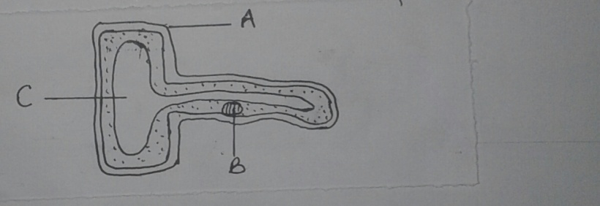

- i)Name the cell (1mk)

ii)Name the parts labeled A,B and C (3mks)

- State the functions of part labeled C (1mk)

- State the function of the following cell organelles.
- Ribosomes (1mk)

- Lysosomes (1mk)

