NAME _______________________________________________AD.NO___________
CLASS_________________________
3KNT FRATERNITY EXAMINATION 2017
231/1
BIOLOGY PAPER 1
TIME :2 HOURS
This paper consists of 80 marks

INSTRUCTIONS: ANSWER ALL QUESTIONS
- Name the apparatus used for the collection of
- Butterfly (1mk)

- Arphidis (1mk)

- Frog (1mk)

2 a) The scientific name of sweet potato was written as ipomes batata. State two errors made above. (2mks)

b) Write the above scientific name correctly. (1mk)

3. State the functions of the following cell organelles (2mks)
i)Golgi bodies

ii) Smooth endoplasmic reticulum

b) Name two structures that are found in plant cells but absent in animal cells. (2mks)

4a) Outline the importance of osmosis in plants (2mks)

b) Distinguish between haemolysis and plasmolysis (2mks)
5. The set up below was used to investigate a biological process
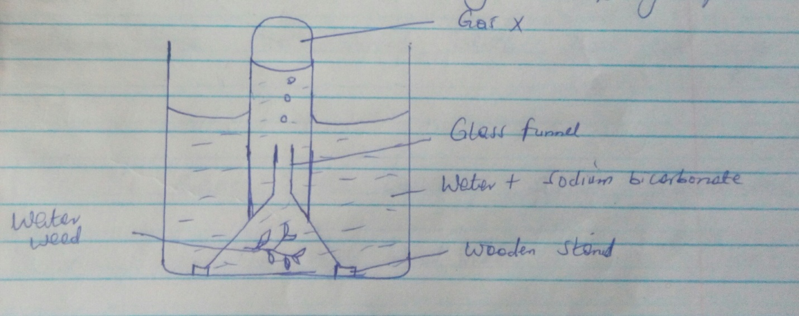

- Suggest the aim of the above experiment (1mk)

- Name the gas represented by X (1mk)

- Write an equation for the reaction that leads to the formation of the gas in (b) above. (2mks)

- State the role of sodium bicarbonate in the experiment (1mk)

6. Give three factors that determine the amount of energy a human being requires in a day (3mks)

7. a) Define the term transpiration . (1mk)

b) Name three sites through which plants lose water (3mks)

8. Name the diseases of the circulatory system characterized by
i) formation of blood clot inside blood vessels (1mk)

ii) Dilated veins and darkened skin colour (1mk)

iii Hardening of the arterial wall (1mk)

9. State three sites of gaseous exchange in mesophyes (3mks)

10. Give three adaptations of gill filament for gaseous exchange (3mks)

11. A process that occurs in plants is represented by the equation below
C₆ H₁₂ O₆ _____________ 2C₂ H₅ OH + 2CO₂ + Energy
Glucose __________Ethanol + carbon (iv)+ energy (1mk)
- Name the process above (1mk)

- State the economic importance of the process in (a) above (3mks)

12. Explain why plants do not require specialized excretory organs (4mks)

13. The diagram below shows the structure of a breed mould.
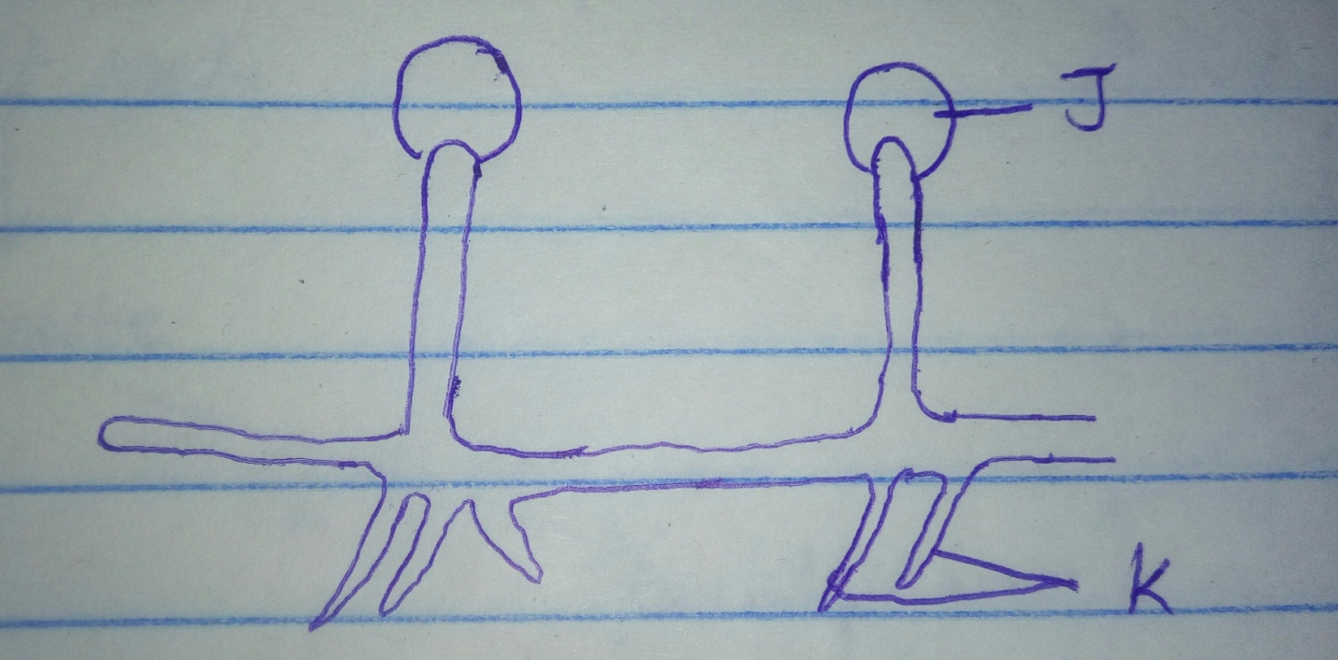

- Name the part labeled J (1mk)

- Name two functions of the part labeled K (2mks)

14 Describe three characteristics of a populations (3mks)

- a) State two advantages of self pollination (2mks)

- Name the parts of a flower that are responsible for the production of gametes. (2mks)

16. The diagram below represents events occurring during reproduction
Adult male Adult female

Gamete Gamete
Fertilization

Zygote

Adult
- From the diagram identity the number representing (2mks)
i)meiosis ________
ii)mitosis _______
- Name the structures where meiosis takes place in animals (1mk)

17. State three factors in seeds that cause dormancy (3mks)

18.Distinguish between complete and incomplete metamorphosis in insects and give an example in each case (4mks)

19. State three structural differences between DNA and RNA (3mks)

20. a) Distinguish between homologous and amologous structure (2mks)

b)State two evidences that support the theory of organic evolution. (2mks)

21. State three biological importance of troprisms in plants. (3mks)

22. The diagram below represent a nerve cell.
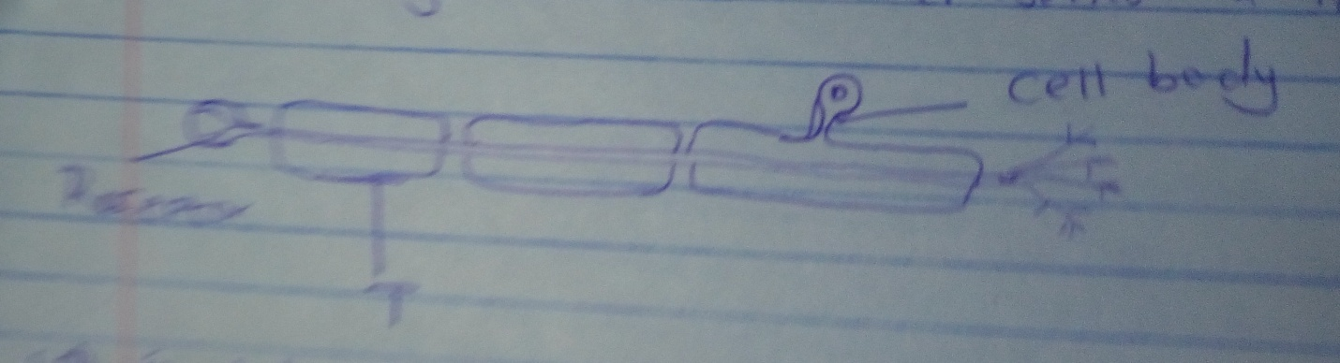

- i) identity the nerve cell (1mk)
ii) Give a reason for your answer in a(i) above . (1mk)

- Name one structure labeled T

- Using a n arrow indicate on the diagram the direction of movement of an impulse in the cell. (1mk)

23. Name two tissues in plants which are thickened with lignin. (2mks)

24. State structural differences between biceps and muscles of the gut. (2mks)

