PATHWAY EVALUATION EXAMINATION - 2016
Biology Paper 1
FORM 4
JULY/AUGUST

MARKING SCHEME

- (a) What is respiration? (1 mark)
Respiration is the process by which energy is liberated from organic compounds such as glucose./ This is the breakdown of food to provide energy.
.b) Name two types of respiration. (2 marks)
- Aerobic Respiration
- Anaerobic. Respiration
2. You have been presented with the bacteria “Vibrio cholerae” to classify.
(a) To which kingdom will you classify it (1 mark)
Kingdom Monera /Prokaryota
(b) State two characteristics of the organisms in kingdom named in (a) above. (2 marks)
- These are very small unicellular organisms.
- They lack a nuclear membrane
- do not have any bound membrane organelles.
3. a)The diagram below shows a certain plant.
- Name the division in the kingdom Plantae to which the plant belongs (1mark)
Pteridophyta rej if P is not in capital

- State the functions of structure labeled K and L. (2marks)
K- for anchorage
L- A produce spores
4. State two differences between animal cell and plant cell. (2 marks)

Plant Cell |  |  |  |  |  | Animal Cell
• | Has a cell wall and a cell membrane. |  |  |  | · | Has cell membrane only.
• | Nucleus at periphery. |  |  |  | • | Nucleus at the center.
• | Have chloroplasts. |  |  |  | • | Have no chloroplasts.
• | Has a large central vacuole. |  |  |  | · | Has no vacuoles, they are small and scattered.
• | Are usually large. |  |  |  | • | Are usually small.
• | Are regular in shape. |  |  |  | · | Irregular in shape.
• | Has no centriole. |  |  |  | · | Has centrioles.
• | Stores starch, oils and protein. |  |  |  | · | Store glycogen and fats.

5. (a) State two properties of monosaccharide. (2 marks)
- They are soluble in water.
- They are crystallisable.
- They are sweet.
- They are all reducing sugars.

(b) Give one example of a monosaccharide. (1 mark)
- Glucose
- Fructose
- Galactose
6. Explain three ways in which ileum is adapted for absorption. (3 marks)

- It is highly coiled to ensure that food moves along slowly to allow time for its digestion and absorption.

- It is long to provide a large surface area for absorption.

- The epithelium has many finger-like projections called villi (singular villus) to greatly increase the surface area for absorption.

- Villi have microvilli that further increase the surface area for absorption.

- The wall of villi has thin epithelial lining to facilitate fast diffusion of products of digestion.

- Has numerous blood vessels for transport of the end products of digestion.

- Has lacteal vessels; for absorption of fatty acids and glycerol and transport of lipids.

7. The procedure below was followed to show that a certain gas is produced when food is burned.
- A little food substance maize flour is placed inside a boiling tube.
- The boiling tube is stoppered using a rubber bung connected to a delivery tube inserted into a test-tube with limewater.
- The food is heated strongly to bum.
- Observations are made on the changes in lime water (calcium hydroxide) as gas is produced.
- What was likely to have been observed in the colour of lime water? (1 mark)

The clear lime water turns white due to formation of calcium carbonate precipitate
- Give your inference for (a) above. (1 mark)
Carbon (Iv) oxide is produced.

8. (a) Name the condition in which there is concentration of urea in the blood of human being.
(1 mark)
Uraemia
b) Give two symptoms of the condition in (a) above. (2 marks)
- colouration of skin
- smell of urine in breath
- nausea
- vomiting.
9. The scientific name of dog is Canis familiaris. Identify: (2 marks)
(a) The specific name.
(b) generic name.
Canis is the generic name
familiaris the specific name
10. Distinguish between parasitism and symbiosis. (2 marks)

Parasitism is an association between members of different species while Symbiosis an association in which organisms of different species derive mutual benefit from one another.

- An investigation was set up as shown in the diagram below.
Glass rod
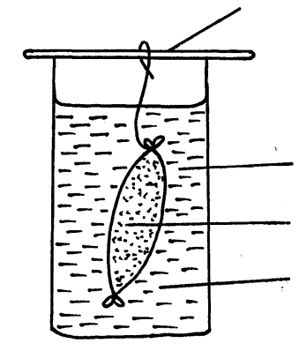

Visking tubing

Starch suspension
Iodine solution

After 30 minutes, starch suspension had turned blue-black while iodine solution retained its colour.
- Name the physiological process that was being investigated in the experiment.
(1 mark)
Diffusion; rj osmosis
- Account for the results observed after 30 minutes. (3 marks)
Visking is semi-permeable; allowing the smaller molecules of iodine to pass across ( to the starch suspension) while the larger starch molecules cannot across ( to the iodine solution);
- Below is a diagram of an organelle that is involved in respiration

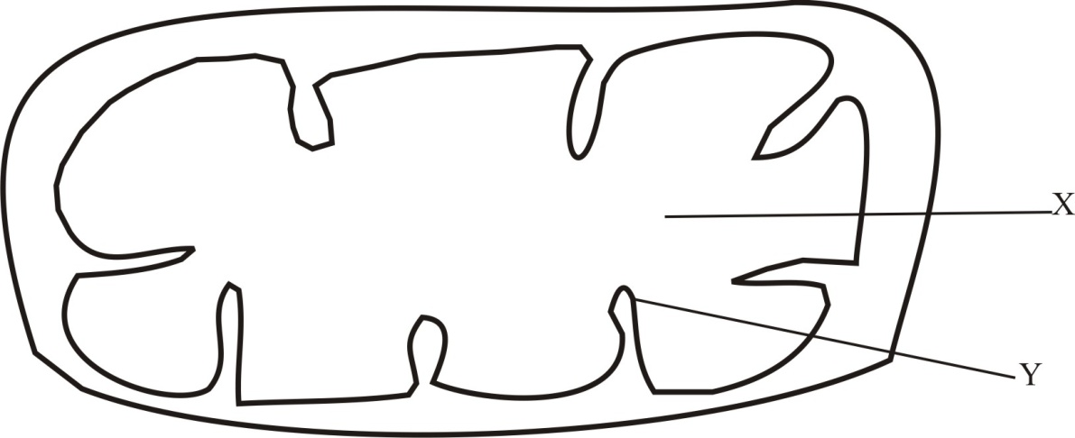

- Name the organelle ( 1mark)
Mitochondrion; rej Mitochondria
- Name the part labeled X. (1 mark)
Matrix
- What is the purpose of the part labeled Y (1 mark)
Increase surface area of attachment of respiratory enzyme;
- (a) What is the meaning of the term interphase ? (1 mark)

State of the nucleus when the cell is just about to divide.

b) State two activities that take place during interphase. (2 marks)
- Replication of genetic material so that daughter cells will have the same number of chromosomes as the parent cell.
- Division of cell organelles such as mitochondria, ribosomes and centrioles.
- Energy for cell division is synthesised and stored in form of Adenosine Triphosphate (ATP) to drive the cell through the entire process.
14. State any three changes that take place in a flower after fertilization. (3 marks)
- The integuments develops into seed coat (testa).
- The zygote develops into an embryo.
- The triploid nucleus develops into an endosperm.
- The ovules become seeds.
- The ovary develops into a fruit.
- The ovary wall develops into pericarp.
- The style, dries up and falls off leaving a scar.
- The corolla, calyx and stamens dry up and fall off.
- In some the calyx persists.

15. The diagram below shows cell division in a mammal. Use it to answer questions that follow.
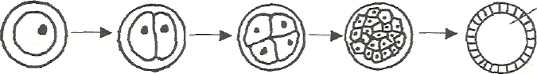
A B C D
(a) Name what each of the following letters represents: (3 marks)
- A – Zygote
- B – Morula
- C – Blastula
b) Name the two layers into which D differentiate. (2 marks)
- Endoderm
- ectoderm

16. Give a reason for each of the following
(a) The trachea of the tracheal system have circular rings of chitin ( 1 mark)
To prevent the trachea from collapsing during contraction and relaxation of the
abdominal muscles.
(b) Tracheoles of the tracheal system lacks rings of chitin (1 mark)
To reduce the distance of diffusing gases.

- a) (i) Name the respiratory surface in insects. (1 mark)
Tracheole
(ii)State two features that adapt the structured named in a(i) above to its function.
(2marks)
- Moist to dissolve diffusing gases;
- Highly branched to increase S.A for diffusion of diffusing gases;
- One – cell thick/thin wall ti shorten distance covered by diffusing gases;

- Why are the fish gills highly vascularized? (2 marks)
Rapid transport of diffusing gases; to maintain a steep diffusion gradient for efficient gaseous exchange;
- (a) What name is given to the units that make up DNA? (1 mark)
Nucleotides
b) List the components of (a) above. (2 marks)
- A five-carbon sugar (deoxyribose).
- Phosphate molecule
- A man who is tall gets married to a woman who is short.
- Using a punnet square show the possible blood groups of their offspring’s if both of them
are heterozygous for their blood groups. (4 marks)

- Determine: (1 mark)

- F1 genotype Tt
- F1 Phenotypic ratio =All tall.

- Study the diagram of the mammalian tooth below and answer the questions that follow.
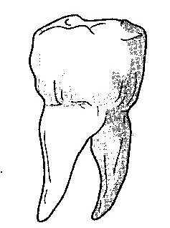

(a) Identify the tooth. (1 mark)
Premolar/molar
(b) Give two reasons for your answer in (a) above. (2 marks)
- Has two roots
- has cusps
- has broad surface;
(c) State one adaptation of the tooth to its function. (1 mark)
- Has cusps to increase surface area for grinding food.
- Has a broad surface to increase surface area for chewing/grinding.
- Has two roots for firm anchorage in the jaw.

- The sentences in the table below are from the part of conversation between Akinyi and Helen. They can be used as analogies of gene mutation.

 | Intended message | Actual message
1. | Who needed a drive? | Who needed a driver?
2. | Yesterday was my shopping day | Yesterday was my hopping day
3 | I like that class. | I like that glass.
4 | What a tap. | What a pat.

For each of these messages identify the type of gene mutation illustrated (4 marks)
1- Insertion
2 – Deletion
3 – Substitution
4 – Invertion
- The diagram below shows a mammalian bone.
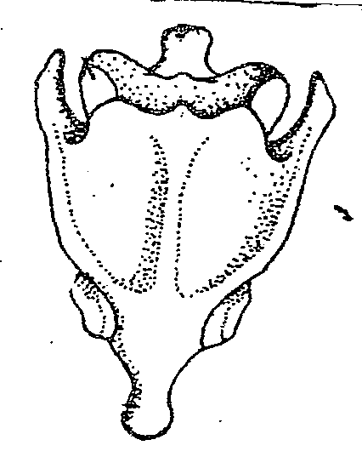

- Identify the bone (1 mark)
………………………………………………………………………………………………………………
- Give a distinctive reasons for your answer in (a) above. (1 mark)
………………………………………………………………………………………………………………
- Name the bone that articulate with the bone drawn above at the proximal end. (1 mark)
…………………………………………………………………………………………………………
- The diagram below shows a simplified nitrogen cycle.
Nitrogen in Atmosphere

Ammonia
Animals

Nitriate
H
K
G
Nitrite

- Name the process represented by (3 marks)
P ………………………………………………………
K ………………………………………………………
H ………………………………………………………
- Name the organisms involved in process J (1 mark)
………………………………………………………………………………………………………
- Name organisms represented by G (1 mark)
………………………………………………………………………………………………………

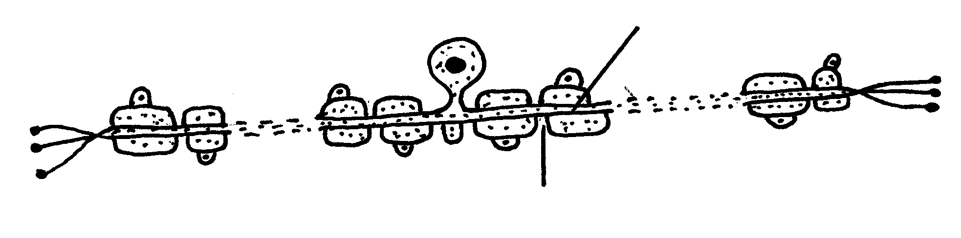
- The diagram below illustrate a neurone.
Axon

Node of ranvier

- Name the neurone drawn above. (1mark)
Sensory neurone
- (i) What is the function of the neurone named in (a) above? (1 mark)
Links the sense organ with the central nervous system
(ii)What is the role of the node of ranvier? (1 mark)
Propagate the nerve impulses/speed up the transmission of anerve impulse
- The concentration of glucose has risen in Manuel’s blood. Explain what is likely to happen. (2 marks)
Insulin is produced which increases oxidation of glucose; facilitate conversion of glucose into glycogen / fats for storage; inhibits conversion of glycogen into glucose;

