NAME………………………………………………………….INDEX NO………………………
SCHOOL…………………………………………………….. DATE……………………………
SIGN…………………………….
231/1
BIOLOGY
PAPER 1
(Theory)
JULY/AUGUST 2016
TIME: 2 HOURS

TOP EVALUATION EXAMINATIONS 2016
Kenya Certificate of Secondary Education

INSTRUCTIONS TO CANDIDATES
- Write your name and index number in the spaces provided above
- Sign and write the date of examination in the spaces provided above
- Answer all questions
- Answers must be written in the spaces provided in the question paper
- Additional pages must not be inserted
- Candidates should check the question paper to ascertain that all the pages are printed as indicated and that not questions are missing
- Candidates should answer the questions in English.

FOR EXAMINER’S USE ONLY
Question | Maximum score | Candidates Score
1-25 | 80

- (a) What is respiration? (1 mark)
………………………………………………………………………………………………………………………………………………………………………………………………………….
b) Name two types of respiration. (2 marks)
………………………………………………………………………………………………………………………………………………………………………………………………………………
2. You have been presented with the bacteria “Vibrio cholerae” to classify.
(a) To which kingdom will you classify it? (1 mark)
……………………………………………………………………………………………………
(b) State two characteristics of the organisms in kingdom named in (a) above. (2 marks)
………………………………………………………………………………………………………………………………………………………………………………………………………………………………………………………………………………………………………………………
3. a)The diagram below shows a certain plant.
- Name the division in the kingdom Plantae to which the plant belongs (1mark)
……………………………………………………………………………………………..
- State the functions of structure labeled K and L. (2marks)
………………………………………………………………………………………………………………………………………………………………………………………………………………………………………………………………………………

4. State two differences between animal cell and plant cell. (2 marks)
………………………………………………………………………………………………………………………………………………………………………………………………………………………………………………………………………………………………………………………………………………………………………………………………………………………………
5. (a) State two properties of monosaccharide. (2 marks)
………………………………………………………………………………………………………………………………………………………………………………………………………………
(b) Give one example of a monosaccharide. (1 mark)
………………………………………………………………………………………………………
6. Explain three ways in which ileum is adapted for absorption. (3 marks)
………………………………………………………………………………………………………………………………………………………………………………………………………………………………………………………………………………………………………………………………………………………………………………………………………………………………………………………………………………………………………………………………………………………………………………………………………………………………………………

7. The procedure below was followed to show that a certain gas is produced when food is burned.
- A little food substance maize flour is placed inside a boiling tube.
- The boiling tube is stoppered using a rubber bung connected to a delivery tube inserted into a test-tube with limewater.
- The food is heated strongly to bum.
- Observations are made on the changes in lime water (calcium hydroxide) as gas is produced.
- What was likely to have been observed in the colour of lime water? (1 mark)
……………………………………………………………………………………………………………………………………………………………………………………………………
- Give your inference for (a) above. (1 mark)
…………………………………………………………………………………………………………………………………………………………………………………………………..
8. (a) Name the condition in which there is concentration of urea in the blood of human being.
(1 mark)
……………………………………………………………………………………………………..
b) Give two symptoms of the condition in (a) above. (2 marks)
……………………………………………………………………………………………………………………………………………………………………………………………………
9. The scientific name of dog is Canis familiaris. Identify: (2 marks)
(a) The specific name.
………………………………………………………………………………………………..
(b)generic name.
………………………………………………………………………………………………..
10. Distinguish between parasitism and symbiosis. (2 marks)
………………………………………………………………………………………………………………………………………………………………………………………………………………………………………………………………………………………………………………………

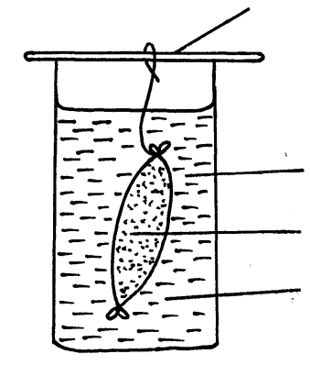
- An investigation was set up as shown in the diagram below.
Glass rod

Visking tubing
Starch suspension

Iodine solution

After 30 minutes, starch suspension had turned blue-black while iodine solution retained its colour.
- Name the physiological process that was being investigated in the experiment. (1 mark)
……………………………………………………………………………………………..
- Account for the results observed after 30 minutes. (3 marks)
………………………………………………………………………………………………………………………………………………………………………………………………………………………………………………………………………………………………
- Below is a diagram of an organelle that is involved in respiration

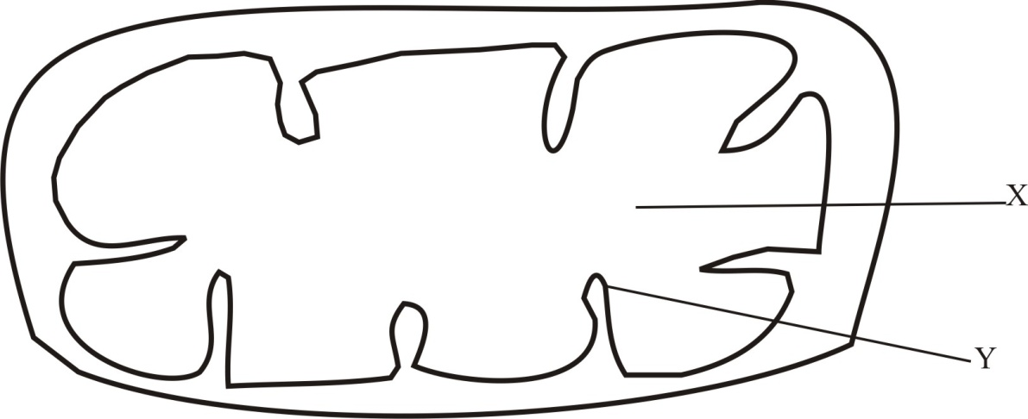
- Name the organelle ( 1mark)
…………………………………………………………………………………….
- Name the part labeled X. (1 mark)
……………………………………………………………………………………..
- What is the purpose of the part labeled Y (1 mark)
……………………………………………………………………………………….
- (a) What is the meaning of the term interphase ? (1 mark)

……………………………………………………………………………………………………………………………………………………………………………………………………

b) State two activities that take place during interphase. (2 marks)

………………………………………………………………………………………………………………………………………………………………………………………………………………………………………………………………………………………………………………
14. State any three changes that take place in a flower after fertilization. (3 marks)
……………………………………………………………………………………………………………………………………………………………………………………………………………………………………………………………………………………………………………………..
15. The diagram below shows cell division in a mammal. Use it to answer questions that follow.
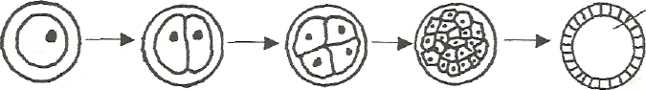
A B C D
(a) Name what each of the following letters represents: (3 marks)
- A – ………………………………………………………………………………………
- B – ………………………………………………………………………………………
- C – ……………………………………………………………………………………….
b) Name the two layers into which D differentiate. (2 marks)
…………………………………………………………………………………………………………………………………………………………………………………………………………………………………………………………………………………………………………………..
16. Give a reason for each of the following
(a) The trachea of the tracheal system have circular rings of chitin ( 1 mark) …………………………………………………………………………………………………………………………………………………………………………………………………………………………………………………………………
(b) Tracheoles of the tracheal system lacks rings of chitin (1 mark)
………………………………………………………………………………………………………………………………………………………………………………………………………………
- a) (i) Name the respiratory surface in insects. (1 mark)
…………………………………………………………………………………………………..
(ii)State two features that adapt the structured named in a(i) above to its function.
(2marks)
……………………………………………………………………………………………………………………………………………………………………………………………………………………………………………………………………………………………………………………..
- Why are the fish gills highly vascularized? (2 marks)
………………………………………………………………………………………………………………………………………………………………………………………………………………
- (a) What name is given to the units that make up DNA? (1 mark)
…………………………………………………………………………………………………………...
b) List the components of (a) above. (2 marks)
………………………………………………………………………………………………………………………………………………………………………………………………………………………………………………………………………………………………………………………………

- A man who is tall gets married to a woman who is short.
- Using a punnet square show the possible blood groups of their offspring’s if both of them
are heterozygous for their blood groups. (4 marks)

- Determine: (1 mark)

- F1 genotype ………………………………………………………………………
- F1 Phenotypic ratio ……………………………………………………………..

- Study the diagram of the mammalian tooth below and answer the questions that follow.
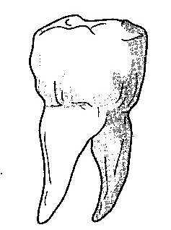

(a) Identify the tooth. (1 mark)
…………………………………………………………………………………………………….

(b) Give two reasons for your answer in (a) above. (2 marks)
………………………………………………………………………………………………………………………………………………………………………………………………………………
(c) State one adaptation of the tooth to its function. (1 mark)
………………………………………………………………………………………………………………………………………………………………………………………………………………
- The sentences in the table below are from the part of conversation between Akinyi and Helen. They can be used as analogies of gene mutation.

 | Intended message | Actual message
1. | Who needed a drive? | Who needed a driver?
2. | Yesterday was my shopping day | Yesterday was my hopping day
3 | I like that class. | I like that glass.
4 | What a tap. | What a pat.

For each of these messages identify the type of gene mutation illustrated (4 marks)
1……………………………………………………………………………………………
2……………………………………………………………………………………………
3……………………………………………………………………………………………
4……………………………………………………………………………………………
- The diagram below shows a mammalian bone.
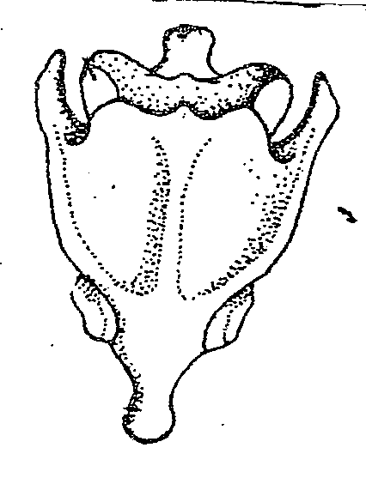

- Identify the bone (1 mark)
………………………………………………………………………………………………………………
- Give a distinctive reasons for your answer in (a) above. (1 mark)
………………………………………………………………………………………………………………
- Name the bone that articulate with the bone drawn above at the proximal end. (1 mark)
…………………………………………………………………………………………………………
- The diagram below shows a simplified nitrogen cycle.
Nitrogen in Atmosphere

Ammonia
Animals

Nitriate
H
K
G
Nitrite

- Name the process represented by (3 marks)
P ………………………………………………………
K ………………………………………………………
H ………………………………………………………
- Name the organisms involved in process J (1 mark)
………………………………………………………………………………………………………
- Name organisms represented by G (1 mark)
……………………………………………………………………………………………………

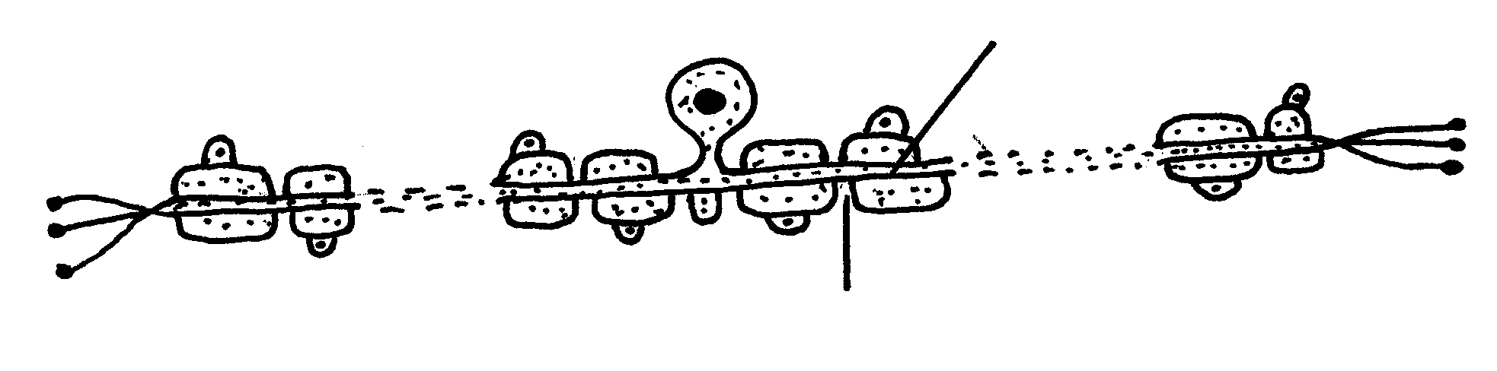
- The diagram below illustrate a neurone.
Axon

Node of ranvier

- Name the neurone drawn above. (1mark)
……………………………………………………………………………………….
- (i) What is the function of the neurone named in (a) above? (1 mark)
…………………………………………………………………………………………………………………………………………………………………………………….
(ii)What is the role of the node of ranvier? (1 mark)
……………………………………………………………………………………………………………………………………………………………………………………………..
- The concentration of glucose has risen in Manuel’s blood. Explain what is likely to happen. (2 marks)
……………………………………………………………………………………………………………………………………………………………………………………………………………………………………………………………………………………………………………………………….

