**Name………………………………………………………Index No……………………………………..….……...**

**Candidate’s Signature…………………………………………...**

**Date…………………..…………………………..**

**231/2**

**BIOLOGY**

**PAPER 2**

**(THEORY)**

**JULY/AUGUST 2014**

**TIME: 2 HOURS**

***Kenya Certificate of Secondary Education (K.C.S.E.)***

**231/2**

**Biology**

**Paper 2**

**2 hours**

**INSTRUCTIONS TO CANDIDATES**

* Write your **name**, **index number** and **school** in the spaces provided
* Sign and write the date the examination was done in the spaces provided
* This paper consists of two sections, section A and section B. Answer **ALL** the questions in section A in the spaces provided on the question paper. In section B, answer question 6 **(compulsory)** and **either** question 7 **or** 8 in the spaces provided after question 8
* Be brief and precise. Unnecessary information and wrong spellings especially of technical terms shall be penalized
* All answers **must** be written in the **English** language

**FOR EXAMINER’S USE ONLY**

|  |  |  |  |
| --- | --- | --- | --- |
| **QUESTION NUMBER** | **QUESTION** | **MAXIMUM SCORE** | **CANDIDATE’S SCORE** |
| **SECTION A** | 1 | 08 |  |
| 2 | 08 |  |
| 3 | 08 |  |
| 4 | 08 |  |
| 5 | 08 |  |
| **SECTION B** | 6 | 20 |  |
| 7 | 20 |  |
| 8 | 20 |  |
| TOTALSCORE |  | **80** |  |

*This paper consists of* ***8*** *printed pages. Candidates are advised to check the question paper carefully to ensure that all the pages are printed as indicated and no questions are missing*

**SECTION A (40 MARKS)**

*Answer* ***ALL*** *the questions in this section in the spaces provided on the question paper.*

1. Study the diagram below and answer the questions that follow.

Parental Phenotype: Red Flowers X white flowers

F1 generation All Pink

1. State the type of dominance displayed in the above cross. (1mk)

…………………………………………………………………………………………………………….

…………………………………………………………………………………………………………….

1. Using letter R to represent the gene for reed colour and W for white colour, state the parental

genotypes. (2mks)

…………………………………………………………………………………………………………….

…………………………………………………………………………………………………………….

…………………………………………………………………………………………………………….

1. If the F1 was selfed, work out the phenotypic ratio of F2 generation. (3mks)

…………………………………………………………………………………………………………….

…………………………………………………………………………………………………………….

…………………………………………………………………………………………………………….

…………………………………………………………………………………………………………….

…………………………………………………………………………………………………………….

…………………………………………………………………………………………………………….

…………………………………………………………………………………………………………….

…………………………………………………………………………………………………………….

…………………………………………………………………………………………………………….

1. 480 red flowered, plants were obtained in the second filial generation when F1 was selfed.

How many F2 plants were pink? Show your working. (2mks)

…………………………………………………………………………………………………………….

…………………………………………………………………………………………………………….

…………………………………………………………………………………………………………….

…………………………………………………………………………………………………………….

…………………………………………………………………………………………………………….

…………………………………………………………………………………………………………….

1. The diagram below shows the movement of water, from the soil up the plant. Study it and answer the questions that follow.

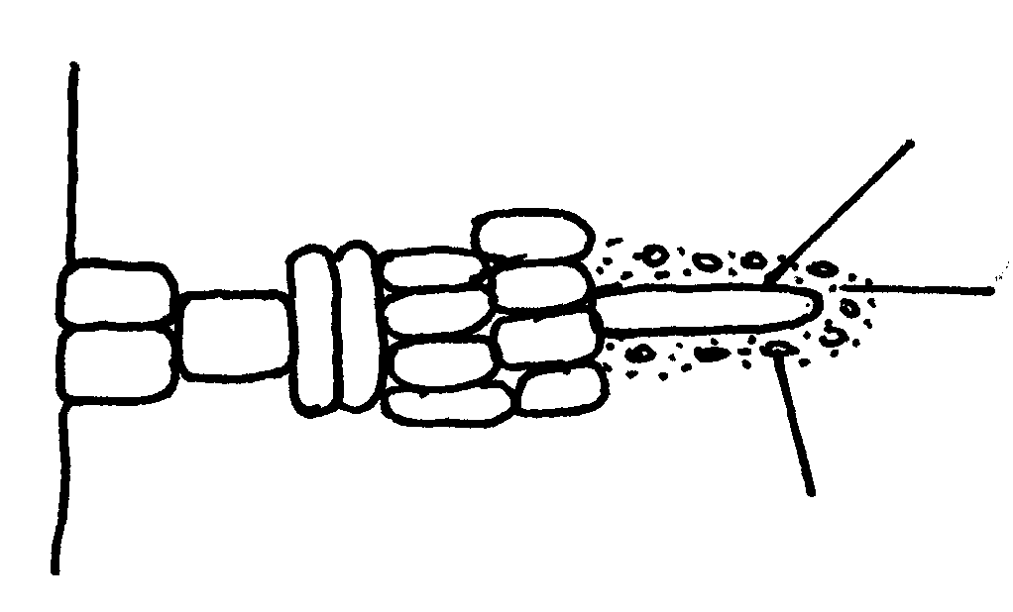

**Roothair**

**Film of water around soil particles**

**Soilparticles**

1. (i) Name the structure labeled **L**  (1mk)

**L** …………………………………………

(ii)State the adaptations of structure L to its functions. (2mks)

…………………………………………………………………………………………………………….

…………………………………………………………………………………………………………….

1. Describe the movement of water from the soil to the structure labeled **L** (3mks)

…………………………………………………………………………………………………………….

…………………………………………………………………………………………………………….

…………………………………………………………………………………………………………….

1. Apart from capillarity, name **one** other force that ensures upward movement of water in the plant

through structure **L**. (1mk)

…………………………………………………………………………………………………………….

…………………………………………………………………………………………………………….

1. The graph below shows the effect of substrate concentration on the rate of enzyme reaction.

**Rate of reaction**

**B C**

**A**

**Substrate concentration**

1. Account for the shape of the graph between

(i) **A** and **B** (3mks)

…………………………………………………………………………………………………………….

…………………………………………………………………………………………………………….

…………………………………………………………………………………………………………….

…………………………………………………………………………………………………………….

(ii) **B** and **C**  (2mks)

…………………………………………………………………………………………………………….

…………………………………………………………………………………………………………….

…………………………………………………………………………………………………………….

…………………………………………………………………………………………………………….

1. How can the rate of reaction be increased after point **B**? (1mk)

…………………………………………………………………………………………………………….

…………………………………………………………………………………………………………….

1. State **two** other factors that affect the rate of enzyme reaction. (2mks)

…………………………………………………………………………………………………………….

…………………………………………………………………………………………………………….

1. The diagram below represents the nitrogen cycle

**Nitrogen in the air**

**Lightning**

**C**

**A**

**D**

**Nitrates**

**Nitrogen in plants**

**Feeding**

**Animals**

**Death and decay**

**B**

**Death and decay**

**Ammonia**

**Nitrifying bacteria**

(a) State the process labeled

**A**…………………………………………….. (1mk)

**D**…………………………………………….. (1mk)

(b) Name the compound represented by **B** (1mk)

…………………………………………………………………………………………………………….

…………………………………………………………………………………………………………….

(c) Name the group of organismslabelled **C**  (1mk)

…………………………………………………………………………………………………………….

…………………………………………………………………………………………………………….

(d) (i)Name the group of plants which promote process **A** (1mk)

…………………………………………………………………………………………………………….

…………………………………………………………………………………………………………….

(ii) State the part of the plant where process **A** takes place. (1mk)

…………………………………………………………………………………………………………….

…………………………………………………………………………………………………………….

(e)How would excess pesticides in the soil interfere with process **A** (2mks)

…………………………………………………………………………………………………………….

…………………………………………………………………………………………………………….

1. The diagram below represents growing seedlings which were subjected to unilateral direction of light at the

beginning of the experiment. They were treated at as follows.

**A** – tip of seedling was cut off

**B**- tip was covered with aluminum foil cap

**C**- tip was left intact.

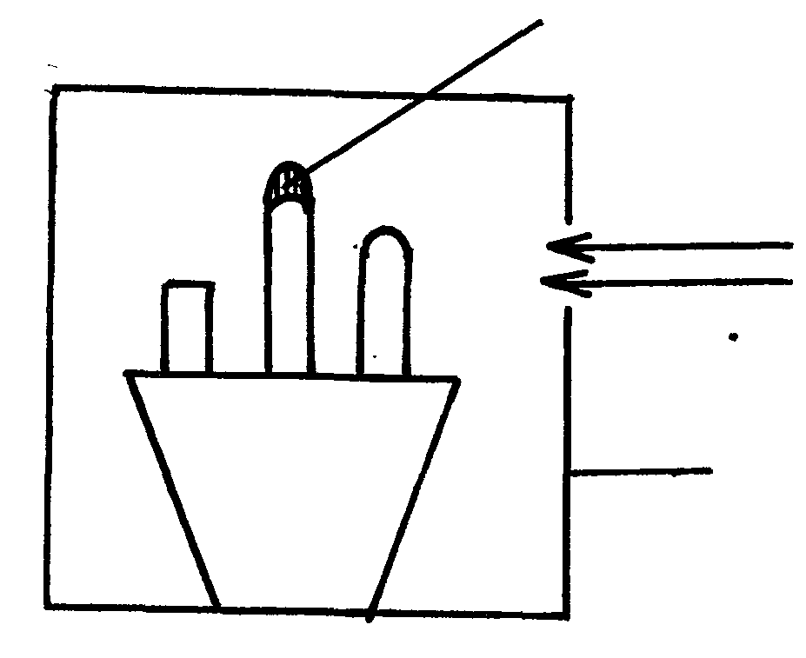

**Aluminium foil cap**

**Light**

**Box painted black inside**

(a) (i) state the observations that would be made in the seedlings **A,B,** and **C** after five days. (3mks)

**A**…………………………………………………

**B**…………………………………………………

**C**…………………………………………………

(ii) Account for the observation made in seedling **C** in a(i) above. (3mks)

…………………………………………………………………………………………………………….

…………………………………………………………………………………………………………….

…………………………………………………………………………………………………………….

(b) If the tin foil were removed from the seedling B, What results would be observed after 3 days? (1mk)

…………………………………………………………………………………………………………….

…………………………………………………………………………………………………………….

(c) State the expected results after 3 days if the box was removed. (1mk)

…………………………………………………………………………………………………………….

…………………………………………………………………………………………………………….

**SECTION B**

***Answer question 6 compulsory in the paces provided. Answer either question 7 or 8 in the spaces provided after question 8.***

1. In an experiment to investigate certain processes in a given species, the rates of carbon (iv) Oxide released and intake were measured over a long period of time. The results of the investigation were shown below.

|  |  |  |  |  |  |  |  |  |  |  |
| --- | --- | --- | --- | --- | --- | --- | --- | --- | --- | --- |
| **Time of day(hours)** | **6** | **8** | **10** | **1** | **14** | **16** | **18** | **20** | **22** | **24** |
| **Carbon (iv) consumed (mm3/min)** | **10** | **43** | **69** | **91** | **91** | **50** | **18** | **0** | **0** | **0** |
| **Carbon (iv) released ( mm3/min)** | **38** | **22** | **10** | **3** | **3** | **16** | **31** | **48** | **48** | **48** |

On the graph provided, draw graphs of volume of carbon(iv) oxide consumed and released against

time on the same axes. (7mks)



1. Name the chemical process changes represented by.
2. Carbon (iv) oxide consumed. (1mk)

…………………………………………………………………………………………………………….

1. Carbon (iv) oxide released (1mk)

…………………………………………………………………………………………………………….

1. Account for the shape of the curve for
2. Carbon (iv) oxide consumed (3mks)

……………………………………………………………………………………………………………

………………………………………………………………………………………………………….

………………………………………………………………………………………………………….

1. Carbon (iv) oxide released. (3mks)

……………………………………………………………………………………………………………

……………………………………………………………………………………………………………

………………………………………………………………………………………………………….

1. What compensation point? (1mk)

……………………………………………………………………………………………………………

……………………………………………………………………………………………………………

1. From the graph find the time of day when the plants attained the compensation point. (2mks)

……………………………………………………………………………………………………………

……………………………………………………………………………………………………………

1. Explain how temperature affects the rate of carbon (iv) oxide consumption in plants. (2mks)

……………………………………………………………………………………………………………

……………………………………………………………………………………………………………

1. (a) Describe the process of fertilization in a flowering plant. (15mks)

(b) State the changes that take place in a flower after fertilization.

8. (a) Discuss eye accommodation. (10mks)

(b) Discuss the process of hearing in man. (10mks)

……………………………………………………………………………………………………………

……………………………………………………………………………………………………………

……………………………………………………………………………………………………………

……………………………………………………………………………………………………………

……………………………………………………………………………………………………………

……………………………………………………………………………………………………………

……………………………………………………………………………………………………………

……………………………………………………………………………………………………………

……………………………………………………………………………………………………………

……………………………………………………………………………………………………………

……………………………………………………………………………………………………………

……………………………………………………………………………………………………………

……………………………………………………………………………………………………………

……………………………………………………………………………………………………………

……………………………………………………………………………………………………………

……………………………………………………………………………………………………………

……………………………………………………………………………………………………………

……………………………………………………………………………………………………………

……………………………………………………………………………………………………………

……………………………………………………………………………………………………………

……………………………………………………………………………………………………………

……………………………………………………………………………………………………………

……………………………………………………………………………………………………………

……………………………………………………………………………………………………………

……………………………………………………………………………………………………………

……………………………………………………………………………………………………………

……………………………………………………………………………………………………………

……………………………………………………………………………………………………………

……………………………………………………………………………………………………………

……………………………………………………………………………………………………………

……………………………………………………………………………………………………………

……………………………………………………………………………………………………………

……………………………………………………………………………………………………………

……………………………………………………………………………………………………………

……………………………………………………………………………………………………………

……………………………………………………………………………………………………………

……………………………………………………………………………………………………………

……………………………………………………………………………………………………………

……………………………………………………………………………………………………………

……………………………………………………………………………………………………………

……………………………………………………………………………………………………………

……………………………………………………………………………………………………………

……………………………………………………………………………………………………………

……………………………………………………………………………………………………………

……………………………………………………………………………………………………………

……………………………………………………………………………………………………………

……………………………………………………………………………………………………………

……………………………………………………………………………………………………………

……………………………………………………………………………………………………………

……………………………………………………………………………………………………………

……………………………………………………………………………………………………………

……………………………………………………………………………………………………………

……………………………………………………………………………………………………………

……………………………………………………………………………………………………………

……………………………………………………………………………………………………………

……………………………………………………………………………………………………………

……………………………………………………………………………………………………………

……………………………………………………………………………………………………………