MWAKICAN JOINT EXAMINATION TEAM
(M.J.E.T)

NAME:__________________________________ADM NO:_________ CLASS: __________

BIOLOGY
FORM TWO
END OF TERM ONE 2019 EXAM
TIME : 2 HOURS

INSTRUCTIONS
- Write your name and admission number in the spaces provided above.
- Answer all the questions in this paper in the spaces provided.

Foe examiner’s use only
Question  1-29 | Maximum score  100 | Students score

1 State three factors that affect the rate of diffusion. (3mks)

.
2(a) Name the organelle that encloses the cell contents (1mk)

b) In what ways are the properties of the organelle you have named in 2(a) above affected by on high temperatures? (2mks)

3 Study the diagram below and answer the questions that follow
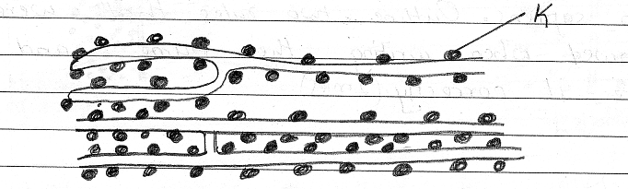

(a) Identify the organelle above and state its function in a cell. (2mks)

(b) Name the structure labeled K and also states function. (2mks)

4(a) Name the branch of Biology that deals with the development of techniques for application of biological processes in medicine and industries. (1mk)

b) Give the functions of the following apparatus.
(i) Hand lens (1mk)\

(ii) A pair of forceps (1mk)

c) Why is a motor vehicle not considered a living organism yet it moves? (1mk)

5.. The scientific name of a human being is homo sapiens. Outline two rules that were not followed when writing their name and then write it correctly. (2mks)

b) A group of students wanted to collect the following animals for study during a biology lesson. Which apparatus would you advice them to use for
(a) Flying insects. (1mk)
(b) Crawling stinging insects. (1mk)

(c) Small arthropods from barks of trees. (1mk)

6(a) Differentiate diffusion and osmosis. (3mks)

(b) The set up below illustrates certain physiological processes.
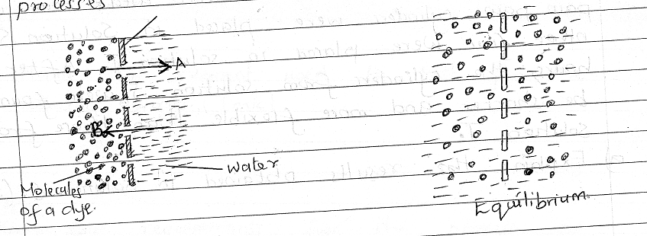

(i) Name process A and B. (2mks)
A - …………………………………………………………………..

B - ……………………………………………………………………
II) Give one significance of process B in plants. (1mk)

7 The equation below shows a process that takes place in the body.
Amino acid + amino acid A Y + water
B

a) Name product Y (1mk)

B) Name processes A and B (2mks)

8 An experiment was carried out to investigate a certain physiological process. Eight raw paw paw cylinders of the same size were used. Four of the paw paw cylinders were placed in solution S. The other four were placed in solution T. After two hours,the cylinders from solution S were found to be shorter and more flexible than those from solution T.
a) Explain the results obtained in solution S. (2mks)

b) Explain why the rate of mineral salt absorption increases with an increase in oxygen concentration. (2mks)

9 State the function of each of the following parts of a light microscope.
a) Mirror (1mk)

b) Fine adjustment knob (1mk)

10(a) State two functions of carbohydrates in the human body. (2mks)

b) State two properties of monosaccharides. (2mks)

c) Name the reagent used to test for the reducing sugars. (1mk)

11 State four requirements for the process of photosynthesis. (4mks)

12(a) Name the region in a mammalian alimentary where bile is stored (1mk)

(b) State the importance of vitamin A(retinol) in the human diet. (1mk)

13(a) The diagram below illustrates the behavior of red blood cells placed in two different solutions x and Y.

s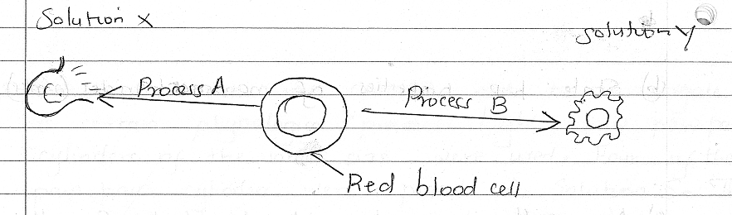
a) Suggest the nature of solution X and Y (2mks)

X –
Y –
b) Name process A and B (2mks)
A –
B –
c) Plant cells do not burst when immersed in distilled water while animal cells burst. Explain (2mks)

14(a) State two factors that denature enzymes. (2mks)

(b)(i) Name two enzymes that are secreted in an inactive form. (2mks)

(ii) Explain why they are secreted in an inactive form. (1mk)

15(a) State two functions of bile juice in the digestion of food. (2mk)

b) If the bile duct of an animal is blocked which food substance would not be digested.(1mk)

c) State two roles of mucus in the stomach. (2mks)

16 The diagram below shows the longitudinal section of a root hair in the soil.
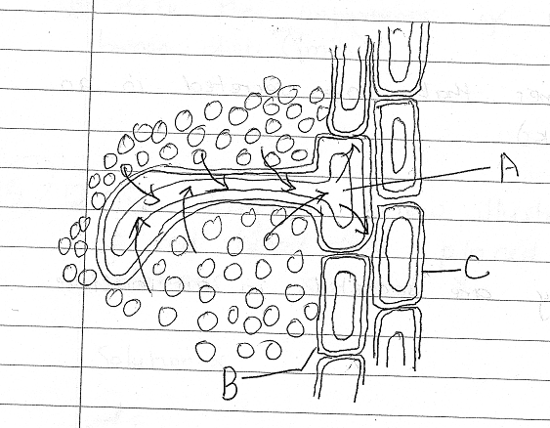

i) Name the parts labeled A,B and C. (3mks)
A –
B –
C –

b) Name the process by which water passes from the soil to the part labeled A. (1MK)

C) How is the root hair adapted to perform their function? (1mk)

17 What is the role of vascular bundles in plants nutrition? (3mks)

18(a) Explain the following
(i) when transplanting seedlings it is advisable to reduce some of the leaves (2mks)

ii) There are generally fewer stomata on the upper side of the leaf than on the lower side of the leaves. (2mks)

b) State two ways in which xylem vessels are adapted to their function. (2mks)

19 The diagram below represents a transverse section through a plant organ.
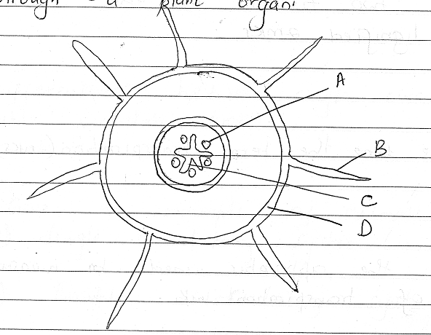

A(i) From which plant organ was the section obtained? (1mk)

b) Give two reasons for your answer. (2mks)

c) Name the parts labeled A,C and D. (3ms)
A -
C –
D -
d) State two functions of the part marked B. (2mks)

20(a) Name two tissues in the stem that are lignified. (2mks)

b) Define term transpiration. (2mks)

c) Name the apparatus used to measure the rate of transpiration. (1mk)

21 Explain how each of the following adaptations reduce transpiration in xerophytes
a) Sunken stomata. (2mks)

b) Thick cuticle

c) Needle-like leaves

22(a) Which type of circulatory system is found in members of the class. (2mks)

i) insecta

ii) mammalia

b) Name the structures that prevents backflow of blood in veins. (1mk)

23(a) Differentiate between single circulation and double circulation. (2mks)

(b) Give an example of animals that possess
(i) Single circulatory system (1mk)

(ii) Double circulatory systems (1mk)

24 Name four forces that moves water and mineral salts up the xylem (4mks)

