NAME.......................................................................INDEX NO..............................
SCHOOL.......................................................................... DATE.............................
SIGN.............................................
231/3
Biology paper 3
(Practical)
1 ¾ HRS
July/August 2019.

Kenya Certificate of Secondary Education 2019

231/3
Biology paper 3
(Practical)
TIME: 1 ¾ HRS
July/August 2019.

INSTRUCTIONS TO CANDIDATES
- Write your name and index number in the spaces provided at the top of this page.
- Answer all the questions in the spaces provided.
For examiner’s use only

Question | Maximum score | Candidate’s score
1 | 13
2 | 15
3 | 12
Total score | 40

MARKING SCHEME
- You are provided with powder Q and powder R. Measure 10ml of distilled water and put it in a boiling tube. Put powder Q in the boiling tube, shake and make a solution. Label it solution Q. Measure 10ml of distilled water and put it in another boiling tube. Put powder R in the boiling tube, shake and make a solution. Label it solution R.

- Using the reagents provided carryout food tests on the two solutions to determine the food present in the two solutions. ( 8mks)

Solution | Food | Procedure | Observation | Conclusion
Q | Starch; | To about 2mk of solution Q, add 3 drops of iodine and shake | Blue black; | Starch present;
 | Protein; | To about 2ml of solution Q,add few drops of NaOH solution followed by afew drops of 1% copper (II) sulphate solution. | Colour changes to purple | Proteins present;
R | Starch; | To about 2mk of solution R, add 3 drops of iodine and shake | Blue black; | Starch present;
 | Protein; | To about 2ml of solution R,add few drops of NaOH solution followed by afew drops of 1% copper (II) sulphate solution. | RETAINS THE BLUE COLOUR OF COPPER (ii) SULPHATE; | Proteins absent;

b (i). Which of the two food substances should be included in a diet to protect a child suffering from kwashiorkor? (1mk)
Powder Q
ii). Give a reason for your answer in b (i) above. (1mk)
It contains proteins;
C (i) name two enzymes in the human body which digest the food substances found in powder. (2mks)
Salivary amylase/pancreatic amylase;
Pepsin/trypsin;
ii) State the organ from which each enzyme you have stated in c (i) acts. (2mks)
Salivary amylase – mouth / Pancreatic amylase – ileum;
Pepsin – stomach / Trypsin – ileum;

- Observe the three photographs carefully and answer the questions that follow
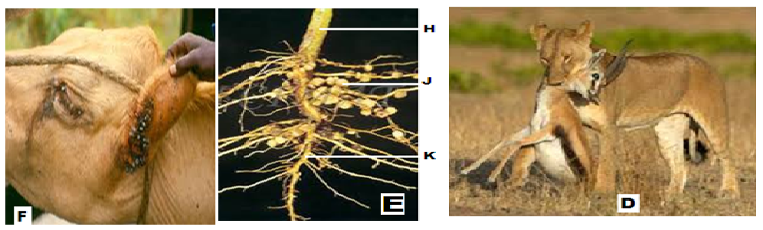
- Identify the structures labeled H, J, and K (3mks)
H stem;
J root nodule;
K tap root;
- Suggest the group of plant from which the root is obtained (1mk)
Legume;
- Explain the relationship found at point J (4mks)
Symbiosis; Rhizobium bacteria fix nitrogen to nitrates; which are used by the legume to make plant protein; the legume shares manufactured food with Rhizobium;
- Explain how the relationship benefits a farmer. (2mks)
The nitrates formed reduce the need for the farmer to use fertilizers; hence saves;
- State one difference between the relationships in photographs D and F. (1mk)
In D the preditor kills prey for food while the parasite does not kill the host;
- Construct one food chain from the organisms in photograph D (1mk)
- State two disadvantages of the relationship shown in photograph F (2mks )
The host loses nutrients;
The parasite can transmit diseases;
- The photographs below show a certain physiological process.

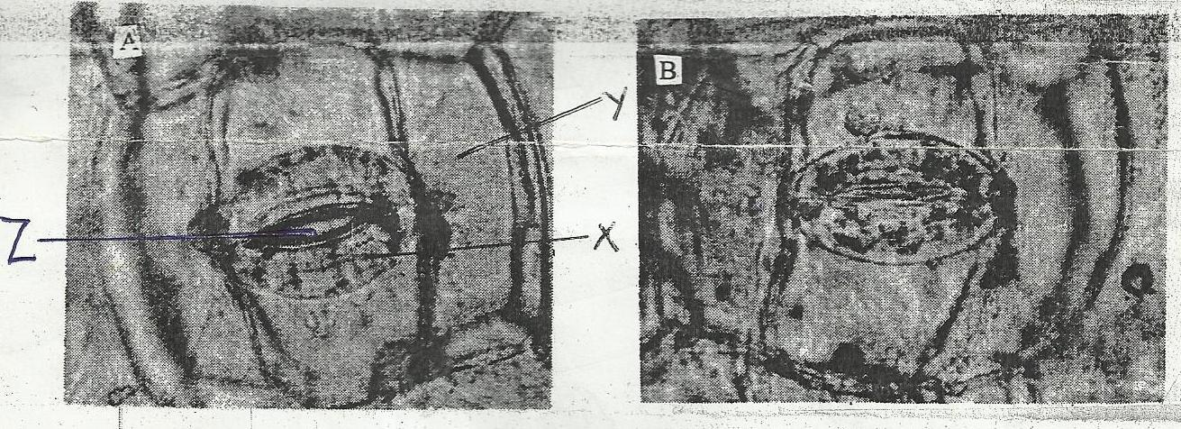
A
B
Z
X
Y

- Name the physiological process shown by the photographs. (1Mark)
Gaseous exchange;
- Name cells X and Y. (2Marks)
X guard cell;
Y epidermal cell;
- How is cell X adapted to function? (2Marks)
Thick inner walls and thin outer wall that strtch differently opening the stomata;
Has chloroplast that photosynthesize making sugar which is necessary for opening and closing of stomata;
- i) Name two substances that passes through part Z. (2Marks)
Water vapour;
Oxygen;
Carbon (IV) oxide; (any two)

ii) Describe the significance of the process shown by figure A. (2Marks)
Gaseous exchange;
Transpiration;

- State three theories that explain the appearance of figure A and B. (3Marks)
Photosynthetic theory;
Starch sugar interconversion theory;
Potassium ion theory;

