**231/1 BIOLOGY PAPER 1 2019 FORM 4**

**Kenya Certificate of Secondary Education**

**END OF TERM II EXAMINATION**

**MARKING SCHEME**

1. Some form one students wanted to collect the following animals for study in the laboratory. State the suitable apparatus they should use to collect

i) a house fly (1 mark)

Sweep net;

ii) A scorpion (1 mark)

pair of forceps;

iii) Ants (1 mark)

pooter

2. The diagram below represents a mammalian vertebra.

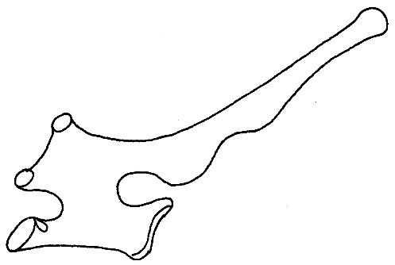

(a) Identify the vertebra represented above. (1mk)

Thoracic vertebrae ;

(b) Give a reason for your answer. (1mk)

- Long neurospine; short transverse processes;

- Presence of tubercular/capitular demi - facets;

3. (a) Explain the role of oxygen in Active transport (1mk)

Oxidize food to produce energy required in active transport rej to produce energy

(b) Name two processes that depend on Active transport in animals (2mks)

Reabsorption of sugar and some salts by kidney;

Absorption of digested food from alimentary canal;

Excretion of waste products from body cell;

Transmission of nerve impulse.

4. Explain how sunken stomata lower the rate of transpiration (2mks)

Form pits that accumulate moisture; lowering saturation deficit between the atmosphere and sub stomatal airspaces; reducing transpiration.

5. State how xylem vessel is adapted to its function (3mks)

* Lignified walls to prevent them from collapsing /offer support
* Hollow and tubular for continuous flow of water;
* Narrow to enhance capillarity;
* Made of dead cells; /to reduce water demand

6). a) Define the term immunity. (1mk)

Ability of the body to identify/ recognize foreign antigens and develop mechanisms of destroying them. / ability to resist infection;

b) Distinguish between natural immunity and acquired immunity. (1mk)

Natural immunity is inborn /inherited /passed from parents to offspring while acquired immunity is obtained in life;

c) Identify one immunizable disease in Kenya. (1mk)

Tuberculosis; poliomyelitis; diphtheria; whooping cough; measles;/hepatitis

7. State two adaptations of the alveolus to its functions. (2mks)

Thin epithelium for reduction of diffusion distance of respiratory gases;

Highly vascularized to transport gases/maintain a steep concentration gradient;

Moist surface to dissolve respiratory gases so that they diffuse in solution form;

1. Why may an asthmatic patient produce a wheezing sound during breathing? (1mk)

This is because muscles around the bronchioles contracts and so reduce their diameter.

(b) What is the significance of the cartilage found in the human trachea being incomplete (c- shaped rings) (1mk)

To permit swallowing in the oesophagus ;

8. Define the following terms;

(i) Inter-specific competition. (1mk)

Competition between individuals of different species.

(ii) Carrying capacity (1mk)

Maximum number of organisms an area can comfortably support with depletion of available resources.

9. Suggest two methods that can be used to determine that type of food eaten by animals.(2mks)

Analyzing animal droppings

Direct observation of the animal while feeding

Dissection and analysis of the gut content

Dentition

10. (a) State one significance of genetics counseling (1mk)

Provides information and advice to enable the victim to arrive at an informed decision on their genetic make up./disoders.

(b) Part of a strand of DNA molecules was found to have the following sequence

A-T-C-G-G-G-A-T-C-T. What is the sequence?

(i) Of the complementary strand? (1mk)

T-A-G-C-C-C-T-A-G-A

(ii) On a m- RNA strand copied

U-A-G-C-C-C-U-G-U (1mk)

11). The paddles of whales and the fins of fish adapt these organisms to aquatic habitats.

a) Name the evolutionary process that may have given rise to these structures. (1mk)

Convergent evolution;

b) What is the name given to such structures? (1mk)

Analogous structures;

c) Give two examples of vestigial organs in man. (2mk)

Coccyx; appendix; reduced ear muscles/nictating membrane/reduced body hair;

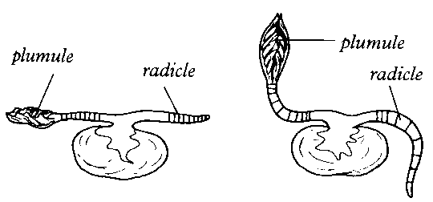12). An experiment was set to investigate a certain aspect of response. A seedling was put on a horizontal position as shown in figure M below. After 24 hours, the set up was as shown in figure N.

**N**

**M**

a) Name the response exhibited. (1mk)

Geotropism;

b) Explain the curvature of the shoot upwards. (3mk)

Gravity causes downward migration of auxins; causing high concentration of auxins on the lower part of the shoot; this stimulates faster growth on the lower part compared to the upper part; making the shoot to curve upwards

13.The following is an equation representing a type of respiration

C6H12O6 2C2H5OH + 2CO2 + Energy

a) Identify the type of respiration. (1mk)

Anaerobic respiration in plants;

b) Suggest industrial applications of the process shown in the equation above (2mks)

- Beer brewing

- Bread baking / leavening of bread

- production of dry ice

14.

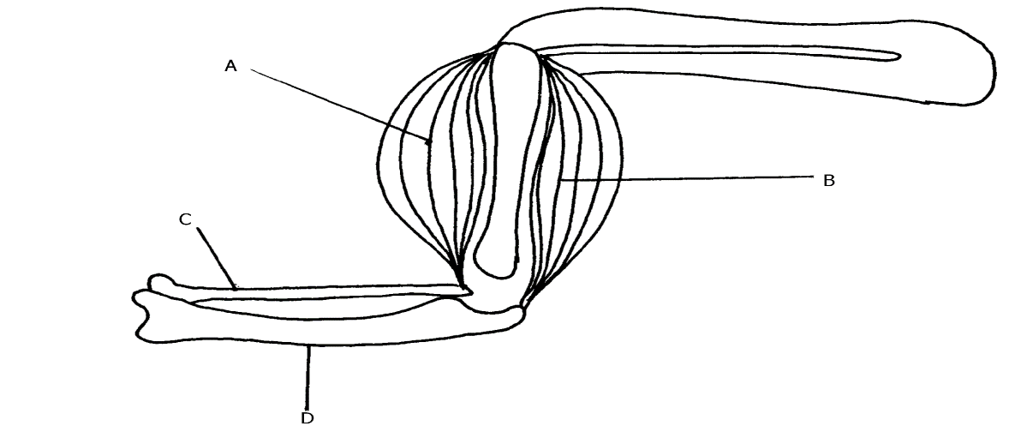

a) Name the bones labeled C and D. (2 mark)

C-Radius

D-Ulna

b) What happens to structure A and B as the arm is straightened (1 mark)

Muscle B contracts and muscle A relax

15. Below is a graphical representation of the effects of different concentration of auxins on shoot and root growth. Study it carefully and then answer the questions that follow.

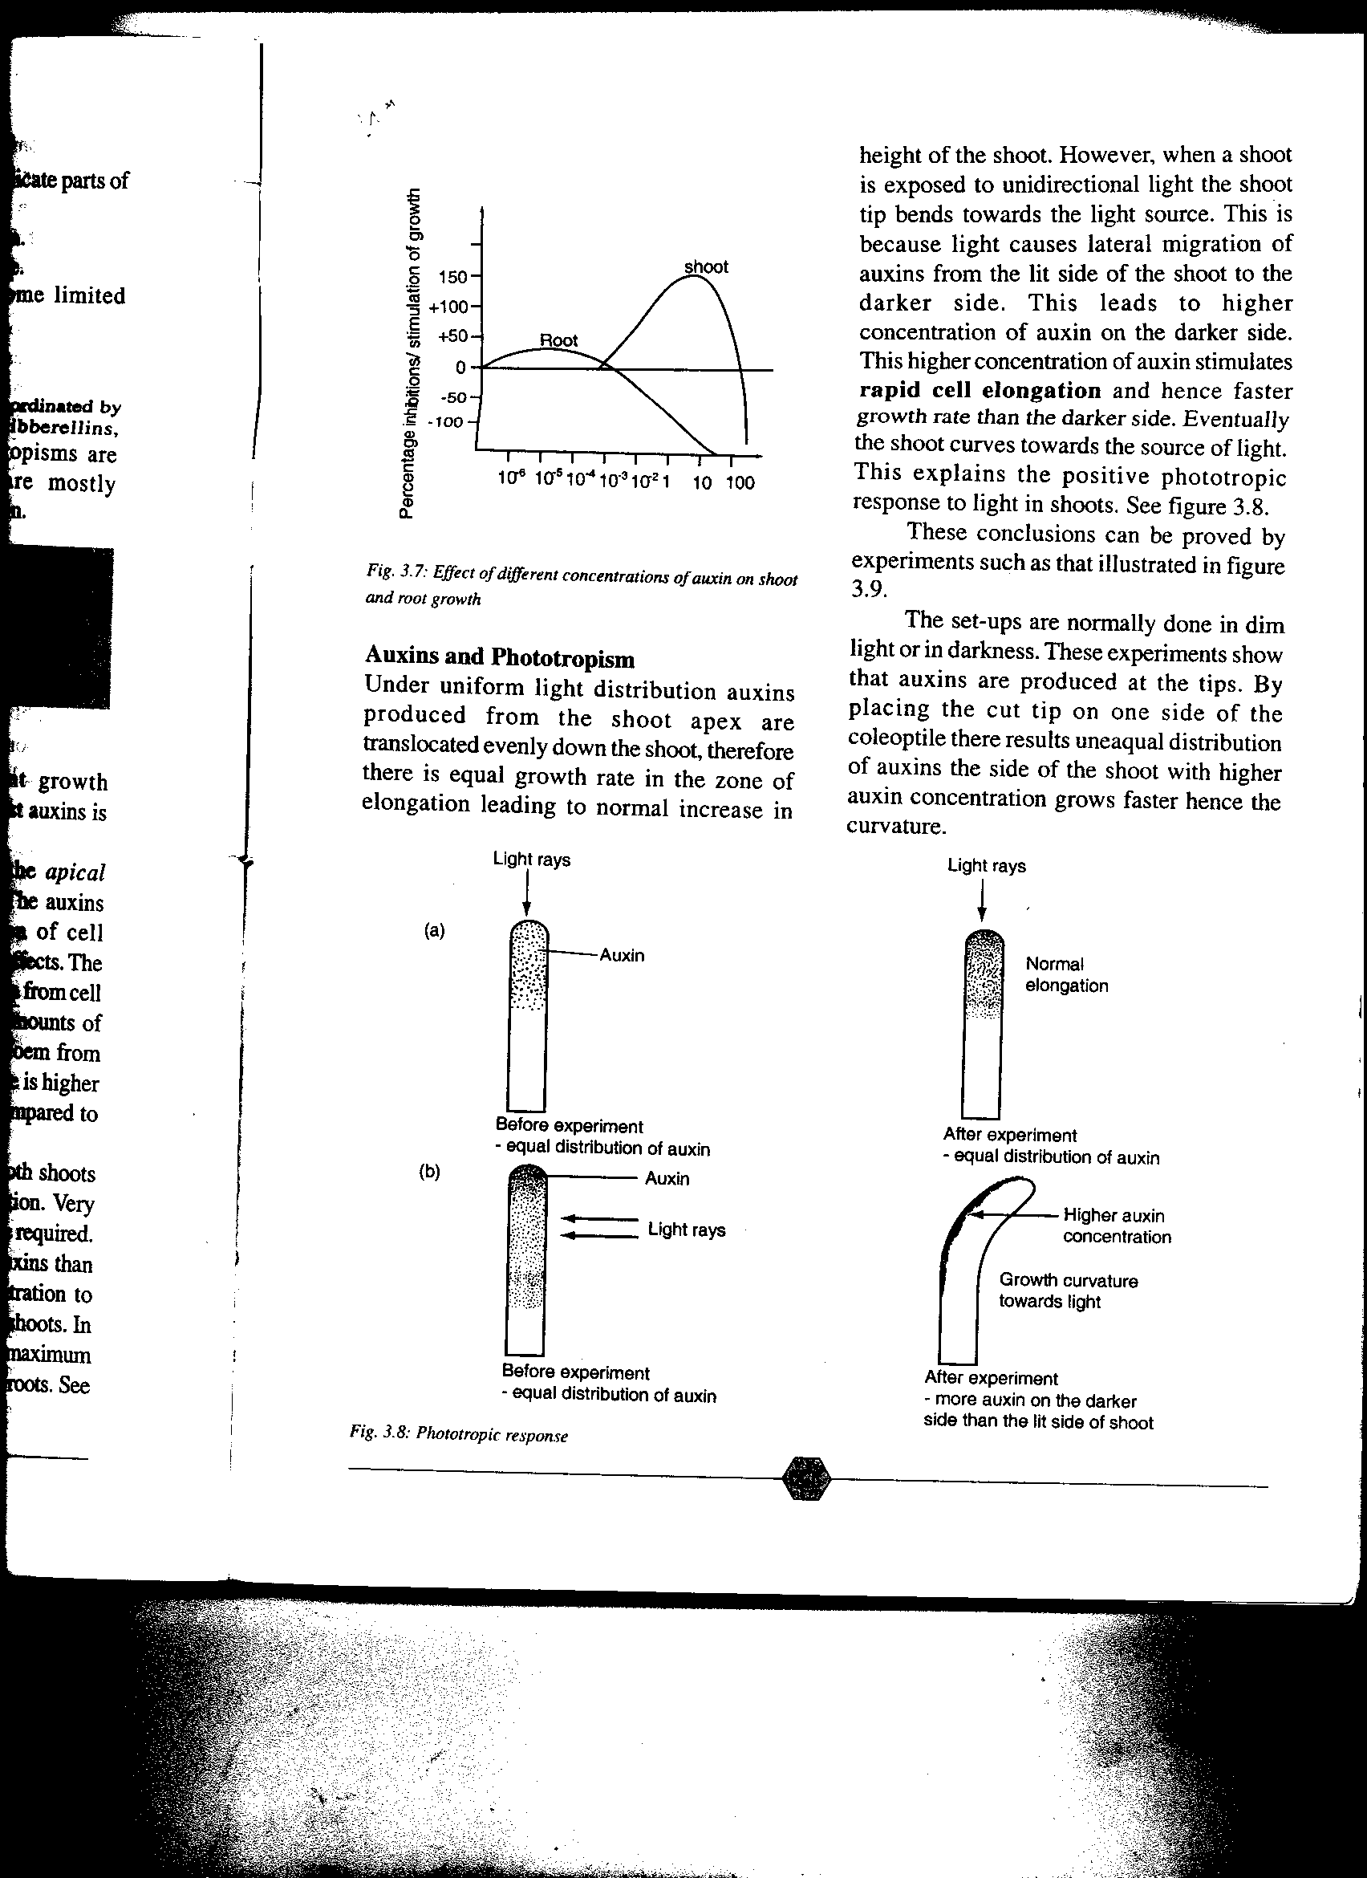

Auxin concentration (ppm)

(a)Identify conclusions that can be drawn from the graph. (3mks)

**- Auxins influence growth in both roots and shoots;**

**- shoots require more auxin to stimulate growth than roots/roots require less auxin to stimulate growth;**

**- higher auxin concentration inhibit growth;**

16. The illustration below shows a transverse section through a mammalian kidney.

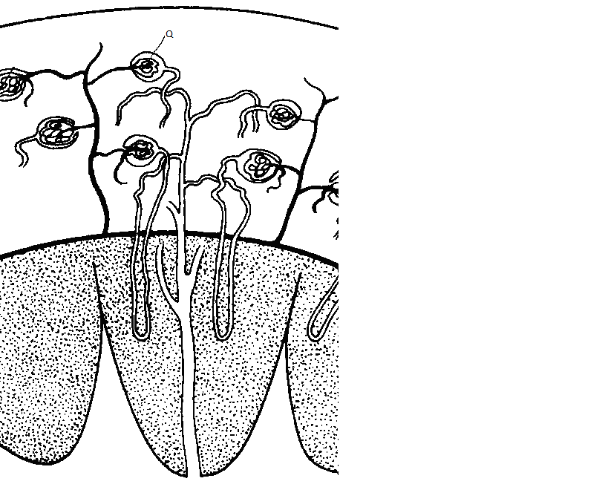

**Y**

**X**

(a) Name the structures labelled **X** and **Y**.

**X Cortex;**

**Y** **Medulla;**

(b) State the process in **Q** that leads to the formation of glomerular filtrate. (1mk)

**Ultrafiltration ;**

17. State **three** differences in composition between umbilical artery and umbilical vein. (3 marks)

|  |  |
| --- | --- |
| **Umbilical vein** | **Umbilical artery** |
| Rich in food nutrients e.g glucose | Less food nutrients |
| Has more Oxygen | Has less Oxygen |
| Has less nitrogenous wastes e.g urea | Has more nitrogenous wastes |
| less Carbon(IV) oxide | more Carbon (IV) oxide |

18. (a)What is meant by the term taxonomy? (1mk)

It is the science/study of classification;

(b)When are two organisms considered to belong to the same species. (2mks)

When they can freely interbreed; to give rise to viable/fertile offspring;

19).The diagram below shows part of alimentary canal of a mammal

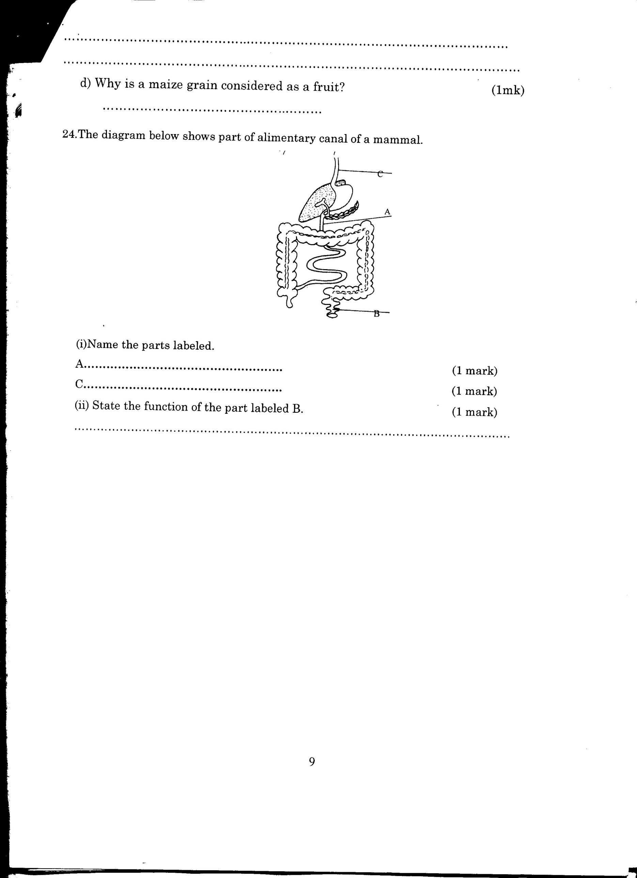

(i)Name the parts labeled A and C (2mks)

A - Duodenum

C - Oesophagus /gullet

(ii)State the function of the part labeled B (1mk)

Temporally storage of feaces / undigested /indigestible materials

/Absorption of water;

20). The graph below shows the relationship between body temperatures and external temperatures in a human being and a snake. Study it and answer questions that follow.

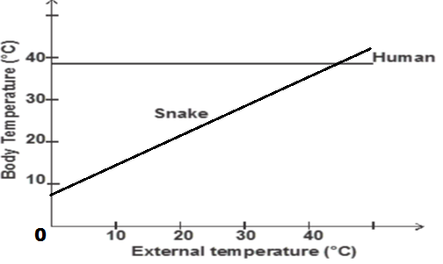

 a**)** What happens to the temperature of each organism as the external temperature increases.(2 marks)

Human -remains constant;

Snake -increases;

**b)** Humans are described as homoithermic. State the advantage of this condition. (2marks)

- enables them to be active throughout;

- enables them exploit different habitats;

(*any one 1mk)*

21. **a)**Name two products of light stage during photosynthesis. (2 marks)

  a)Hydrogen atoms; oxygen gas;Energy /ATP

**b)** State three differences between light stage and dark stage of photosynthesis. (3 marks)

|  |  |
| --- | --- |
| Light | Dark |
| Occur in presence of light  - occur in grana  - produce hydrogen atoms and oxygen gas | - occur any time;  - occur in stroma;  produce glucose; |

22.The diagram below represents a cell organelle.



**a)** Identify the organelle. (1 mark)

Mitochondrion;

**b)** Name the part labelled B (1 mark)

Cristae;

**c)** State the functions of the part labelled A (1 mark)

oxidation of food/action of respiratory substrate by enzymes.

23 **.**The diagram below represents a plant cell that was subjected to a certain treatment.



**At the start At the end of the experiment**

**a)** Account for the shape of the cell at the end of the experiment. (2 marks)

  Plant cell was placed in hypertonic solution to its cell sap, it lost water by osmosis.;it became plasmolysed

**b)** Draw a diagram to illustrate how an animal cell would appear if subjected to the same treatment. (1 marks)

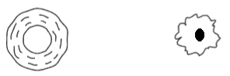

At start At the end of

Experiment

24.a)Give a reason why each of the following steps are followed when preparing cross sections of a leaf for examination under a microscope.

i) Cutting thin sections. (1 mark)

To allow light to penetrate the sections;

Also avoids overlapping of tissues;

ii) Placing the sections in water. (1 mark)

 To avoid drying up which may distort the cells;

To maintain turgidity of the cells

25.a ) Name two tissues in plants that provide mechanical support. (2 marks)

Xylem tissues;

Collenchyma tissues;

Turgid parenchyma tissues;

Schlerenchyma tissues;

b. Name the types of joints formed by each of the following pairs of bones:

i) Axis and atlas. (1 mark)

Pivotal joint;

ii) Humerus with clavicle and scapula. (1mk)

  Ball and socket joint

26.) The diagram below represents a simple reflex ark

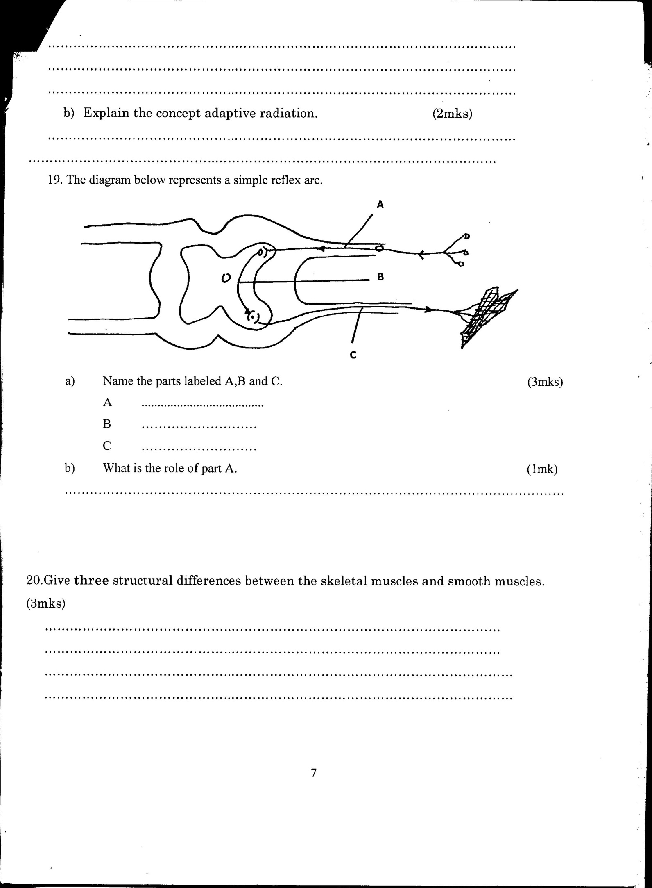

(a)Name the parts labeled A, B and C (3mks)

A -sensory Neurone

B—Relay Neurone

C—Motor Neurone

(b)What is the role of part A (1mk)

Conduct impulse from the sensory organ to the spinal cord /CNS;