NAME ________________________________________ CLASS______ADM. NO. __________

231/3
BIOLOGY
PAPER 3
JULY 2019

BIOLOGY
PAPER 3

INSTRUCTIONS TO CANDIDATES

- Write your name and index number in the spaces provided above.
- Sign and write the date of examination in the spaces provided above.
- You are required to spend the first 15 minutes of the 1 ¾ hours allowed for this paper reading the whole paper carefully before commencing your work.
- Answers must be written in the spaces provided in the question paper.

For Examiner’s Use only:-

Question | Maximum Score | Candidate’s Score
1 | 12
2 | 14
3 | 14
TOTAL | 40

This paper consists of 4 printed pages. Candidates should check to ascertain that all pages are printed as indicated and that no questions are missing.

- You are provided with a specimen labeled T which is a fruit. Use it to answer the questions that follow.
- Make a transverse section of the specimen T. Draw and label at least 3 parts. (Save the specimen for use in question 2) 5mks

- With reasons, state the identity of fruit T.
Type of fruit………………………………………………………………………..1mk
Reason …………………………………………………………………………………1mk
- Suggest the possible agent of dispersal and give two reasons
Agent …………………………………………………………………………………1mk
Reason …………………………………………………………………………………….
…………………………………………………………………………………….
…………………………………………………………………………………2mk
- What is the placentation of T? …………………………………………………….1mk
- Specimen T was green in colour before it was treated with a plant hormone.
Suggest the plant hormone.
…………………………………………………………………………………………1mk
- (a) Crush a piece of the specimen T in a test tube using a stirring rod, add some water and shake. Decant into another test tube. Use the reagents available to establish the food substances present in specimen T extract by filling in the table below.. 9mks
FOOD | PROCEDURE | OBSERVATIONS | CONCLUSION

(b) Identify one type of organic substance absent in T. …………………………………………..1mk
(c) Based on the tests you have carried out above, give one reasons why consuming a lot of T may be unsuitable to a diabetic person.
…………………………………………………………………………………………………………
……………………………………………………………………………………………………2mks
(d) How can you show that somebody is diabetic in the school laboratory? 2mks
………………………………………………………………………………………………………….
………………………………………………………………………………………………………….
- Below are photographs of two specimens, J and K. Both of them belong to the same phylum and class. Observe them carefully before you answer the questions that follow.
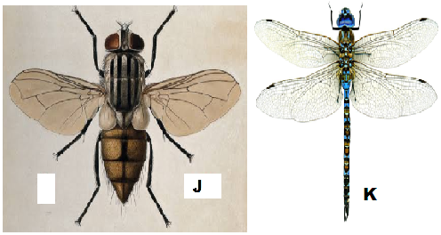
- Name the class to which J and K belong and support your answer with two reasons.
Class ………………………………………………………………………………….1mk
Reasons 2mks
- ……………………………………………………………………………………….
- ……………………………………………………………………………………….
- Suggest why the circulatory fluid in J and K has no haemoglobin. 2mks
…………………………………………………………………………………………
………………………………………………………………………………………….
- Observe their wings and suggest the type of evolution that could have taken place to give rise to J and K, and then give a reason for your answer.
Type of evolution …………………………………………………………………1mk
Reason ……………………………………………………………………………………
……………………………………………………………………………………
………………………………………………………………………………..2mks
- Below is a diagram showing the life cycle of specimen J.
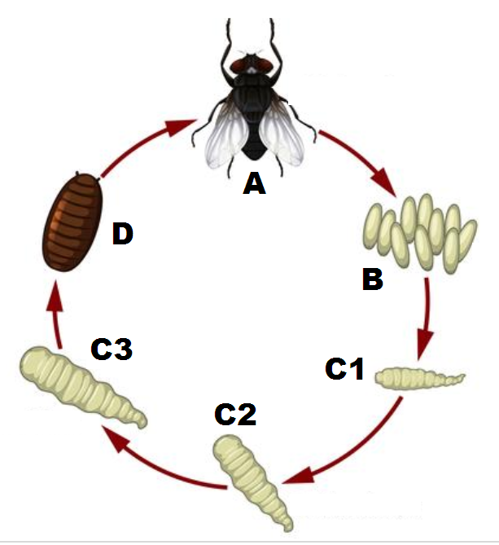
- Identify the stage labeled D. ……………………………………………………..1mk
- Name the hormone responsible for the change from D to A. 1mk
……………………………………… ……………………………………….
- Explain the differences in the change from C2 to C3 and from C3 to D. 4mks
…………………………………………………………………………………………..
…………………………………………………………………………………………..
………………………………………………………………………………………….
………………………………………………………………………………………….

