MWAKICAN PRE-MOCK
FORM 4
231/1
BIOLOGY PAPER 1 MARKING SCHEME
1(a) To increase the surface area for attachment of respiratory enzymes.
(b)(i) Stroma
(ii) bears chlorophyll / site for the light dependent reactions of photosynthesis.
2(a) Ovule
(b) Ovary
3(a) Schlerenchyma
xylem vessels and tracheids
(b) the cells absorb water through osmosis and become turgid i.e turgidity of the ells
4(a) Salmonella typhi
(b) Neisseria gonorrhea
(c) Mycobacterium tuberculosis

5 Protandry
Self sterility or incompatibility
Heterostyly
6(a)(i) grasses, acacia trees
(ii) wild dogs,hyenas
(b) grasses caterpillars spiders
Grasses aphids praying mantis
Acacia caterpillars carnivorous beetles
Acacia rabbits wild dogs
Grasses rabbits hyenas
7 smaller needle like leaves to reduce leaf surface area
- leaves covered with thick waxy cuticle
- sunken stomata
- few stomata located on the lower side of the leaf
- hairy leaves
8 (a) Auxin
(b) (i) promotes reabsorption of sodium ions and the secretion of potassium ions by the kidney tubules. This results in restoration of normal osmotic pressure
9 If the substrate is excess,increasing the enzyme concentration results to increase in enzyme activity.
(10)(a) Centromere divides and the sister chromatids separate
- Spindle fibres begin to shorten and the chromatids move to the opposite poles
(b) -Gamete formation (reproductive sex cells)
- Source of variation
11 During vigorous exercise the rate of breathing increases to meet the increased demand for oxygen.
This also helps in eliminating the extra carbon (iv) oxide produced
12 The overall effect of insulin is to lower the concentration of sugar in the blood.
- stimulates conversion of excess glucose to glycogen for storage.
13(a) The visking tubing will become turgid or expand increase in volume of the solution in the visking tube.
(b) Sucrose is hypertonic while distilled water is the hypotonic solution; water molecules move from the beaker into the visking tubing by osmosis through the semi-permeable risking tubing
14(a) sebum
(b) -cooling the body when the water evaporates
- excrete excess salts,lactic acid and urea
- Kills micro organisms/sweat contains sodium and potassium salts,and urea that contributes to defence
15 - prevents scurvy/bleeding of gums/poor healing of woulds/prevents degeneration of muscles and cartilage/Antioxidant/enhances absorption of iron; Development of healthy gums;synthesis of collagen
16(a) Homodont – organisms has same type of teeth and of the same size
Heterodont –organisms have different types of teeth with different sizes, shapes and functions
(b) Slice flesh and crush bones
(c) i=$\frac{0}{3}$ C= $0/1$ , PM =$3/3$’ M= $3/3$

1(a) The dog has a small surface area to volume ratio hence it tends to lose less heat on the other hand a rat has a large surface area to volume ratio hence it tends to loose a lot of heat energy to the surroundings/Requires more energy to replace the one lost through the physical means.
(b) Baking and Brewing industry
- Dairy industry
- Production of biogas
- Sewage treatment
- Making silage
- Production of fossil fuels
18(a) used for tanning or treating leather
(b) Used as anti-malaria drug
(c) Used as a beverage drink(stimulant of brain)
19 -Head and thorax fused forming cephalothorax. The other body part is the abdomen
- Have between 5-20 pairs of limbs
- Have 2 pairs of antenna
- Have a pair of compound eyes
- Gaseous exchange is through gills
(b) Sori/sorus
20(a) - causes disease epidemics
- Releases phosphates and sulphates causing eutrophication
– causes reduced oxygen concentration resulting in death of aquatic organisms
(b) Respiration.
21(a) - site of fertilization
- connects the ovary to the uterus
(b) Epididymis – stores sperms temporarily
(c) Produces eggs or ova
Secretes a hormone called oestrogen
22(a) It has many contrasting and easily observable characteristics
-it matures relatively fast
- it is usually self pollinated but can easily be cross pollinated
(b)(i) Dominant gene- it is the gene that expresses itself in the heterozygous state (Tt)
Recessive gene – it is the gene that is suppressed in the heterozygous state and only expresses itself in the homozygous state (tt)
(ii) - Continous variation – The differences in a character of a given population has several or many intermediate forms between two extremes/there are ranges
- Discontinous variation – a character has clear cut differences. There are no intermediate forms
23 The food store in the endosperm or cotyledon is converted into new cytoplasm while the embryo is growing and adding on more protoplasm.
24(a) it is a remain of an ancestral form of an organism that has been accidentally preserved in a naturally occurring material eg in sedimentally rocks.
(b) There are several missing links in the fossil records between one fossil generation and the next. Only a few fossils have been discovered.
- Some parts of the fossils have been distorted giving the wrong impressions
-Some fossils have been destroyed by geological activities.
25(a) A – Denitrifying bacteria
E – Nitrifying bacteria ie nitrobacteria

(b) B- Nitrogen fixation
D- Feeding
(c) Plants
Reasons – they are consumed by animals
- Are the organisms that can be able to absorb and use nitrates
26(a)(i) Arachnida
(ii) Spider,ticks,mites,scorpions
(iii) Protoctista

27 -Are Biconcave in shape so as to increase the surface area for gaseous exchange
-Have no nucleas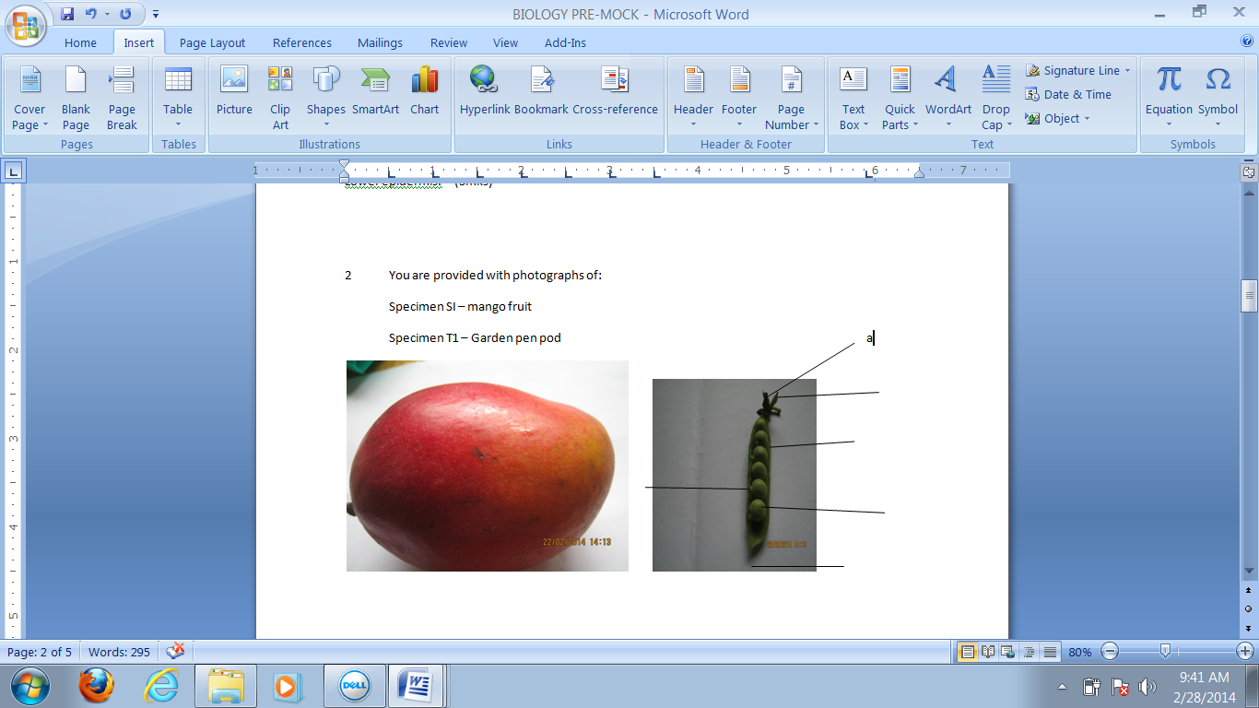 so as to create more space for haemoglobin to occupy
- Thin epithelium to reduce distance of diffusion of gases
-They have haemoglobin that has a high affinity for oxygen
- They are small in order to pass through the narrow hume of capillaries
-

