2019 FORM FOUR
Kenya Certificate of Secondary Education

231/3 BIOLOGY
PAPER THREE
TIME: 1¾ HRS
INSTRUCTIONS
- Answer all questions in spaces provided
Examiner’s Use
QUESTIONS | MAX.MARKS | CAND.SCORE
1 | 9
2 | 13
3 | 18
TOTAL | 40

- Study the organisms below
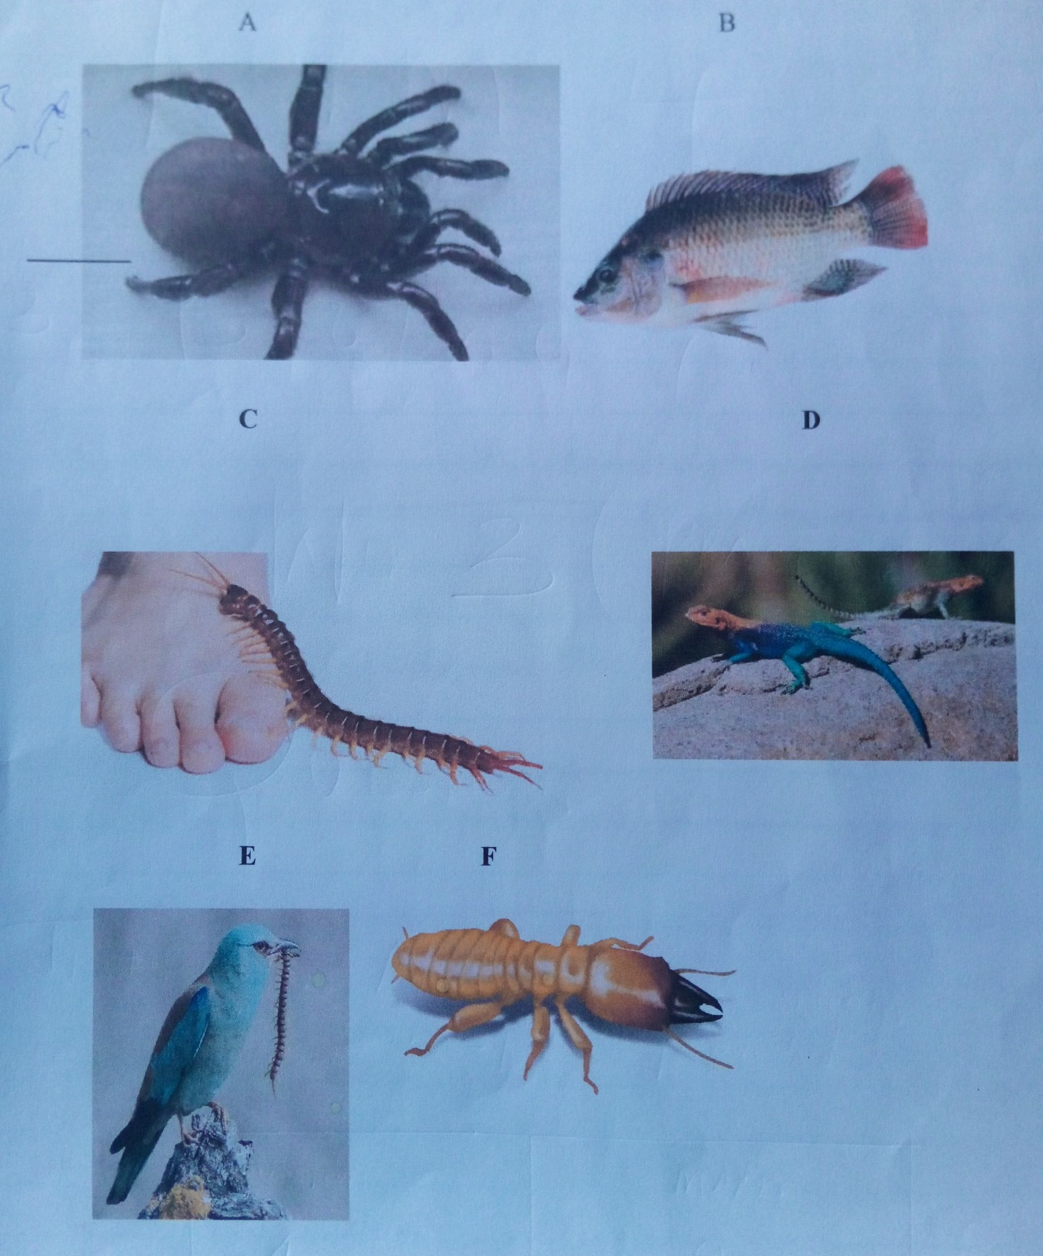

- Complete and use the key below to identify the organisms (2mks)
1.a) Organism with endoskeleton …………………………………………………………...go to 2
1. b) ______________________________________...........................................................................go to 4
2. a) Has scales on the body ………………………………………………………………..…..go to 4
2 b) Has no scales on the body …………………………………………………………….…mammalian
3a) Has cephalothorax …………………………………………………………………………...Arachnida
3b) Has no cephalothorax …………………………………………………………….………..go to 5
4a) _________________________________.......................................................................................Pisces
4b) Has no fins …………………………………………………………………………………………go to 7
5a) Has three pairs of legs ………………………………………………………………………..Insect
5b) Has more than three pairs of legs ……………………………………………………….go to 6
6a) Two pairs of legs per segment …………………………………………………………..Diplopoda
6b) One pair of legs per segment …………………………………………………………….Chilopoda
7a) Has feathers ………………………………………………………………………………………… Aves
7b) Has no feathers …………………………………………………………………………………go to 8
8a) Has a tail ……………………………………………………………………………………………Reptilia
8b) Has no tail …………………………………………………………………………………………Amphibia
- Identify the organisms above using the completed key above (6mks)
Specimen Steps followed Identity
A ______________________________ _______________________________
B ______________________________ ______________________________
C _______________________________ ______________________________
D _______________________________ ______________________________
E _______________________________ _______________________________
F _______________________________ _______________________________
- Name the phylum in which specimens C, E and F belong to. (1mk)
……………………………………………………………………………………………….....................................................
- Give three reasons for your answer in (c) above (3mks)
………………………………………………………………………………………………………………………………………………………………………………………………………………………………………………………………………………………………………………………………………………………………………………………………………………………………
- Name one feature that is common in organisms B, E and D (1mk)
…………………………………………………………………………………………………………………………………………
- You are provided with the following;
- Hydrogen peroxide
- Specimen K
- Pestle and mortar
- 4 test tubes
- A scalpel
- Source of heat
- Test tube holder
Using a scalpel, obtain three peeled cubed from specimen K measuring about 1cm x 1cm x 1cm. For the first cube, you are required to boil it in water for five minutes. For the second cube, you are required to crush it into a paste. For the last cube, you are required to use it as it is.

Label three test tubes A, B and C and put 2ml of hydrogen peroxide in each test tube. To test tube A, add the boiled cube and record your observation.
To test tube B. add the crushed paste and record your observation.
To test tube C, add the unboiled cube remaining and record your observation.
- Complete the table below (3mks)
Test tube | Observation
A
B
C

- Explain your observation in test tube A (1mk)
…………………………………………………………………………………………………………………………………………………………………………………………………………………………………………………………………………
……………………………………………………………………………………………………………………………………
- Between test tubes B and C, in which test tube was the volume of foam produced the highest? Explain (3mks)
……………………………………………………………………………………………………………………………………
……………………………………………………………………………………………………………………………………
……………………………………………………………………………………………………………………………………
……………………………………………………………………………………………………………………………………
- Apart from temperature, state two other factors that affect the rate of enzyme controlled reactions (2mks)
……………………………………………………………………………………………………………………………………
……………………………………………………………………………………………………………………………………
……………………………………………………………………………………………………………………………………

- The photographs below shows specimen of different types of fruits. Examine them and answer the questions that follow.
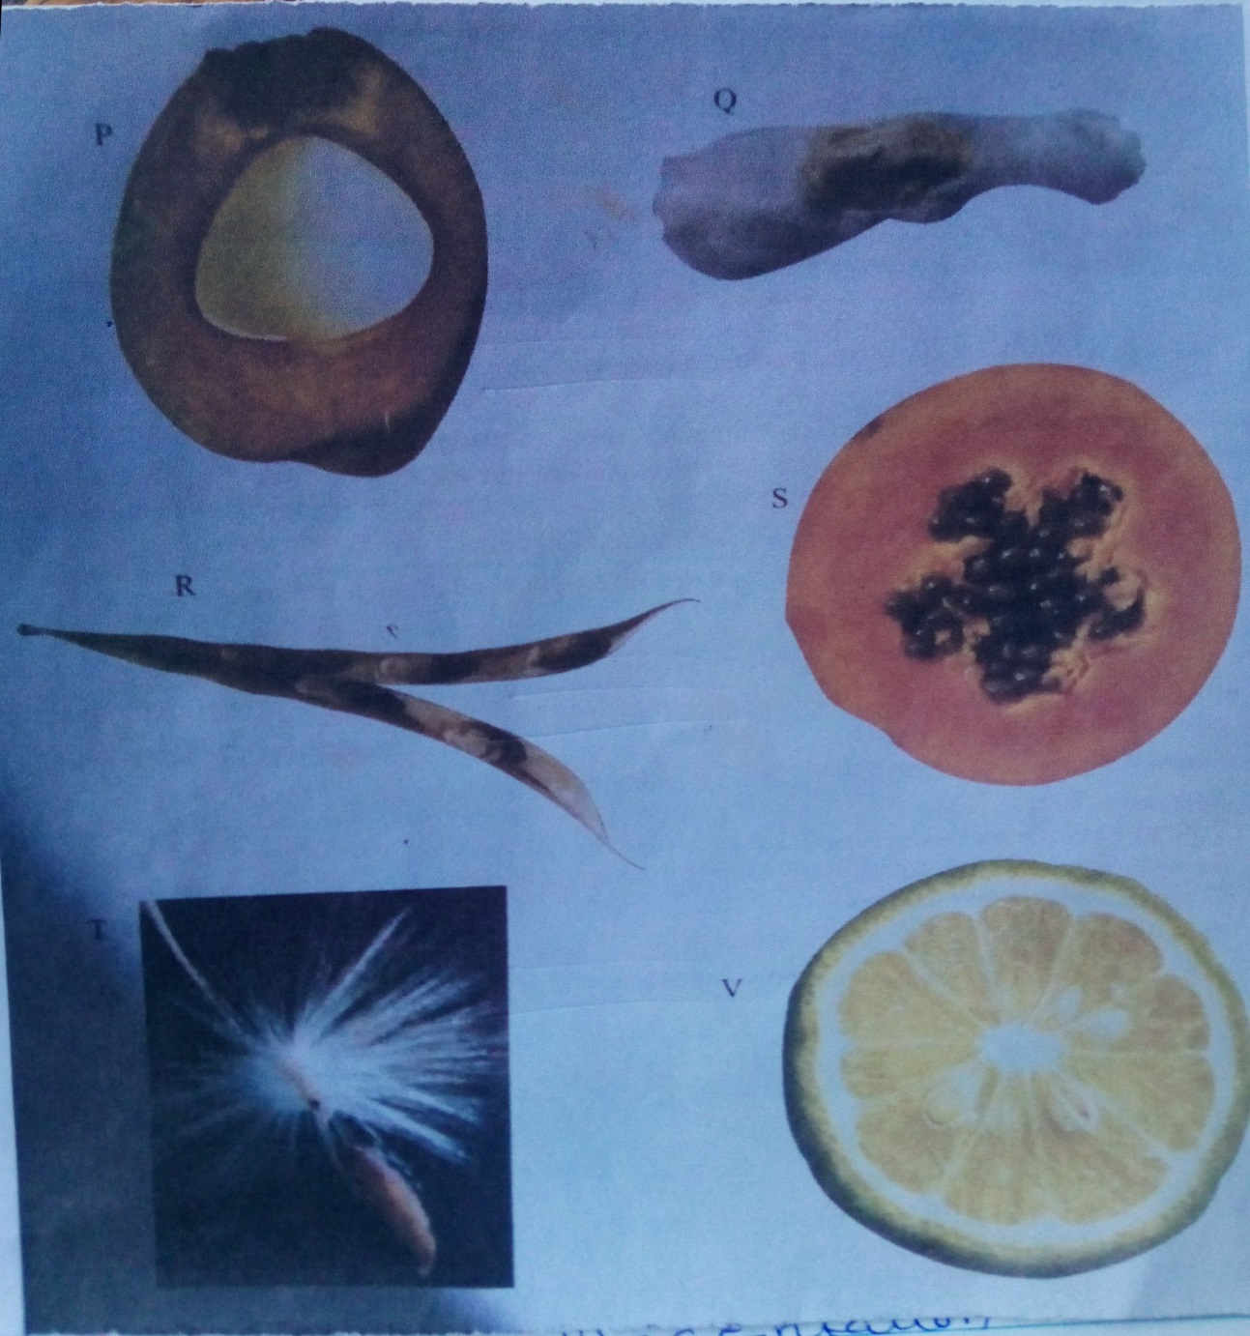

- State four differences between specimen P and R (4mks)
……………………………………………………………………………………………………………………………………
……………………………………………………………………………………………………………………………………
……………………………………………………………………………………………………………………………………
……………………………………………………………………………………………………………………………………
……………………………………………………………………………………………………………………………………
……………………………………………………………………………………………………………………………………
- State the types of gynoecium and placentation of specimen P, S and V (4mks)
- Specimen P Gynoecium …………………………………………..
Placentation ………………………………………….
- Specimen S Gynoecium …………………………………………….
Placentation……………………………………………
- Specimen V Gynoecium ……………………………………………..
Placentation ……………………………………………..
- In the table below name the mode of dispersal for each specimen and the features that adapt the specimen to its mode of dispersal. (6mks)
Specimen | Mode of dispersal | Adaptive features
P
Q
R
S
T
v

- Draw and label a plan diagram of specimen V (4mks)

