MWAKICAN JOINT EXAM
BIOLOGY FORM I
END OF TERM THREE
YEAR 2019

TIME: 2 HOURS
NAME: ______________________________________________

ADM NO: _________________ DATE _____________________

INSTRUCTIONS:
- Write your Name and Admission number in the spaces provided
- Answer all the questions in the spaces provided
- Candidates should check the question paper to ascertain that all the pages are printed and no questions are missing.

- a) Give two main branches of Biology. (2mks)

b) Outline two precautions to take during collection and observation of
specimens. (2mks)

- State the kingdoms to which the following organisms belong. (3mks)
- Plasmodium -
- Bat -
- Yeast –

- Name the most appropriate biological tool that an ecologist student can use for collecting:
- grasshoppers from grass (1 mark)

(ii) Ants from a tree trunk (1 mark)

- Mangifera indica is the name given to a mango tree. What does each of the name represent?
Indica – (1 mark)
Mangifera – (1 mark)
(b) Name this method of identifying organisms. (1 mark)

- (a) What do you understand by the term cell specialization as used in biology? (2 marks)

(b) Name any two specialized cells in plants and state how each is modified.
Cell Modification (4 marks)
- The equation below represents a process that takes place in plants.
6CO₂ + 6H₂O C₆H₁₂O₆ + 6O₂
(Carbon IV) Oxide Water (Glucose) (Oxygen)

- Name the process. (1mk)

- State three conditions necessary for the process to take place. (3mks)

- State three ways in which leaves are adapted to carry out the process named in
- Above efficiently (3mks)

- What is the role of light during the light stage of photosynthesis? (1mk)

- The diagram below represents the lower jaw of a mammal.

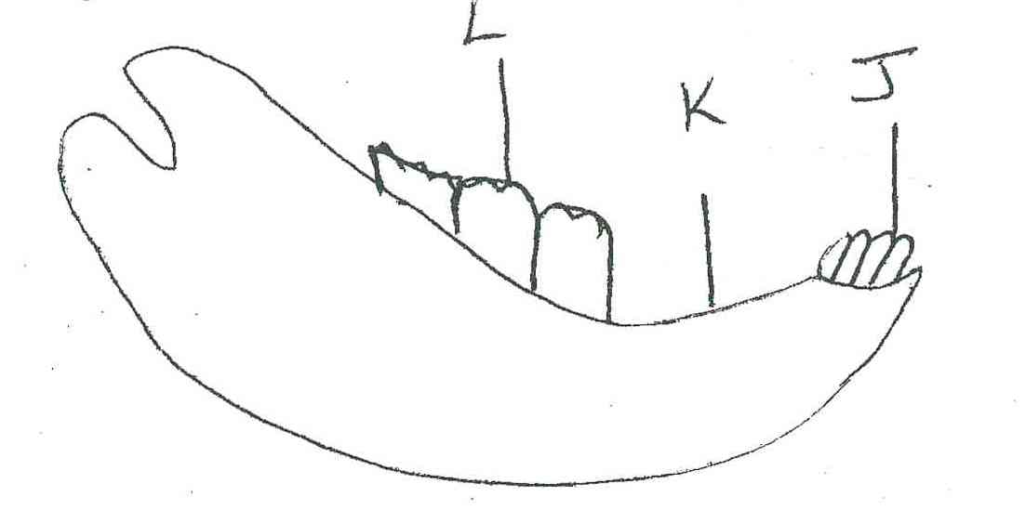

- Name the mode of nutrition of the mammal whose jaw is shown. (1mk)

- Give reason for your answer in (a) above. (1mk)

- State one structural and one functional difference between the teeth labeled J and L. (2mks)

J

L

- i) Name the toothless gap labeled K. (1mk)

ii)State the function of the gap.
- Name the substance that is responsible for hardening of teeth. (1mk)

- Name two dental hygiene practices. (2mks)

- List two dental diseases. (2mks)

- Define the following terms. (3mks)
- Ingestion

- Digestion

- Egestion

- Name two salivary glands in humans. (2mks)

ii) State two functions of saliva. (2mks)

- Name two nutrients that are absorbed without being digested by enzymes in humans.(2mks)

- State the functions of the following enzymes (4mks)
- Salivary amylase

- Pepsin
- Rennin

- Pancreatic lipase

- State two functions of hydrochloric acid produced at the stomach. (2mks)

- State two functions of the bile juice in the digestion of food. (2mks)

- List four adaptations of ileum to its functions. (4mks)

- Give the name given to the study of:-
- Inheritance and variation (1mk)

- Insects (1mk)

- State the function of the following cell organelles
- Ribosome (1mk)

- Lysosome (1mk)

- State the functions of the following parts of a light microscope.
- Objective lens (1mk)

- Diaphragm (1mk)

- a) State two properties of monosaccharide. (2mks)

b)What is the main function of monosaccharide in organisms? (1mk)
- State the formula for calculating magnification when using the following
- Hand lens (1mk)

- A light microscope (1mk)

- Explain why a mule, a product of mating between a horse and a donkey is sterile. (1mk)

- Name the taxonomic unit with:
- The greatest number of organism. (1mk)

- With the least number of organisms. (1mk)

- What name is given to the process whereby :
- Red blood cells shrink after losing their water to a hypertonic solution?(1mk)

- Plant cells become flaccid after losing their water to a hypertonic solution?(1mk)

- The figure below shows a small piece of visking tubing which is filled with potassium permanganate solution. Its free ends were tied tightly to prevent leakage .It was then dipped in a beaker full of distilled water. The set up was left for 2 hours .Its was observed that the distilled water was coloured purple.
- What physiological process was being investigated.(1mk)

- Account for the observation made in (a) above.(3mks)

- State three factors that affect the rate of diffusion (3mks)

- What does a semi-permeable membrane correspond to in an animal cell? (1mk)

- The cells shown below were obtained from two different plant cells which were immersed in 25% and 2% salt solution.
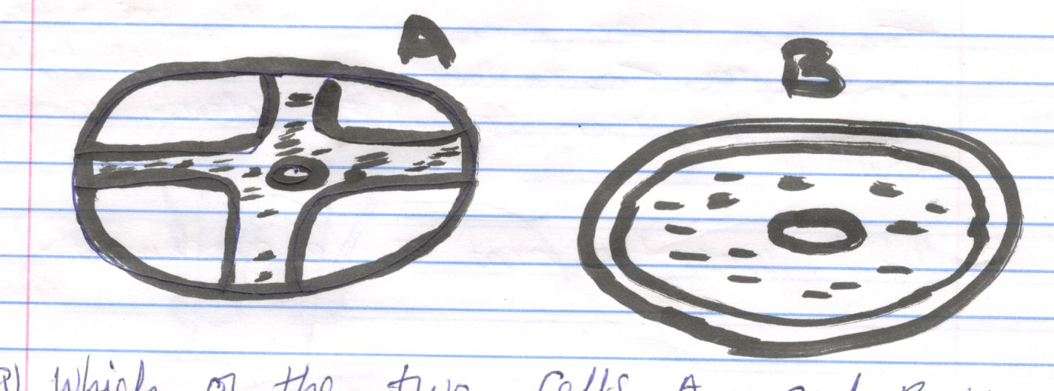
- Which of the two cells A and B was immersed in; (2mks)
- 25% salt solution………………………………………………
- 2% salt solution………………………………………………..
- Comment on the cell placed in 25% salt solution (2mks)

- What biological process was being investigated (1mk)

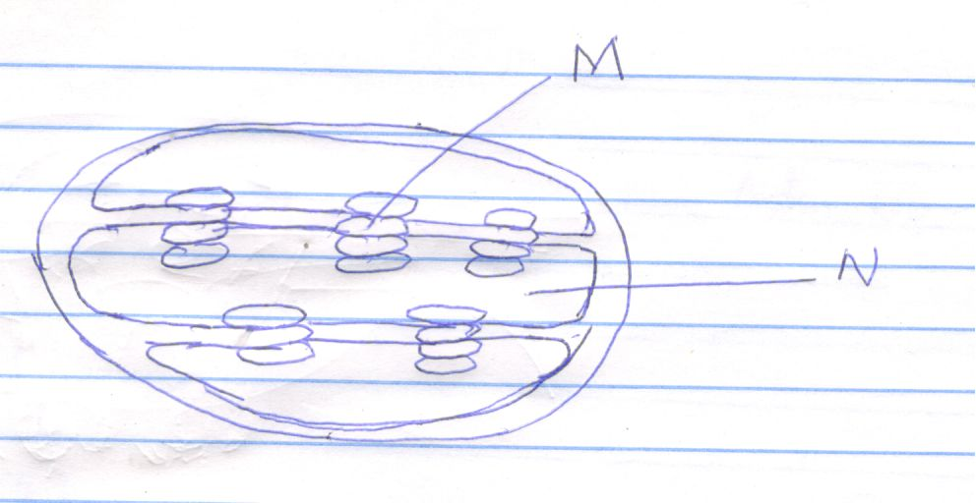
- Identify the organelle (1mk)

- State the function of the organelle (1mk)

- i) Name the part labeled N (1mk)

ii) Name the chemical compound contained in the structure labeled M. (1mk)

- a) Classify the following carbohydrates into monosaccharides, disaccharides and polysaccharides:
Starch, sucrose, maltose, fructose, glucose, and cellulose. (3mks)

- What are the names given to the types of reactions shown in (i) and (ii) below? (2mks)
- C₂H₁₂O₆ + C₂H₁₂O₆ C₁₂H₂₂O₁₁ + H₂O
Glucose fructose sucrose water

- C₁₂H₂₂O₁₁ + H₂O C₆H₁₂O₆ + C₆H₁₂O₆
Sucrose water glucose fructose
- The apparatus shown below is used to investigate an aspect of photosynthesis. Examine it carefully and answer the questions that follow.

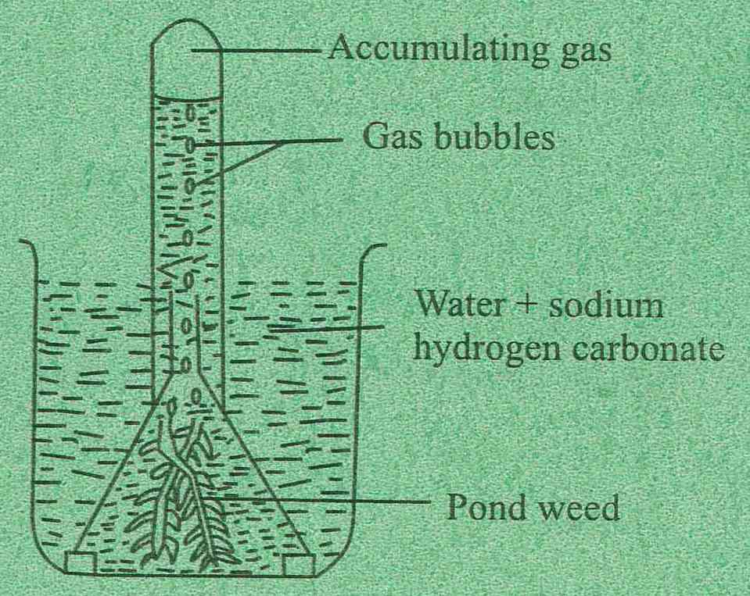

- What aspect of photosynthesis is being investigated? (1mk)

- How can you verify the identity of the gas that accumulates in the test tube? (1mk)

- What is the role of sodium hydrogen carbonate? (1mk)

- What environmental factors are required in order to get a positive result? (2mks)

