NAME…………………………………………CLASS………ADM……………

MWAKICAN JOINT EXAM

FORM 2 BIOLOGY EXAM

END OF 2ND TERM 2 2019

INSTRUCTIONS:
Answer all the questions in the spaces provided.

For examiner use only

QUESTIONS | TOTAL SCORE | STUDENT SCORE
1 – 16 | 100

1(a) Name the three main branches of biology. (3mks)

b) List two other branches of biology(sub-branches) and for each give a definition. (4mks)

2 Biological knowledge can be used to solve environmental problems and enables one to pursue various careers.
(a) list three environmental problems that can be solved using biological knowledge; (3mks)

b) Which three careers require the knowledge of biology. (3mks)

3(a) The scientific name of irish potato in Solanum Tuberosum. Identify two errors that have been made when writing the name. (2mks)

b) Which taxonomic group does the name solanum refer to? (2mks)

4 Which organelles performs the following functions:
a) Transports proteins within the cells (1mk)

b) Contains lytic enzymes (1mk)

c) Processing and transportation of glycoprotein (1mk)

d) Regulate the passage of materials into and out of a cell. (1mk)

5 The diagram below represents a cell as seen under the electron microscope.

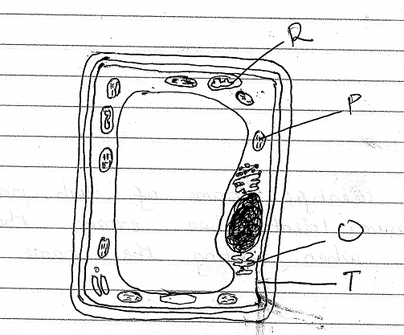

a)(i) Based on the diagram state whether it represents an animal cell or a plant cell. (1mks)

(ii) Give two reasons for your answer in 5(a)(i) above. (2mks)

b) State the functions of the structure labeled P, Q and R. (3mks)

P –

Q –

R –

C) State three properties of the structure labeled T. (3mks)

d) Name the part of the cell that is used in maintaining support in plant cells. (1mk)

6(a) State the function of the following parts of a light microscope.
(i) Mirror (1mk)

(ii) Condenser (1mk)

(iii) Eye piece (1mk)

(b) Which part of a microscope enable one to change from medium to high power objective lens. (1mk)

(c) Explain why it is not advisable to use the coarse adjustment knob when viewing objects with the high power objective lens. (2mks)

7 Study the diagram below and answer the questions below:

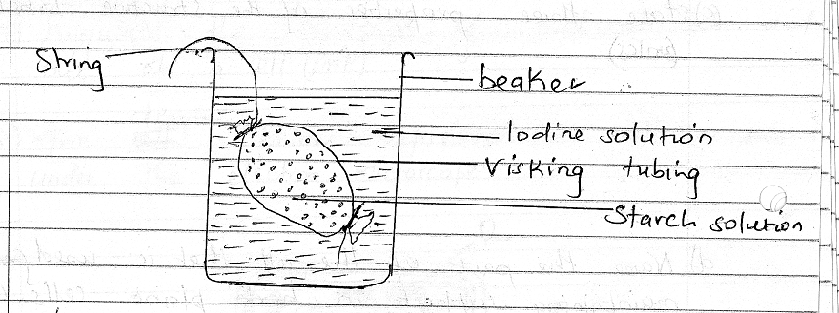

(a) Which physiological process was being investigated? (1mk)

(b) State two observations made after 30 minute. (2mks)

(c) Give an explanation for the observation made in 7(b) above. (3mks)

(d) State two factors that affect the process you named in 7(a) above. (2mks)

8(a) Photosynthesis take place in two stages. Name the two stages and state where in the chloroplast each takes place. (4mks)

Stage II -

Stage II -

(b) State the role of light in the process of photosynthesis. (1mk)

(c) Which cells in a leaf that contains chloroplasts. (3mks)

(d) List two raw materials necessary during photosynthesis. (2mks)

9(a) Name two enzymes that digest proteins in the human alimentary canal. (2mks)

b) Explain why the enzymes you have named in
(a) above secreted in inactive form. (1mk)

10(a) Name two features that increase the surface area of the small intestines. (2mks)

b) During a practical investigation students were provided with the following:
Food substance, 10% sodium hydroxide solution, 1% copper sulphate solution and iodine solution.
(i) Identify two food substances that the students were expected to test. (2mks)

11. The diagram below represents a transverse section through a plant organ.

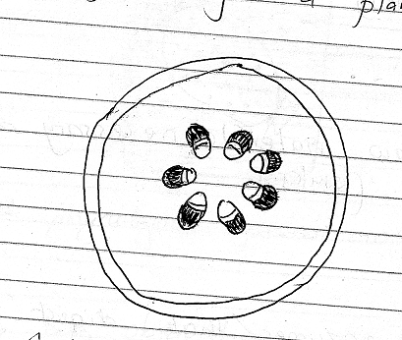

(a)(i) From which plant organ was the section obtained? (2mks)

(ii) Give two reasons for your answer in (a)(i) above (2mks)

b) On the diagram identify and name the part that
(i) Transports water and mineral salts. (1mk)

(ii) Trans - locates synthesized food materials. (1mk)

12) State two structural differences between arteries and veins. (2mks)

13 The diagram below shows a vertical section through a mammalian heart.

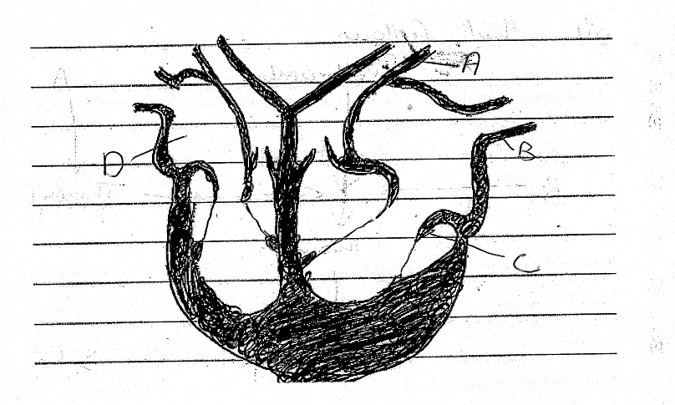

(a) Name the parts labeled A and D. (2mks)

(b) Use arrows to show the direction in which blood flows out of the heart. (2mks)

c) Name the muscle that makes up the heart chambers. (1mk)

d) Which part of the heart is referred to as the pacemaker. (1mk)

14(a) Give two reasons why blood cloting is important. (2mks)

b) The diagram below illustrates the blood clotting process. Use it to answer the questions that follow.

Prothrobin A

B Thromboplastin

Thrombin

Fibrinogen C

Name
(a) The blood cell represented by A (1mk)

(b) Metal ion represented by B (1mk)

c) End product represented by C (1mk)

15(a) State three structures used for gaseous exchange in terrestrial plants. (2mks)

b) How are guard cells structurally adapted for gaseous exchange. (4mks)

c) Nam three structures used for gaseous exchange in frogs. (3mks)

16(a) Define respiration. (1mk)

b) Name the site of aerobic respiration in a cell. (1mk)

c) List two substances needed for respiration to take place. (2mks)

17 a)How are the respiratory surfaces in mammmals adapted to their fuctions (3mks)

b)State the functions of the following parts of a gill. (3mks)

i)Gill rakers

ii) Gill bar

iii) Gill filaments

