Name: ……………………………………………………………………………………………………..
Admission No.……………….. Class……….………………….. Date………………………….

231/2
BIOLOGY
PAPER 2
JULY 2019
TIME: 2 HOURS
MWAKICAN JOINT EXAMINATION
Form Three End of Term Two Examination - 2019

INSTRUCTIONS TO CANDIDATES:
- Write your name and Admission number in the spaces provided.
- Answer all the questions in Section A in the spaces provided.
- In section B answer questions 6 (compulsory) and either question 7 or 8 in the spaces provided.

For Examiner’s Use Only:
SECTION | QUESTIONS | MAXIMUM SCORE | CANDIDATES SCORE
A | 1 | 8
 | 2 | 8
 | 3 | 8
 | 4 | 8
 | 5 | 8
B | 6 | 20
 | 7 | 20
 | 8 | 20
 | TOTAL | 80

SECTION A (40 Marks)
Answer all questions in this section in the spaces provided.
- (a) The figure below shows the effect of pH on an enzyme catalysed reaction.
Enzyme activity
5
4
3
2
1

pH

- State the pH at which the enzyme is most active……………………………………. (1 mark)
- Name one enzyme likely to be the one in the figure above and suggest the part of the alimentary canal where it is found. (2 marks)
Name...............................................................................................................................
Location in the alimentary canal......................................................................................
- Name the digestive juice that contains the enzyme. (1 mark)
...........................................................................................................................................
b) Explain how temperature affects the rate of enzyme controlled reactions (3 marks)
…………………………………………………………………………………………………………………………………………………………………………………………………………………………………………………………………………………………………………………………………………………………………………………………………………………………………………………………………………………………………………………………………………………………………………………………………………
……………………………………………………………………………………………………………………
c) What is enzyme specificity? (1 mark)
…………………………………………………………………………………………………………………………………………………………………………………………………………………………………………
2. The figures below represent mammalian tissue as seen under a light microscope.
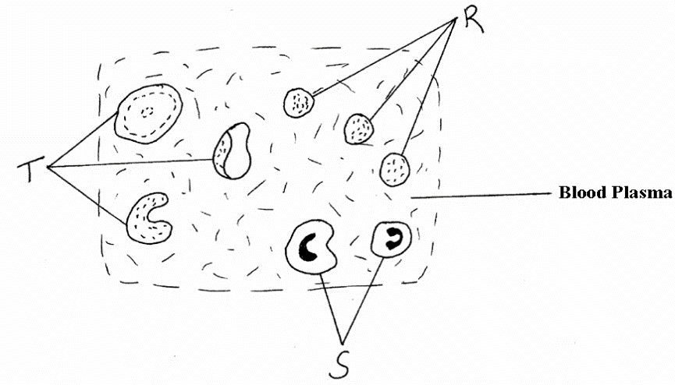
(a) Identify the tissue ……………………………………………………… (1 mark)
(b) Name the cells represented by (3 marks)
R…………………………………………………………………………….
S…………………………………………………………………………….
T…………………………………………………………………………….
(c) State the function of structure S and R. (2 marks)
S ……………………………………………………………………………………………….
R………………………………………………………………………………………………..
(d) Explain one adaptations of structure T to its function. (1 mark)
………………………………………………………………………………………………………………………………………………………………………………………………………………………………………………………………………………………………………………………………………………………………
(e) Name one defect of the circulatory system. (1 mark)
……………………………………………………………………………………………………………………
- (a)Define the term photosynthesis (1 mark)
……………………………………………………………………………………………………………………
……………………………………………………………………………………………………………………

(b) State two raw materials of photosynthesis (2 marks)
…………………………………………………………………………………………………………………….............................................................................................................................................................................................................................................................................................................................

(c)State two factors that affect the rate of photosynthesis (2 marks)
……………………………………………………………………………………………………………………
……………………………………………………………………………………………………………………
d)Describe briefly the light stage of photosynthesis (3 marks)
…………………………………………………………………………………………………………………….............................................................................................................................................................................................................................................................................................................................................................................................................................................................................................
4. The diagram below represents the nitrogen cycle.
Nitrogen
in air
Animals
Ammonia
Nitrogen
in plants
Nitrates
B
Feeding
Death
and decay
Lightning
C
A
D
Death and decay
Nitrifying bacteria

(a) Identify the processes labelled A and D. (2 marks)
A ………………………………………………………………………………………….
D ………………………………………………………………………………………….
(b) Name the compound represented by B. ………………………………………………… (1 mark)
(c) Name the group of organisms labelled C. ………………………………………………. (1 mark)
(d) (i) Name the group of plants that promote process A
.……………………………………………………………………………………………. (1 mark)
- In which part of the plant does process A take place? (1 mark)
……………………………………………………………………………………………………
(e) How would excess pesticides in the soil interfere with process A (2 marks)
……………………………………………………………………………………………………………………
……………………………………………………………………………………………………………………
5. Below is a diagram of a plant a student collected while carrying out an ecological study.
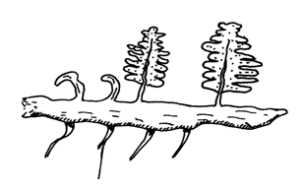
Adventitious root
- With reasons identify the division into which the students classified the plant.
Division ………………………………………………………………………… (1mark)
Reasons ………………………………………………………………………………….. (2marks)
………………………………………………………………………………………………
(b) (i) Name the structure that produces spores in this plant. (1mark)
………………………………………………………………………………………………
- State two differences between the plant division above and that of the division spermatophyta. (2 marks)
Spermatophyta

c) Give two distinguishing features of class Amphibia (2 marks)
…………………………………………………………………………………………………………………..
…………………………………………………………………………………………………………………..
………………………………………………………………………………………………………………….
SECTION B (40 marks)
Answer question 6 (compulsory) and either question 7 or 8 in the spaces provided.
6. The table below shows how the quantities of sweat and urine vary with external temperature.
External temperature °C | 0 | 5 | 10 | 15 | 20 | 25 | 30 | 35
Urine cm³/hr | 100 | 90 | 80 | 70 | 60 | 50 | 40 | 30
Sweat cm³/hr | 5 | 6 | 10 | 20 | 30 | 60 | 120 | 200

- On the same graph, plot the quantities of urine and sweat produced against the external temperature. (7 marks)
(b) At what temperature are the amounts of sweat and urine produced equal? (1 mark)
…………………………………………………………………………………………………………
(c) What happens to the amount of sweat produced as the temperature rises? Explain the observation. (3 marks)
……………………………………………………………………………………………………………
……………………………………………………………………………………………………………
……………………………………………………………………………………………………………
……………………………………………………………………………………………………………
(d) Explain the observation made on the amount of urine produced as the temperature
increases. (3 marks)
……………………………………………………………………………………………………………
……………………………………………………………………………………………………………
……………………………………………………………………………………………………………
……………………………………………………………………………………………………………
(e) How does the skin regulate temperature? (6 marks)
……………………………………………………………………………………………………………
……………………………………………………………………………………………………………
……………………………………………………………………………………………………………
……………………………………………………………………………………………………………
……………………………………………………………………………………………………………
……………………………………………………………………………………………………………
……………………………………………………………………………………………………………
……………………………………………………………………………………………………………
……………………………………………………………………………………………………………
……………………………………………………………………………………………………………
……………………………………………………………………………………………………………
……………………………………………………………………………………………………………
……………………………………………………………………………………………………………
……………………………………………………………………………………………………………
……………………………………………………………………………………………………………
……………………………………………………………………………………………………………
……………………………………………………………………………………………………………
7.a) What is meant by the term digestion (2 marks)
b)Describe how mammalian small intestine is adapted to its function (18mks)
8. a) Explain how xerophytes are adapted to their habitats (10 marks)
b) Describe how insect pollinated flowers are adapted to pollination. (10 marks)
…………………………………………………………………………………………………………… ……………………………………………………………………………………………………………
……………………………………………………………………………………………………………
……………………………………………………………………………………………………………
……………………………………………………………………………………………………………
……………………………………………………………………………………………………………
……………………………………………………………………………………………………………
……………………………………………………………………………………………………………
……………………………………………………………………………………………………………
……………………………………………………………………………………………………………
……………………………………………………………………………………………………………
……………………………………………………………………………………………………………
……………………………………………………………………………………………………………
……………………………………………………………………………………………………………
……………………………………………………………………………………………………………
……………………………………………………………………………………………………………
……………………………………………………………………………………………………………
……………………………………………………………………………………………………………
……………………………………………………………………………………………………………
……………………………………………………………………………………………………………
……………………………………………………………………………………………………………
……………………………………………………………………………………………………………
……………………………………………………………………………………………………………
……………………………………………………………………………………………………………
……………………………………………………………………………………………………………
……………………………………………………………………………………………………………
……………………………………………………………………………………………………………
……………………………………………………………………………………………………………
……………………………………………………………………………………………………………
……………………………………………………………………………………………………………
……………………………………………………………………………………………………………
……………………………………………………………………………………………………………
……………………………………………………………………………………………………………
……………………………………………………………………………………………………………
……………………………………………………………………………………………………………
……………………………………………………………………………………………………………
……………………………………………………………………………………………………………
……………………………………………………………………………………………………………
……………………………………………………………………………………………………………
……………………………………………………………………………………………………………
……………………………………………………………………………………………………………
……………………………………………………………………………………………………………
……………………………………………………………………………………………………………
……………………………………………………………………………………………………………
……………………………………………………………………………………………………………
……………………………………………………………………………………………………………
……………………………………………………………………………………………………………
……………………………………………………………………………………………………………
……………………………………………………………………………………………………………
……………………………………………………………………………………………………………
……………………………………………………………………………………………………………
……………………………………………………………………………………………………………
……………………………………………………………………………………………………………
……………………………………………………………………………………………………………
……………………………………………………………………………………………………………
……………………………………………………………………………………………………………
……………………………………………………………………………………………………………
……………………………………………………………………………………………………………
……………………………………………………………………………………………………………
……………………………………………………………………………………………………………
……………………………………………………………………………………………………………
……………………………………………………………………………………………………………
……………………………………………………………………………………………………………
……………………………………………………………………………………………………………
……………………………………………………………………………………………………………
……………………………………………………………………………………………………………
……………………………………………………………………………………………………………
……………………………………………………………………………………………………………
……………………………………………………………………………………………………………
……………………………………………………………………………………………………………
……………………………………………………………………………………………………………
……………………………………………………………………………………………………………
……………………………………………………………………………………………………………
……………………………………………………………………………………………………………
……………………………………………………………………………………………………………
……………………………………………………………………………………………………………
……………………………………………………………………………………………………………
……………………………………………………………………………………………………………
……………………………………………………………………………………………………………
……………………………………………………………………………………………………………
……………………………………………………………………………………………………………
……………………………………………………………………………………………………………
……………………………………………………………………………………………………………
……………………………………………………………………………………………………………
……………………………………………………………………………………………………………
……………………………………………………………………………………………………………
……………………………………………………………………………………………………………
……………………………………………………………………………………………………………
……………………………………………………………………………………………………………
……………………………………………………………………………………………………………
…………………………………………………………………………………………………………………………………………………………………………………………………………………………
Last Printed Page

