NAME ………………………………………………ADM. NO ………………CLASS:……….

DATE……………..
231/3
BIOLOGY
PAPER 3
PRACTICAL
TIME: 1³/₄HRS

MWAKICAN FORM 3 JOINT EXAMINATION - 2019
TERM 2
KENYA CERTIFICATE OF SECONDARY EDUCATION

Instruction to Candidates
- Write your Name, Adm. No., Class and Date in the spaces provided
- Answer all the questions
- You are required to spend the first 15 minutes of the 1³/₄Hrs around for this paper reading the whole paper carefully before commencing your work
- Answers must be written in the spaces provided in the question paper. Additional
Pages must not be inserted.

FOR EXAMINER’S USE ONLY
QUESTION | MAXIMUM SCORE | CANDIDATE’S SCORE
1  2  3 | 11  15  14
TOTAL SCORE | 40

- You are provided with visking tubing a solution labelled E, Iodine solution labelled solution F. Benedict’s solution labelled solution L, and a piece of thread.
Tie one end of the visking tubing tightly using the thread provided. With the help of a dropper put 10ml of the solution labelled E into the visking tubing. Tie the other end of the visking tubing tightly.
Ensure that there is no leakage at both ends of the visking tubing. Wash the outside of the visking tubing with water. Place the visking tubing in a 100ml beaker. Add distilled water into the beaker to reach the level of the liquid in the visking tubing. Allow the setup to stand for 30 minutes or more.
a)Using 2ml in a test tube in each case test for the food substance in the liquid outside the visking tube using. (3mks)
TEST | PROCEDURE | OBSERVATION | CONCLUSION
Iodine Solution(Solution F)
Benedict’s solution (Solution L)

B) Using 2ml in a test tube in each case test for the food substance in the contents of the visking tubing using. (3mks)
TEST | PROCEDURE | OBSERVATION | CONCLUSION
Iodine Solution(Solution E)
Benedict’s solution (Solution L)
C) Account for your results in a and b above. (4mks)

d)Highlight the role of the physiological process demonstrated here (1mk)

- The photograph below is of a mammalian heart. Study it and answer the questions that follows

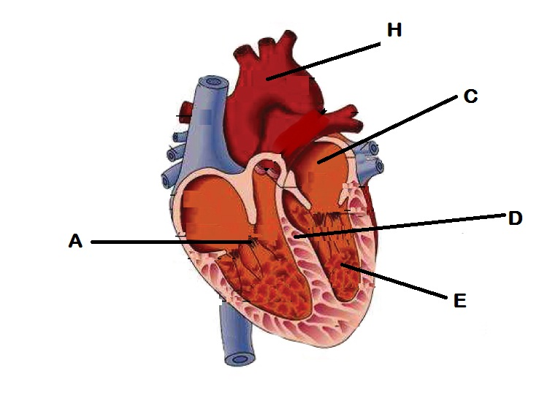
- Name the parts labelled D and E. (2mks)

- State the role of part D. (1mk)

- Account for the structural differences between the parts marked C and E. (3mks)

- Name:
- Valve A (1mk)
- State it’s function. (1mk)

- Name the part marked C. (1mk)

- i) Name the blood vessel marked H. (1mk)

ii)State two fuctional differences between the arteries and the veins. (2mks)

g)State 3 structural adaptations of the heart (3mks)

- Study the following illustration of various mammalian teeth and answer the questions that follow.
A B
C D
- Identify the teeth. (4mks)
A
B
C
D

+
- Complete the table below. (8mks)
Tooth | Function | Adaptation
A
B
C
D

C) Write the dental formula of an adult human being. (1mk)

- Distinguish between heterodont and homodont animals. (1mk)

