NAME: ____________________________________ INDEX NO: ___________
DATE: CANDIDATE’S SIGN:

231/3
BIOLOGY
PAPER 3
PRACTICAL
JULY 2019
TIME: 1 ¾ HOURS

MOKASA II JOINT EVALUATION EXAMINATION
Kenya Certificate of Secondary Education
231/3
BIOLOGY
PAPER 3
PRACTICAL
JULY 2019
TIME: 1 ¾ HOURS

INSTRUCTIONS TO CANDIDATES

- Write your Name and Index No. in the spaces provided above
- Answer ALL the questions in the spaces provided

FOR EXAMINERS USE ONLY
QUESTION | MAXIMUM SCORE | CANDIDATES SCORE
1
2
3
TOTAL

- You are provided with the following: pieces of thread, two pieces of visking tubing 6cm, Distilled water in a beaker, iodine solution in a beaker, Solution Y and Solution X. Open the two visking tubings and tie one end tightly. Using a dropper put 4 cm3 of Solution Y and 4 cm3 of solution X into each visking tubing, respectively. Ensure that the visking tubing containing solution X is immersed in the beaker containing iodine solution(set up B) and the visking tubing containing solution Y is immersed in beaker containing Distilled water (set up A) . Leave the set up for 30 minutes. Remove the Visking tubing and make observation

(a) State the observations 2 Marks
A……………………………………………………………………………………………………………………………………………………………………………………………………………………………………………………………………………………………………………………………………………………………………………………………………….
B……………………………………………………………………………………………………………………………………………………………………………………………………………………………………………………………………………………………………………………………………………………………………………………………………………………

(b) State the physiological process in 2Marks
A……………………………………………………………………………………………………
B……………………………………………………………………………………………………

(c) Account for the observation made in
A……………………………………………………………………………………………………………………………………………………………………………………………………………………………………………………………………………………………………………………………………………………………………………………………………………….. 2(marks)
B……………………………………………………………………………………………………………………………………………………………………………………………………………………………………………………………………………………………………………………………………………………………………………………………………………… 3(marks)

(d) State the importance of physiological process A in plants 2 Marks
………………………………………………………………………………………………………………………………………………………………………………………………………………………………………………………………………………………………………………………………………………………………………………………………………………………………
(e) How can you speed the process in B? 1Mark
……………………………………………………………………………………………………………………………………………………………………………………………………………………………………………………………………………………………………………………..
- Below are photographs of invertebrates which belong to the same class. Examine them
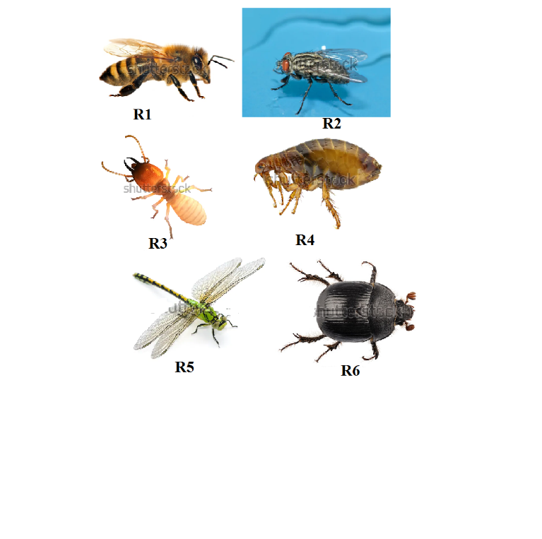

- To which class do the above invertebrates belong? 1Mark
………………………………………………………………………………………………………………………………………………………………………………………………………………
- State two characteristics of the class named in (a) above 2 Marks
……………………………………………………………………………………………………………………………………………………………………………………………………………………………………………………………………………………………………………………………………………………………………………………………………………………………………………………………………………………………………………………………………
- Complete the dichotomous key below to identify the invertebrates to their orders 3marks
1a. Animal with wings …………………………………………………… go to 3
b. …………………………………………………….go to 2
2a. Animal with hairy body ……………………………………………………Siphonoptera
b. Animal with smooth body……………………………………………………Isoptera

3a. Animal with one pair of wings………………………………………………...Diptera
b. ………………………………………….........go to 4
4a. Fore wings hard/elytra…………………………………………………………Coleoptera
b. …………………………………………………. ....Go to 5
5a. Long slender abdomen…………………………………………………………Odonata
b. Short broad abdomen…………………………………………………………..Hymenoptera

- Using the dichotomous key above, identify to which orders the various organisms belong. In each case write down the steps that you followed to arrive at your answer. (6mks)

Specimen | Steps | Identity
R1
R2
R3
R4
R5
R6

- You are provided with specimen K. Use it to answer the questions that follow
- Describe the floral parts 3 Marks

- Cut the specimen K longitudinally. Draw one of the sections 4 marks

- With a reason state the agent of pollination 2 Marks
……………………………………………………………………………………………………………………………………………………………………………………………………………………………………………………………………………………………………………………..
- The photographs labelled Q, R,and S are sections of some plant parts.
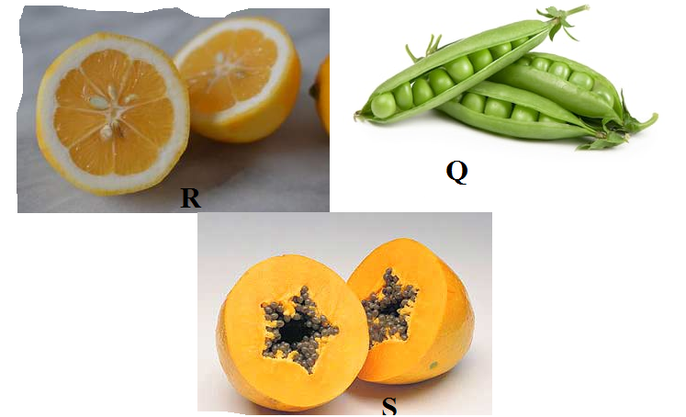

(i ) Name the type of placentation in the specimens shown in photographs Q, R and S (3 marks)
Q………………………………………………………………………………………………….
R………………………………………………………………………………………………….
S………………………………………………………………………………………………….

(ii) Giving a reason in each case, name the mode of dispersal of the specimen in photograph Q and S (4mark)
Q Mode……………………………………………………………………………………………..
Reason ……………………………………………………………………………………………………………………………………………………………………………………………………………………………………………………………………………………………………………………..
S
Mode………………………………………………………………………………………………..
Reason
………………………………………………………………………………………………………………………………………………………………………………………………………………………………………………………………………………………………………………………

THIS IS THE LAST PRINTED PAGE

