END OF TERM EXAM 2019
BIOLOGY PAPER ONE FORM FOUR TERM 2 2019
TIME: 2HRS PAPER 231/1
NAME: _______________________________________ CLASS: ___________ ADM NO: _______
INSTRUCTIONS
Attempt all the questions in this paper on the spaces provided.
- List down cell structures that can only.
- Be seen under the light microscope (2mks)

- Be seen under the electron microscope (2mks)

- Name three forces that drive the process of transpiration in plants. (3mks)

- State four functions of plant roots (4mks)

- Study the diagram below and answer the questions below it
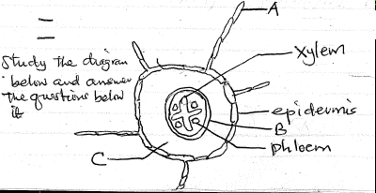

- Name structures B and C (2mks)
B

C

- State two ways in which structure labeled A is adapted to its functions (2mks)

- Describe the following terms;
- Isotonic solution (1mk)

- Plasmolysis (1mk)

- Turgidity (1mk)

- Draw a neat diagram showing the structures of a mitochondrion (4mks)

- Study the diagram below and answer the questions that follow
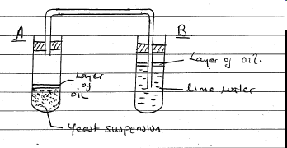
- What is respiration? (1mk)

- Why is the layer of oil poured over:- (2mks)
- The yeast suspension

- The lime water

- Name the type of respiration taking place in boiling tube A (1mk)

- What is the expected observation in boiling tube B (1mk)

- .
- State the name of the organelle where respiration takes place (1mk)

- How is the organelle you have named in 8(a) adapted to its functions (2mks)

- .
- What is oxygen debt? (1mk)

- State the products of aerobic respiration (3mks)

- .
- What is homeostasis? (1mk)

- State two homeostatic functions of the liver (2mks)

- Mention two diseases that affect the liver (2mks)

- Describe the following terms;
- Hibernate

- Aestivate

- During which stage of cell division does;
- Spindle fibres form (1mk)

- Synapsis take place (1mk)

- Chromosome assemble at the equation (1mk)

- Give reason why do fishes, reptiles and amphibians lay several eggs (3mks)

- How are flowers adapted to insect pollination (4mks)

- State three changes which take place in a flower after fertilization (3mks)

- Distinguish the following as used in biology
- Sigmoid growth curve and intermittent growth curve (2mks)

- Growth and development (2mks)

- State three differences between growth in plants and animals (3mks)

- .
- Define the term mutation (1mk)

- State two functions of DNA (2mks)

- Write a complimentary base sequence of mRNA that could be coded for using DNA strand shown below (1mk)
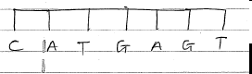
- .
- .
- What is etiolation (1mk)

- State the importance of etiolation (1mk)

- Distinguish between a neurone and a nerve (1mk)

- .
- What does the term evolution mean (1mk)

- Give an example of a vestigial structure in human (1mk)

- .
- State two evidences of evolution (2mks)

- Differentiate between homologous and analogous structures (1mk)

- .
- The diagram below represents a neurone
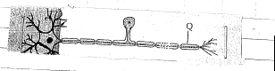
- Name the neurone (1mk)

- Using an arrow, show the direction of movement of impulses. (1mk)

- State the survival name in the way shoot and roots respond to gravity (1mk)

- Explain why most recessive genres are expressed phenotypically in male offspring of humans (3mks)

