FORM FOUR PRE-MOCK EXAMINATION.
TERM 1 2021
SEPTEMBER 2021
BIOLOGY PAPER ONE
TWO HOURS
Instructions to candidates
- Write your name and class in the space provided above
- Sign and write the date of the examination in the spaces provided above
- Answer all the questions in the spaces provided
- This paper consists of 10 printed pages
- Candidates should check the question paper to ascertain that all the pages are printed as indicated and no questions are missing.
- Candidate should answer all the questions in English
FOR EXAMINERS USE ONLY

QUESTION | MAXIMUM SCORE | CANDIDATE’S SCORE
- 32 | 80

- Identify the following. (2mrks)
- Type of movement in cells.
Cytoplasmic streaming
- Arrangement of leaves on a plant.
Phyllotaxy

- Explain how adequate water supply increases the rate of glucose formation in plants. (1mrks)
Provides more hydrogen ions that reacts with carbon (IV) oxide forming glucose
- Name the element obtained from insects by insectivorous plants. (1mrk)
Nitrogen

- A mushroom research station would like to employ a researcher. Which scientist is most appropriate. (1mkr)
Mycologist
- Name the branch of biology that deals with phylogenetic relationship between organisms. (1mrk)
Evolution
- State the role of the diaphragm.
- In the light microscope. (1mrk)
Regulates the amount of light passing through the condenser to illuminate the specimen
- During ventilation in man. (1mrk)
Contract and relaxes, increasing and decreasing volume of the thorax cavity. (all must be present and orderly)
- Explain why plants absorb water in waterlogged soil but not mineral salts. (2mrks)
Water absorption is by osmosis which does not require energy; mineral salts are absorbed by active transport that requires energy that depends on oxygenthat is deficient in water logged soil;

- A biological washing detergent removes stains like oils from cloths.
- Name the enzyme that it contains. (1mrk)
Lipase
- Explain why the stains would be removed faster with the detergent in water at 35ºc rather than at 15^{O}c. (1mrk)
35^{O}c – optimum temperature for the enzyme by 15^{O}c inactivates the enzyme.
- Below is a diagram of an embryo sac.
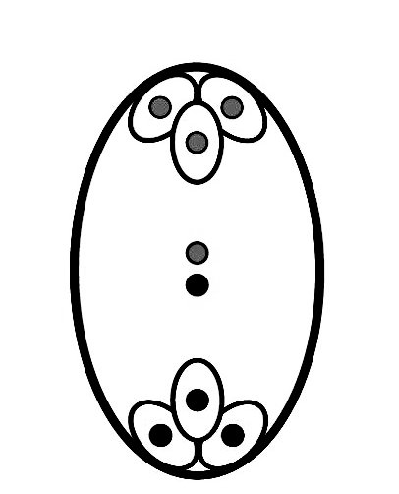
K
J
Identify the structures labelled. (2mrks)
J. Polar nuclei

K. Antipodal cells
- Explain why low temperature will cause seed dormancy by not very high temperatures. (1mrk)
Dormancy is a resting period caused by low temperature while high temperature destroys the embryo.

- Explain why the average length of the chicken egg is 6cm while that of a human is 0.1mm. (1mrk)
The chicken egg stores food for the developing embryo while the human one does not store food.

- Identify two features that enable mammalian fallopian tubes perform their function. (2mrks)
Cilia
Smooth muscles.

- State a limiting factor of using a potometer to measure the rate of transpiration. (1mrk)
It assumes all the water absorbed is transpired (yet some may be used up)
- Name the tissue that transports hormones in plants. (1mrk)
Phloem.
- To control the spread of malaria, fish are introduced into water bodies near residential area.
- Name this method of population control. (1mrk)
Biological control
- State an advantage of the above method. (1mrk)
No pollution; No residual effect. (mark any one)
- Apart from vaccination, state two ways of controlling highly infectious disease among animals. (2mrks)
Isolation; Quarantine

- Name the enzyme that breaks down hydrogen carbonate ions in mammalian blood to release carbon (IV) oxide. (1mrk)
Carbonic anhydrase
- Explain why obligate anaerobes die in presence of oxygen. (1mrk)
Lack catalase enzyme to break down toxic hydrogen peroxide produced during aerobic respiration

- Name the group of sporangia born on fern leaves. (1mrk)
Sori
- Why are fruits not produced in gymnosperms? (1mrk)
Absence of ovaries.

- Explain why lactating mothers need extra energy. (1mrk)
Secretion of milk requires more energy.
- State the function of interstial cells found in the testes. (1mrk)
Secretion of testosterone.
- Below is a diagram showing a foetus in the uterus.
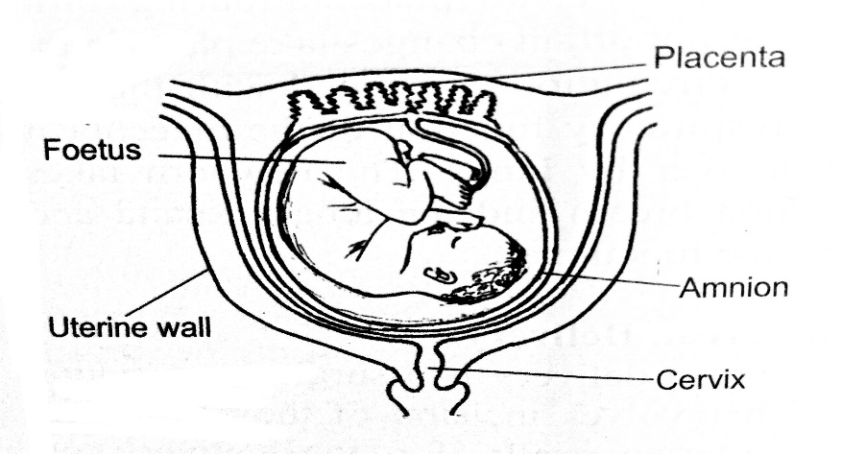
State two observations showing that parturition is about to take place. (2mrks)
Dilation of the cervix
The foetus is upside down.
- The symptoms of typhoid disease include high fever, vomiting and diarrhoea. Explain why they may lead to death if not treated. (2mrks)
High fever is due to increased temperature which may denature enzymes affecting metabolism; vomiting and diarrhoea may cause dehydration.
- The table below represents a chromatid which undergoes a mutation, the letters genes.
Before mutation
L | M | N | O | P | Q
After mutation
L | O | N | M | P | Q

- Name the type of mutation. (1mrk)
Inversion

- Identify the nucleic acid whose base sequence is shown below. (1mrk)
G-A-C-U-A-G-A-C-G
RNA
- If the above strand was involved in protein synthesis, how many amino acids would the protein have. (1mrk)
3
- Explain why resistance to antibiotics is considered an example of evolution. (2mrks)
The gene for resistance due to mutation is transmitted; hence creating a new population of resistant strains.

- People are encouraged to take the corona virus disease vaccine. How does it work. (1mrk)
Stimulates the body to make antibodies
- What is the significance of;
- Red blood cells lacking mitochondria. (1mrk)
Not to use up oxygen.
- Xylem vessels being dead. (1mrk)
Not to lose water to the neighboring cells
- Use of fossil fuel as source of energy causes global warming. Governments are being encouraged to use ‘clean energy’. State two sources of this energy. (2mrks)
Hydroelectric power
Wind
Solar
Geothermal
- An athlete training to take part in an international competition moved to a high attitude area to train for 12 days. He took his pulse rate per minute and recorded as shown below.

Day | 1 | 2 | 3 | 4 | 5 | 6 | 7 | 8 | 9 | 10 | 11 | 12
Pulse rate | 72 | 78 | 89 | 92 | 92 | 90 | 86 | 80 | 77 | 74 | 72 | 72
Account for the change in the pulse rate from.
- Day 1-5. (2mrks)
Low oxygen concentration; increases pulse rate to supply more oxygen to the tissues
- Day 6-12. (2mrk)
Acclimatization/ more RBC have formed; tissues get adequate supply of oxygen.
- A patient complained of frequent thirst. A sample of the patient’s urine was found not to have any sugar.
- Name the hormone the person was deficient of. (1mrk)
Antidiuretic hormone/ Vasopressin.
- Name the gland that secretes the above hormone. (1mrk)
Pituitary gland

- The paddles of a whale and fins of a fish adapt them to aquatic habitat.
- Name the evolutionary process that may have given rise do these structures. (1mrk)
Convergent evolution
- What name is given to such structures. (1mrk)
Analogous structures
- State two advantages of natural selection. (2mrks)
Allows survival of organisms with better qualities
Eliminates organisms with unfavorable traits

- Explain why ingestion of salty food may reduce the amount of water passed out in urine. (2mrk)
Salt increases osmotic pressure by blood; hence more water is reabsorbed from kidney tubules
- Explain why small birds puff their features when cold. (2mrks)
To reduce heat loss; feathers trap more air that insulates against heat loss.

- Explain why halophytes have pneumatophores. (1mrk)
Have lenticels that are sites for gaseous exchange.
- Explain how the following features adapt root hairs cells to absorption
- Large sap vacuole. (1mrk)
Store sap to increase osmotic pressure to facilitate osmosis.
- Numerous mitochondria. (1mrk)
For generation of more energy to facilitate active transport.
- A certain metabolic pathway takes place following sequence.
J-K-L-M-N
An inhibitor was added to the reactants during an experiment. At the end of the experiment, there was more K and little L, M and N.
- At what stage of the sequence was the inhibitor added. (1mrk)
K-L
- Briefly explain how the inhibitor affected the reaction. (2mrks)
The inhibitor competes with K for the active of the enzyme; hence accumulation of K.

- Suggest a change in the diet of a person whose liver is damaged. (1mrk)
Avoid lipids/ fatty food.
- State the importance of caecum in herbivores. (1mrk)
Harbor bacteria that secrete cellulose to digest cellulose.
- Name the polysaccharide that offers mechanical support in;
- Arthropods (1mrk)
Chitin
- Plants. (1mrk)
Cellulose

- Explain why an effective respiratory system is associated with the circulatory system. (2mrks)
Circulation system transports away the respiratory gases; creating a steep diffusion gradient
- Distinguish between haemoglobin and myoglobin. (2mrks)
Haemoglobin- A protein found in the RBCs to transport oxygen
Myoglobin- A protein found in muscles that stores oxygen

- New born babies have a higher heart beat than adults. Explain why? (2mrk)
Babies have a larger surface area to volume ratio hence they lose heat; require more oxygen for respiration to maintain body temperature at optimum.
- What Is the advantage of oxyhaemoglobin over carboxyhaemoglobin? (1mrk)
Oxyhaemoglobin is unstable and dissociates easily.

- Explain why;
- Fish pass a lot of water over the gills frequently. (1mrk)
For maximum extraction of oxygen/gaseous exchange as there is less dissolved oxygen/ gases in water.

- Lack of magnesium leads to yellowing of leaves. (1mrk)
Magnesium is required for synthesis of chlorophyll.
- The organisms below belong to kingdom Animalia.
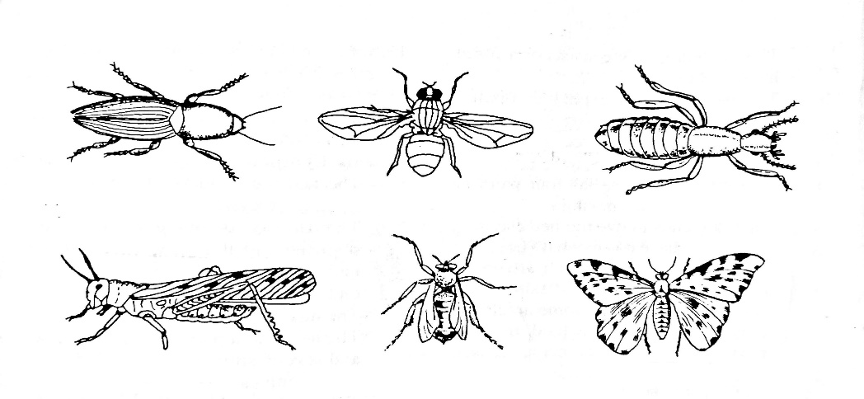
- Name the phylum and class where they belong. (2mark)
- Phylum. Arthropoda
- Class. Insecta
- Give a reason for placing the organisms in the class in (a(ii) above. (1mrk)
3 body parts
3 pairs of legs
A pair of antennae (mark any one)

