KOIMBI BOYS SECONDARY SCHOOL
END-TERM 2 EXAMS 2019
FORM 4 BIOLOGY

NAME……………………………………………… ADM.NO…………CLASS……..
231/2
BIOLOGY
PAPER 2
FORM 4
2 HOURS

INSTRUCTION TO CANDIDATES

1. This paper has two sections; A and B.
2. Answer all the questions in section A in the spaces provided on the question paper.
3. From section B, answer questions 6 (Compulsory) and any other question in the spaces provided after question 8.

- a).Name the sex chromosome in human that is considered to be genetically empty (1mk)

……………………………………………………………………………………………………………………………………………………………

…………………………………………………………………………………………………………………………………………………………..b) Colour blindness is a human disease inherited through a recessive gene carried on the X chromosome. If the carrier female married a normal male .Work out expected genotypes of their children. Show all your working (let n stand for colour blindness) (3mks)

……………………………………………………………………………………………………………………………………………………………

……………………………………………………………………………………………………………………………………………………………

……………………………………………………………………………………………………………………………………………………………

……………………………………………………………………………………………………………………………………………………………

……………………………………………………………………………………………………………………………………………………………
c) Work out the genotype ratio of the offsprings (1mk)

……………………………………………………………………………………………………………………………………………………………

……………………………………………………………………………………………………………………………………………………………

…………………………………………………………………………………………………………………………………………………………..
d). Work out the probability of the first child being a carrier female (1mk)

……………………………………………………………………………………………………………………………………………………………

- a) which branch of biology did the microscope give rise to? (1mk)

…………………………………………………………………………………………………………………………………………………
b(i)What is an organelle? (1mk)

……………………………………………………………………………………………………………………………………………………………
(ii) What is the role of the nucleus in a cell (1mk)

………………………………………………………………………………………………………………………………………………………
(iii) Name the chemical material in the nucleus which enableit to perform its function (1mk)

……………………………………………………………………………………………………………………………………………………………
c). Explain briefly why red blood cells have a short life span in a human being (1mk)

……………………………………………………………………………………………………………………………………………………………

…………………………………………………………………………………………………………………………………………………………..
d(i). Explain what happens inside the nucleus in interphase of mitosis (1mk)

……………………………………………………………………………………………………………………………………………………………

…………………………………………………………………………………………………………………………………………………………..

……………………………………………………………………………………………………………………………………………………………

……………………………………………………………………………………………………………………………………………………………
(ii). Give one difference between a nucleus of a somatic cell and a gamete cell (2mks)

……………………………………………………………………………………………………………………………………………………………

……………………………………………………………………………………………………………………………………………………………

……………………………………………………………………………………………………………………………………………………………

……………………………………………………………………………………………………………………………………………………………
- a(i)What is meant by the term biological control (1mk)

……………………………………………………………………………………………………………………………………………………..
(ii)Give an example of biological control (1mk)

……………………………………………………………………………………………………………………………………………………..
b.(i) What is eutrophication? (3mks)

…………………………………………………………………………………………………………………………………………………………………

…………………………………………………………………………………………………………………………………………………………………

………………………………………………………………………………………………………………………………………………………………….
(ii) What are the effects of eutrophication? (3mks)

……………………………………………………………………………………………………………………………………………………………

……………………………………………………………………………………………………………………………………………………………

……………………………………………………………………………………………………………………………………………………………

……………………………………………………………………………………………………………………………………………………………

……………………………………………………………………………………………………………………………………………………………

- The chart below shows blood clotting mechanism

- Name the
- Blood cells represented by B (1mks)
……………………………………………………………………………………………………………………………………………………
- Blood protein represented by C (1mk)

..……………………………………………………………………………………………………………………………………………

- Metal ions represented for blood clotting (1mk)
……………………………………………………………………………………………………………………………………………………
- Which vitamin is required for blood clotting (1mk)

……………………………………………………………………………………………………………………………………………………
- State the conditions under which blood transfusion may be necessary (2mks)
……………………………………………………………………………………………………………………………………………………
……………………………………………………………………………………………………………………………………………………
……………………………………………………………………………………………………………………………………………………..
- State two factors to be considered before blood transfusion (2mks)
……………………………………………………………………………………………………………………………………………………
……………………………………………………………………………………………………………………………………………………
- An experiment was set up to investigate a certain process as shown in the diagram below
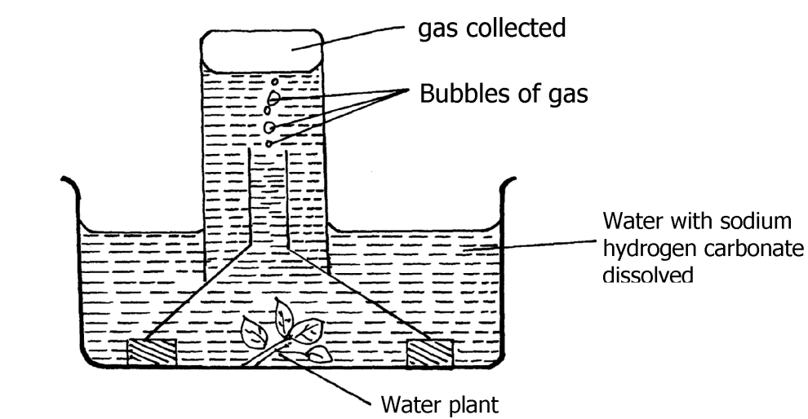
The set – up was left in bright sunlight for 4hrs
- State the aim of the experiment (1mk)

……………………………………………………………………………………………………………………………………………….
- Name M and N (2mks)

M……………………………………………………………………………………………………………………………………………

N…………………………………………………………………………………………………………………………………………….
- Other than sunlight name three factors that would affect the experiment(3mks)
………………………………………………………………………………………………………………………………………………

………………………………………………………………………………………………………………………………………………

………………………………………………………………………………………………………………………………………………

……………………………………………………………………………………………………………………………………………….
- State how the identify of M would be confirmed (1mk)

………………………………………………………………………………………………………………………………………………
- Explain why only submerged water plant was used in this experiment (1mk)

………………………………………………………………………………………………………………………………………………

………………………………………………………………………………………………………………………………………………

……………………………………………………………………………………………………………………………………………….

SECTION B (40mks)
- An investigation was conducted to compare rate of water loss from twigs of two different species of plants Q and L.The twigs had equal leaf surfaces. Theresults of the investigation were recorded in the table below

Time of the day | 6a.m | 8a.m | 10a.m | 12pm | 2pm | 4pm | 6pm | 8pm | 10pm | 12am
Water loss(gh-i species Q | 0 | 4 | 20 | 40 | 55 | 36 | 26 | 20 | 0 | 0
Water loss(gh-1⁻I species L | 8 | 20 | 39 | 131 | 198 | 182 | 130 | 81 | 12 | 12
- On the graph paper provided plot a graph of water loss gh⁻¹ against time of the two plants.(7mks)
- Name the apparatus which might have been used to investigate the value of water loss (1mk)

………………………………………………………………………………………………………………………………………………………..
- State two precautions that were taken in setting up the experiment (2mks)

……………………………………………………………………………………………………………………………………………………………

……………………………………………………………………………………………………………………………………………………………

……………………………………………………………………………………………………………………………………………………………
- Which of the plant species is likely to be adapted in and conditions? Give a reason (2mks)

……………………………………………………………………………………………………………………………………………………………

……………………………………………………………………………………………………………………………………………………………
- Use the graph to answer the following questions
- At what time of the day was 60gh ⁻¹ of water lost by species L ? (1mk)

……………………………………………………………………………………………………………………………………………………..
- What was the rate of water loss from plant species Q at 11.00am? (1mk)

……………………………………………………………………………………………………………………………………………………
- Account for the rate of water loss between 6.00am to 1.00pm by plant species L (4mks)

……………………………………………………………………………………………………………………………………………………………

……………………………………………………………………………………………………………………………………………………………

……………………………………………………………………………………………………………………………………………………………

……………………………………………………………………………………………………………………………………………………………

……………………………………………………………………………………………………………………………………………………………
- Suggest how the stomata of species Q are structurally adapted to water loss (2mks)

……………………………………………………………………………………………………………………………………………………………

……………………………………………………………………………………………………………………………………………………………

……………………………………………………………………………………………………………………………………………………………

……………………………………………………………………………………………………………………………………………………………
- a).state five differences between aerobic and anaerobic respiration (5mks)
b.Discuss the application of anaerobic respiration in industry and at home (15mks)

- a.what is meant by the term natural selection (2mks)
b. Describe how natural selection brings about the adaptations of a species to its environment(12mks)
c. Distinguish between convergent and divergent evolution (2mks)
d. Name four evidences to show that evolution has taken place (4mks)
……………………………………………………………………………………………………………………………………………………………

……………………………………………………………………………………………………………………………………………………………

……………………………………………………………………………………………………………………………………………………………

……………………………………………………………………………………………………………………………………………………………

……………………………………………………………………………………………………………………………………………………………

……………………………………………………………………………………………………………………………………………………………

……………………………………………………………………………………………………………………………………………………………

……………………………………………………………………………………………………………………………………………………………

……………………………………………………………………………………………………………………………………………………………

……………………………………………………………………………………………………………………………………………………………

……………………………………………………………………………………………………………………………………………………………

……………………………………………………………………………………………………………………………………………………………

……………………………………………………………………………………………………………………………………………………………

……………………………………………………………………………………………………………………………………………………………

……………………………………………………………………………………………………………………………………………………………

……………………………………………………………………………………………………………………………………………………………

……………………………………………………………………………………………………………………………………………………………

……………………………………………………………………………………………………………………………………………………………

……………………………………………………………………………………………………………………………………………………………

……………………………………………………………………………………………………………………………………………………………

……………………………………………………………………………………………………………………………………………………………

……………………………………………………………………………………………………………………………………………………………

……………………………………………………………………………………………………………………………………………………………

……………………………………………………………………………………………………………………………………………………………

……………………………………………………………………………………………………………………………………………………………

……………………………………………………………………………………………………………………………………………………………

……………………………………………………………………………………………………………………………………………………………

……………………………………………………………………………………………………………………………………………………………

……………………………………………………………………………………………………………………………………………………………

……………………………………………………………………………………………………………………………………………………………

……………………………………………………………………………………………………………………………………………………………

……………………………………………………………………………………………………………………………………………………………

……………………………………………………………………………………………………………………………………………………………

……………………………………………………………………………………………………………………………………………………………

……………………………………………………………………………………………………………………………………………………………

……………………………………………………………………………………………………………………………………………………………

……………………………………………………………………………………………………………………………………………………………

……………………………………………………………………………………………………………………………………………………………

……………………………………………………………………………………………………………………………………………………………

……………………………………………………………………………………………………………………………………………………………

……………………………………………………………………………………………………………………………………………………………

……………………………………………………………………………………………………………………………………………………………

……………………………………………………………………………………………………………………………………………………………

……………………………………………………………………………………………………………………………………………………………

……………………………………………………………………………………………………………………………………………………………

……………………………………………………………………………………………………………………………………………………………

……………………………………………………………………………………………………………………………………………………………
……………………………………………………………………………………………………………………………………………………………

……………………………………………………………………………………………………………………………………………………………

……………………………………………………………………………………………………………………………………………………………

……………………………………………………………………………………………………………………………………………………………

……………………………………………………………………………………………………………………………………………………………

……………………………………………………………………………………………………………………………………………………………

……………………………………………………………………………………………………………………………………………………………

……………………………………………………………………………………………………………………………………………………………

……………………………………………………………………………………………………………………………………………………………

……………………………………………………………………………………………………………………………………………………………

……………………………………………………………………………………………………………………………………………………………

……………………………………………………………………………………………………………………………………………………………

……………………………………………………………………………………………………………………………………………………………

……………………………………………………………………………………………………………………………………………………………
……………………………………………………………………………………………………………………………………………………………

……………………………………………………………………………………………………………………………………………………………

……………………………………………………………………………………………………………………………………………………………

……………………………………………………………………………………………………………………………………………………………

……………………………………………………………………………………………………………………………………………………………

……………………………………………………………………………………………………………………………………………………………

……………………………………………………………………………………………………………………………………………………………

……………………………………………………………………………………………………………………………………………………………

