231/3 CONFIDENTIAL

Source of heat
Iodine solution
specimen K –Gymnospermae with cones
SPECIMEN L -Angiospermae with flowers eg Lantana camara L
Substance Y -yeast scoop
Solution X- lime water
1-testtube
1 boiling tube
Thermometer
Measuring cylinder
Delivery tube corked with the BT
Water bath
Access to light microscope ( label Low power objective as A and revolving nose piece as B
Access to stain iodine or methylene blue
Petri dish
Scalpel
White tile
Source of heat

Biology pp3 Marking Scheme

1. You are provided with 10% glucose solution and substance labeled Y. Also provided is a solution labeled X. You are to investigate the reaction between the glucose solution and substance Y. Measure 20.00cm³ of the glucose solution and transfer it to the boiling tube provided. Transfer all the substance Y provided into the solution in the boiling tube. Tightly fit the rubber bung carrying a delivery tube to the boiling tube. Place the boiling tube in a water bath kept between 35 – 38⁰ c. Measure 1.0. Cm3 of solution X and transfer to a test tube. Connect the delivery tube so that the open end enters the solution X. Allow the set – up to stand for about 30 minutes and during this time observe the changes occurring in the boiling tube and in the test tube having solution X.
a) Fill the table below (2 marks)
Tube | Observations
Boiling Tube | Bubbles / effervescence
Test Tube | Solution X turns into white ppt

b) What conclusions can your draw from your observations in the test tube? (2 marks)
The colourless gas produced is carbon (iv) oxide, solution x is lime water / calcium hydroxide.
c) Name the process that took place in the test tube (1 mark)
Fermentation/ anaerobic respiration
d) Shake the contents of the boiling tube and using a dropper remove a little of the contents. Transfer a drop to a glass slide; add two drops of methylene blue stain. Cover with a cover slip and observe using a microscope of x10 or x15 eye piece lens.
(i) Draw and label the substance Y which is in the slide (2 marks)

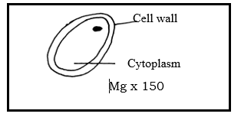
(ii) What is the possible identity of substance Y (1 mark)
Yeast
e) Why was the temperature of the water bath kept between 35 – 38⁰c (1 mark)
It is the optimum temperature range /best temperature/most suitable for functioning of enzymes.
f) If the experiment was done under the following conditions, suggest, giving reasons the expected results.
(i)Water bath was kept at 100⁰c

Observations: (1 mark)
No reaction / no respiration /no co₂ production /no effervescence.
Reasons: At high temperature the enzymes are denatured and yeast cells are killed (1 mark)

g) From the microscope
(i) Name the part labeled A. (1 mark)
Low power objective lens
(ii) Give the function of part labeled B. (1 mark)
Allows change from one objective lens to another,
h) Name the form in which substance Y stores its excess glucose (1 mark)

Glycogen;

.
Question Two

You are provided with specimen K and specimen L,

- State with reasons the sub divisions to which the specimens belong.
 | Sub division (2 mark) | Reason (2 mark)
K | Gymnospermae  Gymnospermaphyta | Presence of cones;
L | Angiospermae  Angiospermaphyta; | Presence of flowers  Presence of veins;

- State two reasons that proofs specimen L is more advanced compared to specimen K. in plant Kingdom (2 marks)
Specimen L produces seeds that are enclosed in a fruit while K produces naked seeds;
Specimen L xylem tissues have both tracheids and xylem vessels while the xylem tissue of K lacks xylem vessels;
- Name the likely habitat of specimen K and give an adaptation that suit K to its habitat (2 marks)
Habitat – arid/semi arid/ desert/ semi desert
Has needle like leaves to reduce the surface area over which transpiration occurs reducing transpiration rate;
- Describe the leaf of specimen L (3 marks)
Broad leaf lamina; hairy leaf lamina; presence of petiole; crenulated leaf margin; green in color
- Study the stem of specimen L.
- State the structural modification observed ( 1mark)
Precence of thorns/spikes
- What is the importance of this modification? (1mark)
Protect the plant from being fed by herbivore. Reduces chances of browser feeding on it
Reject prevents

3.You are provided with the following illustration, use it to answer the questions that follow.
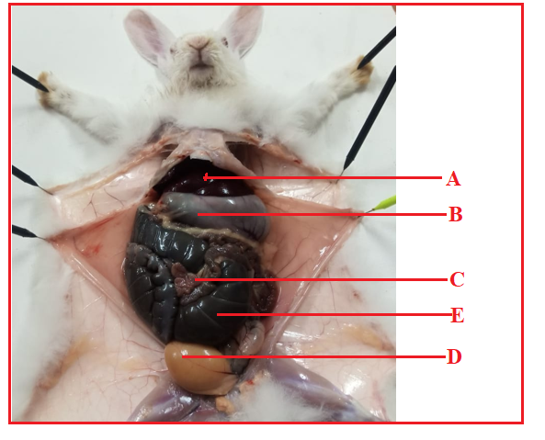

- Name the parts labeled C and E (2marks)
C Ileum/small intestine E caecum
- Classify the organism into Phylum (1mark)
Chordata
- With reason identify the Class of the organism (2marks)
Class | Reason
Mammalia | Body covered with fur

- State the digestive function of the part labeled B (2 marks)
Has smooth muscles that churns ingested food into chyme
Gastric enzymes are releases into it to digest protein
Gastric acid/hydrochloric acid released into it to ensure favorable PH.
- State two adaptation of the part labeled C (4 marks)
Long to provide laege surface area for digestion; coiled to slow down food hence more time for digestion; villus ;microvillus to provide large surface area for digestion; goblet cells;mucus preventing autodigestion; intestinal juice complete digestion fo food

- State two homeostatis function of structure labeled A (2marks)
Blood sugar balance
thermoregulation

