MOCK EXAMS
Kenya Certificate of Secondary School
FORM 3 BIOLOGY
231/3 - BIOLOGY -Paper 3
(PRACTICAL)
END TERM 1 2021 – 1 ¾ hours
____________________________________
Name .............................................. Adm Number................. Class: ………….
Instructions to Candidates
- Write your name and admission number in the spaces provided above.
- Sign and write the date of examination in the spaces provided above.
- Answer all the questions in the spaces provided.
- You are required to spend the first 15 minutes of the 1 ¾ hours allowed for this paper reading the whole paper carefully before commencing your work.
- Additional pages must not be inserted.
____________________________________
For Examiner’s Use Only
Question | Maximum score | Candidate’s score
1 | 14
2 | 13
3 | 13
Total Score | 40

1. You are provided with 10% glucose solution and substance labeled Y. Also provided is a solution labeled X. You are to investigate the reaction between the glucose solution and substance Y. Measure 20.00cm³ of the glucose solution and transfer it to the boiling tube provided. Transfer all the substance Y provided into the solution in the boiling tube. Tightly fit the rubber bung carrying a delivery tube to the boiling tube. Place the boiling tube in a water bath kept between 35 – 40⁰ c. Measure about 1.0. cm3 of solution X and transfer to a test tube. Connect the delivery tube so that the open end enters the solution X. Allow the set – up to stand for about 30 minutes and during this time observe the changes occurring in the boiling tube and in the test tube having solution X.

a) Fill the table below (2 marks)

Tube | Observations
Boiling Tube
Test Tube

b) What conclusions can your draw from your observations in the test tube? (2 marks)
……………………………………………………………………………………………………………………………………………………………………………………………………………………………………………………………………………………………………………………………………………………………………………………………………………………………………………………………….
c) Name the process that took place in the test tube (1 mark)
………………………………………………………………………………………………………………………………………………………………………………………………………………………………………………………………………………………………………….
d) Shake the contents of the boiling tube and using a dropper remove a little of the
contents. Transfer a drop to a glass slide; add two drops of methylene blue stain. Cover with a cover slip and observe using a microscope of x10 or x15 eye piece lens.

(i) Draw and label the substance Y which is in the slide (2 marks)

ii) What is the possible identity of substance Y (1 mark)
…………………………………………………………………………………………………………………………………………………….
e) Why was the temperature of the water bath kept between 35 – 38⁰c (1 mark)
…………………………………………………………………………………………………………………………………………………….
f) If the experiment was done under the following conditions, suggest, giving reasons the expected results.
(i)Water bath was kept at 100⁰c

Observations ( 1mark) | Reasons (1mark)

g) From the microscope
(i) Name the part labeled A. (1 mark)
…………………………………………………………………………………………………………………………………………………….
(ii) Give the function of part labeled B. (1 mark)
…………………………………………………………………………………………………………………………………………………….
h) Name the form in which substance Y stores its excess glucose (1 mark)

…………………………………………………………………………………………………………………………………………………….

2. You are provided with specimen K and specimen L, use them to answer the questions that follows.

- State with reasons the sub divisions to which the specimens belong.
 | Sub division (2 mark) | Reason (2 mark)
K
L

- State two reasons that proofs specimen L is more advanced compared to specimen K. in plant Kingdom (2 marks)
……………………………………………………………………………………………………………………………………………………………………………………………………………………………………………………………………………………………………………………………………………………………………………………………………………………………………………………………..
- Name the likely habitat of specimen K and give an adaptation that suit K to its habitat (2 marks)
………………………………………………………………………………………………………………………………………………………………………………………………………………………………………………………………………………………………………………………………………………………………………………………………………………………………………………………………
- Describe the leaf of specimen L (3 marks)
……………………………………………………………………………………………………………………………………………………………………………………………………………………………………………………………………………………………………………………………………………………………………………………………………………………………………………………………….

- Study the stem of specimen L.
- State the structural modification observed ( 1mark)
…………………………………………………………………………………………………………………………………………………………………………………………………………………………………………………………………………………………………………
- What is the importance of this modification? (1mark)
……………………………………………………………………………………………………………………………………………………………………………………………………………………………………………………………………………………………………………………………………………………………………………………………………………………………………………………………….
3. You are provided with the following illustration, use it to answer the questions that follow.
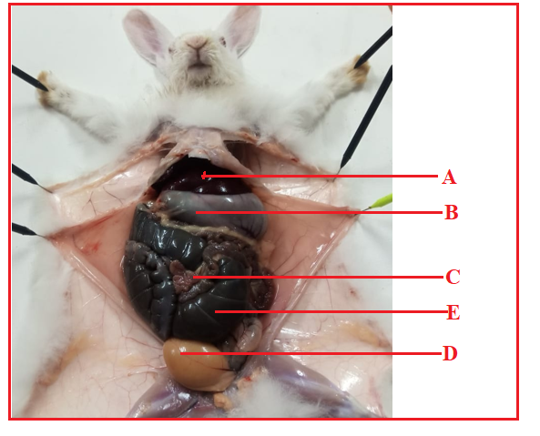
- Name the parts labeled C and E (2marks)
……………………………………………………………………………………………………………………………………………………………………………………………………………………………………………………………………………………………………………………………………………………………………………………………………………………………………………………………….

- Classify the organism into Phylum (1mark)
…………………………………………………………………………………………………………………………………………………….

- With reason identify the Class of the organism (2marks)
Class | Reason

- State the digestive function of the part labeled B (2 marks)
……………………………………………………………………………………………………………………………………………………………………………………………………………………………………………………………………………………………………………………………………………………………………………………………………………………………………………………………….
- State two adaptation of the part labeled C (4 marks)
………………………………………………………………………………………………………………………………………………………………………………………………………………………………………………………………………………………………………………………………………………………………………………………………………………….……………………………………………
- State two homeostatis function of structure labeled A (2marks)
………………………………………………………………………………………………………………………………………………………………………………………………………………………………………………………………………………………………………….

