NAME. ………………………………………..ADM. NO………..……..CLASS:……..

565/1
BUSINESS STUDIES FORM THREE
PAPER 2
JULY 2019
TERM II
Time: 2½ hrs

MWAKICAN JOINT EXAMINATION

INSTRUCTIONS TO CANDIDATES
- Write your name, class and admission number in the spaces provided
- Answer any FIVE questions in the spaces provided
- All questions carry equal marks
- All answers must be written in English

- a) Describe any five disadvantages of operating sole proprietorship business. (10mks)
b) Explain any five factors that may contribute to low national income in a country. (10mks)
- a) Explain five factors that may slow entrepreneurship in a country. (10mks)
b) Explain any five circumstances which may make it necessary for an insurance company to re-insure. (10mks)
- a) Explain any five channels of distributing imported goods. (10mks)
b) The following transactions relates to Laito traders for the month of January 2014.
1st Jan – Started business with shs. 100,000 cash and shs. 200,000 in bank.
2nd Jan- Withdrew shs. 20,000 for office use.
14th Jan – Withdrew shs. 10,000 from bank for private use
Required: Prepare the relevant ledger accounts and balance off the accounts. (10mks)
- a) Explain any five disadvantages to a country where the government involves itself in business. (10mks)
b) Explain any five benefits to a business that uses computers to file documents. (10mks)
- a) The following balances were obtained from the books of Kenya Moja traders on 1st June 2018.
 | Kshs.
Capital | 600,000
Motor van | 200,000
Furniture | 200,000
Stock | 60,000
Debtors | 80,000
Bank | 270,000
Creditors | 180,000
Outstanding electricity bill | 30,000
The following transactions took place during the year ended 31st December, 2018.
- Paid creditors shs. 80,000 by cheque
- Sold motor van and was paid shs. 150,000 in cash and the balance was still outstanding at the end of the year.
- Paid an electricity bill of shs. 20,000 in cash and shs. 10,000 was still outstanding at the end of the year.
Required: Prepare Kenya moja traders balance sheet as at 31st December, 2018. (10mks)
b) Outline any five factors that have facilitated growth of commerce in Kenya. (10mks)
- a) Outline any five conditions under which a business may find it appropriate to accept deferred terms of payment. (10mks)
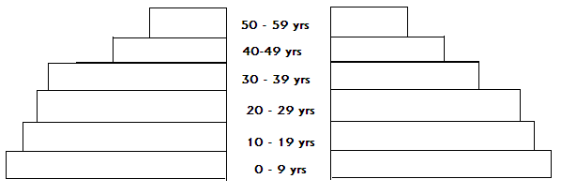
b) Below is a population structure according to the ages. Explain any five challenges to a country with such a population structure. (10mks)

MALE
FEMALE

