Name ……………………………………………ADM No:……………Class……….
233/2 Candidate’s Signature………………
CHEMISTRY Date…………………………………
PAPER 2
FORM THREE
(THEORY)
July/Aug. 2015
2 Hours

Kenya Certificate of Secondary Education
CHEMISTRY
Paper 2
(THEORY)
2 Hours

Instruction to candidates.
- Write your name and admission number in the spaces provided above .
- Sign and write the date of theexamination in the spaces provided above.
- Answer ALL the questions in thespaces provided.
- All questions must be answered in English.
- Mathematical tables and silent electronic calculators may be used.
- All working MUST be clearly shown where necessary.
- This paper consists of 13 printed pages.
- Candidates should check the question paper to ascertain that all the pages are printed as indicated and that no questions are missing.
For Examiner’s use only
Question | Maximum score | Candidate’s score
1 | 11
2 | 12
3 | 12
4 | 11
5 | 12
6 | 12
7 | 10
Total  score | 80

- The grid below shows part of the periodic table. Use it to answer the question that
follows
 |  |  |  |  |  |  |  |  | A
 | B |  |  |  |  |  | C | D |  | E | K
F | G
 |  |  |  |  |  |  |  |  |  | H

- Name the elements that can form ions with a charge of -1.(1mk)

- Name the chemical family into which element F belong. (1mk)

- What type of structure would the oxide of C have? Explain (2mks)

- How does the reactivity of B compare with that of G .Give a reason. (2mks)

- 1.3 g of B reacts completely with 1.21dm³ of E when heated at s.t.p (molar gas volume = 22.4dm³ )
i) Write a balanced chemical equation for the reaction
between B and E. (1mk)

ii) Determine the atomic mass of B (2mks)

iii) using dot(.) and crosses(x) to represent outermost electrons, draw a diagram to show the bonding in the compound formed when B reacts with E. (1mk)

f) State one use of the element K. (1mk)

2. a) Crude oil is a source of many compounds that contain carbon and hydrogen only.
- Give the general name of the compounds that contain carbon and hydrogen only. (1mk)

- Name the process used to separate the components of crude oil. (1mk)

- Draw the structure of the second member of the alkyne homologous series. (1mk)

- Draw the structure of 2-methlybut-2-ene (¹/₂mk)

- Give the IUPAC name of the structure below. (¹/₂mk)

CH₃

CH₃-C-CH₃
CH₃

b) Study the flow chart below and answer the questions that follow.
Butane

Step 1
Step 2

polymerisation
H
W
ethene
Cl₂
Step 3
H_{2(g)}
Nickel catalyst, 180⁰c-250ºc
J

Ethane

    - State the conditions for the reaction in step 1 to occur. (1mk)

    - Identify substance W. (1mk)

    - Describe a simple chemical test to show the difference between the ethene a and substance W. (2mks)

    - Name substance H. (1mk)

    - State one commercial use of the process in step 3. (1mk)

vi. Draw and name substance J (2mks)

3. The schematic diagram shows part of the solvay process used for the manufacture of sodium carbonate.

Process 11
Process 1
UNIT 1
UNIT 11
ammonia
Saturated sodium chloride
Ammonium chloride
Sodium hydrogen carbonate
Sodium carbonate
Carbon (IV) oxide

a) Two main reactions take place in UNIT 1. The first one is the formation of ammonium hydrogen carbonate.

- Write an equation for this reaction. (1 mk)

- Write an equation for the second reaction. (1mk)

b) Name the following processes:- (2mks)

- Process I

- Process II

- Write an equation for process II (1mk)

c) In an experiment to determine the percentage purity of the sample of sodium carbonate produced in the solvay process , 2.15g of the sample reacted completely with 40.0cm³ of 0.5M sulphuric (VI) acid.
- Calculate the number of moles of sodium carbonate that reacted. (2mks)

- Determine the percentage of sodium carbonate in the sample.
(Na=23.0, C=12.0, O=16.0) (2mks)

d) Name one industrialuses of sodium carbonate. (1mks)

e) (i) Starting with calcium oxide, describe how solid sample of calcium carbonate can be prepared. (2mks)

4. (a) Describe the process by which Nitrogen is obtained from air on a large scale.(4 mks)

(b) Study the flow chart below and answer the questions that follow.

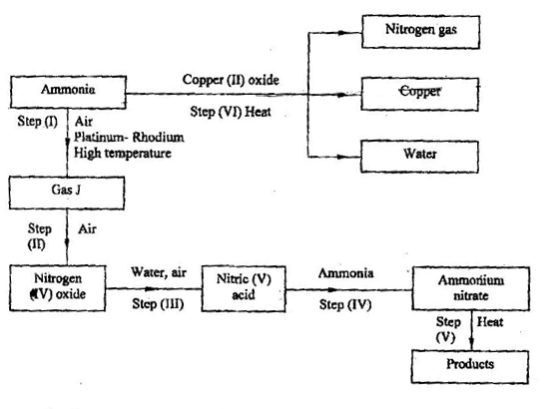

(i) Identify gas J. (1 mk)

(ii) Write the equation for the reaction that occurs in step (V). (1mk)

(iii) Give one use of ammonium nitrate. (1mk)

c. When excess lead nitrate solution was added to a solution containing ammonium chloride , the precipitate formed was found to weigh 5.56g. Determine the amount of ammonium chloride in the solution. (4mks)
(Pb=207, Cl=35.5, N =14, H=1)

5. The set – up below was used to prepare hydrogen gas
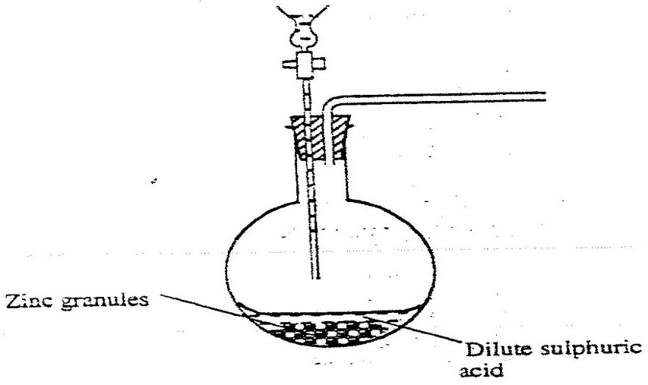
X

a) i Complete the diagram to show how a dry sample of hydrogen gas
can be collected (3mks)

ii Label the apparatus X (1mk)

b) Write an equation for the reaction, which takes place when hydrogen
gas burns in air.(1mk)

c) i)1.2 litres of hydrogen gas produced at room temperature and pressure when 3.27g of zinc was used. Determine the relative atomic mass of zinc.(Molar gas volume is 24 litres) (4mks)

d) State one industrial use of hydrogen gas. (1mks)

e) Describe a test for hydrogen gas. (2mks)

6. Samples of urine from three participants F, G and H at an international sports meeting were spotted onto a chromatography paper alongside two from illegal drugs A₁ and A_{2.}
A chromatogram was run using methanol. The figure below shows the chromatogram.

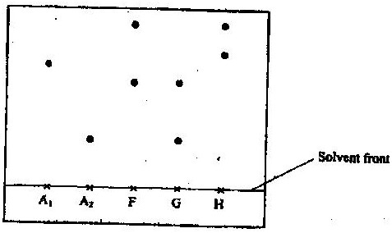

a) Label the solvent front. (1mk)

I Identify the athlete who had used an illegal drug. (1mk)

II Which drug is more soluble in methanol? (1mk)

b) Describe how solid ammonium chloride can be separated from a solid mixture of ammonium
chloride and anhydrous calcium chloride ( 3mks)

(c)The table shows liquids that are miscible and those that are immiscible

Liquid | L₃ | L₄
L₁ | Miscible | Miscible
L₂ | Miscible | Immiscible
Use the information given to answer the questions that follow
(i) Name the method that can be used to separate L₁ and L₃ from a mixture of two
( 1mk)

(ii) Describe how a mixture of L₂ and L₄ can be separated ( 2mks)

d) Study the properties of substances V1 to V4 in the table below and answer
the questions that follow.
Substance | Solubility in water | Solubility in  petrol | Melting Point(ºC) | Boiling point(ºC)
V1 | Insoluble | Soluble | -30 | 250
V2 | Insoluble | Insoluble | 1535 | 3000
V3 | Insoluble | Soluble | 16.8 | 44.8
V4 | Insoluble | Soluble | 75 | 320
i) Which of the substances are liquids at 24⁰C? (1mk)

ii) Describe how a mixture containing V2 and V4 can be separated (2mks)

7. In an experiment, a piece of magnesium ribbon was cleaned with steel wool. 2.4 g of the clean magnesium ribbon was placed in a crucible and completely burnt in oxygen. After cooling, the product weighed 4.0 g

(a) Explain why it was necessary to clean the magnesium ribbon ( 1mk)

(b) What observation was made in the crucible after burning ( 1mk)

(c) Why was there an increase in mass? ( 1mk)

(d) Write the equation for the reaction which took place in the crucible ( 1mk)

(e) The product in the crucible was shaken with water and filtered. Explain the observation which was made when blue and red litmus papers were dropped into the filtrate. ( 3mks)

(f) Calculate the volume of oxygen gas used during the burning.(O=16 : molar volume of a gasis 24,000cm³ at room temperature) (3mks)

