TERM TWO
CHEM P2 FORM 3
MARKING SCHEMES
- 1.(a) Alkali metals
- (i) GR₂ OR CO₂
- (ii) covalent bond
- Z – It has 4 energy levels hence its outermost electron is weakly held by the nucleus hence has greater tendency to lose electrons.
- T₂O
- T₂O₂
- It is below P
- Ionic radius of W is greater that of S. W has an energy 3 level while S has 2 energy levels.
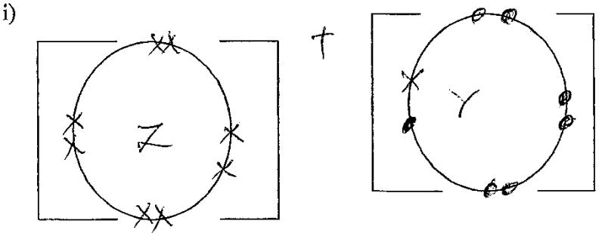
2.
- Mg _{(s)} +2HCl MgCl_{2(aq) + H2(g)}
- Scale -1
- Plotting – 1
Curve – 1

- 150 + 2cm3
- 30cm3
- Mg_{(s)} + 2Hcl_{(aq)} MgCl_{2(aq) + H2(g)}
Mole ratio 1:2
If 24,000cm3 = 1 mole
Therefore 300cm3 = 300 x 1
24,000
= 0.0125 mole

Moles = mass
Rmm
Rmm = 0.3
0.0125
= 24g
3.

- Fractional distillation of liquid air
- Natural gas
By product of crocking of long chain alkanes

- Carbon (iv) oxide
- Sulphur (iv) oxide
- Dust particles
- Temp – 500oC
Pressure – 200 atmospheres
- The compression enhances faster reaction between N_{2 (g) and H2 (g)} hence increases high yield of Ammonia.
- Iron to reduce wastage

- As a fertilizer
- As a refrigerant
- Softening hard water
- Removal of greasy stains
- Manufacture of hydrazine used in rocket fuels
- The black CuO turns to a red brown is related to Cu(s) by ammonia
- P1V1 = P₂V₂
T₁ T₂
V₂ = 250 x 200 x 273
293 x 300
= 155.29cm3

- A salt is a substance found when the Hydrogen ion of an acid is replaced directly or indirectly by a metal or ammonia ion.

- Deliquescent self – is one which absorbs water for the atmosphere to form a solution.
Hydroscopic salt – is one which absorbs water from the atmosphere but does not form solution.
- Used as a drying agent.

- Oxygen gas O₂(g0
- Thermal decomposition
- Add water to the mixture, Nacl dissolves while CuO does not. Filter and heat the filtrate to dryness then cool the Nacl crystals.

- Pb₂+(aq) + SO₄²⁻_{(aq)} PbSO_{4(s)}
- Pb(NO₃)₂ + Na2SO₄ PbSO₄+ 2NaNO₃
Moles of Pb: 3.4 = 0.016425
207
Mole Ratio Pb: PbSO₄
1:1
Therefore moles of PbSO₄ = 0.16425
Hence mass = 0.16425 x 303
(Rmm = 207 + 207 + 32 + 64 = 303)
Therefore mass = 4.9768g

- 2methylbustance
- Pent -2 –ene
- Propyne

- Cn H₂n+2
- Alkanes
- C₂H₆ = 12 x2 + 6 x1 =30
- C₂ H₆
H H
I I
H – C – C – H
I I
H H

- Hydrogen chloride gas
- Hydrogen gas
- Soda lime (sodium hydroxide)
- 2C₂H₂ (g) + 5O₂(g) 4CO₂ +2H₂O(l)
- Polymerization
- C_{x}H_{y} +3O₂(g) 1CO₂(g) + 1 H₂O(l)
Mass 5028g 2.16g
Moles 5.28 = 0.12 2.16 = 0.12
44 18
Mola Ratio = 1:1
Hence C_{x}H_{y} C₁H₂ therefore EF CH₂

- (a) 2Pb(NO₃)3(s) 2PbO(s) + 4 No2(g)

- Oxygen gas
- Dinitrogen tetra oxide
- Nitrogen (IV) Oxide is easily liquefied

- H is red brown in colour
- Has a pungent, irritating smell
- It is denser than air
- Is soluble in water
- Is easily liquefied to form yellow N2O4
- Is poisonous

- Burning Nitrogen Magnesium alit of heat which makes NO2 to dissociate to NO and O2 (g) which supports burning.
- 4mg(s) + 2NO₂(g) 4mgO(s) + N₂(g)
- It should be prepared in a fume chamber or open space.
This is because NO₂ (g) is poisonous.
- Pb(NO3)2(aq) +2Nacl(aq) Pbcl2(s) + 2 NaNO3(aq)
Mole ratio 1;2
Moles = 8.34
278
Therefore mass = 0.06 x58.5 = 3.51
- A)
- Period 4
- B³⁺ - 2.8 D⁻ - 2.8.8
- D
- C
- D – Its melting point is – 101ºC therefore at room temperature (25ºC) it has already melted into a liquid.

