DARAJANI BOYS’ HIGH SCHOOL,
P.O BOX 20-90129, NGWATA

OPENER CAT, TERM II, 2015
FORM 3
CHEMISTRY

NAME:………………………………………….……... ADM.NO:………...CLASS:………...

- a) What is meant by allotropy? (1 mark)
…………………………………………………………………………………………………........
………………………………………………………………………………………………............

b) The diagram below shows the structure of one of the allotropes of carbon

  - Identify the allotrope (1 mark)
……………………………………………………………………………………………...........
……………………………………………………………………………………………............
  - State one property of the above allotrope and explain how it is related to its structure. (2 marks)
………………………………………………………………………………………………….
- The table below gives the atomic numbers of element w, x, y and z. The letters do not represent the actual symbols of the elements.

Element | w | x | y | Z
Atomic number | 9 | 10 | 11 | 12

- Which one of the elements is least reactive? Explain (1 mark)
………………………………………………………………………………………………........
………………………………………………………………………………………………........

- (i) Which two elements would react most vigorously with each other? (1 mark)

………………………………………………………………………………………………
……………………………………………………………………………………………....

(ii) Give the formula of the compound formed when elements in (i) above react.
(1 mark)

3. The diagram below represents an incomplete paper chromatogram of pure dyes x, y, z and
mixture w.

w x y z

Mixture w contains dyes y and z only. Complete the chromatogram to show how mixture w separates (2 marks)

4. 22.2cm³ of sodium hydroxide solution containing 4.0g per litre sodium hydroxide were required for complete neutralisation of 0.1g of a dibasic acid. Calculate the relative formula mass of the dibasic acid. (Na = 23, O=16, H=1) (3 marks)

……………………………………………………………………………………………………………………………………………………………………………………………………………………………………………………………………………………………………………………………………………………………………………………………………………………………………………………………………………………………………………………………………………………………………………....................................................................................................
5. A student set up the experiment below to collect gas K. The glass wool was heated before the magnesium ribbon.
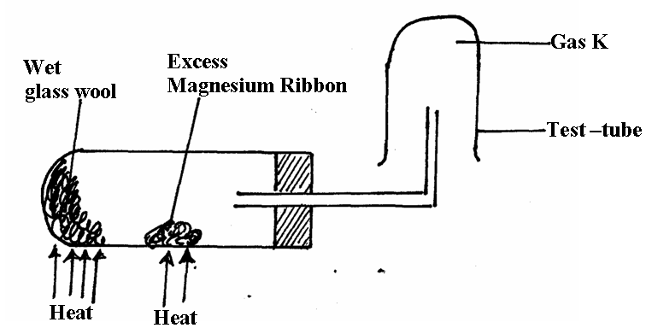

a) What would happen if magnesium was heated before heating the wet glass wool. (1mk)

………………………………………………………………………………………………….
………………………………………………………………………………………………….

b) Write an equation that takes place in the preparation of gas K (1mk)

………………………………………………………………………………………………….
………………………………………………………………………………………………….

c) What property of gas K made it possible to be collected as shown in the diagram (1mk)

………………………………………………………………………………………………….
………………………………………………………………………………………………….
6. A volume of 280cm³ of nitrogen gas diffuse through a membrane in 70 seconds how long
will it take 400cm³ of carbon (IV) Oxide to diffuse through the same membrane . (2mks)

………………………………………………………………………………………………….
………………………………………………………………………………………………….

7. A student set up the experiment below to collect gas K. The glass wool was heated before the magnesium ribbon.

a) What would happen if magnesium was heated before heating the wet glass wool. (1mk)

………………………………………………………………………………………………….
………………………………………………………………………………………………….

b) Write an equation that takes place in the preparation of gas K (1mk)

………………………………………………………………………………………………….
………………………………………………………………………………………………….

c) What property of gas K made it possible to be collected as shown in the diagram (1mk)

………………………………………………………………………………………………….
………………………………………………………………………………………………….
8. A volume of 280cm³ of nitrogen gas diffuse through a membrane in 70 seconds how long
will it take 400cm³ of carbon (IV) Oxide to diffuse through the same membrane . (2mks)

………………………………………………………………………………………………….
………………………………………………………………………………………………….

9. The set-up below was used to prepare a sample of oxygen gas. Study it and answer
the questions that follow.
H₂O₂
MnO₂

- Complete the diagram to show how Oxygen can be collected. (2mks)

(ii) Write a chemical equation of the reaction to produce oxygen. (1mk)

10. In an experiment, a piece of magnesium ribbon was cleaned with steel wool. 2.4g of
the clean magnesium ribbon was placed in a crucible and completely burnt in oxygen.
After cooling the product weighed 4.0g
- Explain why it is necessary to clean magnesium ribbon. (1mk)

b) What observation was made in the crucible after burning magnesium ribbon? (1mk)

c) Why was there an increase in mass? (1mk)

- Write an equation for the major chemical reaction which took place in the crucible. (1mk)

e) The product in the crucible was shaken with water and filtered. State and explain the
observation which was made when red and blue litmus paper were dropped into the filtrate. (1mk)

